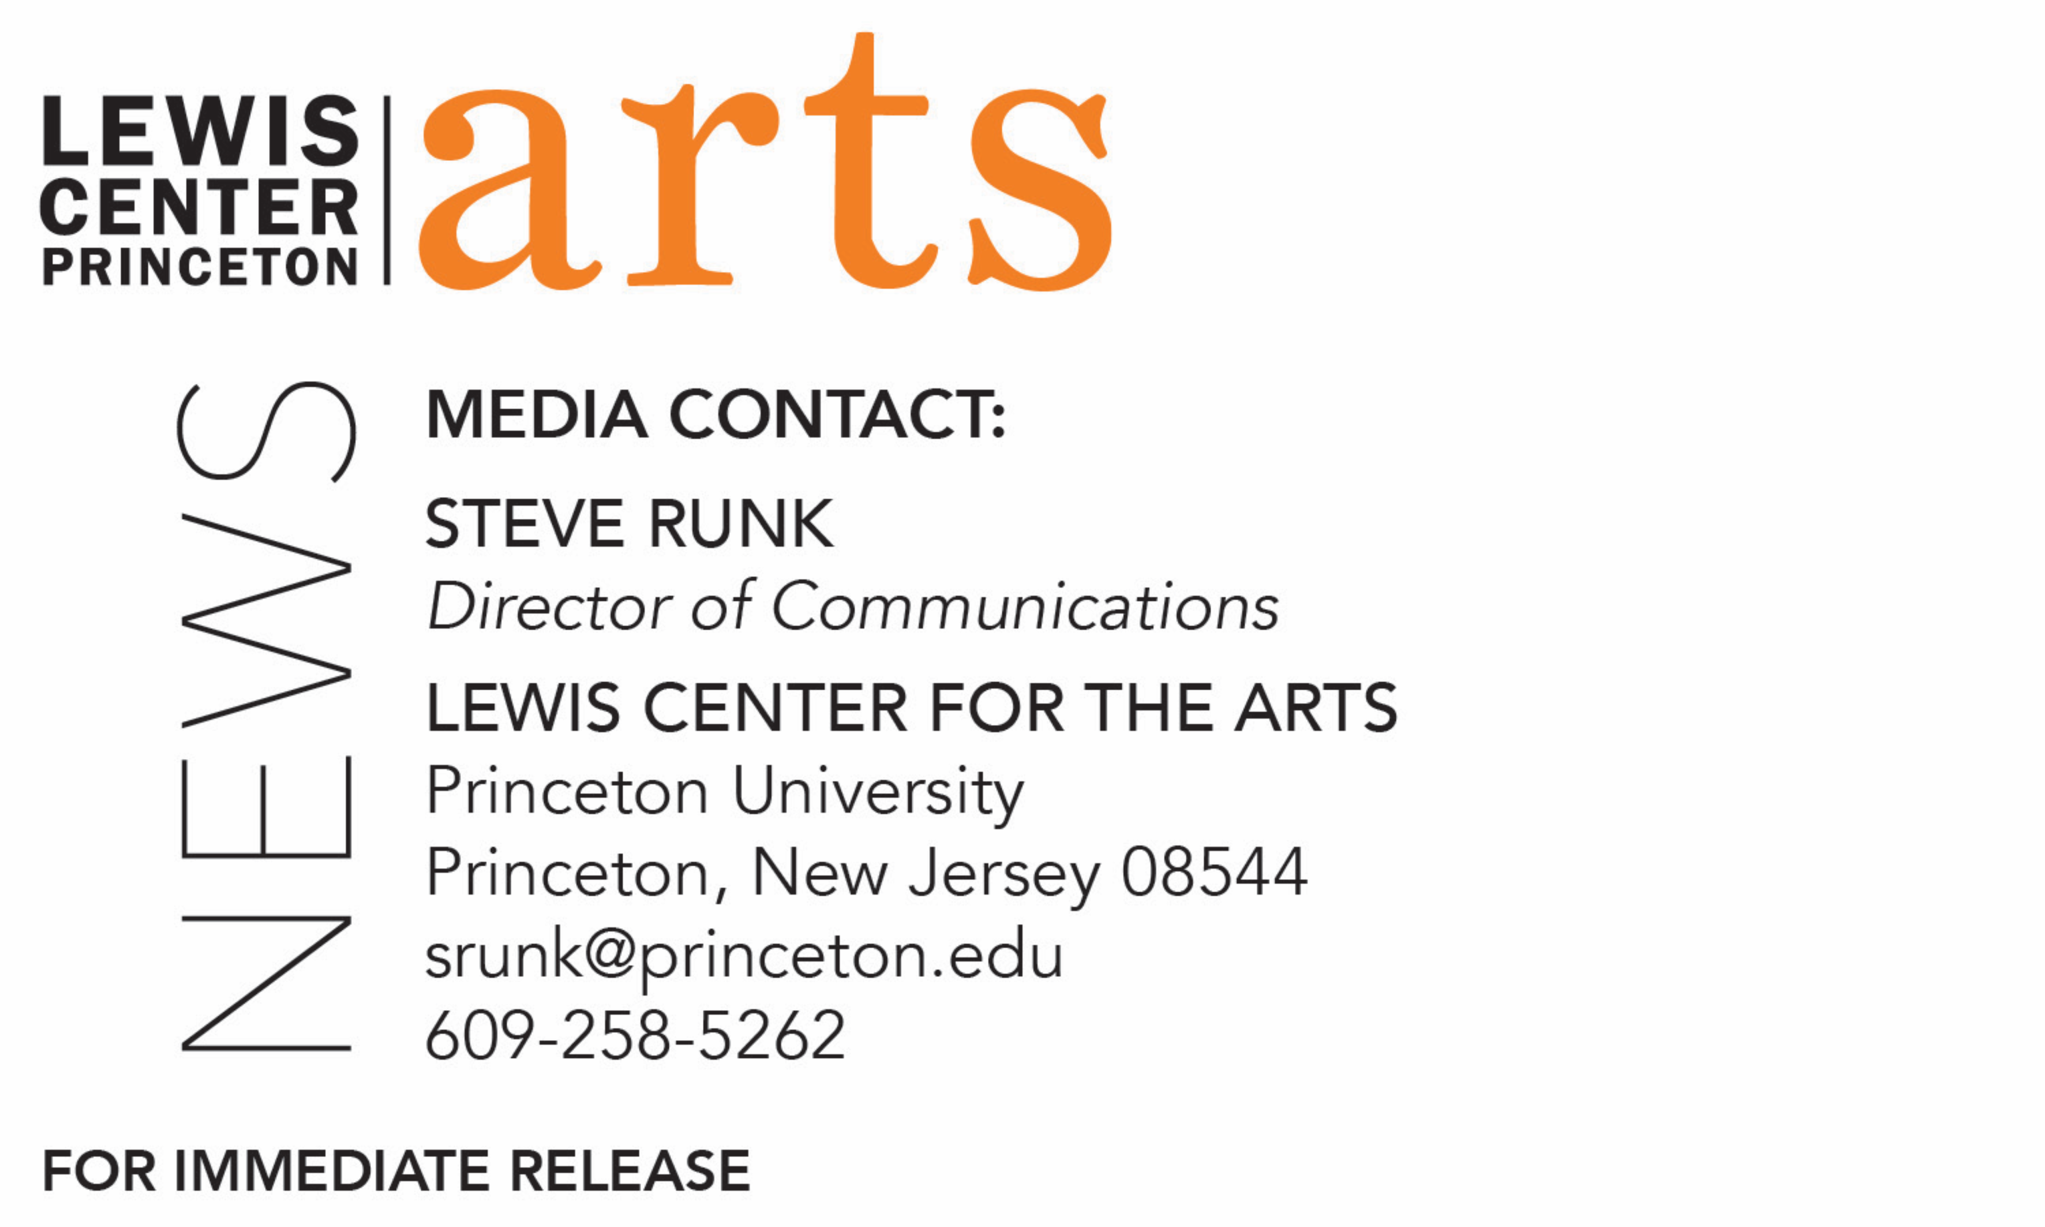

September 24, 2018

Writer Aleksandar Hemon to Join Princeton University’s
Creative Writing Faculty

Photo caption: Award-winning writer Aleksandar Hemon joins Princeton’s Program in Creative Writing faculty in September 2018
Photo credit: Velibor Bozovic

(Princeton, NJ) Award-winning writer Aleksandar Hemon has joined the Lewis Center for the Art’s Program in Creative Writing faculty at Princeton University. He has been appointed Professor of Creative Writing and is teaching undergraduate creative writing workshops, including “Introduction to Fiction” and “Advanced Fiction.”

Aleksandar Hemon is the author of award-winning work in fiction, non-fiction, journalism, and screenplays, including the novel The Lazarus Project, which was a finalist for the 2008 National Book Award and National Book Critics Circle Award. He has published three collections of short stories: The Question of Bruno; Nowhere Man, which was also a finalist for the National Book Critics Circle Award; and Love and Obstacles. He published the novel The Making of Zombie Wars in 2015 and worked as a writer on the hit Netflix show Sense8. He has also published non-fiction, including his 2013 memoir The Book of My Lives, as well as pieces in The New Yorker, Esquire, The New York Times, The Paris Review, and BH Dani. He was awarded a Guggenheim Fellowship in 2003 and a “Genius Grant” from the MacArthur Foundation in 2004. He has taught at Northwestern University, Columbia College Chicago and New York University.

“It is our great good fortune to welcome Aleksandar Hemon, a writer of profound insight and supreme originality, to the faculty in Creative Writing,” said Tracy K. Smith, director of the Program in Creative Writing and current U.S. Poet Laureate. “Writing across genres—from fiction, to memoir, to criticism, to screenplays—he brings a robust energy and furthers the range of international perspectives characterizing our remarkable roster.”

Born in Sarajevo, Hemon graduated from the University of Sarajevo with a degree in literature and visited Chicago in 1992 as a part of a journalism exchange program, intending to stay for just a few months. However, he was unable to return home because of the Bosnian War and graduated from Northwestern University with his master’s degree, simultaneously working a series of jobs while continuing to learn English. He wrote his first story in English in 1995.

“I am honored and delighted to be joining Princeton University and its stellar Program in Creative Writing,” said Hemon. “Moreover, I look forward to meeting and working with the students. I have a feeling it is going to be great.”

Hemon will join Program in Creative Writing faculty Jhumpa Lahiri, Yiyun Li, Paul Muldoon, James Richardson, Tracy K. Smith, Kirstin Valdez Quade, and Susan Wheeler, and a number of distinguished visiting lecturers.

Through the program’s courses, students have the opportunity to pursue original work at both beginning and advanced levels in fiction, poetry, screenwriting and translation under the guidance of these practicing, award-winning writers. Students can earn a certificate in creative writing in addition to their degree in a major. Each year more than two dozen seniors work individually with a member of the faculty on a creative writing thesis, such as a novel, screenplay, or a collection of short stories, poems, or translations.

To learn more about the Program in Creative Writing and the Lewis Center for the Arts, including the more than 100 performances, exhibitions, readings, screenings, concerts and lectures presented each year, most of them free, visit arts.princeton.edu.
###

