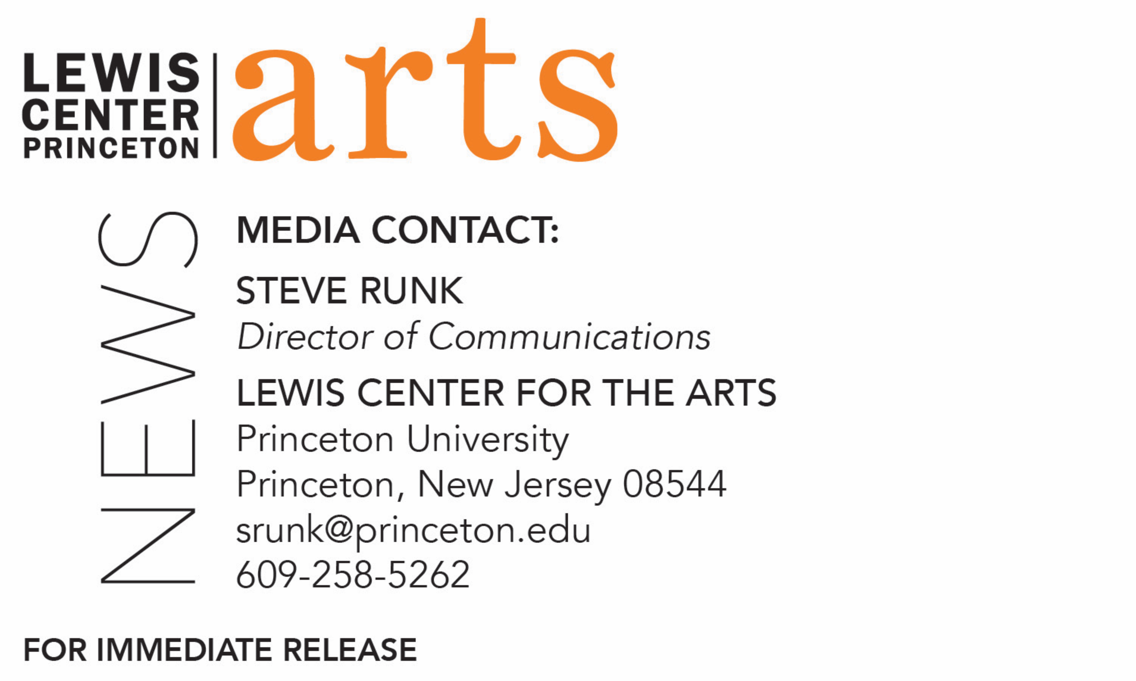

September 7, 2018

Lewis Center for the Arts’ Programs in Theater and Music Theater present
a reading of a new musical
Foreign Bodies

What: Reading of all or excerpts of Foreign Bodies, a new musical in development about germophobia, xenophobia, and the collective cost of personal freedom, inspired by a very real global threat, presented by Princeton University’s Programs in Theater and Music Theater.
Who: Conceived and directed by Princeton alumnus Whitney Mosery (Associate Director on the current Broadway production of Harry Potter and the Cursed Child), book by alumnus Joshua Williams (novelist named a “Star of Tomorrow” by New York Magazine) with music and lyrics by Yve Blake, performed by Princeton students.
When: September 11 at 8:00 p.m.
Where: Wallace Theater at the Lewis Arts complex on the Princeton campus
Free and open to the public

(Princeton, NJ) The Lewis Center for the Arts’ Programs in Theater and Music Theater at Princeton University will present a reading of all or excerpts of a new musical in development, Foreign Bodies, conceived and directed by Princeton alumnus Whitney Mosery, book by alumnus Joshua Williams with music and lyrics by Yve Blake, performed by Princeton students. The reading, which is the culmination of a development workshop created to benefit both current students and recent Princeton alumni, is free and open to the public and will be presented on Tuesday, September 11 at 8:00 p.m. in the Wallace Theater at the Lewis Arts complex on the Princeton campus.

The musical has its roots in a story told to Whitney Mosery in 2016 by a London emergency room doctor about a Polish immigrant with extensively drug-resistant tuberculosis who repeatedly escaped his quarantine cell in a separate wing of the hospital and is returned by police upon his capture. Out of quarantine and out in the community, the man posed the risk of causing a monumental epidemic with catastrophic consequences. However, this young exuberant man, alone in a new country, possibly scared but full of bravado, took every possible opportunity to escape from the hospital and go out on the town.

Mosery began to wonder: Who was this man? How must he feel? Did he know how high the stakes were? And if he did, didn’t he care? If he did know, and did care, and did it anyway... what did that say about how desperately he must need his freedom? Why couldn’t the people responsible for his well-being see how the loss of his freedom was killing him? And on a lighter note: what must those escapades have been like? Where did he go? Did he fall in love, make friends, fight enemies?

She began to imagine a piece of musical theater that moved between the micro or personal – with a focus on the man, his claustrophobic quarantine cell, his limited human interactions in the hospital, the moments of contact within the ocean of humanity he throws himself into on his wild nights out – and the macro - the rhetoric of “economic resources drained by undeserving migrants” joined by an even more insidious chorus of disgust and fear: “they’ll bring disease to our country.” Racism and xenophobia being allowed to run rampant, so long as they remain hidden under the guise of logical concerns about health and safety.

Foreign Bodies is part documentary theater about the world as it is, part musicalized imagining of what the world will be when it enter what the Centers for Disease Control calls the “post-biotic age.” Mosery was offered a six-month residency with the Habitat Theater’s Directors Playground to develop the piece and invited her longtime collaborator, Joshua Williams, to join her in the residency and co-develop the piece. Together, they spent six months writing and devising, and in May 2017, they presented 20 minutes of fully staged new material as part of the Directors Playground Showcase. Yve Blake joined the project, bringing her unique blend of documentary theater techniques and contemporary musical storytelling.

Mosery is a director/deviser/dramaturg based in New York City and London. She was the first American to graduate from Royal Academy of Dramatic Arts (RADA) in London with a M.A. in Theatre Directing and the first Director in Residence at the Almeida Theatre. Her specialty is new plays and musicals, including Girl From Nowhere by Victoria Rigby and Lauren Pritchard (New York Music Festival/St. James Theatre/Edinburgh Fringe); Murder at the Gates by Steven Sater and James Bourne (Pace New Musicals); Zoe Sarnak's A Lasting Impression (NYMF); The Bonapartes by Joshua Williams (Ars Nova’s ANT Fest); Faster Higher Stronger Straighter (Dominion); Sinhaz and Exit Johnny Clarke (Williamstown Theatre Festival). Mosery also directs her own reworkings of classics, including the ritual/bonfire/dance/party/play BACCHANALIA (Greece/UK/Williamstown); Last Words You’ll Hear based on Strindberg and Jung (Latitude Festival); and a three-person M. Butterfly, adapted with support from David Henry Hwang (RADA). As an associate director she has worked on Harry Potter and the Cursed Child (Broadway); American Psycho (Broadway/Almeida); King Charles III (Broadway/West End/Almeida, co-director of international tour); and Mr. Burns (European premiere, Almeida). Mosery has also served as a guest lecturer and panelist at New York University, RADA and Princeton. She holds a B.A. in Classics from Princeton University, Class of 2008.

Williams is a writer, director, translator and theater academic. In 2011, he directed the North American premiere of Ebrahim Hussein's Kinjeketile and is currently translating Hussein's complete works from Swahili into English for Oxford University Press. His own plays have been developed or produced at Princeton University, Theatre Intime, the Capital Fringe Festival, University of California Berkeley, University of Colorado Boulder, the New York Musical Theatre Festival, CAP 21, Ars Nova's ANT Fest, the Habitat Theater's Directors Playground, the University at Buffalo, the Rhinebeck Writers' Retreat and Play Ground San Francisco / Thick House. He is a 2018 recipient of a Sloan Commission from the Ensemble Studio Theater for his new play Ornithology and a member of Princeton’s Class of 2007.

Blake is an award-winning writer, composer and performer originally from Sydney, Australia. As a writer she has completed the Royal Court Writers’ Programme, and developed work with the National Theatre, Old Vic New Voices, Griffin Theatre Company, and Belvoir. Her work has also been presented at The Barbican, Roundhouse, Bush Theatre, and to sell-out audiences at the Soho Theatre. In 2016 Blake was awarded the inaugural ATYP Rebel Wilson Theatremaker Scholarship to write and compose her dream project: Fangirls, A Bloodthirsty Musical based on interviews with hundreds of teenage fangirls. After a workshop at the 2018 Adelaide Cabaret Festival and two presentations at the Barbican and Southbank Centre, Fangirls will premiere at two major Australian theatre companies in 2019 and is currently in development for a screen adaptation. Blake is also currently adapting Lisa Nicol’s beloved children’s book Dr. Boogaloo and the Girl Who Lost her Laughter into a musical for the stage (with Alice Chance), writing a feature film for Aquarius films (Lion), and developing a musical about Mary Wollstonecraft.

Admission to the reading is free and open to the public; seating is on a first-come, first-seated basis.

To learn more about this event, the Programs in Theater and Music Theater, and the over 100 performances, exhibitions, readings, screenings, concerts, and lectures presented each year at the Lewis Center, most of them free, visit arts.princeton.edu.

###

