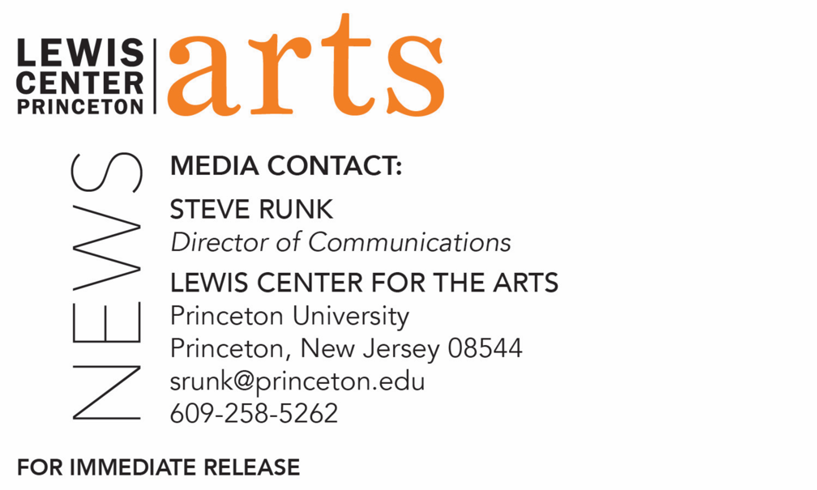

September 18, 2018

Lewis Center for the Arts’ Program in Theater presents
A Conversation about the History of Casting
Princeton Associate Professor Brian Herrera hosts discussion based on his current research

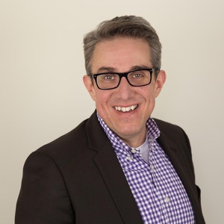
Photo caption: Associate Professor of Theater Brian Herrera
Photos credit: Courtesy of Brian Herrera

Who: Associate Professor of Theater and performance historian Brian Herrera
What: An interactive conversation on the history of casting in U.S. popular performance that aims to press the critical, creative and historical understanding of casting actors in theater, film and television, presented by the Lewis Center for the Arts’ Program in Theater.
When: Monday, September 24 at 4:30 p.m.
Where: Wallace Theater in the Lewis Arts complex on the Princeton University campus
Free and open to the public

(Princeton, NJ) Associate Professor of Theater at Princeton University and performance historian Brian Herrera will lead a conversation about the history of casting in U.S. popular performance on Monday, September 24 at 4:30 p.m. in the Wallace Theater in the Lewis Arts complex on the Princeton campus. The event is free and open to the public.

The conversation is based on Herrera’s ongoing research for his book-length study of the topic, Casting, A History, and will address some key questions: How did contemporary casting practices come into being? How did actors become freelancers? What is the sordid history of the headshot? How has casting changed in the internet era? Why do casting controversies figure so prominently in discussions about race, gender and sexuality in contemporary theatre?

Using these and other questions from the audience, Herrera will guide a lively interactive discussion about the history of casting actors for theater, film and television. This conversation aims to press the critical, creative and historical understanding of casting beyond familiar zero-sum measures of good/bad, success/failure or right/wrong, so as to cultivate an appreciation of casting as a dynamic repertoire of performance techniques, practices and conventions ripe for experimentation, innovation and revision.

Herrera is, by turns, a writer, teacher and scholar, presently based in New Jersey at Princeton, but with deep roots in New Mexico. His work, whether academic or artistic, examines the history of gender, sexuality and race within and through U.S. popular performance. He is author of The Latina/o Theatre Commons 2013 National Convening: A Narrative Report (HowlRound, 2015). His book Latin Numbers: Playing Latino in Twentieth-Century U.S. Popular Performance (Michigan, 2015) was awarded the George Jean Nathan Award for Dramatic Criticism and received an Honorable Mention for the John W. Frick Book Award from the American Theatre and Drama Society. With Stephanie Batiste and Robin Bernstein, Herrera serves as co-editor of the Performance and American Cultures series at NYU Press. He is also the Inaugural Resident Scholar for The Sol Project, an initiative dedicated to producing the work of Latinx playwrights in New York City and beyond. He is presently at work on two book projects: the previously noted Casting, A History and Starring Miss Virginia Calhoun, a narrative portrait of a deservedly obscure early 20th-century actress/writer/producer. Also a performer, his autobiographical solo show I Was the Voice of Democracy has been seen in more than a dozen states, as well as Beirut and Abu Dhabi, and he is currently workshopping two new storywork shows, Boy Like That and Touch Tones. In addition to being a member of the Program in Theater faculty, Herrera is affiliated with Princeton’s Programs in Gender and Sexuality Studies, American Studies and Latino Studies.

To learn more about this event, the Program in Theater, and the more than 100 other performances, exhibitions, readings, screenings, concerts, and lectures presented each year by the Lewis Center, most of them free, visit arts.princeton.edu.

###

