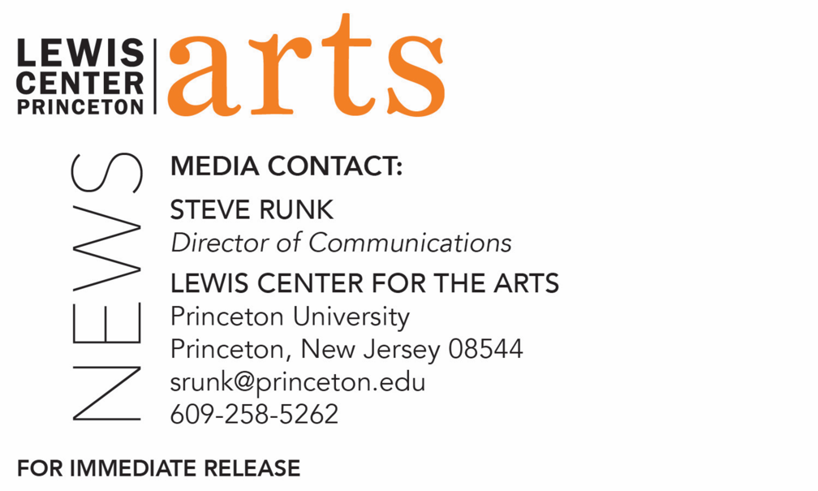

October 8, 2018

Lewis Center for the Arts’ Program in Creative Writing presents
A Reading with Robin Coste Lewis and Sheila Heti
Award-winning writers next in Althea Ward Clark W’21 Reading Series at Princeton

Photo caption 1: National Book Award-winning poet Robin Coste Lewis
Photos credit 1: Kate Flint
Photo caption 2: Celebrated writer and editor Sheila Heti
Photos credit 2: Steph Martyniuk

Who: Reading by National Book Award-winning poet Robin Coste Lewis and writer/editor Sheila Heti
What: Next reading in the 2018-19 Althea Ward Clark W’21 Reading Series
When: Wednesday, October 17, at 7:30 p.m.
Where: Hearst Dance Theater at the Lewis Arts complex on the Princeton University campus
Free and open to the public

(Princeton, N.J.) On Wednesday, October 17, award-winning poet Robin Coste Lewis and celebrated author and editor Sheila Heti will read from their work as part of the Althea Ward Clark W’21 Reading Series of the Program in Creative Writing at the Lewis Center for the Arts. The reading, beginning at 7:30 p.m. in the Hearst Dance Theater at the Lewis Arts complex on the Princeton University campus, is free and open to the public. As a result of audience feedback, all readings for this year’s series have moved to a 7:30 p.m. evening time slot.

Robin Coste Lewis is the author of Voyage of the Sable Venus, winner of the 2015 National Book Award for Poetry. Her work has appeared in various journals and anthologies, including The Massachusetts Review, Callaloo, The Harvard Gay & Lesbian Review, Transition, and VIDA. Lewis earned her M.F.A. from New York University’s Creative Writing Program where she was a Goldwater Fellow in poetry. She also earned her Master of Theological Studies degree in Sanskrit and comparative religious literature from Harvard Divinity School. She is a Cave Canem Fellow and was awarded a Provost’s fellowship in the Creative Writing & Literature Ph.D. Program at University of Southern California. Other fellowships and awards include the Caldera Foundation, the Ragdale Foundation, the Headlands Center for the Arts, the Can Serrat International Art Centre in Barcelona, and the Summer Literary Seminars in Kenya. She was a finalist for the International War Poetry Prize, the National Rita Dove Prize, and semi-finalist for the “Discovery”/Boston Review Prize and the Crab Orchard Series Open Poetry Prize. Lewis has taught at Wheaton College, Hunter College, Hampshire College and the New York University Low-Residency M.F.A. in Paris. Born in Compton, California, her family is from New Orleans.

Coste Lewis will be introduced by Alicia Ostriker, faculty member in the Program in Creative Writing and a poet and critic. Ostriker has published sixteen volumes of poetry, including Waiting for the Light and The Book of Seventy, both of which received the National Jewish Book Award, and The Imaginary Lover, winner of the William Carlos Williams Award.

Sheila Heti is the author of eight books, including most recently the novel Motherhood, and the 2012 novel, How Should a Person Be? which was a New York Times Notable Book and was called by Time magazine “one of the most talked-about books of the year.” She is co-editor of the New York Times bestseller Women in Clothes, which features the voices of 639 women from around the world. Her books have been translated into a dozen languages. Her play, All Our Happy Days are Stupid, had sold-out runs at The Kitchen in New York and Videofag in Toronto. She appeared as Lenore Doolan in Leanne Shapton's book Important Artifacts and performed in Margaux Williamson's film, Teenager Hamlet. She is the former Interviews Editor of The Believer magazine and has conducted many long-form interviews with writers and artists. She has lectured at MoMA, The New Yorker Festival, Columbia University, Brown University, the Hammer Museum, the Cúirt Festival, and the Sydney Writers Festival. Her writing has been published in The New Yorker, McSweeney's, Harper's, The New York Times, n+1, and The London Review of Books. She lives in Toronto.

Heti will be introduced by Daphne Kalotay, faculty member in the Program in Creative Writing. Kalotay’s books include Calamity and Other Stories — shortlisted for the 2005 Story Prize — and the national and international bestseller Russian Winter, which won the 2011 Writers’ League of Texas Fiction Prize. Her bestselling novel Sight Reading was a finalist for the 2014 Paterson Fiction Prize and winner of the 2014 New England Society Book Award in Fiction.

The Lewis Center’s Program in Creative Writing annually presents the Althea Ward Clark W’21 Reading Series, which provides an opportunity for students, as well as all in the greater Princeton region, to hear and meet the best contemporary writers. All readings are free and open to the public. Other readings scheduled in the 2018-2019 series include:
- Guy Maddin and Caryl Phillips on November 14 in the Wallace Theater
- Layli Long Soldier and Princeton Hodder Fellow Jacob Shores-Argüello on February 6 in the Hearst Dance Theater
- Frank Bidart and Yuri Herrera-Gutierrez on March 6 in the Donald G. Drapkin Studio
- Han Kang and Ngũgĩ wa Thiong’o on April 17 in the Hearst Dance Theater

The series will also include readings of new work in December and May by selected students in creative writing courses and readings in May by seniors in the Program from the novels, collections of short stories, poems or translations, or screenplays written as their senior theses under mentorship by the creative Writing faculty.

To learn more about this event, the Program in Creative Writing, and the more than 100 other performances, exhibitions, readings, screenings, concerts, and lectures presented each year by the Lewis Center, most of them free, visit http://arts.princeton.edu/.

###

