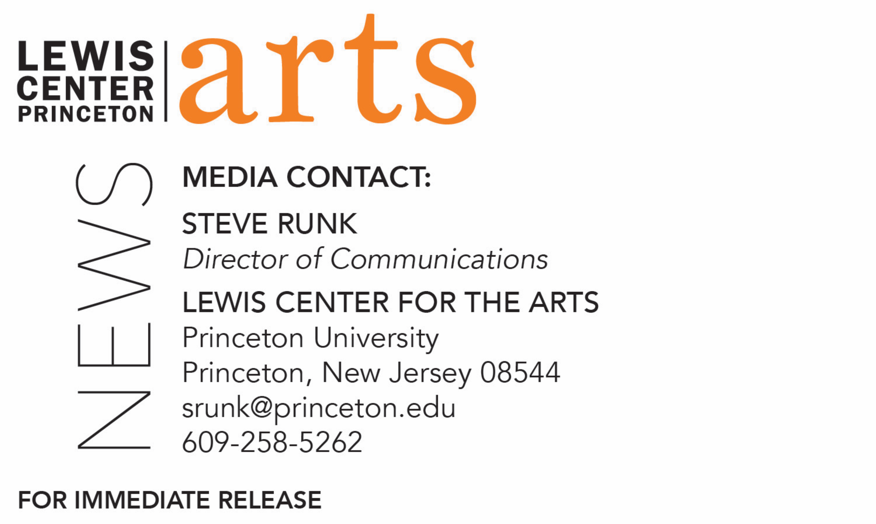

October 15, 2018

Lewis Center for the Arts’ Program in Dance invites the community to
An Ancestral Remembrance Ceremony Honoring James Collins Johnson
through traditional African dance, musical and spiritual ritual

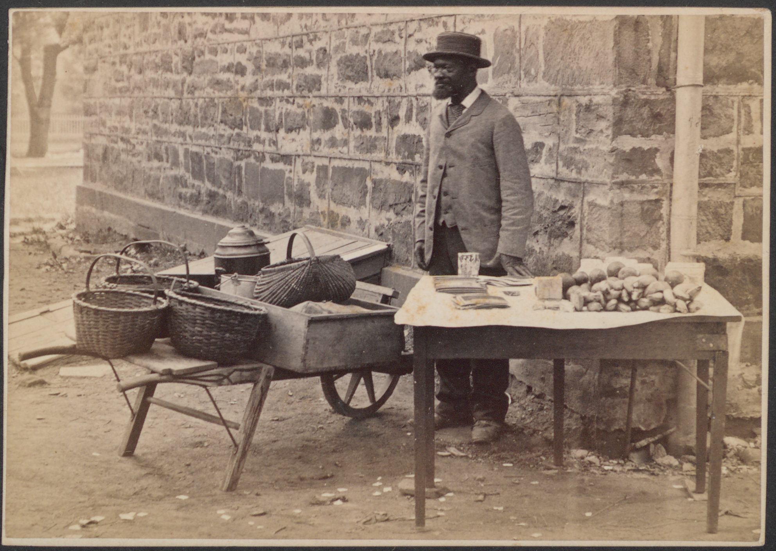
Photo caption: James Collins Johnson
Photo credit: Courtesy of the Princeton & Slavery Project

What: An Ancestral Remembrance Ceremony Honoring James Collins Johnson
through traditional African dance, music and spiritual ritual in advance of a formal dedication naming the easternmost arch at East Pyne for Mr. Johnson. Johnson, whose story was unearthed as part of the Princeton & Slavery Project, was a fugitive enslaved African from Maryland who worked on campus for more than 60 years, first as a janitor and then for many years as a vendor of snacks that he sold from a wheelbarrow.
Who: Ceremony to be led by Chief Ayanda Clarke with students from the fall course, “The American Dance Experience and Africanist Dance Practices” taught by lecturer Dyane Harvey-Salaam, presented by the Lewis Center for the Arts’ Program in Dance with the support of the Campus Iconography Committee and the Princeton & Slavery Project
When: October 22 at 3:30 p.m.
Where: In the easternmost archway and courtyard at East Pyne on the Princeton University campus
Free and open to the public
For more information: https://arts.princeton.edu/events/ancestral-remembrance-ceremony-honoring-james-collins-johnson/

(Princeton, NJ) The Lewis Center for the Arts’ Program in Dance at Princeton University invites the community to an Ancestral Remembrance Ceremony Honoring James Collins Johnson, a fugitive from Maryland who worked on campus for more than 60 years and whose story was unearthed as part of the Princeton & Slavery Project. This ceremony, rooted in African dance, music and spiritual ritual, is in advance of a formal dedication to officially name an archway at East Pyne Hall on the Princeton campus after Johnson. The ceremony will be held on Monday, October 22 at 3:30 p.m. in the archway at East Pyne and is free and open to the public.

The idea for a traditional ceremony to honor Johnson was initiated by Lecturer in Dance Dyane Harvey-Salaam, who teaches the course, “The American Dance Experience and Africanist Dance Practices.” She invited Chief Ayanda Clarke, a frequent guest lecturer to her class, to lead the ceremony in conjunction with the students in her class who will perform in the ritual.

James Collins Johnson was a black man who worked as a servant at the College of New Jersey, now Princeton University. In 1843 he was arrested on suspicion of being a fugitive enslaved African. Johnson had worked as a janitor at Nassau Hall, then a dormitory as well as a classroom building, without incident since 1839 after fleeing slavery in Maryland. His arrest ensued after a student recognized Johnson and alerted his so-called “owners,” who came to Princeton and had him detained for trial as a runaway enslaved African. Tried under the Fugitive Slave Act of 1793, Johnson was adjudged a fugitive and slated for return to slavery. However, a local white woman, Theodosia Ann Mary Prevost, who had strong ties to the college, intervened. Johnson spent the next several years repaying the funds advanced for his purchase. He went on to become a beloved friend of the college during his six-decade career on campus as a vendor of fruits, candies and other snacks that he sold from a wheelbarrow. When he died on July 22, 1902, Johnson was buried in the Princeton Cemetery only a few feet away from some of the country’s most prominent citizens. Alumni and students took up a collection for his burial and erected a gravestone, whose epitaph pays tribute to Johnson as “the students [sic] friend.”

In April, the Princeton University trustees accepted recommendations to name the easternmost arch in East Pyne Hall for Johnson. A formal dedication of the arch is planned for later this fall.

The ceremony to be led by Chief Ayanda (a highly respected Babalawo who was initiated to Ifa in Yorubaland, Nigeria) will include a traditional sacred ritual that will uplift the space, honor Johnson's unique life and sacrifices, and pay homage to the spirit of the ancestors through African dance, music, and prayers. Chief Ayanda sheds some insight on the ceremony: “I am coming to Princeton University for this important ceremony to center the life and legacy of Mr. James Collins Johnson, to remind us all of his humanity, and to respect the contributions that he made to this community. Despite all odds, this man of African ancestry valued the principles of friendship, kindness, and good character. In the ancient African spiritual tradition of Ifa, being a human being of good character is a mandate. So, it is with this understanding that I come to honor the spirit of iwa pele (good character) and to say thank you to the spirit of Mr. Johnson whose life is a light to us all.”

Harvey-Salaam’s course introduces students to American dance aesthetics and practices, with a focus on how its evolution has been influenced by African American choreographers and dancers. The class centers on ongoing study of movement practices from traditional African dances and those of the African diaspora, touching on American jazz dance, modern dance, and American ballet. Work in the dance studio is complemented by readings, video viewings, guest speakers, and dance studies.

Chief Ayanda Clarke is an African American master percussionist, Grammy Award-winning musician, arts educator, and lecturer who was taught initially by his father, the legendary African percussionist and jazz musician Chief Baba Neil Clarke. He has traveled across several continents performing with some of the world’s most revered percussionists and lectures frequently on African culture and music. In 2016 in the ancient City of Osogbo, known for its preservation of African traditional arts and culture (a World Heritage Site landmarked by the United Nations Educational, Scientific and Cultural Organization, UNESCO) — and sponsored by his mentor Chief Fakayode Faniyi — Clarke was installed as a chief in Osogbo, Yorubaland (Nigeria), by a council of elders and high priests. The honor was based on his more than three decades of unwavering commitment to Africa. Clarke’s concert, television, and consulting credits include Lincoln Center, Carnegie Hall, Radio City Music Hall, Michael Jackson: 30th Anniversary Celebration at Madison Square Garden, The Late Show with David Letterman, Good Morning America, America’s Got Talent, the U.S. Open, and Sesame Street. He has performed with and been featured on albums with world-class musicians and pioneers in African American, African, and world music including the late Randy Weston, George Clinton, Erykah Badu, M’bemba Bangoura, and Somi.

In addition to teaching at Princeton, Harvey-Salaam is a performing artist, founding member of Forces of Nature Dance Theatre, educator, choreographer and certified Pilates teacher. She has appeared as a principal soloist with some of the most recognized theater and dance companies across the United States and abroad. Her Broadway, television and film credits include: The Wiz, Timbuktu!, Spell# 7 and Free to Dance. Her choreography has been seen in many theatrical and dance projects including: Loves Fire and Harriet Returns with The Acting Company; The African Company Presents Richard III, Yerma and Flyin'West at New York University’s Graduate Acting Program; lavender lizards and lilac landmines, layla’s dream at University of Florida at Gainesville Graduate Acting Program; Bones of Our Ancestors on PBS Special and the award-winning Great Men of Gospel at New Federal Theatre. Her awards include two Audelco Awards for performance and choreography, a Monarch Merit Award, Goddess and Gurus Award, Black Theatre Award, and she was most recently recognized as one of 12 Distinguished Women by the Harlem Arts Alliance in conjunction with the Greater Harlem Chamber of Commerce.

To learn more about this event, the Program in Dance, and the over 100 performances, exhibitions, readings, screenings, concerts, and lectures presented each year at the Lewis Center, most of them free, visit arts.princeton.edu.

###

