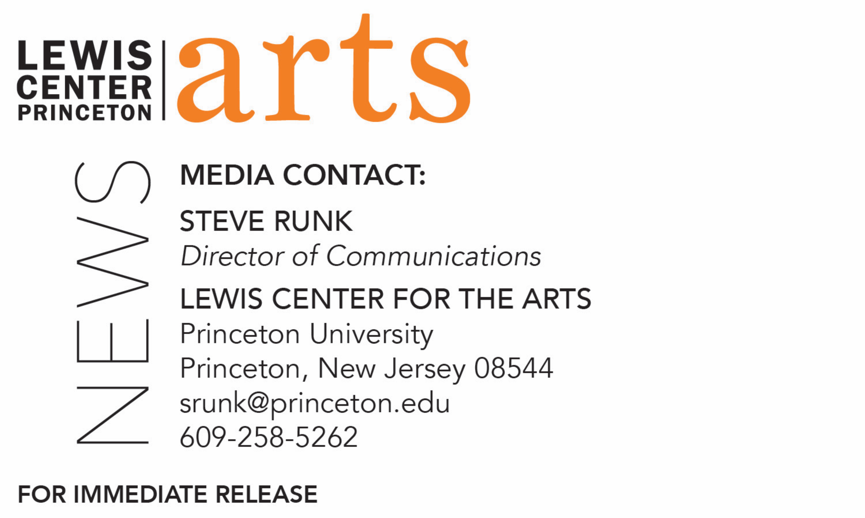

October 2, 2018

Lewis Center for the Arts’ Program in Music Theater at Princeton presents
A Conversation with Broadway Director John Doyle on the Musicals of Stephen Sondheim

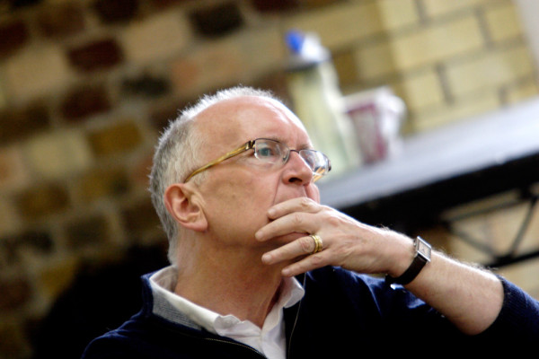
Photo caption: Tony Award-winning director and Visiting Lecturer at Princeton John Doyle
Photo credit: Catherine Ashmore

Who: John Doyle, Tony Award-winning Broadway director and Artistic Director of Classic Stage Company
What: A conversation on his experiences directing the musicals of Stephen Sondheim including Sweeney Todd, Company, Road Show, Merrily We Roll Along, Passion, and Pacific Overtures, first in a three-part series of conversations with Broadway professionals on Sondheim’s work
When: Monday, October 8 at 11:00 a.m.
Where: Godfrey Kerr Theater Studio, Lewis Arts Complex at 120 Alexander Street, Princeton, NJ

(Princeton, NJ) Broadway director and Artistic Director of Classic Stage Company John Doyle will discuss his experiences directing the musicals of Stephen Sondheim in a conversation held as part of Theater Professor Stacy Wolf’s fall course, “The Musical Theatre of Stephen Sondheim: Process to Production.” The discussion will take place on Monday, October 8 at 11:00 a.m. in the Godfrey Kerr Theater Studio at the Lewis Arts complex on the Princeton campus. Presented by the Lewis Center for the Art’s Program in Music Theater, the event is free and open to the public.

Wolf’s course examines a different musical by Stephen Sondheim each week, analyzing his influences and inspirations as well as how the elements of musical theater—from music to dance to design—cohere in his creations. Students are reading libretti, listening to music, viewing taped and live performances, researching production histories, analyzing popular, critical, and scholarly reception to Sondheim’s works, as well as hearing first-hand from visiting professionals.

Doyle has directed a number of Sondheim’s musicals and won the Tony Award for Best Director of a Musical in 2006 for his work on the Broadway production of Sweeney Todd: The Demon Barber of Fleet Street starring Patti LuPone and Michael Cerveris. He directed the Broadway production of Sondheim’s Company, which received the 2007 Tony Award for Best Revival of a Musical, as well as productions of Sondheim’s Road Show, Merrily We Roll Along, Passion, and Pacific Overtures. He has served as artistic director of four major regional theaters in the United Kingdom, currently holds the position of artistic director of Classic Stage Company in New York City, and has an extensive freelance directing career in theatre, film and opera. In addition to directing a number of Sondheim musicals, his credits include The Visit, which received the Tony nomination for Best Musical and a Drama Desk nomination for Best Director; Mahagonny at Los Angeles Opera, which received two Grammy Awards; Caucasian Chalk Circle at American Conservatory Theatre; and Kiss Me Kate at Stratford Festival Theatre. In addition to numerous credits in London’s West End, Doyle has also directed at Sydney Opera House, the Metropolitan Opera, Houston Grand Opera, La Fenice in Venice, Williamstown Theatre Festival, Second Stage Theatre, Princeton’s McCarter Theatre, and Cincinnati Playhouse in the Park. Doyle’s work was most recently represented on Broadway with his acclaimed production of The Color Purple, for which he was nominated for a 2015 Tony Award for Best Director of a Musical. Doyle is currently teaching the course “The Nature of Theatrical Reinvention” in Princeton’s Program in Music Theater.

Wolf teaches courses in American musical theater history, dramaturgy and dramatic literature, histories of U.S. performance, performance theory, and performance studies. She is the author of Changed for Good: A Feminist History of the Broadway Musical (recently named one of the “top ten books every theater lover should read” by Marissa Friedman); A Problem Like Maria: Gender and Sexuality in the American Musical; and the co-editor of The Oxford Handbook of the American Musical. She is currently working on Beyond Broadway: Four Seasons of Amateur Musical Theatre in the U.S., which examines amateur musical theater at high schools, summer camps, community centers, and afterschool programs across the country. Wolf is also director of the Princeton Arts Fellows program in the Lewis Center.

The Program in Music Theater will be hosting discussions regarding Sondheim’s musicals with two other musical theater professionals during the semester. On October 22, Broadway performer Alexander Gemignani will discuss his extensive work performing in the musicals of Stephen Sondheim, as well as host a masterclass for Princeton students. On November 7, librettist John Weidman will discuss his work collaborating with Stephen Sondheim. Both talks are free and open to the public.

Princeton’s Program in Music Theater is a collaboration among the Lewis Center for the Arts’ Program in Theater and Program in Dance and the Department of Music. The program brings together students, faculty, and guest artists in the creation, study, and performance of all forms of music theater; that is, any theatrical form that combines singing, acting, and movement.
For more information on the Program in Music Theater and the more than 100 other performances, exhibitions, readings, screenings, concerts, and lectures presented by the Lewis Center, most of them free, visit arts.princeton.edu.

###

