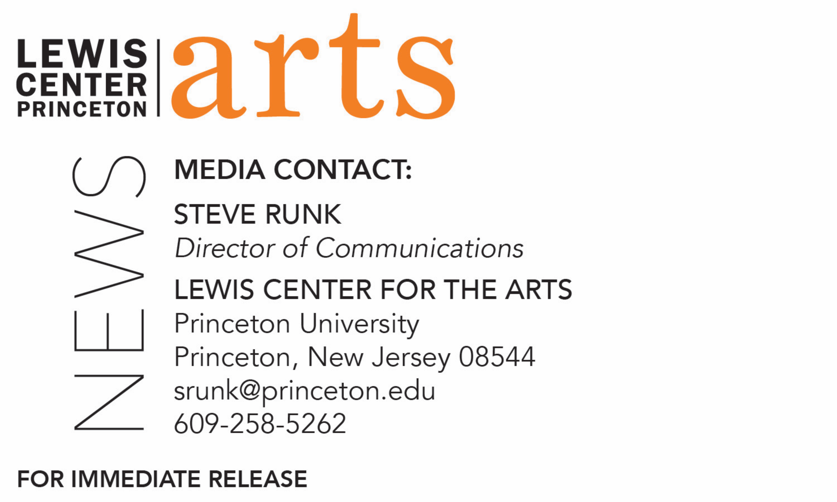

October 8, 2018

The Lewis Center for the Arts’ Program in Theater presents
What You Will: A Collection of Scenes from Twelfth Night
An evening of selected scenes and music from Shakespeare’s dark comedy

Photo caption: Seniors Julia Mosby, Anna Zabel, Kirsten Hansen and Ben Diamond (left to right) will each tackle multiple roles in What You Will: A Collection of Scenes from Twelfth Night at the Lewis Center for the Arts
Photos credit: Justin Goldberg

What/Who: A short, fun evening of selected scenes and music from Shakespeare’s dark comedy Twelfth Night, performed by seniors Ben Diamond, Kirsten Hansen, Julia Mosby, and Anna Zabel, as they challenge their acting and dramaturgy skills to portray a range of characters while exploring the play’s gender, sexuality and power dynamics that remain relevant today, presented by Lewis Center for the Arts’ Program in Theater.
When: October 19, 20 & 21 at 7:30 p.m. with a matinee on October 21 at 2:30 p.m.
Where: Donald G. Drapkin Studio at the Lewis Arts complex on the Princeton campus
Free and open to the public; advance tickets are recommended

(Princeton, NJ) The Lewis Center for the Arts’ Program in Theater at Princeton University will present What You Will: A Collection of Scenes from Twelfth Night on October 19, 20 and 21 at 7:30 p.m. with a matinee on October 21 at 2:30 p.m. in the Donald G. Drapkin Studio at the Lewis Arts complex on the Princeton campus. Seniors Ben Diamond, Kirsten Hansen, Julia Mosby, and Anna Zabel portray a range of characters while exploring the play’s gender, sexuality and power dynamics that remain relevant today.

The four seniors proposed the project as their senior thesis work in pursuit of certificates in the Program in Theater. All are intending to pursue a career in acting and wanted a project that would present a strong challenge to their acting skills. With few opportunities to perform roles in Shakespeare and believing that mastering the performance of the Bard’s work would be a critical experience for them, they chose to focus on one of his dark comedies. They sought to further challenge their abilities by each portraying multiple characters and using minimal sets and costumes in an intimate venue, relying on their performance skills to create the world of the play. The foursome also determined to challenge their dramaturgical skills by resetting the play in the contemporary locale of a small, west coast, island enclave and telling the story through select scenes. Mosby also committed to creating original music for the production that introduces a folk/country vibe to the play.

Diamond, playing Duke Orsino and Malvolio, is a sociology major pursuing certificates in theater and music theater. He originally hails from San Francisco and plans on pursuing a career in the performing arts after Princeton. He has appeared in several shows through the Lewis Center, namely Annie and Rose, Singin’ in the Rain, Hairspray!, Into the Woods, Gurls, and Next to Normal. He is also a member of the Princeton Triangle Club, having performed in their original musicals the past four years, and is a member of Shere Khan A Cappella and BodyHype Dance Company on campus. His regional theater credits include The Crucible at Princeton Summer Theater, Chicago at Hangar Theater in Ithaca, New York, Spamalot, Shrek: The Musical, and Mary Poppins at The Muny in St. Louis.

Hansen, who is an English major from southern California pursuing certificates in theater and music theater, is performing the roles of Viola and Sebastian. She has trained in Shakespearean acting the past two summers with the British Academy of the Dramatic Arts in London and the Commonwealth Shakespeare Company in Boston. Hansen is a member of the Princeton Triangle Club and has acted in and directed many shows on campus with student groups and in the Program in Theater. After graduation she plans to apply to a graduate acting program in London to train where a number of her favorite actors, such as Judi Dench, honed their craft.

Mosby is also a concentrator in English pursuing a certificate in theater and hails from Williamsburg, Virginia. She will perform the roles of Feste and Captain. She began acting during her freshman year of high school and has been performing ever since. At Princeton, she has performed in a number of productions as an actor, a musician, and sometimes as both in one production. This past summer she was a Department of English fellow in the Bread Loaf School of English in Oxford where, in addition to taking graduate seminars and developing her thesis project, she experienced Royal Shakespeare Company productions of Winter’s Tale and Macbeth.

Zabel, who plays the roles of Olivia and Curio, is majoring in comparative literature, studying French, Spanish, and Japanese, and pursuing a certificate in the Program in Theater. She grew up in Brooklyn. In addition to acting, she writes short fiction and plays.
Faculty member and professional actor and director Mark Nelson serves as acting coach to the four seniors as they have collectively devised and self-directed their version of Twelfth Night. Nelson most recently appeared on Broadway in Marianne Elliot's 2018 revival of Angels in America, subbing for Nathan Lane in the role of Roy Cohn. He has appeared in and directed numerous other productions in New York, at regional theaters, in national and international tours, and in film and television. He has received an Obie Award, a Lortel Award, the Emery Battis Award for Classical Acting, and the Lunt-Fontanne Fellowship.

Sophomore Jamie Goodwin serves as stage manager and junior Allison Spann as assistant stage manager. Vince di Mura, the Lewis Center’s Resident Composer and Musical Director, is music consultant on the project and Associate Professor of English Tamsen Wolff is an advisor on the project providing voice and language coaching.

Performances are free and open to the public; however advance tickets are recommended and are available through University ticketing online at tickets.princeton.edu, in person at the box offices at Frist Campus Center and Lewis Arts complex, or by calling 609-258-9220. Seats not occupied 15 minutes prior to curtain time may be made available to other patrons.

To learn more about this event, the Program in Theater, and the more than 100 other performances, exhibitions, readings, screenings, concerts, and lectures presented by the Lewis Center, most of them free, visit arts.princeton.edu.

###

