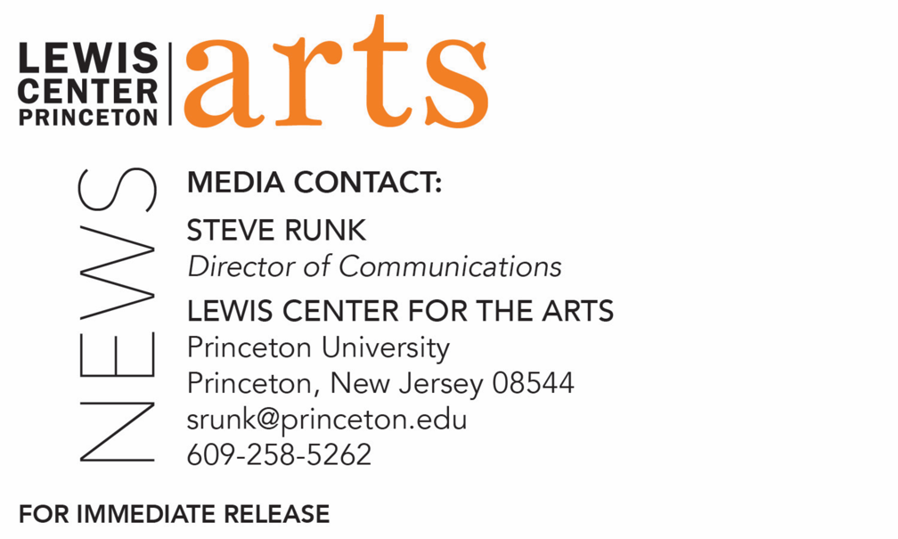

November 30, 2018

Poet Julian Talamantez Brolaski reads with Four Seniors in
Princeton’s Creative Writing Program December 7
The C.K. Williams Reading Series is organized by Princeton students
in collaboration with Labyrinth Books

Princeton Creative Writing Students Offer a Fall Reading
Students from fall courses share selected new work in poetry, fiction, screenwriting and literary translation

Photo caption: Poet Julian Talamantez Brolaski
Photo credit: Charles Ludvig

What/Who: Reading by poet Julian Talamantez Brolaski and four seniors in Princeton's Program in Creative Writing, part of the C.K. Williams Reading Series
When: Friday, December 7 at 6:00 p.m.
Where: Labyrinth Books, 122 Nassau St., Princeton
Free and open to the public

What: Fall Student Reading, part of Althea Ward Clark W’21 Reading Series
Who: Students in the Lewis Center for the Arts’ Program in Creative Writing read from faculty-selected new work in fiction, poetry, screenwriting and literary translation written during the fall semester
When: Wednesday, December 12 at 5:00 p.m.
Where: Donald G. Drapkin Studio at Lewis Arts complex on the Princeton University campus
Free and open to the public

(Princeton, N.J.) Poet Julian Talamantez Brolaski and four seniors in the Lewis Center for the Arts’ Program in Creative Writing at Princeton University will read from their work at 6:00 p.m. on Friday, December 7 at Labyrinth Books, 122 Nassau Street. The reading is part of the C. K. Williams Reading Series, named in honor of the Pulitzer Prize and National Book Award-winning poet who served on Princeton’s creative writing faculty for 20 years.

The series showcases senior thesis students of the Program in Creative Writing alongside established writers as special guests. Featuring student writers Nicolette D’Angelo, Ruting Li, Simi Prasad, and Michelle Yeh, the event is free and open to the public.

Julian Talamantez Brolaski’s most recent book is Of Mongrelitude (Wave Books, 2017), which was recently shortlisted for a Lambda Literary Award for Transgender Poetry. The writer’s pronoun is it. It is also the author of Advice for Lovers (City Lights 2012) and Gowanus Atropolis (Ugly Duckling Presse 2011), co-editer of NO GENDER: Reflections on the Life & Work of kari edwards, as well as lead singer and rhythm guitarist for the Brooklyn-based Juan & the Pines and Oakland-based The Western Skyline. It is currently at work as an editor on The Apache Pollen Path (forthcoming from University of New Mexico Press) with its grandmother, Inés Talamantez. It maintains a blog of handwritten poems at: https://julianspoems.tumblr.com/

The four seniors, who are pursuing a certificate in creative writing in addition to their major areas of study, will read from their senior thesis projects. Each is currently working on a novel, a screenplay, translations, or a collection of poems or short stories as part of a creative thesis for the certificate. Thesis students in the Program in Creative Writing work closely with a member of the faculty, which includes Aleksandar Hemon, Jhumpa Lahiri, Yiyun Li, Paul Muldoon, Kirstin Valdez Quade, James Richardson, Tracy K. Smith, Susan Wheeler, and a number of distinguished lecturers.

Upcoming guests in the C.K. Williams Reading Series include Tina Chang, Hala Alyan and Danez Smith.

On December 12, faculty-selected students enrolled in fall courses in the Program in Creative Writing will read from their recent work as part of the Program’s Althea Ward Clark W’21 Reading Series. The reading at 5:00 p.m. in the Donald G. Drapkin Studio at the Lewis Arts complex will include new works of fiction, poetry, screenwriting, and literary translation written during the past semester as part of the fall creative writing workshops. “The student reading is always a bright point. It’s such a privilege to listen in on what’s been happening all semester in the workshops,” notes Tracy K. Smith, Director of the Program in Creative Writing and the current U.S. Poet Laureate. This reading is also free and open to the public.

The Althea Ward Clark W’21 Reading Series will continue after the first of the year on Wednesday evenings on the Princeton campus. Upcoming guests in that series include Layli Long Soldier and Jacob Shores-Argüello (February 6), Frank Bidart and Yuri Herrera (March 6), and Han Kang and Ngũgĩ wa Thiong’o (April 17).

To learn more about these readings, the Program in Creative Writing, and the more than 100 public performances, exhibitions, readings, screenings, concerts and lectures presented each year by the Lewis Center for the Arts, most of them free, visit arts.princeton.edu.

###

