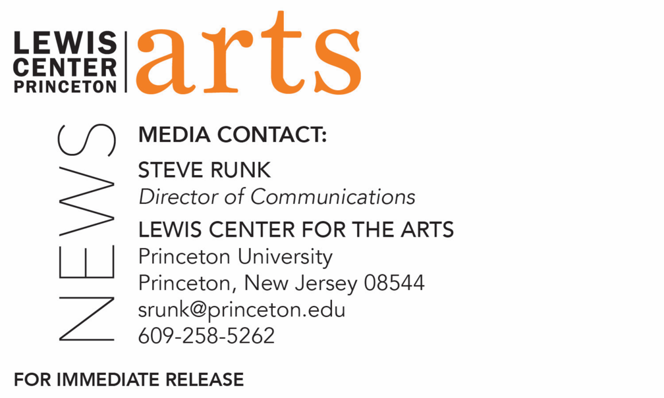

November 2, 2018

Writer Tony Tulathimutte reads with Three Seniors in
Princeton’s Creative Writing Program November 9
The C.K. Williams Reading Series is organized by Princeton students
in collaboration with Labyrinth Books

Photo caption: Writer Tony Tulathimutte
Photo credit: Lydia White

What/Who: Reading by writer Tony Tulathimutte and three seniors in Princeton's Program in Creative Writing, part of the C.K. Williams Reading Series
When: Friday, November 9 at 6:00 p.m.
Where: Labyrinth Books, 122 Nassau St., Princeton
Free and open to the public

(Princeton, N.J.) Author and journalist Tony Tulathimutte and three seniors in the Lewis Center for the Arts’ Program in Creative Writing at Princeton University will read from their work at 6:00 p.m. on Friday, November 9 at Labyrinth Books, 122 Nassau Street. The reading is part of the C. K. Williams Reading Series, named in honor of the Pulitzer Prize and National Book Award-winning poet who served on Princeton’s creative writing faculty for 20 years.

The series showcases senior thesis students of the Program in Creative Writing alongside established writers as special guests. Featuring student writers David Exume, Kirit Limperis, and Iris Samuels, the event is free and open to the public.

Tony Tulathimutte’s novel Private Citizens (2016) was called “the first great millennial novel” by New York Magazine. A graduate of Stanford University and the Iowa Writers’ Workshop, he has written for The New York Times, VICE, WIRED, Playboy, The Believer, NPR’s Selected Shorts, The New Yorker, N+1, The Atlantic, The New Republic, and others. He received a 2017 Whiting Award and an O. Henry Award and has appeared as a guest on Late Night with Seth Meyers. He teaches writing through his Brooklyn-based organization, CRIT.

The three seniors, who are pursuing a certificate in creative writing in addition to their major areas of study, will read from their senior thesis projects. Each is currently working on a novel, a screenplay, translations, or a collection of poems or short stories as part of a creative thesis for the certificate. Thesis students in the Program in Creative Writing work closely with a member of the faculty, which includes Aleksandar Hemon, Jhumpa Lahiri, Yiyun Li, Paul Muldoon, Kirstin Valdez Quade, James Richardson, Tracy K. Smith, Susan Wheeler, and a number of distinguished lecturers.

Upcoming guests in the C.K. Williams Reading Series include Julian Talamantez Brolaski, Tina Chang, Hala Alyan and Danez Smith.

In addition, the Program in Creative Writing presents the Althea Ward Clark W’21 Reading Series, also free and open to the public, on Wednesday evenings on the Princeton campus. Upcoming guests in that series include Guy Maddin and Caryl Phillips (November 14), Layli Long Soldier and Jacob Shores-Argüello (February 6), Frank Bidart and Yuri Herrera-Gutierrez (March 6), and Han Kang and Ngũgĩ wa Thiong’o (April 17).

To learn more about this reading series, the Program in Creative Writing, and the more than 100 public performances, exhibitions, readings, screenings, concerts and lectures presented each year by the Lewis Center for the Arts, most of them free, visit arts.princeton.edu.

###

