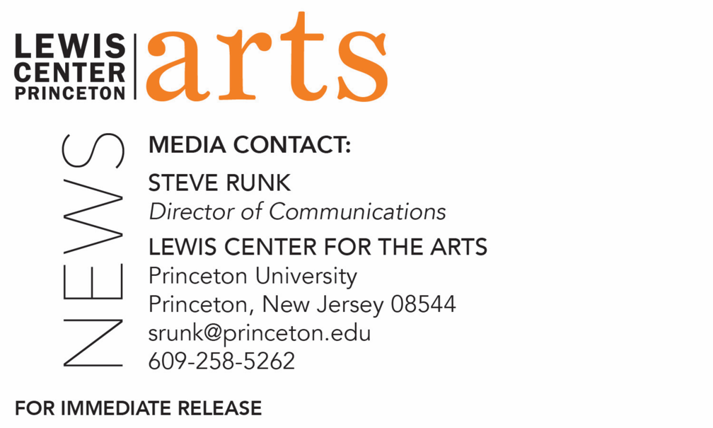

November 19, 2018

Lewis Center for the Arts’ Program in Visual Arts presents a screening of
The Miseducation of Cameron Post
followed by Q&A with director/writer Desiree Akhavan
Film on a teen’s experience in a gay conversion camp is
2018 Sundance Film Festival Grand Jury Prize Winner

Photo caption: A scene from Desiree Akhavan’s film The Miseducation of Cameron Post screening at the Lewis Center for the Arts’ James Stewart Film Theater
Photo credit: Courtesy of Filmrise

What/Who: Screening of the film The Miseducation of Cameron Post with writer/director Desiree Akhavan. The film, winner of the 2018 Sundance Film Festival Grand Jury Prize, tells the humorous story of young Cameron Post as she finds her authentic voice despite the stifling circumstances of being sent to a gay conversion camp. Followed by a Q&A with the director. Presented as part of a fall film series curated by Program in Visual Arts Director Martha Friedman and celebrating the renovation and reopening of the James Stewart Film Theater.
When: Wednesday, November 28 at 7:00 p.m.
Where: James Stewart Film Theater at 185 Nassau Street, Princeton, NJ
Free and open to the public

(Princeton, N.J.) The Lewis Center for the Arts’ Program in Visual Arts at Princeton University will screen the film The Miseducation of Cameron Post on Wednesday, November 28 at 7:00 p.m. The film, which tells the humorous story of a young girl as she finds herself despite being sent to a gay conversion camp, was the 2018 Sundance Film Festival Grand Jury Prize Winner. The screening will be followed by a Q&A with the film’s writer/director Desiree Akhavan and will take place in the newly renovated James Stewart Film Theater at 185 Nassau Street on the University campus. The event is free and open to the public.

The Miseducation of Cameron Post is based on the novel by Emily M. Danforth and follows the titular character (Chloë Grace Moretz) as she is sent to a 1990s gay conversion center after being caught with another girl in the back seat of a car on prom night. Run by the strict and severe Dr. Lydia Marsh (Jennifer Ehle) and her brother, Reverend Rick (John Gallagher Jr.), himself an example of how those in the program can be “cured,” the center is built on repenting for same sex attraction. In the face of intolerance and denial, Cameron meets a group of fellow “sinners,” including the stoner Jane who is an amputee (Sasha Lane) and her friend, Lakota Native American Two-Spirit Adam (Adam Goodluck). This group of teenagers forms an unlikely family as they fight to survive.

The film showcases Akhavan’s eye for detail and one-liners, making her one of the most talked-about new voices in independent film as she crafts an environment in which a cast of emotionally diverse characters wrestle with a desire in constant conflict with faith.

“There is a delicate humanism at work here that feels especially refreshing, a commitment to respecting differences without sacrificing a clear ethical point of view,” notes A. O. Scott of The New York Times.

Akhavan is perhaps best-known for starring in and directing her first film Appropriate Behavior, which premiered at the Sundance Film Festival and won the Grand Jury Award at the San Diego Asian Film Festival. She will also star in and direct the new Channel 4 sitcom The Bisexual.

The Miseducation of Cameron Post concludes a four-film series curated by Program in Visual Arts Director Martha Friedman and celebrating the reopening of the James Stewart Film Theater following a five-month renovation. The changes include upgraded film projection capabilities with state-of-the-art digital projectors while preserving capability for 32 mm and 16 mm film, as well as a new screen, HVAC and electrical systems, new seating and interior finishes.

All films in the series have been open to the public and feature a film screening followed by a conversation with one or more artists connected with the film shown. Past screenings in the series included Lynne Sachs’ The Washing Society, Alexander Shebanow’s Fail State, and Debra Granik’s Leave No Trace.

The film series is supported through the John Sacret Young ’69 Lecture Series fund. Sacret Young is a 1969 graduate of Princeton and an author, producer, director, and screenwriter. He has been nominated for seven Emmy Awards and seven Writers Guild of America (WGA) Awards, winning two WGA Awards. He is perhaps best known for co-creating, along with William F. Broyles Jr., China Beach, the critically acclaimed ABC-TV drama series about medics and nurses during the Vietnam War, and for his work on the television drama The West Wing. Young has also received a Golden Globe and a Peabody Award, and his original mini-series about the Gulf War, Thanks of a Grateful Nation, was honored with his fifth Humanitas Prize nomination.
For more information on the Program in Visual Arts and the more than 100 performances, exhibitions, readings, screenings, concerts and lectures presented each year by the Lewis Center for the Arts, most of them free, visit arts.princeton.edu.

###

