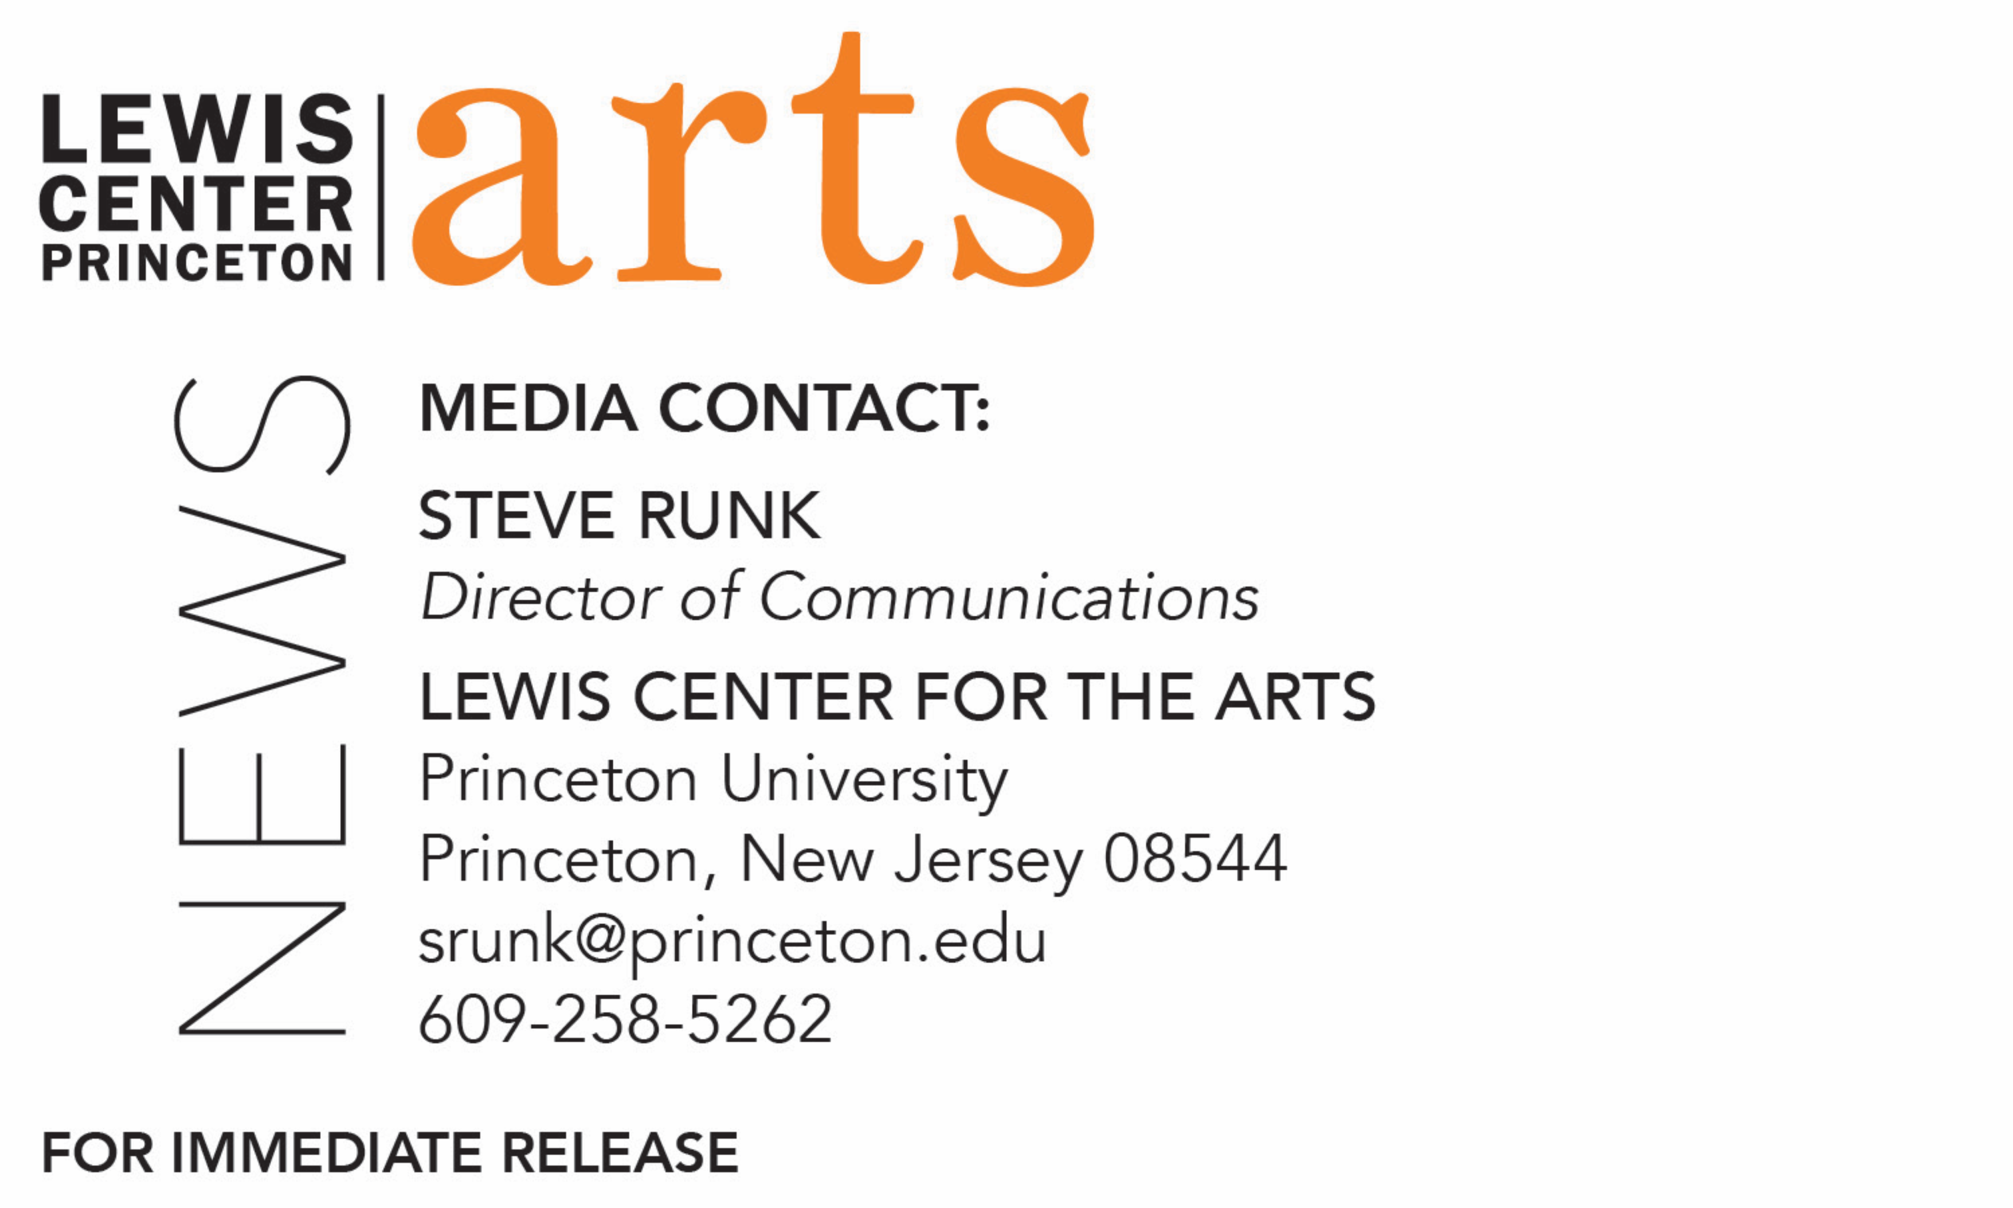

November 20, 2018

The Lewis Center for the Arts’ Program in Theater presents
Miles Gloriosus
Classic Roman comedy by Plautus gets a new translation and a staging that emphasizes the play’s physical comedy

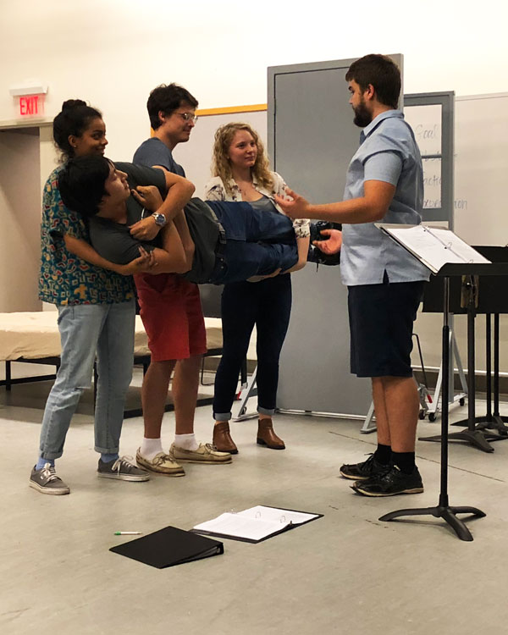
Photo caption: Students in rehearsal for Miles Gloriosus.
Photos credit: Tyler Ashman

What: Miles Gloriosus, the classic comedy by Roman playwright Plautus that was an inspiration for the musical comedy A Funny Thing Happened on the Way to the Forum, in a new translation and a staging that emphasizes the play’s physical comedy
Who: Translated and directed by Princeton senior Jack Busche and featuring senior Justin Ramos in the lead role of Palaestrio, presented by Lewis Center for the Arts’ Program in Theater.
When: November 30 at 8:00 p.m., December 2 at 2:00 p.m., December 7 at 8 p.m., and December 8 at 2 p.m. and 8 p.m. An audience talkback led by Associate Professor Yelena Baraz of the Classics Department will follow the November 30 performance.
Where: Wallace Theater at the Lewis Arts complex on the Princeton University campus
Free and open to the public; advance tickets are recommended

(Princeton, NJ) The Lewis Center for the Arts’ Program in Theater at Princeton University will present the classic Roman comedy by Plautus, Miles Gloriosus, on November 30, December 7 and December 8 at 8:00 p.m. with matinees on December 2and December 8 at 2:00 p.m. in the Wallace Theater at the Lewis Arts complex on the Princeton campus. The production features a new translation of the play by senior Jack Busche who is directing and senior Justin Ramos as Palaestrio in a staging that emphasizes the play’s physical comedy.

Written around 205 B.C.E by Titus Maccius Plautus, Miles Gloriosus, translated as "The Swaggering Soldier" or "Vainglorious Soldier," is the basis for the stock figure in comedies from Roman times to the present. The play is based on one or more Greek plays of unknown authorship and is a complicated farce in which a vain, lustful, and unintelligent soldier, Pyrgopolynices, is duped by his clever slave, Palaestrio, and a courtesan. The work was highly popular, and Pyrgopolynices became the prototype for many swaggering cowards of later comedies including the strutting Capitano of the commedia dell’arte of mid-16th-century Italy, Shakespeare’s Falstaff and Pistol, and the characters of many other Elizabethan playwrights, including Ben Jonson and Beaumont and Fletcher. The influence of Plautus’ Miles Gloriosus can be seen in the works of many other playwrights, from Corneille to George Bernard Shaw and Bertolt Brecht, and was among the plays by Plautus that inspired the musical comedy A Funny Thing Happened on the Way to the Forum with music and lyrics by Stephen Sondheim and book by Burt Shevelove and Larry Gelbart.

Busche and Ramos proposed Miles Gloriosus as their senior thesis in the Program in Theater for a number of reasons.

Busche, a religion major from Stratford, Wisconsin, pursuing certificates in classics, linguistics and theater, was interested in the translation of a classical work that underscores performance but was not finding a translation that satisfied this interest. His English translation of Miles Gloriosus is in American vernacular and his directorial collaboration with the cast focuses on a staging that will be relatable to 21st century American audiences. Busche has performed and directed with a number of Princeton student theater companies including Princeton University Players, Theatre Intime, and Princeton Shakespeare Company, where he adapted Falstaff in Love. Interested in theater prior to attending Princeton, he began taking courses in the Program in Theater his first semester, however Miles Gloriosus is his first production with the Program.

Ramos became interested in the project for the opportunity to explore the physical and verbal comedy offered in the play and particularly in Busche’s translation. A native of Skowhegan, Maine, Ramos is majoring in molecular biology and pursuing a certificate in theater. He has worked on a number of Program in Theater productions, including as a performer in Into the Woods and stage manager for Picnic at Hanging Rock, and he has acted and served as a board member and production manager for Princeton University Players and as a cast member and assistant director for Princeton Triangle Club.

Both seniors observed that the Program in Theater’s seasons, primarily driven by the thesis proposals juniors submit for the coming year, does not typically include comedic works and both wanted to bring comedy into this year’s season. They have worked together previously on Princeton University Players productions of Spamalot and 25th Annual Putnam County Spelling Bee.

Other students in the cast include senior Blaine Crabtree, sophomore Katie Massie, and first-year students Molly Bremer, Tobi Fadugba, BT Hayes, Ian Johnson, Sofia Lodato, and Kate Semmens.

The production team includes senior Will Alvarado as lighting designer and sophomore Tyler Ashman as stage manager.

Theater faculty member and director Elena Araoz is an advisor on the project.

An audience talkback will follow the performance on November 30 led by Associate Professor Yelena Baraz of Princeton’s Classics Department. The discussion will include Roman comedy and its performative history, the state of Rome at the time of the play's writing, and Busche’s vernacular American adaptation. Baraz specializes in Latin literature, Roman cultural history, and the history of ideas and will be teaching a course on Plautus next semester. In 2013 she received the Princeton President’s Distinguished Teaching Award.

The Wallace Theater in the Lewis Arts complex is an accessible venue with details available at arts.princeton.edu/accessibility. Assistive listening devices are available upon request when attending a performance. Patrons in need of other access accommodations are invited to contact the Lewis Center at 609-258-5262 or LewisCtr-Comm@princeton.edu for assistance at least two weeks prior to the selected performance.

Performances are free and open to the public; however advance tickets are recommended and available through University Ticketing online at tickets.princeton.edu, in person at the box offices at Frist Campus Center and Lewis Arts complex, or by calling 609-258-9220. Seats not occupied 15 minutes prior to curtain time may be made available to other patrons.

To learn more about this event, the Program in Theater, and the more than 100 other performances, exhibitions, readings, screenings, concerts, and lectures presented by the Lewis Center, most of them free, visit arts.princeton.edu.

###

