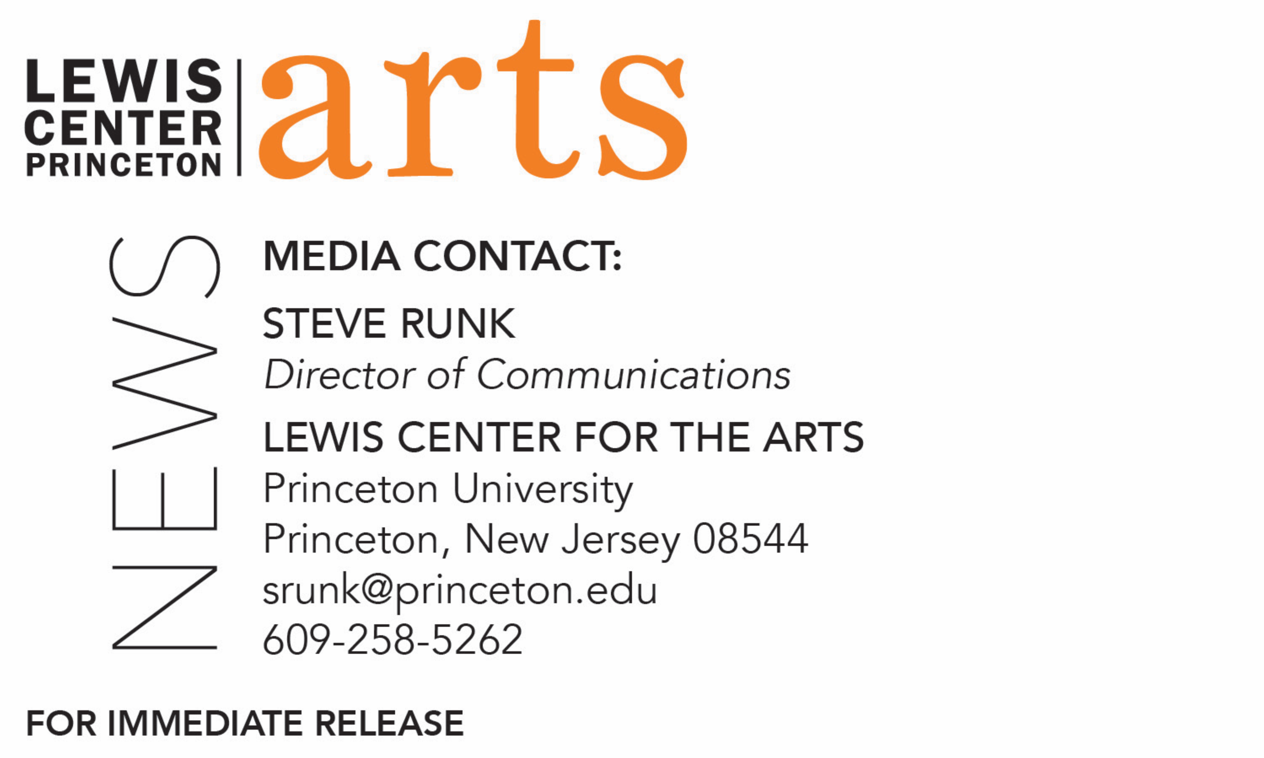

November 9, 2018

Lewis Center for the Arts’ Program in Visual Arts presents
Open Studios
Juniors and Seniors invite the community into their studios to view
works-in-progress and hear about their work

Photo caption: Guests visit a senior’s studio at during the 2017 Open Studios event
Photos credit: M. Teresa Simao

What: Visual Arts Program Open Studios at Lewis Center for the Arts at Princeton University
Who: Junior and senior visual arts students invite the community into their studios to see works-in-progress.
When: Wednesday, November 14, from 4:30 p.m. to 6:00 p.m.
Where: 185 Nassau St., Princeton
Free and open to the public

(Princeton, NJ) Juniors and seniors in the Program in Visual Arts at Princeton University’s Lewis Center for the Arts will open their studios to share and discuss their works-in-progress on Wednesday, November 14, from 4:30 to 6:00 p.m. at the Program in Visual Arts building at 185 Nassau Street. The event is free and open to the public.

The evening of open studios will feature work by students in a wide range of media including photography, sculpture, painting, drawing, printmaking, graphic design, and film. The student artists, from the classes of 2019 and 2020, will be present to discuss their work.

“This is unique chance for the entire community to see Princeton students’ creative work in process — their experiments happening in the lab, so to speak,” notes Jeff Whetstone, Professor of Visual Arts, who is working with the students on the exhibition. “The seniors are almost halfway to their thesis shows, so they are generating ideas, and those concepts are taking form in their studios. It’s so gratifying to see the all the ephemera and collateral objects in an artist’s space. It’s like you can see the mechanisms of how meaning gets created.”

The open studios event will begin at 4:30 p.m. with junior studios on the fourth floor and will continue at 5:15 p.m. with the senior studios on the second floor.

Refreshments will be served throughout the evening.

The Program in Visual Arts at the University offers courses in painting, drawing, graphic design, photography, sculpture, film and video production, and film history and theory. The studio courses in particular emphasize direct, hands-on art making under the guidance of practicing visual arts professionals. In order to develop their work, students are also given access to state-of-the-art technical, analog, and digital labs, including a fully functional letterpress studio. With the opening of the new Lewis Arts complex and the move of the Programs in Dance, Theater, Music Theater and the Princeton Atelier from 185 Nassau Street to new spaces there, the Program in Visual Arts has begun to expand into recently vacated spaces at 185 Nassau Street, including adding more studios for classes and student artists and exhibition spaces.

Junior and senior students pursuing a major or certificate in visual arts have 24/7 access to shared studio loft spaces and semi-private studios, an unusual resource in an undergraduate visual arts program. Throughout the year, their work is exhibited in the Lucas Gallery, the new Hurley Gallery at the Lewis Arts complex, and screened in the newly renovated James Stewart Film Theater, as well in other traditional and non-traditional venues on campus.

Following the Open Studios at 7:00 p.m. on November 14, the Program in Visual Arts will screen the film Leave No Trace, with Academy Award-nominated and Sundance Film Festival Award-winning writer/director Debra Granik. The film, which premiered at the 2018 Sundance Film Festival, tells the emotional story of a father and his teenage daughter who have lived off the grid for years in the forests of Portland, Oregon, until their idyllic life is shattered and both find themselves in the social services system. After clashing with their new surroundings, they set off on a harrowing journey back to their wild homeland. The screening will be followed by a Q&A with the director and is presented as part of a fall film series curated by Program in Visual Arts Director Martha Friedman in celebration of the renovation and reopening of the James Stewart Film Theater. The screening is also free and open to the public.

To learn more about the Program in Visual Arts and the more than 100 performances, exhibitions, readings, screenings, concerts and lectures offered each year at the Lewis Center, most of them free, visit arts.princeton.edu.

###

