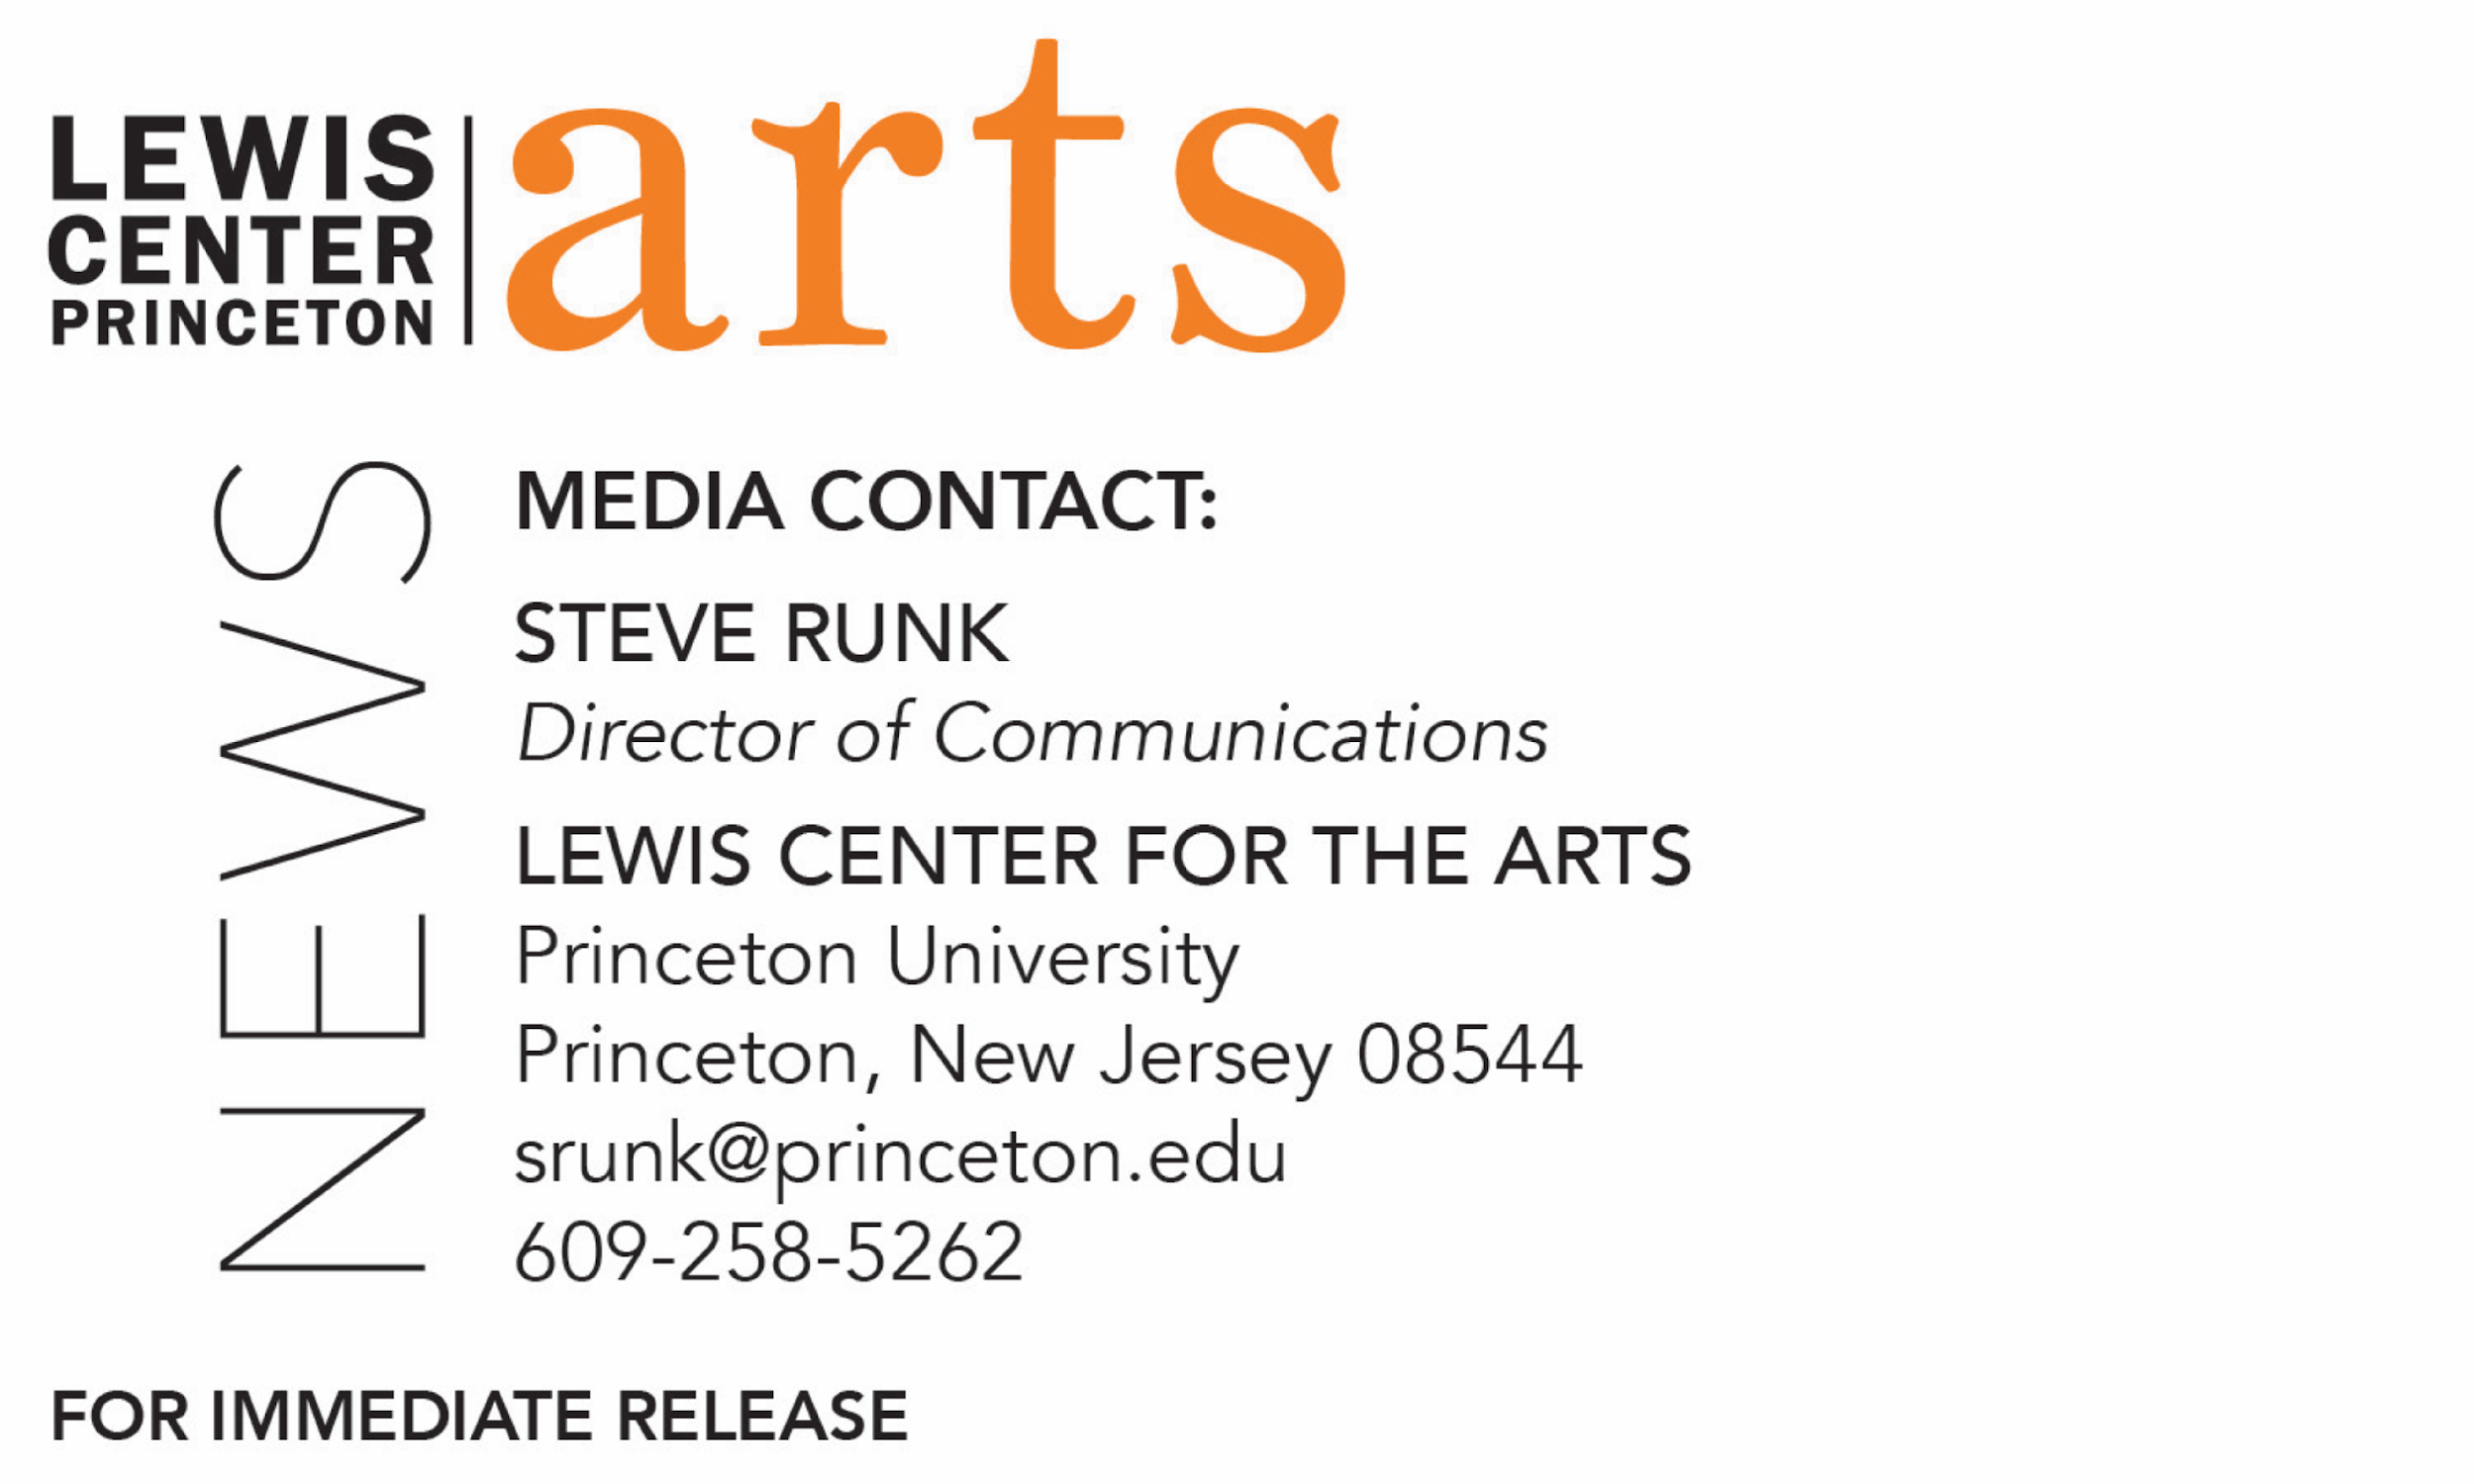

November 12, 2018

Princeton Chinese Theatre in collaboration with the
Lewis Center for the Arts’ Program in Theater present
Teahouse by Lao She

What: Teahouse by Lao She, a masterpiece of contemporary Chinese theater, spanning 50 years in modern Chinese history from the collapse of the Qing dynasty and the Republican Revolution to the birth of the People’s Republic, in a semi-immersive production that also serves as a funeral for the playwright. The majority of the play is performed in English with portions performed in Mandarin (Chinese).
Who: Directed by Princeton senior Changshuo Liu. Presented by Princeton Chinese Theatre in collaboration with the Lewis Center for the Arts’ Program in Theater.
When: November 16, 17 & 18 at 8 p.m. and November 17 at 2:00 p.m. A post-show panel discussion follows the November 17 matinee performance.
Where: Donald G. Drapkin Studio at Lewis Arts complex on the Princeton campus
Tickets: $12 in advance of show dates, $10 for students, and $17 purchased the day of performances at the box office. Available through University Ticketing.
For information and tickets: https://arts.princeton.edu/events/teahouse/2018-11-16/

(Princeton, NJ) Princeton Chinese Theatre in collaboration with the Lewis Center for the Arts’ Program in Theater at Princeton University will present Teahouse by Lao She on November 16, 17 and 18 at 8 p.m. and November 17 at 2 p.m. in the Donald G. Drapkin Studio at the Lewis Arts complex on the Princeton campus. Teahouse is considered a masterpiece of contemporary Chinese theater, spanning 50 years in modern Chinese history from the collapse of the Qing dynasty and the Republican Revolution to the birth of the People’s Republic, bringing together over sixty characters who represent all walks of life. The production is directed by senior Changshuo Liu.

Liu is staging the play as a semi-immersive production with some of the audience seated at tables during the first act in a recreation of a Beijing teahouse, which serves as the backdrop to – and a metaphor for -- the enormous changes that occur over the span of the play’s history. He is also wrapping the original play with a funeral for playwright Lao She with interludes before and during the performance that include music. Lao She committed suicide in 1967 during China’s Cultural Revolution.

Princeton Chinese Theatre was founded in 2008 and is run entirely by students with the vision of sharing their experience and love for China with their fellow students. The group presents two shows each year, one in fall and one in spring, typically in the Mandarin language, while hosting other activities throughout the year.

Liu is a Princeton Chinese Theatre board member and a senior majoring in Mathematics pursuing certificates in the Program in Theater and in Applications in Computing and Applied Math. The production is Liu’s creative thesis in theater. Prior to Teahouse, Liu directed Playhouse for Princeton Chinese Theatre and acted in Elektra and Charles Francis Chan Jr.’s Exotic Oriental Murder Mystery in the Program in Theater.

Teahouse was written in 1957 and follows the lives of the teahouse owner and his customers from all levels of Beijing society through three distinct periods in modern Chinese history, from 1898 to 1948 during the fall of the Qing dynasty, the establishment of the Republic, and the civil war between the Nationalists and the Communists. The more than 60 characters in the play reflect, through the changes in their own lives, the changes occurring at the time in Chinese society, revealing the heart and soul of the Chinese people over a critical time in the nation’s history.

Liu chose the play for its continued relevance today, noting that “Teahouse is not only about the culture, nor the mosaic-styled portrayal of history. It resonates so much with the current world changes we are undergoing right now. I often think of this play as an image of a lonely fisherman fighting against a high wave in a huge storm until he gets swallowed. The storm originated very far away, and, when it arrives, the fisherman has no escape. Just like today, the politics between countries are moving like giant machines crushing over the bones of millions of innocents. The censorship, the despair of the lowest class in the society, have not changed from one era to another.”

Liu is staging the play with about 60 percent of the dialogue in English and 40 percent in Mandarin. His intention of using some English is to accommodate English-speaking audiences, but the script is edited in such a way that the language a character is speaking reflects the degree of foreign influences he or she has experienced or to whom the character is speaking. He further explains that during the era of the play, China was opening up to other countries, commodities and cultures, and the mix of Chinese language and English in this production echoes the mixed society of those times. In addition, he notes, care has been taken to allow English-speaking audiences to understand the main framework of the play without the loss of its authenticity.

The cast of 25 not only includes Princeton University undergraduate and graduate students, but also students from local high schools and professionals in the local community. In addition to Princeton Chinese Theatre and the Lewis Center, the production is made possible through support from the Department of East Asian Studies.

A post-show panel discussion on the play led by Elena Araoz, a faculty member in the Program in Theater, Professor Xin Wen from Department of East Asian Studies and Guangchen Chen, Lecturer in the Council of the Humanities and Comparative Literature and Cotsen Postdoctoral Fellow in the Society of Fellows, will be presented at 4:45 p.m. following the matinee performance on November 17.

Tickets are $12 in advance of show dates, $10 for students, and $17 purchased the day of performances at the box office. Advance tickets are available through Princeton University Ticketing online at tickets.princeton.edu or by calling 609-258-9220 and in-person at the Frist Campus Center Ticket Office or Roth Box Office at the Lewis Arts complex.

To learn more about this event, the Program in Theater, and the more than 100 other performances, exhibitions, readings, screenings, concerts, and lectures presented by the Lewis Center, most of them free, visit arts.princeton.edu. To learn more about Princeton Chinese Theatre visit princetonchinesetheatre.com.

###

