Media contacts:
Don Jay Smith  LKS Associates  don@lksassociates.com  973-714-4763 | Steve Runk, Director of Communications Lewis Center for the Arts, Princeton University srunk@princeton.edu  609-258-5262

For immediate release

January 23, 2019

Black Maria Film Festival 38th Premiere Screening
Renowned internationally touring film festival kicks off its 2019 tour with free screening at Princeton University

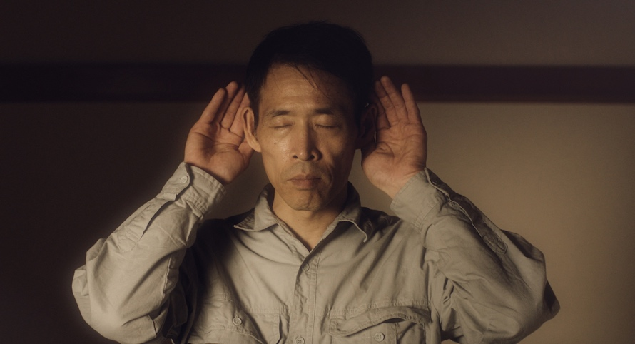
Photo caption: A still from filmmaker Takeshi Kushida’s short film Voice, one of five films to be screened at the Black Maria Film Festival premiere at Princeton.
Photo credit: Courtesy of Takeshi Kushida

What: The 38th annual tour of the renowned Black Maria Film Festival will premiere at Princeton University with a screening of five diverse, award-winning, short films before launching its international tour.
Who: Presented by the Thomas Edison Media Arts Consortium and Program in Visual Arts of the Lewis Center for the Arts at Princeton University. Filmmakers Lynn Tomlinson and Kelly Gallagher will be present to discuss their work and participate in an audience Q&A with Festival Director Jane Steuerwald.
When: February 9 at 7:30 p.m.; pre-screening reception at 7:00 p.m.
Where: James Stewart Film Theater at 185 Nassau Street in Princeton
Free and open to the public

(Princeton, NJ) The Black Maria Film Festival will kick off its 38th annual tour with a screening of five award-winning films on Saturday, February 9 at the James Stewart Film Theater at 185 Nassau Street. The screening will begin at 7:30 p.m., preceded by a pre-screening reception at 7:00 p.m. Some of the filmmakers and Festival Director Jane Steuerwald will be at the screening to discuss the films being shown. The event is free and open to the public; no tickets are required.

For 38 years the Black Maria Film Festival has been celebrating creativity and innovation in the moving-image arts. The Festival was founded in 1981 as a tribute to Thomas Edison’s development of the motion picture at his West Orange laboratory, dubbed the “Black Maria” film studio, the first in the world. The studio received its name from Edison’s employees who thought the studio’s boxy shape and black tar paper covering resembled the so-called “black maria” police paddy wagons.

An annual juried competition of short works in all genres, the Festival is a project of the Thomas Edison Media Arts Consortium, which also showcases the New Jersey Young Filmmakers Festival and the Global Insights Collection, an archive of films focusing on the environment, people with disabilities, international issues, and films with themes of social justice. For the 2019 Festival, the organization has partnered with the Lewis Center for the Arts at Princeton University. Following the premiere at Princeton, the Festival will travel over the next 12 months across the U.S. and abroad.

“We’ve hosted the Black Maria Film Festival numerous times over the years, and it’s always been met with a really enthusiastic response from the students and community audiences,” said Su Friedrich, filmmaker and Professor of Visual Arts in the Lewis Center, who brought the Festival to Princeton. “The range of films is wonderful and surprising and, as someone who teaches and sees a lot of films, I’m introduced each time to fantastic works by new makers who I didn’t know about before and whose work I then begin to follow.”

Black Maria received more than 400 submissions for the 2019 Festival tour from every continent around the globe except Antarctica. Following an extensive pre-screening by experts in the field of film curation, media studies and production, the highly regarded Festival jurors, Margaret Parsons, Head Curator of Film at the National Gallery of Art in Washington, DC, and Henry Baker, Emmy Award-winning filmmaker and former director of Synapse Video Center, chose 55 films for the 2019 collection and awarded the top prizes.

The five top-prize films being screened at the Princeton premiere include:

Henrietta Bulkowski, an animated film by Los Angeles filmmaker Rachel Johnson, the story of a determined young woman, challenged by a severe hunchback, who will stop at nothing to fulfill her dream of seeing the world and finding happiness;

Ulises (Ulysses), a narrative film by Jorge Malpica of Catalonia, Mexico, in which Ulysses orders his men to tie him to his ship's mast, thus preventing him from surrendering to the enchanting mermaid's call, which devoured the unwary men seduced by it;

Voice, a narrative film by Takeshi Kushida of Tokyo, that tells the story of a lonely man who becomes fascinated with a shadow that appears on the wall of his apartment;

My Gossip, a film incorporating live-action, stop-motion and digital animation by Kelly Gallagher of Chester Springs, Pennsylvania, is a personal documentary colorfully exploring the radical importance of women's close friendships in which the filmmaker, who will attend the screening, examines her relationship with her own best friend, and how women's friendships were historically weaponized against them;

And The Elephant’s Song, an animated film by Lynn Tomlinson of Owings Mills, Maryland, who also will be present at the screening, tells the true and tragic tale of Old Bet, the first circus elephant in America, as recounted in song by her friend, an old farm dog, and portrayed in colorful, handcrafted animation.

The Festival will subsequently travel to more than 50 museums, cultural centers, colleges, and universities throughout the United States and abroad. Venues interested in scheduling a screening should contact Festival Director Jane Steuerwald at jane@blackmariafilmfestival.org. The Festival offers programming options ranging from a custom-curated program presented by the host site, to an in-person film presentation by the Festival director, including a Q & A and dialog with the audience.

In addition to the support provided for the 2019 tour by the Lewis Center, the Black Maria Film Festival receives generous support from New Jersey State Council on the Arts; the Charles Edison Fund; the Hudson County Office of Cultural and Heritage Affairs and Tourism; The Hoboken Historical Museum; WithumSmith+Brown; Lowenstein Sandler, LLP; Adobe Systems, Inc. and Microsoft through TechSoup.org.

To learn more about the Black Maria Film Festival and Thomas Edison Media Arts Consortium, visit blackmariafilmfestival.org. To learn more about the Lewis Center for the Arts, the premiere screening, and the more than 100 public performances, exhibitions, readings, screenings, concerts and lectures presented each year, most of them free, visit arts.princeton.edu.

###

