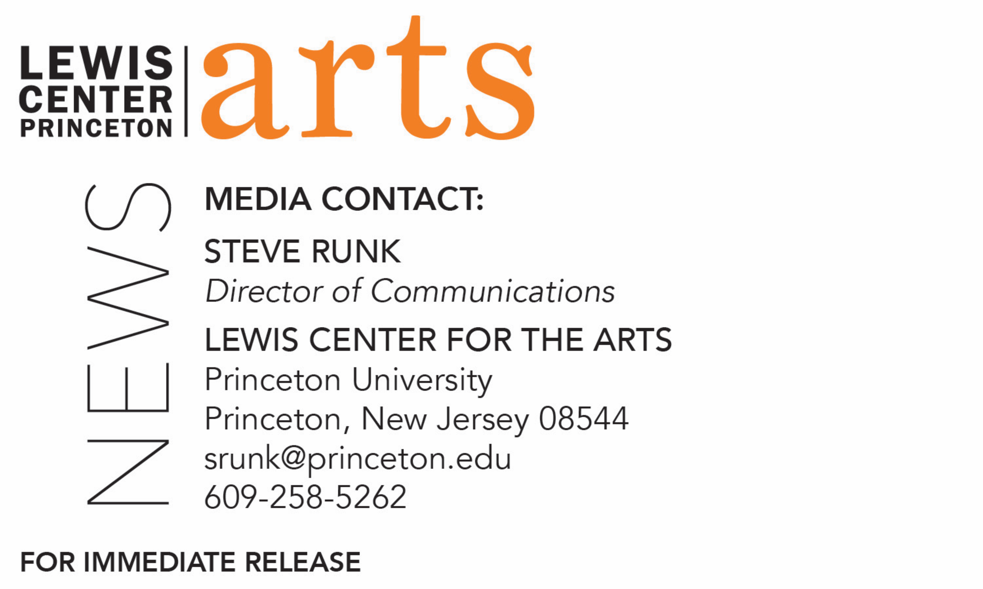
January 24, 2019
Princeton University's Lewis Center for the Arts, Department of English and
Humanities Council present
Black Poetry: A Gala Reading
Free public Gala Reading on February 14 kicks off the historic Black Poetry: A Conference

Photo caption: The nine poets who will read at the Black Poetry Gala Reading on February 14 at Princeton, kicking off the historic Black Poetry Conference: Elizabeth Alexander, Kwame Dawes, Toi Derricotte, Rita Dove, Yusef Komunyakaa, Haki Madhubuti, Harryette Mullen, Sonia Sanchez, and Kevin Young (left to right, top to bottom).

What: Black Poetry: A Gala Reading by a diverse group of award-winning poets, kicking off an historic conference on Black Poetry
Who: Reading by award-winning poets Elizabeth Alexander, Kwame Dawes, Toi Derricotte, Rita Dove, Yusef Komunyakaa, Haki Madhubuti, Harryette Mullen, Sonia Sanchez, and Kevin Young, organized by U.S. Poet Laureate and Director of Princeton’s Program in Creative Writing Tracy K. Smith, Princeton Arts Fellow Jaamil Olawale Kosoko, and Associate Professor of English Joshua Kotin
When: Thursday, February 14 at 7:00 p.m.
Where: Matthews Theatre at McCarter Theatre Center, 91 University Place
Simulcast: Conference activities February 15 & 16 from 10 a.m.-9 p.m. simulcast at James Stewart Film Theater at 185 Nassau St., however seating is limited – check the website for availability
Free and open to the public; no tickets required for Gala Reading
For more information: https://arts.princeton.edu/events/black-poetry-gala-reading/

(Princeton, NJ) Princeton University's Lewis Center for the Arts, Bain-Swiggett Fund/Department of English, and Humanities Council will present Black Poetry: A Gala Reading on Thursday, February 14 at 7:00 p.m. at the Matthews Theatre at McCarter Theatre Center. The reading features nine award-winning poets and kicks off an historic gathering of 42 poets, Black Poetry: A Conference, organized by U.S. Poet Laureate and Director of Princeton’s Program in Creative Writing Tracy K. Smith, Princeton Arts Fellow Jaamil Olawale Kosoko, and Associate Professor of English Joshua Kotin. The reading is free and open to the public; no tickets are required.

Poets scheduled to read at the event include:
Elizabeth Alexander, author of American Sublime (2005), shortlisted for the Pulitzer Prize, a winner of the Jackson Poetry Prize, a founding member of Cave Canem, and recognized as a pivotal figure in African American poetry who was asked by President Barack Obama to compose and read a poem for his inauguration;

Kwame Dawes, a poet, novelist, and non-fiction writer, recipient of the Forward Prize for Poetry, a Pushcart Prize, the Hurston/Wright Legacy Award, the Poets and Writers Barnes & Noble Writers for Writers Award, and a Guggenheim Foundation fellowship, and creator of the Pulitzer Prize Center project HOPE: Living and Loving with AIDS in Jamaica;

Toi Derricotte, recipient of the Lucille Medwick Memorial Award from the Poetry Society of America, the Distinguished Pioneering of the Arts Award from the United Black Artists, the Paterson Award for Sustained Literary Achievement, and two Pushcart Prizes, and a co-founder of Cave Canem;

Rita Dove, the first African-American to be named U.S. Poet Laureate, a Pulitzer Prize-winning poet, fiction writer, playwright and lyricist, recipient of a National Humanities Medal, and editor of the influential Penguin Anthology of 20th Century American Poetry;

Yusef Komunyakaa, recipient of the Pulitzer Prize, the Wallace Stevens Award, the Kingsley Tufts Poetry Award, the Ruth Lilly Poetry Prize, and the William Faulkner Prize, who as a correspondent serving in the Vietnam War received a Bronze Star and whose book, Dien Cai Dau (1988), is regularly described as one of the best books of poetry from the War;

Haki Madhubuti, a member of the Black Arts Movement, who has written more than 20 books of poetry, nonfiction, and critical essays, co-founder of Black Books Bulletin, the International Literary Hall of Fame for Writers of African Descent, and the National Black Writers Retreat, and recipient of an American Book Award and the Kuumba Workshop Black Liberation Award;

Harryette Mullen, a recipient of the Academy of American Poets Fellowship, artist grants from the Texas Institute of Letters and the Helene Wurlitzer Foundation of New Mexico, the Gertrude Stein Award in Innovative American Poetry, and a Rockefeller Fellowship from the Susan B. Anthony Institute for Women’s Studies at the University of Rochester;

Sonia Sanchez, national and international lecturer on Black culture and literature, women’s liberation, peace and racial justice, the author of over 20 books and one of the most significant voices of the Black Arts Movement whose most recent awards include the 2018 Wallace Stevens Award from the Academy of American Poets for proven mastery in the art of poetry;

Kevin Young, recipient of the Quill Award in Poetry, the Paterson Award for Sustained Literary Excellence, the Before Columbus Foundation American Book Award, the Lenore Marshall Poetry Prize, the Greywolf Press Nonfiction Prize, poetry editor of the New Yorker, and the director of New York Public Library's Schomburg Center for Research in Black Culture.

“Black Poetry: A Conference is a truly historic international and inter-generational gathering,” said Smith. “We see it as an extension of the Black Writers Conferences held at Fisk University more than 50 years ago. The idea for the conference grew out of Jaamil’s desire to host a poetry reading on campus during his time as a Princeton Arts Fellow. Over the span of three days, more than 40 black poets will come together to read from their work and consider the most urgent social, political and artistic questions of our time. We are pleased to open the Gala Reading to scholars, artists, and book-lovers in Princeton and beyond.”

In addition to the poets participating in the Gala Reading, other poets involved in the conference include Camae Ayewa (Moor Mother), Jericho Brown, Mahogany L. Browne, Camille Dungy, Cornelius Eady, Eve Ewing, Nikky Finney, Vievee Francis, Joanne V. Gabbin, Rachel Eliza Griffiths, Myronn Hardy, Terrance Hayes, Tyehimba Jess, Taylor Johnson, Saeed Jones, Douglas Kearney, Robin Coste Lewis, Nathaniel Mackey, Dawn Lundy Martin, J Mase III, Shane McCrae, Jessica Care Moore, Fred Moten, Morgan Parker, M. NourbeSe Philip, Rowan Ricardo Phillips, Koleka Putuma, Roger Reeves, Ed Roberson, Lemn Sissay, Patricia Smith, Natasha Trethewey, and Simone White, and photographer Deana Lawson.

“The impulse to co-organize a convening centering Black poetics grew quite urgently out of a need to better understand the complexity of the contemporary socio-political moment,” adds Kosoko. “I find that in times of cultural unrest, the people need to hear from the poets. Black poetry, especially, has a way of speaking most directly to the heart of these matters in regard to ethical, spiritual, and emotional survival.”

The conference is being cosponsored by Princeton’s Department of African American Studies, the University Center for Human Values, the Department of Comparative Literature, the Program in Canadian Studies, the Program in American Studies, and the Interdisciplinary Doctoral Program in the Humanities.

“When Tracy suggested a conference at a reading I organized for a course on contemporary poetry, I immediately said yes—for the opportunity to collaborate with her and Jaamil,” notes Kotin, “and more important: to help make the event happen. At this particular historical moment, I cannot imagine a more significant gathering of poets. As a scholar of poetry, I feel honored to be in the room for such vital discussions, debates, and performances.”

Books by the 42 conference poets will be available for sale before and after the Gala Reading with the poets available to sign their books.

Smith is the author of the memoir Ordinary Light and four books of poetry, most recently Wade in the Water (2018) and Life on Mars (2011), which received the 2012 Pulitzer Prize. She is currently in her second term as United States Poet Laureate.

Kosoko is a Nigerian American poet, curator, and performance artist originally from Detroit. He is a 2019 Red Bull Arts Detroit Writing Fellow, 2017-2019 Princeton Arts Fellow, a 2017 Cave Canem Poetry Fellow, and a recipient of a 2018 U.S. Artists International Award from the Mid-Atlantic Arts Foundation. He works internationally in the spheres of performance, poetry, and education. Kosoko’s poems can be found in such publications as The American Poetry Review, Poems Against War, The Dunes Review, and Silo. In 2009, he published the chapbook, Animal in Cyberspace, and, in 2011, he published, Notes on an Urban Kill-Floor: Poems for Detroit (Old City Publishing).

Kotin is the author of the critical book, Utopias of One (2018), and director of The Shakespeare and Company Project. He is a former Editor of Chicago Review.

While registration for the conference, running February 15 and 16, is full with a waiting list being compiled for possible open seats, the conference panels, provocations and evening readings will be simulcast from 10 a.m. to 9 p.m. both days in the James Stewart Film Theater at 185 Nassau Street on the Princeton campus. The simulcast is free and open to the public, however seating is limited and guests are advised to check availability at blackpoetry.princeton.edu.

The Matthews Theatre at McCarter Theatre Center is an accessible venue. Open captioning and American Sign Language interpretation will be provided at the Gala Reading, and assistive listening devices are available from the venue staff upon request. The newly renovated James Stewart Film Theater is also an accessible venue and the simulcast will be closed-captioned. Patrons in need of other access accommodations are asked to contact the Lewis Center at LewisCtr-Comm@princeton.edu at least two weeks in advance of the event.

To learn more about the Lewis Center for the Arts and the more than 100 public theater and dance performances, exhibitions, readings, screenings, concerts and lectures presented each year by the Lewis Center, most of them free, visit arts.princeton.edu.

# # #

