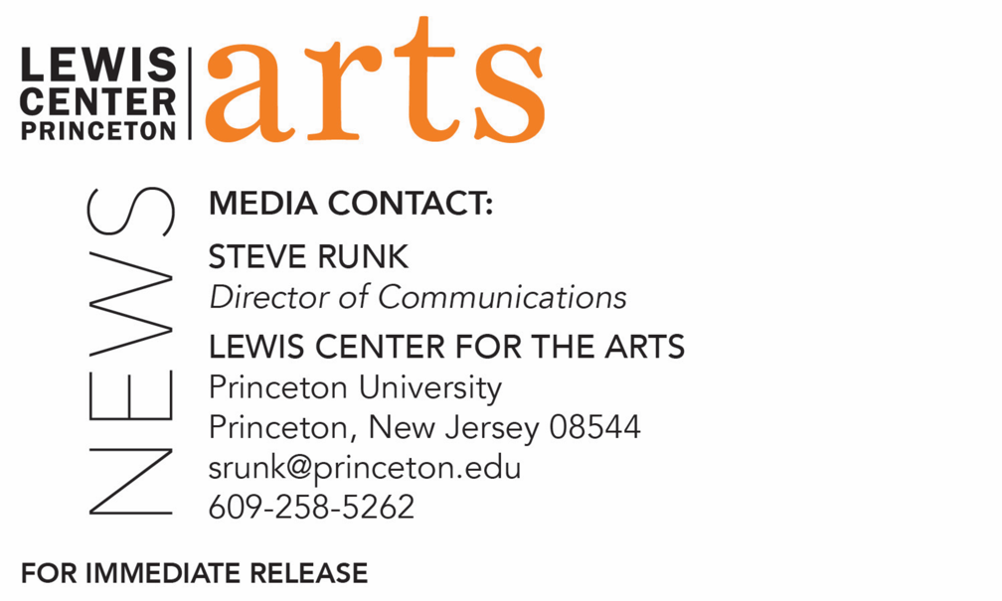

February 12, 2019

Award-winning Poet Tina Chang reads with Five Seniors in
Princeton’s Creative Writing Program February 22
The C.K. Williams Reading Series is organized by Princeton students
in collaboration with Labyrinth Books

Photo caption: Award-winning poet Tina Chang
Photo credit: Tom Callan

What/Who: Reading by award-winning poet Tina Chang and five seniors in Princeton's Program in Creative Writing, part of the C.K. Williams Reading Series
When: Friday, February 22 at 6:00 p.m.
Where: Labyrinth Books, 122 Nassau St., Princeton
Free and open to the public

(Princeton, N.J.) Award-winning poet Tina Chang and five seniors in the Lewis Center for the Arts’ Program in Creative Writing at Princeton University will read from their work at 6:00 p.m. on Friday, February 22 at Labyrinth Books, 122 Nassau Street. The reading is part of the C. K. Williams Reading Series, named in honor of the Pulitzer Prize and National Book Award-winning poet who served on Princeton’s creative writing faculty for 20 years.

The series showcases senior thesis students of the Program in Creative Writing alongside established writers as special guests. Featuring student writers Christian Bischoff, Sena Cebeci, Crystal Liu, Remi Shaull-Thompson, and Helena Van Brande, the event is free and open to the public.

Born in Oklahoma, poet Tina Chang moved with her family to New York City when she was a year old. As a child, Chang was sent to live with family in Taiwan for two years before returning to New York. She earned a B.A. at SUNY-Binghamton and an M.F.A. at Columbia University. Chang is the author of the poetry collections Half-Lit Houses (2004) and Of Gods & Strangers (2011). Her work has been featured in the anthologies Asian American Poetry: The Next Generation (2004) and From the Fishouse: An Anthology of Poems that Sing, Rhyme, Resound, Syncopate, Alliterate, and Just Plain Sound Great (2009). She coedited the anthology Language for a New Century: Contemporary Poetry from the Middle East, Asia, and Beyond (2008).

The first woman to be named poet laureate of Brooklyn, New York, Chang discussed her appointment with The New York Times: “The ultimate goal is to break down the wall between people and poetry,” Chang noted. “Somewhere along the way, we have felt intimidated by it, or we have felt we have to be well-educated in order to be able to access it or walk into that world.”

Chang has received awards from the Academy of American Poets, Barbara Deming Memorial Fund, Ludwig Vogelstein Foundation, New York Foundation for the Arts, and Van Lier Foundation. She has also been granted residencies at the MacDowell Colony, Djerassi Resident Artists Program, Vermont Studio Center, and Virginia Center for the Creative Arts.

The five seniors, who are pursuing a certificate in creative writing in addition to their major areas of study, will read from their senior thesis projects. Each is currently working on a novel, a screenplay, translations, or a collection of poems or short stories as part of a creative thesis for the certificate. Thesis students in the Program in Creative Writing work closely with a member of the faculty, which includes Aleksandar Hemon, Jhumpa Lahiri, Yiyun Li, Paul Muldoon, Kirstin Valdez Quade, James Richardson, Tracy K. Smith, Susan Wheeler, and a number of distinguished lecturers.

Upcoming guests in the C.K. Williams Reading Series include Hala Alyan and Danez Smith.

To learn more about this reading, the Program in Creative Writing, and the more than 100 public performances, exhibitions, readings, screenings, concerts and lectures presented each year by the Lewis Center for the Arts, most of them free, visit arts.princeton.edu.

###

