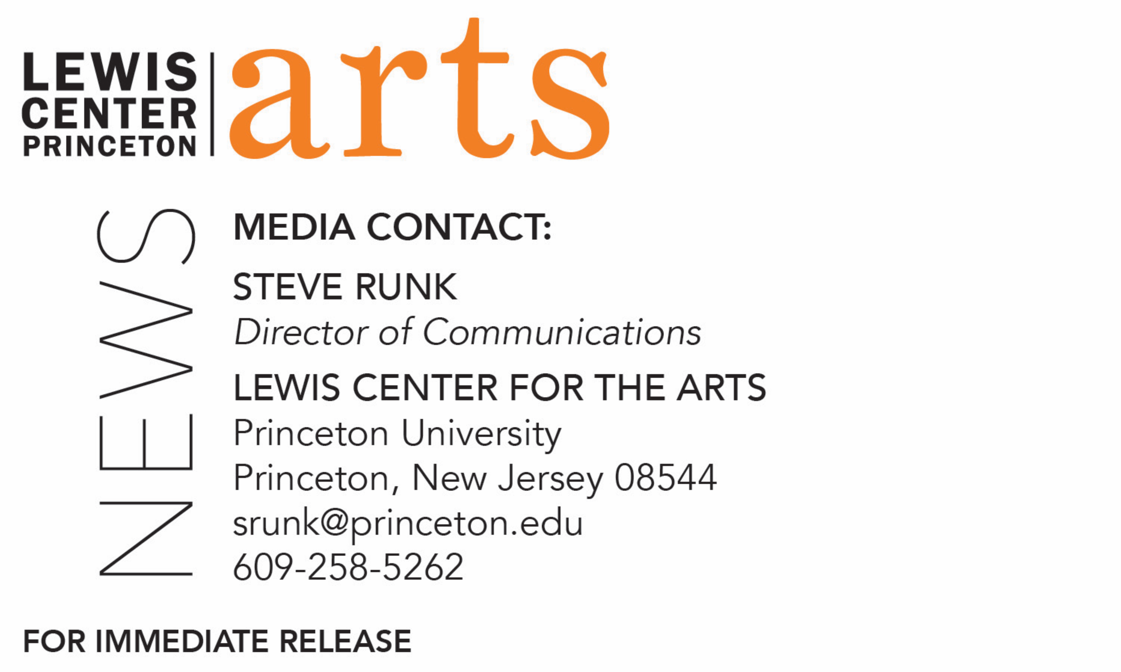
February 22, 2019

Lewis Center for the Arts’ Program in Creative Writing presents
A Reading by poet Frank Bidart and novelist Yuri Herrera
Next in Althea Ward Clark W’21 Reading Series at Princeton University

Photo caption/credit 1: Poet Frank Bidart, photo by James Franco
Photo caption/credit 2: Novelist Yuri Herrera, photo by Victoria Bush

Who/What: Reading by award-winning writers Frank Bidart and Yuri Herrera, next in the 2018-19 Althea Ward Clark W’21 Reading Series presented by the Lewis Center for the Arts’ Program in Creative Writing at Princeton University
When: Wednesday, March 6, at 7:30 p.m.
Where: Donald G. Drapkin Studio at Lewis Arts complex on the Princeton University campus
Free and open to the public

(Princeton, N.J.) On Wednesday, March 6, award-winning writers Frank Bidart and Yuri Herrera will read from their work as part of the Althea Ward Clark W’21 Reading Series of the Lewis Center for the Arts’ Program in Creative Writing. The reading, beginning at 7:30 p.m. in the Donald G. Drapkin Studio at the Lewis Arts complex on the Princeton University campus, is free and open to the public. In response to audience feedback, all readings for this year’s series have moved from 4:30 p.m. to a 7:30 p.m. evening time slot.

Frank Bidart’s first books, Golden State and The Book of the Body, both published in the 1970s, gained critical attention and praise, but his reputation as a poet of uncompromising originality was made with The Sacrifice, published in 1983. All three books are collected in In the Western Night: Collected Poems 1965-1990, which won the National Book Award and Pulitzer Prize in Poetry. Bidart grew up in California and entertained thoughts of becoming an actor or director when he was young. His plans changed, however, when he was introduced to literature at the University of California - Riverside. After graduating from the University of California, Bidart continued his education at Harvard University. His position in American letters has been solidified through later works such as Star Dust, Watching the Spring Festival, and Desire, which was nominated for the Pulitzer Prize, the National Book Award, and the National Book Critics Circle Award. Among his most notable pieces are dramatic monologues presented through such characters as Herbert White, a child-murderer, and Ellen West, a woman with anorexia.

Bidart will be introduced by Pulitzer Prize-winning poet Paul Muldoon, Princeton’s Howard G.B. Clark ’21 University Professor in the Humanities and Professor of Creative Writing.

Yuri Herrera, born in Actopan, México in 1970, has written three novels, all of them translated into several languages: Trabajos del reino (Kingdom Cons, And Other Stories, 2017), Señales que precederán al fin del mundo (Signs Preceding the End of the World, And Other Stories, 2015), and La transmigración de los cuerpos (The Transmigration of Bodies, And Other Stories, 2016). He is currently an assistant professor at Tulane University in New Orleans.

Herrera will be introduced by Michael Wood, Professor, Emeritus, in Princeton’s Department of English.

The Lewis Center’s Program in Creative Writing annually presents the Althea Ward Clark W’21 Reading Series, which provides an opportunity for students, as well as all in the greater Princeton region, to hear and meet the best contemporary writers. All readings are at 7:30 p.m. in venues in the Lewis Arts complex and are free and open to the public. The series continues on April 17 with a reading by Han Kang and Ngũgĩ wa Thiong’o in the Hearst Dance Theater.

The series will also include readings in May of new work by selected students in spring creative writing courses and readings by seniors in the Program from the novels, collections of short stories, poems or translations, or screenplays written as their senior theses under mentorship by the Creative Writing faculty.

To learn more about this event, the Program in Creative Writing, and the more than 100 other performances, exhibitions, readings, screenings, concerts, and lectures presented each year by the Lewis Center, most of them free, visit arts.princeton.edu.

###

