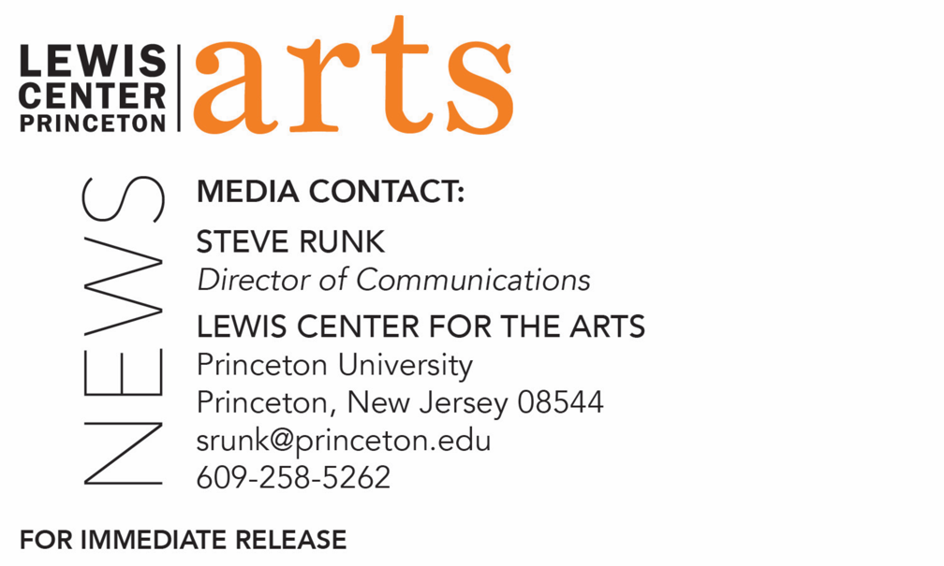

February 27, 2019

Fund for Irish Studies at Princeton University presents
“The Myth of Paternity: James Joyce and His Father”
Scholar and Bestselling Author Colm Tóibín delivers
A Lecture at Princeton University

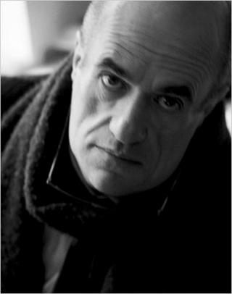

Photo caption: Colm Tóibín, gives a lecture on “The Myth of Paternity: James Joyce and his Father”
Photo credit: Courtesy www.colmtoibin.com

What/Who: Bestselling author Colm Tóibín lectures on “The Myth of Paternity: James Joyce and his Father” as part of the spring 2019 Fund for Irish Studies event series. Toibín’s latest book, Mad, Bad, Dangerous to Know: The Fathers of Wilde, Yeats, and Joyce, was published in 2018. Presented by Princeton’s Fund for Irish Studies
When: Friday, March 8 at 4:30 p.m.
Where: James Stewart Film Theater at 185 Nassau Street on the Princeton University campus

(Princeton, NJ) Bestselling author Colm Tóibín will present a lecture entitled “The Myth of Paternity: James Joyce and his Father” on Friday, March 8 at 4:30 p.m. in the James Stewart Film Theater at 185 Nassau Street on the Princeton University campus. Part of the 2018-19 Fund for Irish Studies series at Princeton University, the event is free and open to the public.

Tóibín’s latest book, Mad, Bad, Dangerous to Know: The Fathers of Wilde, Yeats, and Joyce, was published in 2018. His examination of three writers’ relationships with their fathers is full of insight and intrigue. Mad, Bad, Dangerous to Know began its life as a series of Richard Ellmann Lectures, given at Emory University, Georgia, in the biographer’s memory. In the chapter on Joyce’s father, Tóibín devotes himself to looking for the man among the pages of his son’s stories and novels. Tóibín understands that what captivated Joyce was the dizzying, unfathomable space between what he knew about his father, and what he felt about him. Out of this, he forged his style: generous, varied, and replete.

Colm Tóibín is the author of nine novels, including The Blackwater Lightship; The Master, winner of the Los Angeles Times Book Prize; Brooklyn, winner of the Costa Book Award; The Testament of Mary; and Nora Webster, as well as two story collections. He is the Irene and Sidney B. Silverman Professor of the Humanities at Columbia University. Three times shortlisted for the Man Booker Prize, Tóibín lives in Dublin and New York.

The Fund for Irish Studies affords all Princeton students, and the community at large, a wider and deeper sense of the languages, literatures, drama, visual arts, history, politics, and economics not only of Ireland but of “Ireland in the world.” The series is co-produced by the Lewis Center for the Arts and the spring 2019 edition of the series is organized by Fintan O’Toole Visiting Lecturer in Theater and Acting Chair of the Fund for Irish Studies.

Information about the Fund for Irish Studies series events can be found at fis.princeton.edu. Other upcoming events in the current series include:
- Professor Maureen Murphy, past president of the American Conference for Irish Studies and a past chair of the International Association for the Study of Irish Literatures, presents the lecture “Irish Emigrant Girls in New York” on March 29
- Award-winning filmmaker Sinead O’Shea screens her documentary A Mother Brings Her Son to be Shot followed by a discussion with Fintan O’Toole on April 12 at 1 p.m. at Princeton Garden Theatre
- Novelist Anne Enright will present a reading on May 3

The Fund for Irish Studies is generously sponsored by the Durkin Family Trust and the James J. Kerrigan, Jr. ’45 and Margaret M. Kerrigan Fund for Irish Studies.

To learn more about the more than 100 public performances, exhibitions, readings, screenings, concerts, lectures and special events, most of them free, presented each year by the Lewis Center for the Arts, visit arts.princeton.edu.

###

