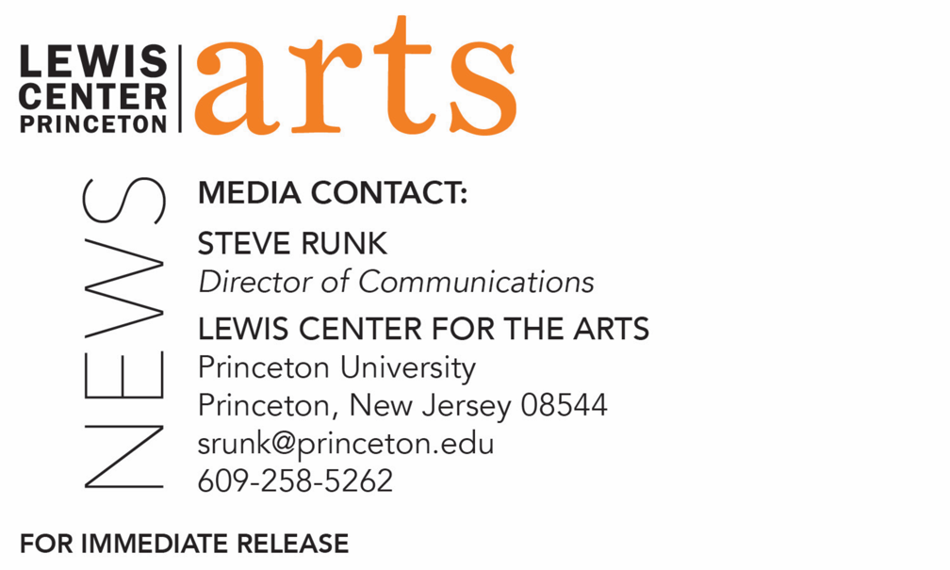

February 11, 2019

Fund for Irish Studies at Princeton University presents
“Escaping from History: The Dreamworld of Brexit”
Irish Scholar and theater critic Fintan O’Toole delivers
the 2019 Robert Fagles Memorial Lecture at Princeton University

Photo caption: Fintan O’Toole, Leonard L. Milberg ’53 Visiting Lecturer in Theater at the Lewis Center for the Arts at Princeton
Photo credit: Courtesy of Fintan O’Toole

What: The 2019 Robert Fagles Memorial Lecture “Escaping from History: The Dreamworld of Brexit,” presented by Princeton’s Fund for Irish Studies
Who: Irish theatre critic and scholar Fintan O’Toole
When: Friday, February 22 at 4:30 p.m.
Where: James Stewart Film Theater at 185 Nassau Street on the Princeton University campus

(Princeton, NJ) Irish critic and scholar Fintan O’Toole will present the 2019 Robert Fagles Memorial Lecture, entitled “Escaping from History: The Dreamworld of Brexit,” on Friday, February 22 at 4:30 p.m. in the James Stewart Film Theater at 185 Nassau Street on the Princeton University campus. Part of the 2018-19 Fund for Irish Studies series at Princeton University, this event is free and open to the public.

O’Toole’s writings on Brexit, the prospective withdrawal of the United Kingdom from the European Union, won both the European Press Prize and the George Orwell Prize for Journalism in 2017. His new book on Brexit, Heroic Failure, has been widely acclaimed and a U.S. edition, The Politics of Pain will be published in the fall.

“Escaping from History: The Dreamworld of Brexit” begins with the claim by James Joyce’s Stephen Dedalus that “history is a nightmare from which I am trying to awake”. Applying this to the crisis for Ireland and Britain that has been created by Brexit, he suggests that each of the two countries has been trying to escape history, but in radically different ways. Ireland is trying to escape from the consequences of simplistic ideas of belonging; Britain is trying to escape from ordinariness back into a dream world of greatness.

Fintan O’Toole, one of Ireland’s leading public intellectuals, is a columnist for The Irish Times and Leonard L. Milberg ’53 Visiting Lecturer in Theater in Princeton’s Lewis Center for the Arts and the Department of English. He also contributes to The New York Review of Books, The New Yorker, Granta, The Guardian, The Observer, and other international publications. His books on theater include works on William Shakespeare, Richard Brinsley Sheridan, and Thomas Murphy. His books on politics include the best sellers Ship of Fools and Enough is Enough. In 2011, The Observer named O’Toole one of “Britain’s top 300 intellectuals.” He has received the A.T. Cross Award for Supreme Contribution to Irish Journalism, the Millennium Social Inclusion Award, and Journalist of the Year in 2010, the Orwell Prize, and the European Press Prize. O’Toole’s History of Ireland in 100 Objects, which covers 100 highly charged artifacts from the last 10,000 years, is currently the basis for Ireland’s postage stamps. Judging Shaw: The Radicalism of GBS, was published by the Royal Irish Academy in 2017, and he has recently been appointed official biographer of Seamus Heaney.

Robert Fagles, for whom the annual Memorial Lecture is named, was a member of the Princeton faculty for 42 years in the Department of Comparative Literature and a renowned translator of Greek classics. His critically acclaimed translations of Homer’s “The Iliad” and “The Odyssey” became bestsellers.

The Fund for Irish Studies affords all Princeton students, and the community at large, a wider and deeper sense of the languages, literatures, drama, visual arts, history, politics, and economics not only of Ireland but of “Ireland in the world.” The series is co-produced by the Lewis Center for the Arts and the spring 2019 edition of the series is organized by O’Toole.

Information about the Fund for Irish Studies series events can be found at fis.princeton.edu. Other events scheduled in the current series include:
- Acclaimed author and journalist Colm Toibín presents the lecture “The Myth of Paternity: James Joyce and his father” on March 8
- Professor Maureen Murphy, past president of the American Conference for Irish Studies and a past chair of the International Association for the Study of Irish Literatures, presents the lecture “Irish Emigrant Girls in New York” on March 29
- Award-winning filmmaker Sinead O’Shea screens her documentary A Mother Brings Her Son to be Shot followed by a discussion with O’Toole on April 12 at Princeton Garden Theatre
- Novelist Anne Enright will present a reading on May 3

The Fund for Irish Studies is generously sponsored by the Durkin Family Trust and the James J. Kerrigan, Jr. ’45 and Margaret M. Kerrigan Fund for Irish Studies.

To learn more about the more than 100 public performances, exhibitions, readings, screenings, concerts, lectures and special events, most of them free, presented each year by the Lewis Center for the Arts, visit arts.princeton.edu.

###

