

February 11, 2019

Lewis Center for the Arts presents real lies
An evening of thought-provoking performance choreographed by Princeton seniors William Keiser and James Jared

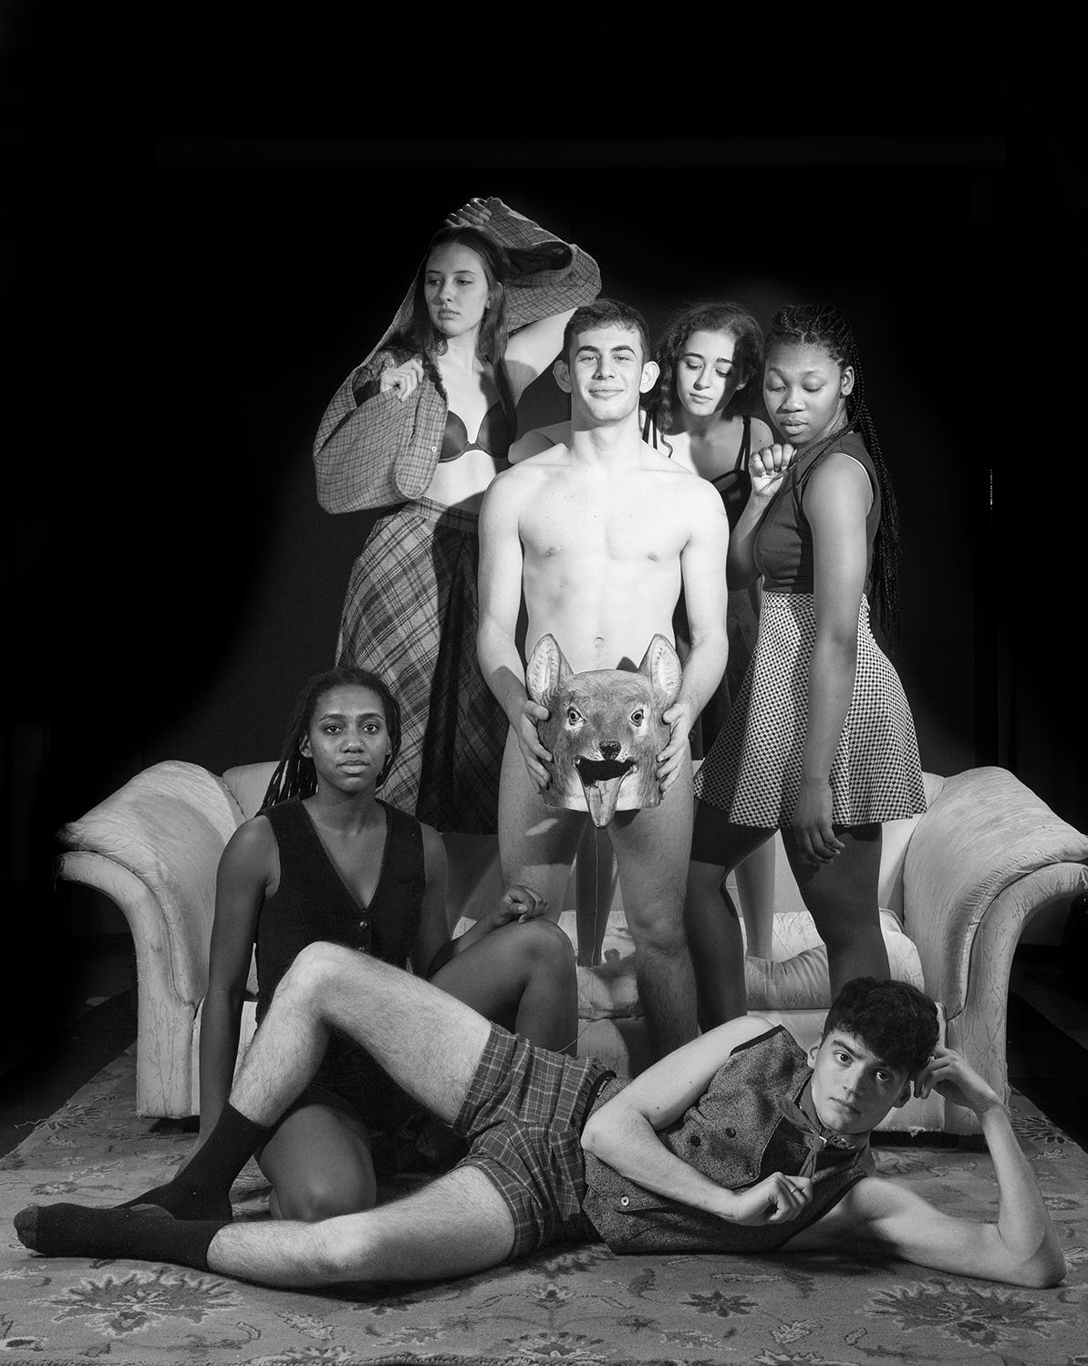
Photo caption 1: Cast of senior William Keiser’s sections of real lies
Photo caption 2: Cast of senior James Jared’s sections of real lies
Photo credit: Sanneh

What/Who: real lies, an original production choreographed and directed by Princeton seniors James Jared and William Keiser that explores a multitude of dichotomies - discipline/pleasure, internal/external, and performer/audience, among others - through dance. Uniting the story of Pinocchio with a study of artistry and performance, two casts and two choreographers share one stage in an evening of thought-provoking performance, presented by the Lewis Center for the Arts’ Program in Dance
When: February 21 at 8:30 p.m., February 22 at 9:30 p.m., February 23 at 2 p.m. & 8:30 p.m.
Where: Hearst Dance Theater at Lewis Arts complex on the Princeton University campus
Free and open to the public, however advance ticket reservations are encouraged
For more information and tickets: https://arts.princeton.edu/events/real-lies/2019-02-21/

(Princeton, NJ) The Lewis Center for the Arts’ Program in Dance at Princeton University will present real lies, an original production choreographed and directed by Princeton seniors James Jared and William Keiser that explores a multitude of dichotomies — discipline/pleasure, internal/external, and performer/audience, among others — through dance. Uniting the story of Pinocchio with a study of artistry and performance, two casts and two choreographers share one stage in an evening of thought-provoking performance. Performances will be held February 21 at 8:30 p.m., February 22 at 9:30 p.m., February 23 at 2 p.m. & 8:30 p.m. at the Hearst Dance Theater at the Lewis Arts complex on the Princeton University campus. The performances are free and open to the public, however advance tickets reservations are encouraged.

real lies represents Jared and Keiser’s independent theses in the Program in Dance. The show unites Jared’s’ exploration of artistry and performance with Keiser’s abstracted rendition of the story of Pinocchio. Jared’s work aims to highlight the dialogue that occurs through the stage proscenium and explores the extremity of various conceptions of dance. Keiser’s work follows the figure of Pinocchio as he runs away from his creator, Geppetto, meets false friends, joins the military, gets lost in a world of hedonistic pleasure, and ultimately must find balance within himself. Presented as one show, the pieces are interwoven to form an evening of internal and external elements.

Keiser is concentrating in the Media and Aesthetics track of the German department. He hails from Pompano Beach, Florida, where he studied classical ballet intensively for nine years before coming to Princeton. On campus, he dances for two student-run dance companies and writes for Arch & Arrow literary magazine. In this work, Keiser is fascinated by the multi-generational immigrant family, the volatility of the sixties, the hedonism of the late seventies, the anatomy of a party, inferiority complexes, and theories of modernity. After graduation, Keiser plans to continue choreographing and writing on the west coast.

Jared is a senior from Carpinteria, California, concentrating in the Circuits and Systems track of the Electrical Engineering department. He also dances with a student-run company and works as a climbing instructor at the Outdoor Action climbing wall. His work challenges the expectations of artistry and performance in a concert setting and utilizes kinesthetic empathy as a tool to expose the dialogue that occurs between performer and audience. As a dancer trained in a variety of techniques, Jared believes he has found a voice of his own in this show that he hopes will be heard.

The productions features strobe lights, partial nudity, and interaction with the dancers and therefore may not be suitable for all audiences.

The student cast includes seniors Danielle Isakov and James Jared, juniors Caroline Bailey, Abigail Kostolansky, and Cooper Young, sophomores Yolore Airewele, Ysabel Ayala, Sophie Blue, Enver Ramadani, and Auset Taylor, and first year students Jonathan Golden and Jared Harbour. Lighting for the production is designed by Tess James. The production stage manager is Andrea Cibelli. Rebecca Lazier, Susan Marshall, and Rebecca Stenn are the project’s faculty advisors. Musical accompaniment and composition are provided by Vince Di Mura.

To learn more about this event, the Program in Dance, and the more than 100 other performances, exhibitions, readings, screenings, concerts and lectures presented each year at the Lewis Center, most of them free, visit arts.princeton.edu.

###

