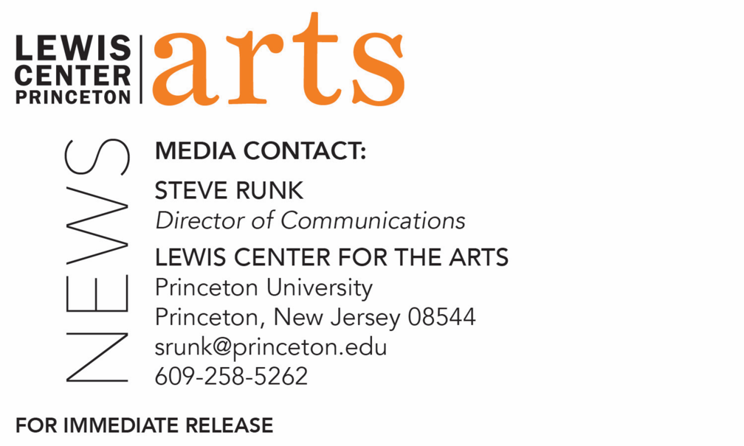

February 8, 2019

Lewis Center for the Arts’ Program in Theater presents
A Conversation with Poet/Playwright Lemn Sissay
Award-winning author of plays for stage and BBC radio discusses his work in theater

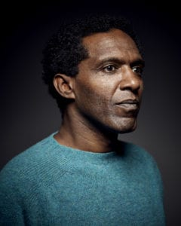
Photo caption: Award-winning poet and playwright Lemn Sissay
Photos credit: Hamish Brown

What/Who: Lemn Sissay, award-winning author of a series of collections of poetry and of plays for stage and BBC radio, associate artist at London’s Southbank Centre, and a Member of the Order of the British Empire bestowed by Queen Elizabeth for Services to Literature, joins Princeton students in a public conversation, hosted by Professors Elena Araoz and Brian Herrera, as part of the Lewis Center for the Arts’ Program in Theater course “Creative Intellect.”
When: Friday, February 15 at 3 p.m.
Where: Berlind Rehearsal Room. McCarter Theatre Center, 91 University Place, Princeton
Free and open to the public; limited seating on a first-come, first-seated basis.

(Princeton, NJ) Award-winning poet and playwright Lemn Sissay will discuss his work in theater with Princeton students in a public conversation, hosted by Professors Elena Araoz and Brian Herrera, as part of the Lewis Center for the Arts’ Program in Theater course “Creative Intellect,” on Friday, February 15 at 3:00 p.m. in the Berlind Rehearsal Room at McCarter Theatre Center, 91 University Place. The event is free and open to the public.

Sissay is author of a series of books of poetry, articles, records, broadcasts, public art, commissions and plays. He is an associate artist at Southbank Centre in London, a patron of The Letterbox Club and The Reader Organisation, ambassador for The Children’s Reading Fund, trustee of Forward Arts Foundation, an inaugural trustee of World Book Night, and an honorary doctor of Letters. He was the first poet commissioned to write for London Olympics and his Landmark Poems are installed throughout Manchester and London. Sissay’s award winning play Something Dark, directed by National Theatre of Wales artistic director John McGrath, has been performed throughout the world and his stage adaptation of Benjamin Zephaniah’s novel Refugee Boy at West Yorkshire Playhouse toured Britain in 2014. Broadcasts include the BBC-TV documentary, Internal Flight, and a radio documentary, Child of the State, both based on his life, and his TED Talk has close to a million views. Sissay was the first Black Writers Development Worker in the north of England. He created and established Cultureword, which has developed, supported and published many new writers. He is a Member of the Order of the British Empire bestowed by Queen Elizabeth for Services to Literature.

The “Creative Intellect” course is a collaborative workshop designed to bridge the critical and creative dimensions of performance research. Students in this current spring semester course are leading the development of performance research projects and devising and producing works that will be presented in a festival format in late April.

To learn more about this event, the Program in Theater, and the more than 100 other performances, exhibitions, readings, screenings, concerts, and lectures presented each year by the Lewis Center, most of them free, visit arts.princeton.edu.

###

