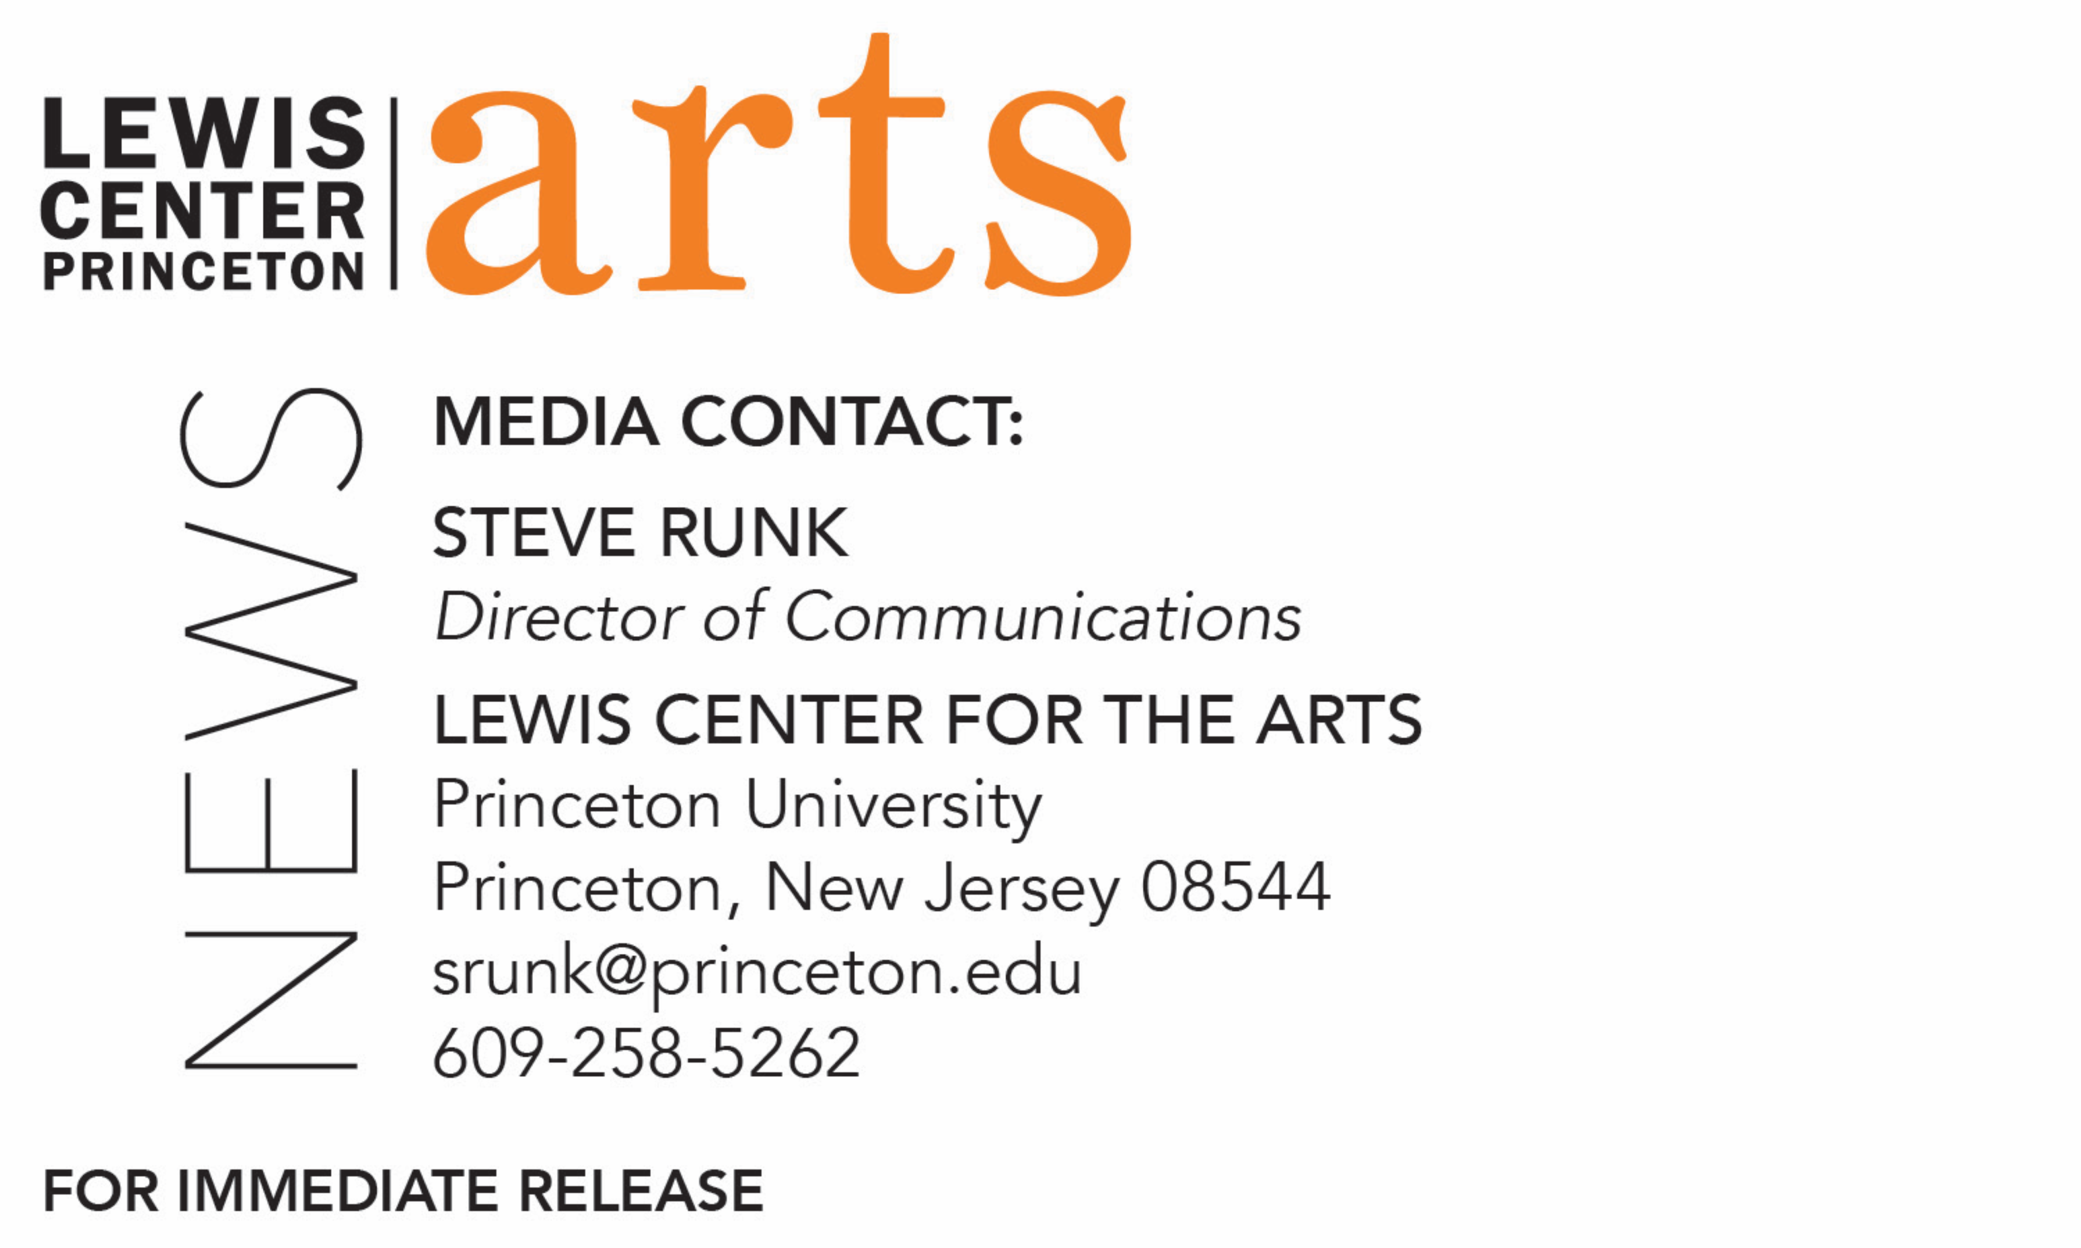
February 25, 2019

Grammy Award-winning Broadway Professionals Kurt Deutsch and Paul Bogaev at Princeton University
Series of two events about the American Musical Theater
at the Lewis Center for the Arts

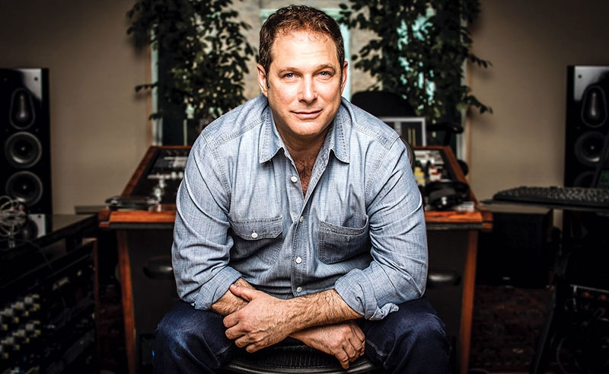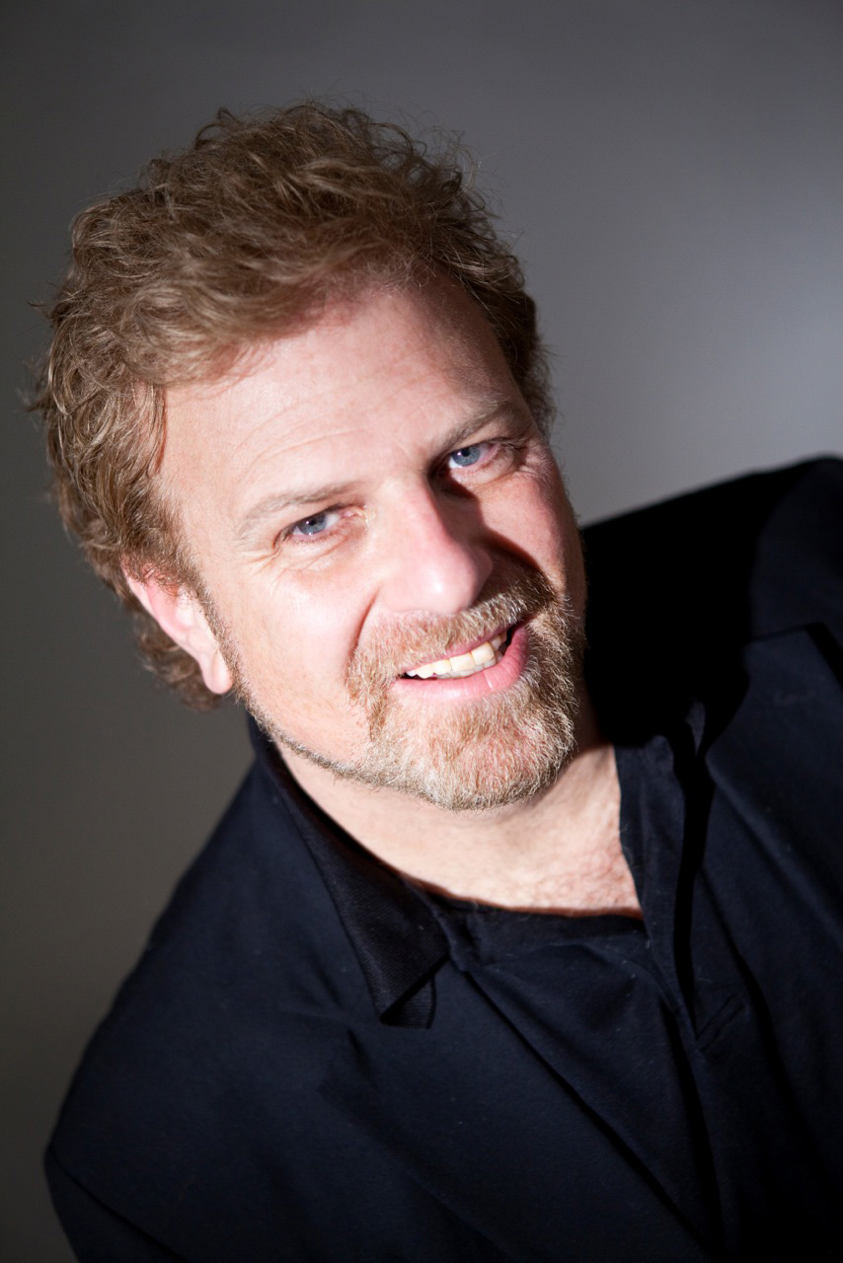
Photo caption/credit 1: Producer Kurt Deutsch. Photo by Alex Turshen
Photo caption/credit 2: Musical director Paul Bogaev. Photo courtesy Paul Bogaev

Who: Kurt Deutsch, President and Founder of Sh-K-Boom/Ghostlight Records and Senior Vice President of Theatrical & Catalog Development for Warner/Chappell Music; Grammy and Emmy Award-winning musical director, arranger, conductor and composer Paul Bogaev
What: A conversation about the recording and music publishing business with Kurt Deutsch and a masterclass with Paul Bogaev, both part of Theater Professor Stacy Wolf’s spring course “Race and the American Musical from Minstrelsy to Hamilton,” series of two events with Broadway professionals
When: Wednesday, March 6 at 3:00 p.m. and Wednesday, March 13 at 3:00 p.m.
Where: Donald G. Drapkin Studio, Lewis Arts complex, Princeton, NJ
Free and open to the public
Event info: https://arts.princeton.edu/events/conversation-with-kurt-deutsch/ and https://arts.princeton.edu/events/musical-theatre-master-class-paul-bogaev/

(Princeton, N.J.) The Lewis Center for the Arts’ Programs in Theater and Music Theater at Princeton University welcome Grammy Award-winning Broadway professionals Kurt Deutsch and Paul Bogaev as guests to Professor of Theater Stacy Wolf’s spring course, “Race and the American Musical from Minstrelsy to Hamilton.” In cosponsorship with Princeton’s Keller Center for Innovation in Engineering Education, Senior Vice President for Theatrical & Catalog Development for Warner/Chappell Music and President of Sh-K-Boom Records Kurt Deutsch will discuss the recording and music publishing business in a conversation with students on Wednesday, March 6. Emmy Award-winning musical director, arranger, conductor and composer Paul Bogaev will give a master class with Princeton students on Wednesday, March 13. Both events begin at 3:00 p.m. in the Donald G. Drapkin Studio at the Lewis Arts complex in Princeton and are free and open to the public to observe.

Wolf’s American Studies course, cross-listed with the Programs in Music Theater and Theater, and the Department of African American Studies, examines race as a key component of Broadway musical theater, examining musicals from Rodgers and Hammerstein’s The King & I to Lin-Manuel Miranda’s blockbusters In the Heights and Hamilton. Students analyze scripts, critical articles, cast albums, and performances to understand how race and ethnicity structure the aesthetics and politics of American theater. The semester includes a trip to Philadelphia to see a musical.

Kurt Deutsch is an actor, director, record producer and film producer. Warner/Chappell Music, and Sh-K-Boom Records, a division of Warner Arts Music, has over 150 albums in its catalog, including The Book of Mormon; In the Heights, the Original Cast Recording; Original Motion Picture Soundtrack and New Off-Broadway Cast Recordings of The Last Five Years; Beautiful: The Carole King Musical; Next to Normal; the 2009 revival of Hair; Legally Blonde: The Musical; Bloody Bloody Andrew Jackson, and many more Broadway and Off-Broadway shows. A recipient of several Grammy Awards, Deutsch received his first Grammy in 2009 as co-producer for Best Musical Show Album for The Original Broadway Cast Album In The Heights. As an actor, Deutsch has appeared on Broadway in Broadway Bound and A Few Good Men, in regional theaters around the country, as a series regular on the television series The Human Factor and Winnetka Road, and as a guest star on Sex and the City, Law & Order, Quantum Leap, Matlock, and Models Inc. His film roles include The Eye of the Storm, The First To Go and Labor Pains.

Paul Bogaev is a multi-award-winning artist whose film credits include the Oscar-winning Chicago, for which he won a Grammy Award; Nine; Dreamgirls, starring Jamie Foxx, Beyoncé Knowles, Eddie Murphy and Jennifer Hudson; Across the Universe; and the Disney films Mulan, The Lion King, and The Emperor’s New Groove. Among his many Broadway credits are Elton John and Tim Rice’s Aida, for which he won his first Grammy; Tarzan; Bombay Dreams, for which he was nominated for a Tony Award; Sunset Boulevard; Chess; Cats; Starlight Express; Les Miserables; Spider Man: Turn Off the Dark; and most recently, Viva Mixtia.

Bogaev also served as music director of the ABC-TV musicals Cinderella, South Pacific, and Annie, for which he won an Emmy Award. He has worked with a number of pop, film, and theater stars over the course of his career, including Sting, Phil Collins, Bono, Barbra Streisand, Whitney Houston, Hugh Jackman, Richard Gere, Catherine Zeta-Jones, Penelope Cruz, Keith Urban, and Fergie. As a symphony conductor, he conducted the music for Francis Ford Coppola’s presentation of the silent film epic Napoleon with major orchestras around the world.

“We are absolutely thrilled to welcome Kurt and Paul to Princeton to share their knowledge and experience with our students,” said Wolf.

Wolf teaches courses in American musical theater history, dramaturgy and dramatic literature, histories of U.S. performance, performance theory, and performance studies. She is the author of Changed for Good: A Feminist History of the Broadway Musical (named one of the “top ten books every theater lover should read” by Marissa Friedman); A Problem Like Maria: Gender and Sexuality in the American Musical; and the co-editor of The Oxford Handbook of the American Musical. She is currently finishing Beyond Broadway: The Pleasure and Promise of Musical Theatre Across America, which examines local musical theater at high schools, summer camps, community centers, and afterschool programs across the country. Wolf is Director of the Program in Music Theater and Director of Fellowships in the Lewis Center.

The Program in Music Theater is a collaboration among the Lewis Center for the Arts’ Program in Theater and Program in Dance and the Department of Music, which brings together students, faculty, and guest artists in the creation, study, and performance of music theater to support and develop all forms of music theater—that is, any theatrical form that combines singing, acting, and movement—as both an artistic practice and a field of scholarly study.

For more information on these events, the Program in Music Theater and the more than 100 public performances, exhibitions, readings, screenings, concerts and lectures presented each year by the Lewis Center for the Arts, most of them free, visit arts.princeton.edu.

###

