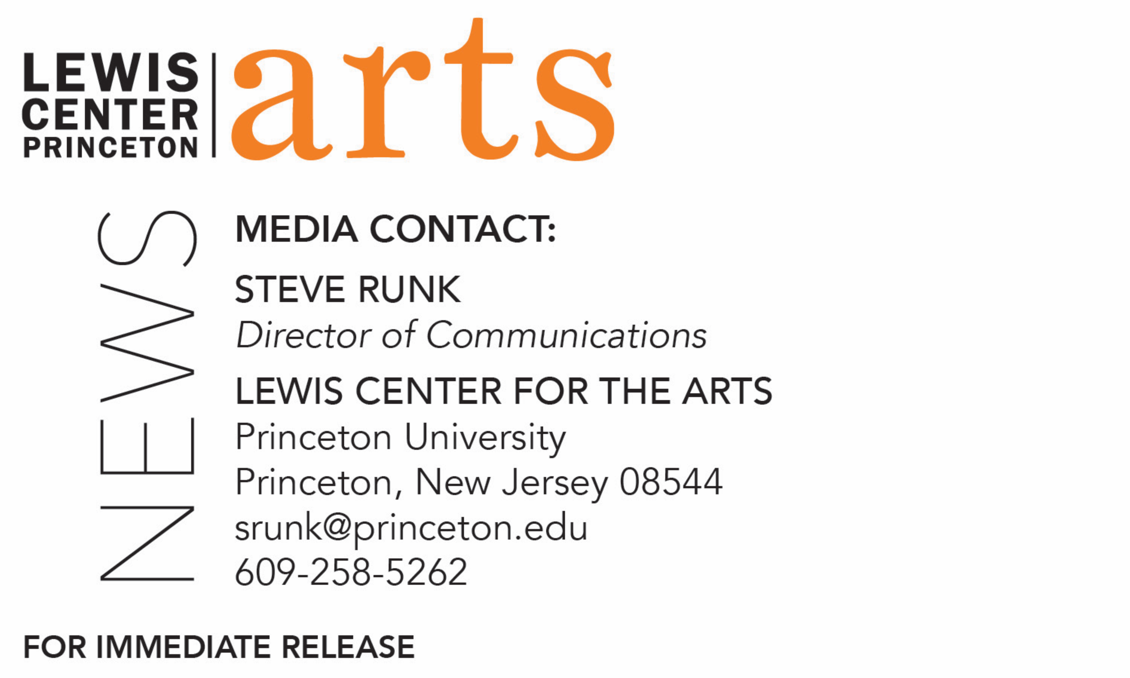

February 25, 2019

Visual Arts Program at the Lewis Center for the Arts presents
a screening of student work in film, video, and digital animation
Work from fall courses “How to Make a Film,” “Intermediate Video and Film Production,” “Documentary Filmmaking,” and “Digital Animation”

Photo caption/credit: A still from the animated short film I Saw Seven Traffic Cones by Princeton senior Kyra Gregory

Who/What: A screening of 34 student-created short films from fall semester courses “How to Make a Film” and “Intermediate Video and Film Production,” taught by Moon Molson; “Documentary Filmmaking” taught by Lynne Sachs; and “Digital Animation,” taught by Tim Szetela
When: Friday, March 1 at 7:00-10:00 p.m.
Where: James Stewart Film Theater at 185 Nassau Street
Free and open to the public

(Princeton, NJ) The Visual Arts Program at Princeton University’s Lewis Center for the Arts will present a screening of 34 short student films created in the fall semester courses “How to Make a Film” and “Intermediate Video and Film Production,” taught by Moon Molson; “Documentary Filmmaking” taught by Lynne Sachs; and “Digital Animation,” taught by Tim Szetela. The screening, which is free and open to the public, will be presented on Friday, March 1 from 7:00 to 10:00 p.m. in the James Stewart Film Theater, located on the first floor of 185 Nassau Street. A reception will follow the screening.

In Molson’s course “How to Make a Film,” students explored the basic tools and approaches for film production with digital media through hands-on exercises, screenings, critical readings and group critiques. Students developed their visual storytelling voices through technical instruction in camera, sound editing, and post production, paired with the conceptual frameworks of visual composition, film grammar and cinema syntax.

In “Intermediate Video and Film Production,” second level film/video students completed one short film over the course of the semester in their choice of style and genre (narrative, documentary, experimental, hybrid, etc).

Molson’s short films have premiered at the Sundance Film Festival, screened at over 250 international film festivals, and have received more than 100 awards worldwide, including the Grand Jury Prizes at Palm Springs, South by Southwest (SXSW), and the Student Academy Awards. He has attended the 2008 Sundance Screenwriters & Directors Labs, the 2008 Film Independent (FIND) Directors Labs, the 2015 Warner Brothers Television Directors' Workshop, and 2016 FOX Global Directors Initiative as a Fox Director Fellow. Molson was named a 2017 Pew Foundation Fellow, a 2015 Guggenheim Fellow in Film-Video, and was one of Filmmaker Magazine's “25 New Faces of Independent Film” in Summer 2007. He has received grants from The Jerome Foundation, New York Foundation for the Arts, New York State Council on the Arts, and the Sundance Institute.

In Lynne Sachs’ "Documentary Filmmaking” course, each student shot and edited two
reality-based films. In the process, students asked themselves fundamental questions: To what extent do you trust what you hear and see? How do the ethics and politics of representation affect your production process? Who is making and who is looking at images in this age of seemingly unlimited technological access? Students also explored a range of documentary approaches including the observational, activist, personal, and experimental.

Sachs makes films and writes poems that explore the intricate relationship between personal observations and broader historical experiences. Strongly committed to a dialogue between theory and practice, she searches for a rigorous play between image and sound, pushing the visual and aural textures in her work with every new project. Her films have been exhibited at the Museum of Modern Art, the Whitney, Walker Art Center, and Wexner Center for the Arts. Sachs received a 2014 Guggenheim Fellowship in the Creative Arts.

In Tim Szetela’s “Digital Animation” course, students worked with a variety of timed-based collage, composition, visualization, and storytelling techniques, while learning the fundamental techniques and technology of 2D animation production. Students produced a range of short animated films, which explore identity, dreams, memory, moms, dads, talent shows, generative candy, dance, satellites, teleporting ink, and visionary eggs.

Szetela is a designer, animator, and digital artist. He uses a varying toolset of analog and digital media, software, and code, to make films, games, maps, and other interfaces that visualize location, language, and technology. Rewordable, the game he co-designed using computational linguistics, was published by Penguin Random House in 2017. His short films have screened at numerous international animation festivals, including Anima Mundi, Annecy, Ottawa, Stuttgart, and Zagreb. He has shown work at the Museum of Modern Art, Metropolitan Museum of Art, the Museum of the Moving Image, and at a variety of digital media and technology festivals, conferences, and exhibitions.

To learn more about this event, the Program in Visual Arts, and the more than 100 public performances, exhibitions, readings, screenings, concerts and lectures presented each year by the Lewis Center for the Arts, most of them free, visit arts.princeton.edu.

###

