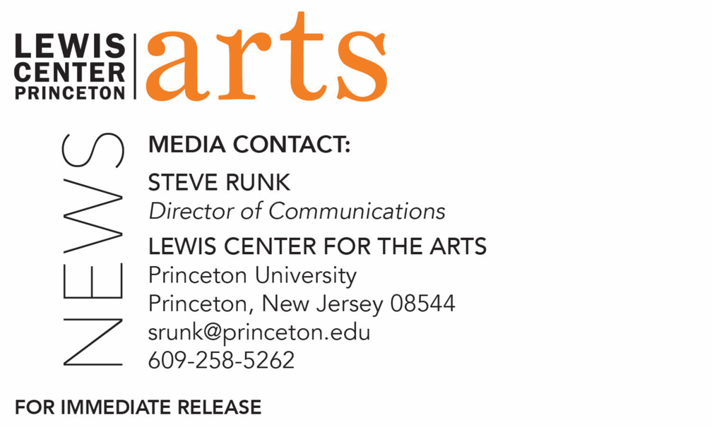

March 28, 2019

Award-winning poet Danez Smith reads with Four Seniors in
Princeton’s Creative Writing Program April 5
The C.K. Williams Reading Series is organized by Princeton students
in collaboration with Labyrinth Books

Photo caption/credit: Poet Danez Zmith, photo by Beotis Creative

What/Who: Reading by award-winning poet Danez Smith and four seniors in Princeton's Program in Creative Writing, part of the C.K. Williams Reading Series
When: Friday, April 5 at 6:00 p.m.
Where: Labyrinth Books, 122 Nassau St., Princeton
Free and open to the public
Event info: https://arts.princeton.edu/events/c-k-williams-reading-series-danez-smith/

(Princeton, N.J.) Award-winning poet Danez Smith and four seniors in the Lewis Center for the Arts’ Program in Creative Writing at Princeton University will read from their work at 6:00 p.m. on Friday, April 5 at Labyrinth Books, 122 Nassau Street. The reading is part of the C. K. Williams Reading Series, named in honor of the Pulitzer Prize and National Book Award-winning poet who served on Princeton’s creative writing faculty for 20 years.

The series showcases senior thesis students of the Program in Creative Writing alongside established writers as special guests. Featuring student writers Cody Cortes, Madeleine Le Cesne, Annabelle Tseng, and Jonah Herzog Arbeitman, the event is free and open to the public.

Danez Smith describes themself as a Black, queer, poz writer, teacher and performer from St. Paul, Minnesota. Smith is the author of Don’t Call Us Dead (Graywolf Press, 2017), a finalist for National Book Award, and [insert] boy (YesYes Books, 2014), winner of the Kate Tufts Discovery Award and the Lambda Literary Award for Gay Poetry. They are the recipient of fellowships from the Poetry Foundation and the McKnight Foundation, and they are a 2017 National Endowment for the Arts Fellow, as well as the winner of the inaugural Four Quartets Prize from the Poetry Society of America. Smith’s work has been featured widely, including in The New Yorker, The New York Times, Buzzfeed, Best American Poetry, PBS NewsHour, and on the Late Show with Stephen Colbert.

The four seniors, who are pursuing a certificate in creative writing in addition to their major areas of study, will read from their senior thesis projects. Each is currently working on a novel, a screenplay, translations, or a collection of poems or short stories as part of a creative thesis for the certificate. Thesis students in the Program in Creative Writing work closely with a member of the faculty, which includes Aleksandar Hemon, Jhumpa Lahiri, Yiyun Li, Paul Muldoon, Kirstin Valdez Quade, James Richardson, Tracy K. Smith, Susan Wheeler, and a number of distinguished lecturers.

To learn more about this reading, the Program in Creative Writing, and the more than 100 public performances, exhibitions, readings, screenings, concerts and lectures presented each year by the Lewis Center for the Arts, most of them free, visit arts.princeton.edu.

###

