March 4, 2019

Lewis Center for the Arts’ Programs in Theater and Music Theater present
Choreopoem
A devised work of original poetry, music, dance and drama that explores the circumstances and issues of black female students at Princeton

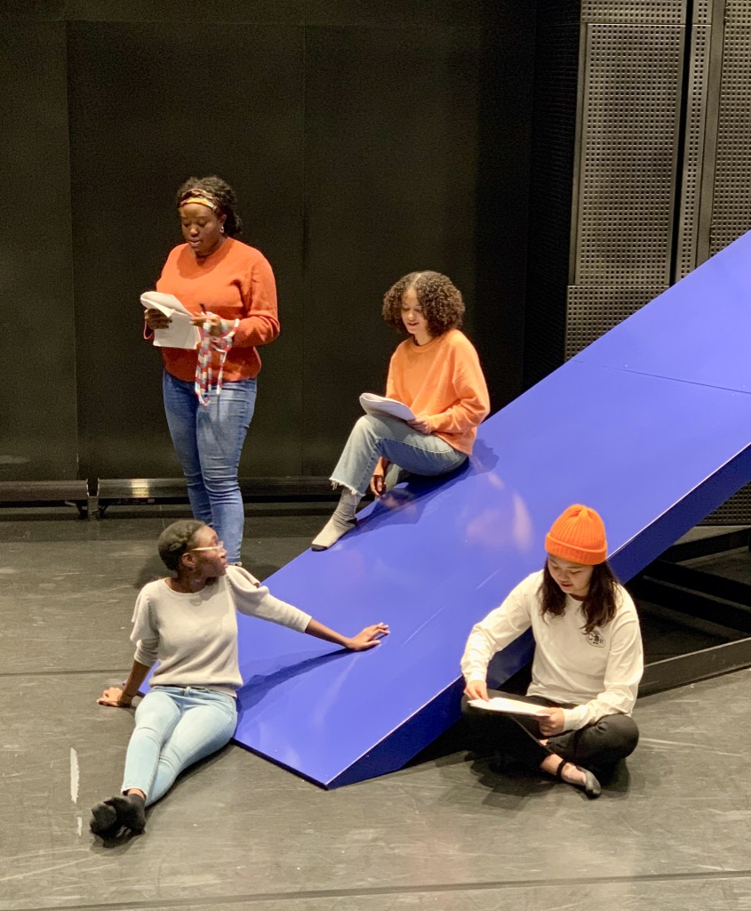

Photo caption: Cast members of Choreopoem in rehearsal
Photos credit: Feyisola Soetan

What: An original choreopoem devised by three Princeton seniors and their cast that addresses the circumstances and issues of black female students at Princeton through seven vignettes developed through workshops, such as innocence, exclusion, privilege, social climbing, colorism and sexism in dating, trauma and healing, and “black girl magic.”
Who: Devised by three Princeton seniors, Feyisola Soetan, who wrote the piece based on her anthropological research; Janelle Spence, who is directing; and Jessica Bailey, who is choreographing, presented by the Lewis Center for the Arts’ Programs in Theater and Music Theater
When: March 8, 9, 13 & 14 at 8 p.m.; March 10 at 7 p.m.
Where: Wallace Theater at Lewis Arts complex on the Princeton University campus
Free and open to the public; advance tickets are recommended, available through University Ticketing at tickets.princeton.edu
For information: https://arts.princeton.edu/events/choreopoem/2019-03-08/

(Princeton, NJ) The Lewis Center for the Arts’ Programs in Theater and Music Theater at Princeton University will present an original Choreopoem, a devised work of original poetry, music, dance and drama exploring the circumstances and issues of black female students at Princeton, on March 8, 9, 13 and 14 at 8 p.m. and March 10 at 7 p.m. at the Wallace Theater at the Lewis Arts complex on the Princeton campus. The production has been created by three Princeton seniors, Feyisola Soetan, who wrote the piece; Janelle Spence, who is directing; and Jessica Bailey, who is choreographing. Choreopoem is free and open to the public, however advance tickets are recommended.

Using anthropological research conducted by Soetan, including participant observation and group discussions within the black community at Princeton, the three seniors devised the new work in collaboration with their cast of nine actors through a series of workshops. Through seven vignettes, the women explore issues such as innocence, exclusion, privilege, social climbing, colorism and sexism in dating, trauma and healing, and “black girl magic.”

The term choreopoem was first coined in 1975 by American writer Ntozake Shange in a description of her work, for colored girls who have considered suicide/when the rainbow is enuf. Shange's departure from traditional poetry and storytelling resulted in a new art form that does not contain specific plot elements or characters but instead focuses on creating an emotional response from the audience.

The three seniors proposed the creation of this original work as a joint thesis in pursuit of certificates in theater or music theater, in addition their majors. Spence wanted to tackle a project with an interplay of movement and light with music, but not a traditional musical theater piece. She also set a goal to develop a piece that would encourage involvement from non-theater students who would bring their own intellectual explorations into the work’s development process. Soetan sought to devise work that drew from her studies in ethnography, playwriting and gender and sexuality studies and her exploration of social-political theory. Bailey was interested in experimentation and a therapeutic and “disruptive” approach to theater-making with a focus on the body. Her interest in including hip-hop dance in a theater piece overlapped with Spence’s interests as well.

Bailey is majoring in sociology and pursuing certificates in African American studies and music theater. The Chicago native has a background in dance and has worked with children through a parks and recreation program and participated in dance competitions in the Midwest. At Princeton, she has been involved with the student dance group BodyHype as assistant artistic director, a choreographer of numerous works, in casting and publicity, and as a mentor for sophomores and juniors. She has also been involved in the Lewis Center’s Program in Dance performing in the Princeton Dance Festival in a piece created by Hearst Choreographer-in-Residence Abby Zbikowski that was developed with the cast. Bailey also served as a choreographer on the concurrently running Lewis Center production of The Odyssey and performed in a workshop production of a new musical, Mad Dreams, written by a member of the theater faculty and the Lewis Center’s resident music director and composer. She particularly notes the influence of courses with Professor of Theater Stacy Wolf including one on the work of Stephen Sondheim and one on race and the American musical theater.

Soetan, who is from Brooklyn, is pursuing certificates in theater and gender and sexuality studies in addition to majoring in anthropology. She has performed in the Lewis Center productions of Zoyka’s Apartment and Eclipsed. She also appeared in a production of a new play by a then-senior in the program, Spring on Fire, which was an instructive experience in how to bring a new work to the stage. Soetan performs with the student dance group diSiac, primarily focusing on hip-hop dance. She has also choreographed African dance for the group. Soetan’s devised work has been inspired by courses in political anthropology, ethnography, the psychology behind prejudice, and playwriting with Nathan Alan Davis.

Spence is from New York City and is a major in the Department of Spanish and Portuguese Languages. She is also pursuing certificates in African American studies, Latin American studies, and music theater. She has been dancing since the age of three and had a background in playwriting, theater and musical theater before arriving at Princeton. She has served in production and stage management roles in Lewis Center productions and has done some Spanish theater work as well. She is artistic director of the student dance group Mas Flow and has performed with the group BodyHype. For this project she notes the influence of the course, “Movements for Diversity in American Theater” taught by Associate Professor of Theater Brian Herrera. Her other senior thesis is on Spanish cinema examining the work of an Afro-Cuban film director and people of color in theater.

The cast of Choreopoem includes seniors Jack Busche, Kirsten Hansen and Madeleine Le Cesne; juniors Ayo Foster-McCray, Carol Lee, Katie Massie, Ozichi Okorom, and Mofope Olarinmoye; and sophomore Yezekiel Williams. Senior Tamia Goodman is stage manager and junior Milan Eldridge is lighting designer and assistant stage manager. Junior Matthew Oakland is sound designer and live accompanist. Nehassaiu de Gannes is serving as faculty advisor and guest artist Tess James is lighting advisor.

Choreopoem is free and open to the public, but advance tickets are recommended and available through University Ticketing at tickets.princeton.edu.

To learn more about this event, the Programs in Theater and Music Theater, and the more than 100 other performances, exhibitions, readings, screenings, concerts, and lectures presented by the Lewis Center, most of them free, visit arts.princeton.edu.

###

