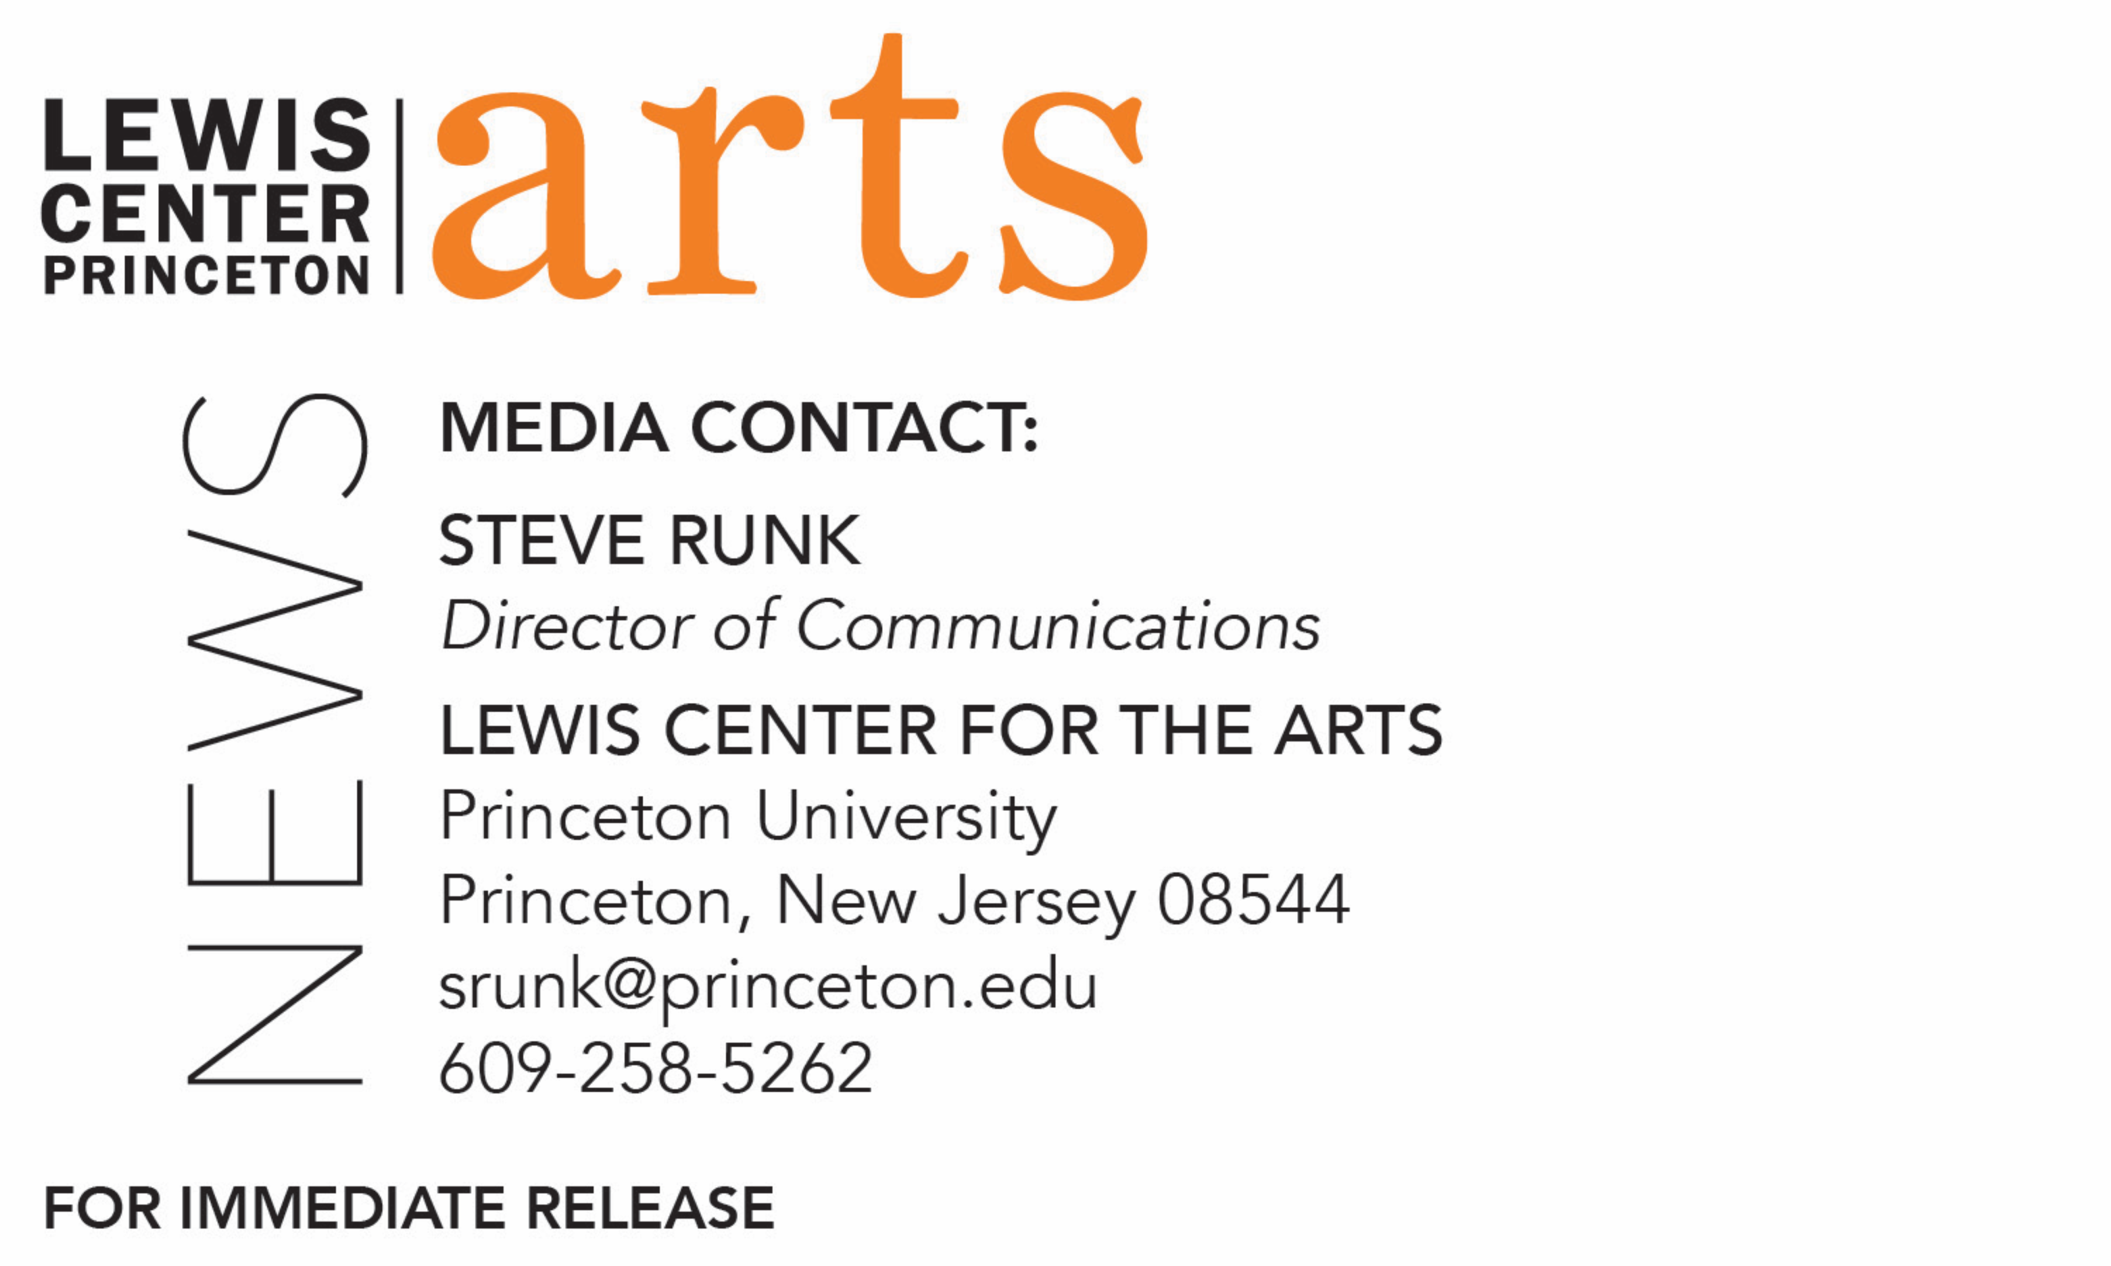

March 19, 2019

Fund for Irish Studies at Princeton University presents
“Irish Emigrant Girls in New York”
Irish Studies Scholar Maureen O’Rourke Murphy delivers
A Lecture at Princeton University

Photo caption 1: Professor Maureen O’Rourke Murphy, past president of the American Conference for Irish Studies, past Chair of the International Association for the Study of Irish Literatures, director of the New York State Great Irish Famine Curriculum Project (2001), and historian of the Irish Hunger Memorial in Battery Park City
Photo credit 1: Courtesy of Maureen O’Rourke Murphy
Photo caption 2: Irish woman immigrant c. 1907 arriving at Ellis Island
Photo credit 2: American Museum of Natural History

What/Who: “Irish Emigrant Girls in New York,” a lecture by professor Maureen O’Rourke Murphy, past president of the American Conference for Irish Studies, past Chair of the International Association for the Study of Irish Literatures, director of the New York State Great Irish Famine Curriculum Project (2001), and historian of the Irish Hunger Memorial in Battery Park City, part of the spring 2019 Fund for Irish Studies event series. Presented by Princeton’s Fund for Irish Studies.
When: Friday, March 29 at 4:30 p.m.
Where: James Stewart Film Theater at 185 Nassau Street on the Princeton University campus
Free and open to the public
For information: https://arts.princeton.edu/events/fund-for-irish-studies-irish-emigrant-girls-in-new-york/

(Princeton, NJ) Historian and scholar Maureen O’Rourke Murphy will present a lecture, entitled “Irish Emigrant Girls in New York,” on Friday, March 29 at 4:30 p.m. in the James Stewart Film Theater at 185 Nassau Street on the Princeton University campus. Part of the 2018-19 Fund for Irish Studies series at Princeton University, this event is free and open to the public.
A unique aspect of Irish migration to the U.S. was the predominance of young women travelling alone. Between 1883 and 1908, 307,823 young Irish women arrived at the Port of New York. Most of the girls who were not met by family or friends were assisted by the Mission of Our Lady of the Rosary for the Protection of Irish Immigrant Girls.
The Mission was the inspiration of Charlotte Grace O’Brien (1845-1909), the daughter of William Smith O’Brien, who was deported to Tasmania for his part in the 1848 Rebellion. Murphy has led the research into the rich archives of this extraordinary institution and her lecture will explore this fascinating story.
Maureen O’Rourke Murphy is the Joseph L. Dionne Professor of Teaching, Leadership and Learning at Hofstra University, in Hempstead, New York. A past president of the American Conference for Irish Studies and a past chair of the International Association for the Study of Irish Literatures, Murphy was one of the six senior editors of the prizewinning Dictionary of Irish Biography published in nine volumes and online by the Royal Irish Academy and Cambridge University Press in 2009. Murphy directed the New York State Great Irish Famine Curriculum Project (2001), which won the National Conference for the Social Studies Excellence Award in 2002; she was also the historian of the Irish Hunger Memorial in Battery Park City. She is currently the historian, with John Ridge, of the Mission of Our Lady of the Rosary/Watson House Project. Murphy edited Irish Literature: A Reader (1987, rev. ed. 2006), with James MacKillop. She also edited Asenath Nicholson’s Annals of the Famine in Ireland (1998) and Ireland’s Welcome to the Stranger (2002). She edited Annie O’Donnell’s Your Fondest Annie in 2005. Her biography Compassionate Stranger: Asenath Nicholson and the Great Irish Famine was published in 2016. Murphy has been awarded honorary degrees by the State University of New York at Cortland and by the National University of Ireland. She received the President of Ireland’s Award for Service in 2015.

The Fund for Irish Studies affords all Princeton students, and the community at large, a wider and deeper sense of the languages, literatures, drama, visual arts, history, politics, and economics not only of Ireland but of “Ireland in the world.” The series is co-produced by the Lewis Center for the Arts and the spring 2019 edition of the series is organized by Fintan O’Toole.

Information about the Fund for Irish Studies series events can be found at http://fis.princeton.edu/. Upcoming events in the current series include:
- Award-winning filmmaker Sinead O’Shea screens her documentary A Mother Brings Her Son to be Shot followed by a discussion with Fintan O’Toole on April 12 at 1 p.m. at Princeton Garden Theatre
- Novelist Anne Enright will present a reading on May 3

The Fund for Irish Studies is generously sponsored by the Durkin Family Trust and the James J. Kerrigan, Jr. ’45 and Margaret M. Kerrigan Fund for Irish Studies.

To learn more about the more than 100 public performances, exhibitions, readings, screenings, concerts, lectures and special events, most of them free, presented each year by the Lewis Center for the Arts, visit arts.princeton.edu.

###

