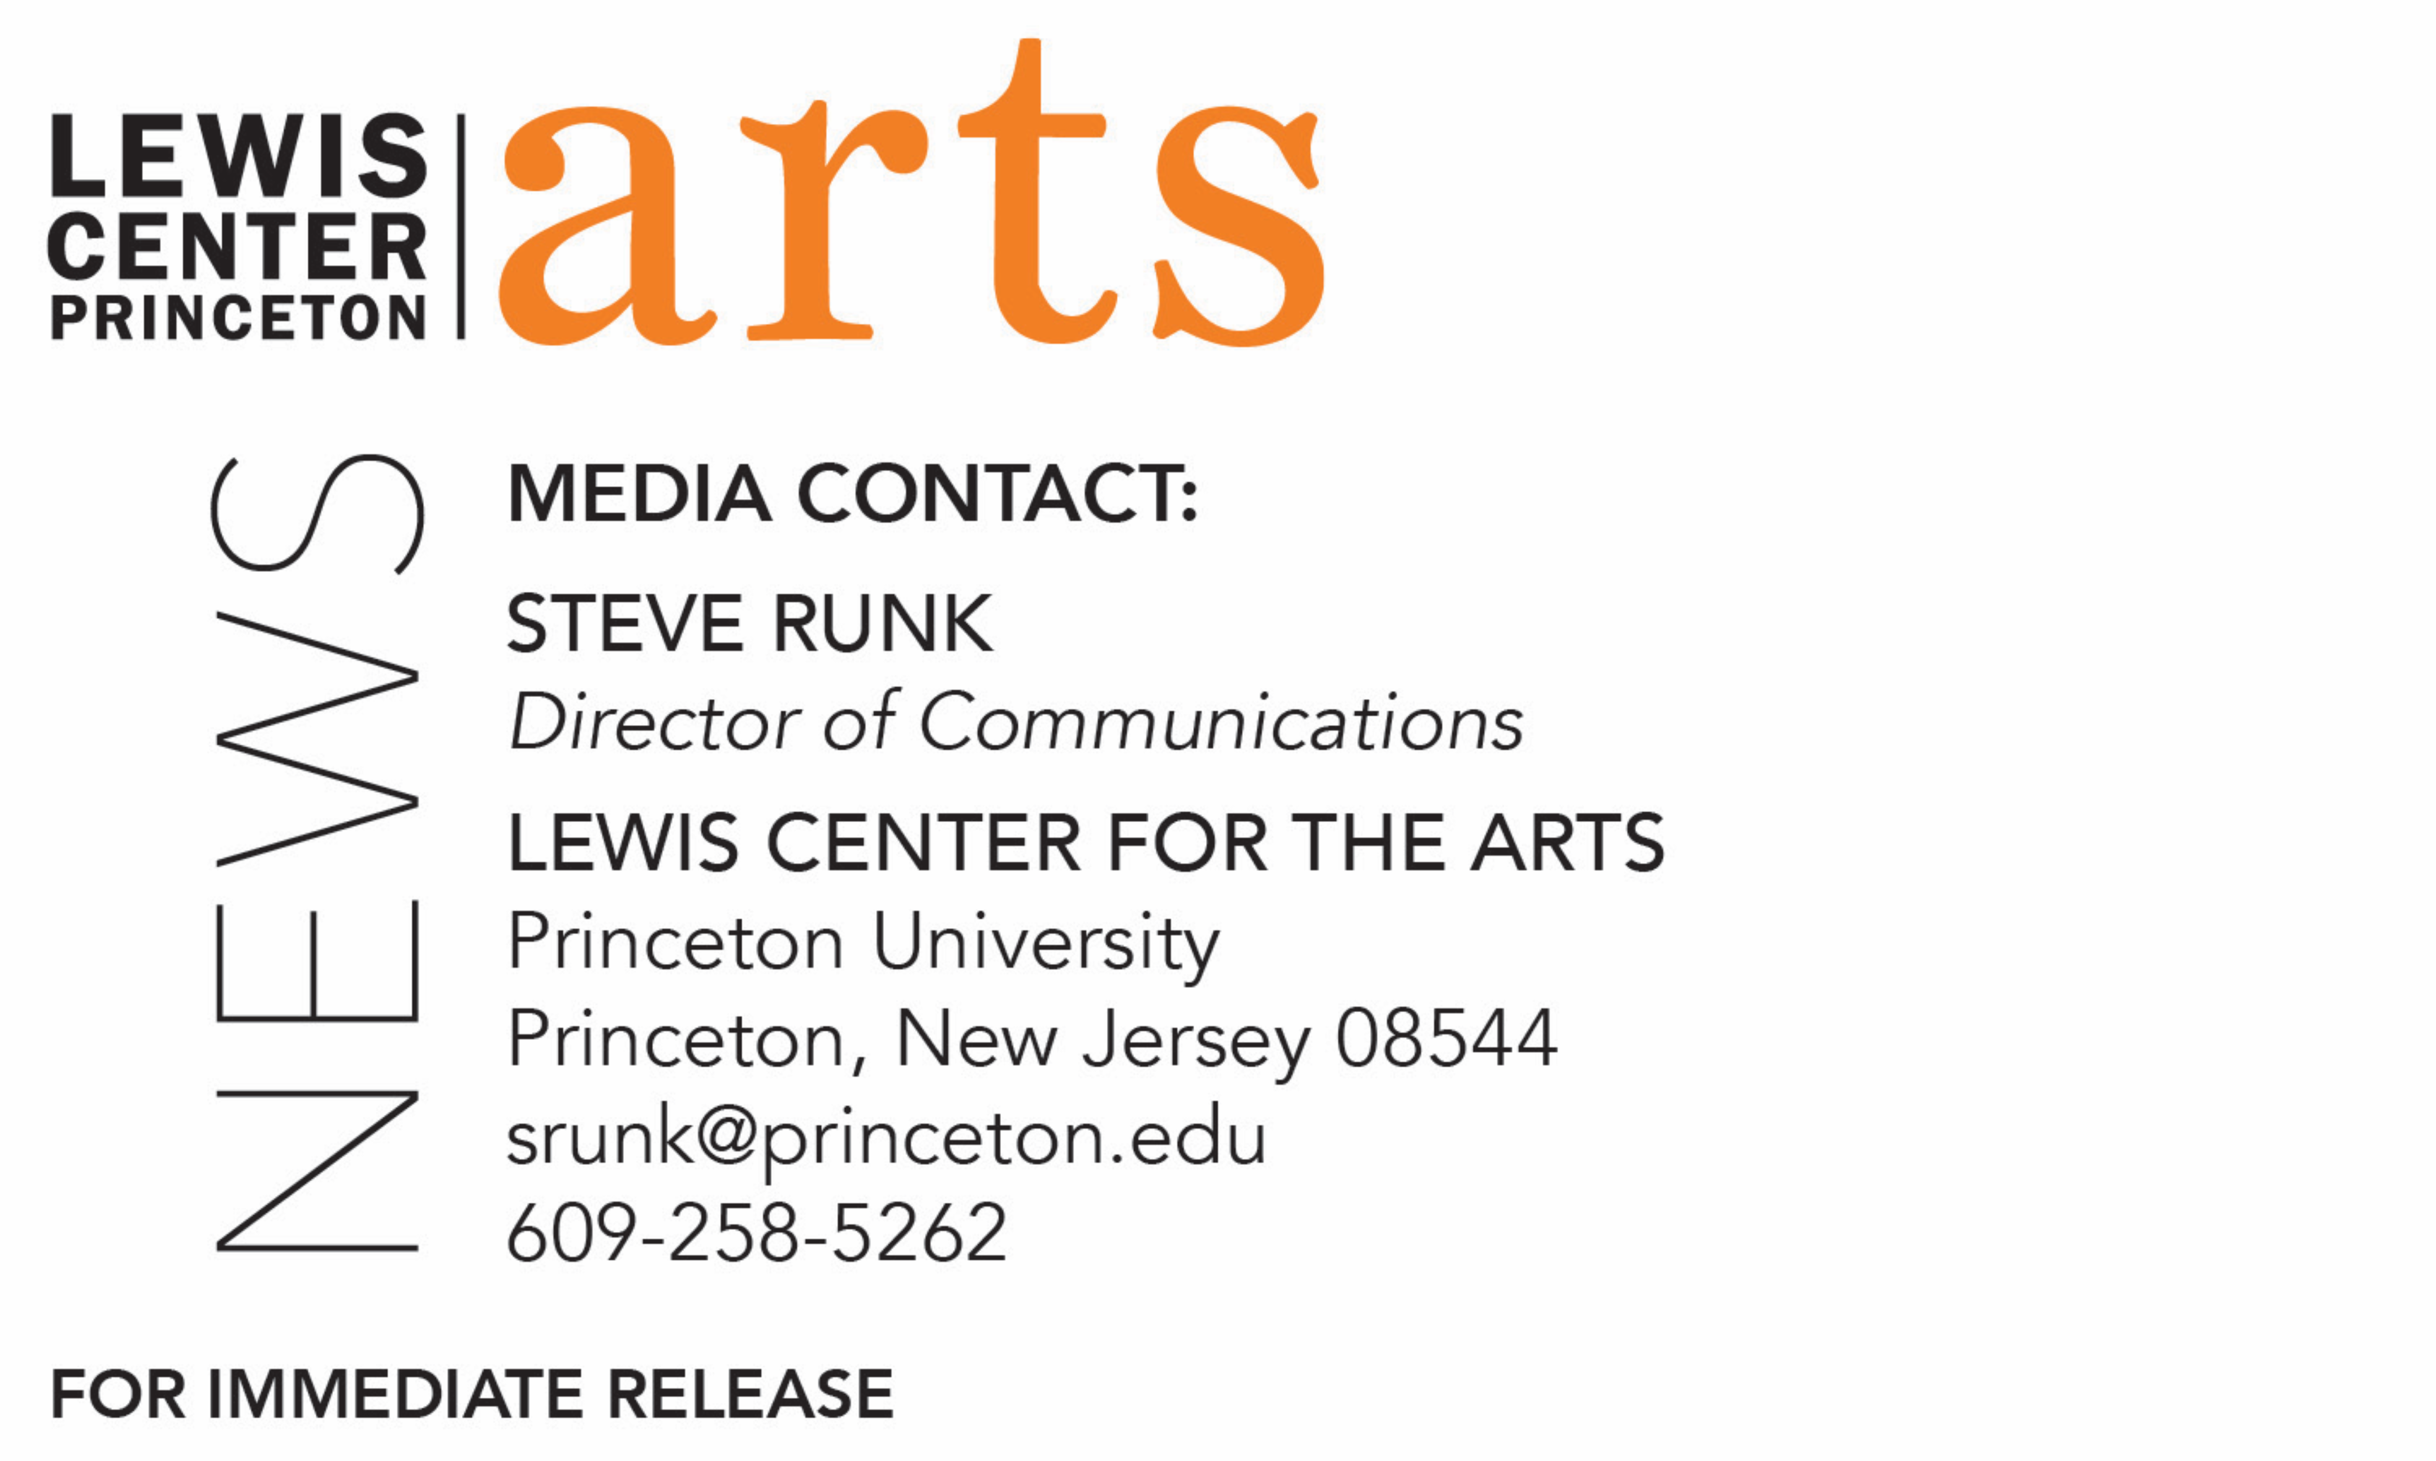

March 28, 2019

Princeton’s Lewis Center for the Arts presents a screening of
The Green Book: Guide to Freedom
Documentary about “The Negro Motorist Green Book” first published in the 1930s is followed by Q&A with the filmmaker at Princeton Garden Theatre

Image credit 1: Smithsonian Networks
Image credit 2: New York Public Library

What/Who: Screening of the documentary The Green Book: Guide to Freedom followed by a Q&A with filmmaker Yoruba Richen and Professor of Visual Arts Su Friedrich. The film takes a deeper look into the real story of Victor H. Green’s “The Negro Motorist Green Book” during the Jim Crow era and beyond. Green, a black postal carrier from Harlem, first published this book in the 1930s that was part travel guide and part survival guide. It helped African-Americans navigate safe passage across America well into the 1960s. Presented in collaboration with Princeton Garden Theatre and co-sponsored by Princeton’s Department of African American Studies.
When: Tuesday, April 2 at 7:30 p.m.
Open to the public; free for Princeton University faculty, students, and staff with Princeton ID and general admission tickets available through the Garden Theatre box office.

(Princeton, NJ) The Lewis Center for the Arts’ Program in Visual Arts in collaboration with Princeton Garden Theatre presents a screening of the documentary The Green Book: Guide to Freedom about the “The Negro Motorist Green Book,” first published in the 1930s. Part travel guide and part survival guide, the book helped African-Americans navigate safe passage across America well into the 1960s. The screening, on Tuesday, April 2 at 7:30 p.m. at the Garden Theatre, 160 Nassau Street, will be followed by a Q&A with the film’s writer/director Yoruba Richen and Professor of Visual Arts Su Friedrich. The event is co-sponsored by Princeton’s Department of African American Studies. Tickets are available through the Garden Theatre box office and website and are free to Princeton University students, faculty and staff with Princeton ID.

Currently also being shown on the Smithsonian channel, the film takes a deeper look into the real story of Victor H. Green’s “The Negro Motorist Green Book.” In the 1930s, Green, a black postal carrier from Harlem, began publishing this annual guide in the era of Jim Crow laws, when open and often legally prescribed discrimination against African Americans and other non-whites was widespread. These travelers, often journeying by automobile to avoid other discriminatory practices on public transportation, faced a variety of dangers and inconveniences along the road, from refusal of food and lodging to arbitrary arrest. In response, Green wrote his guide to services and places relatively friendly to African Americans, eventually expanding its coverage from the New York area to much of North America. The film explores some of the segregated nation’s safe havens and notorious “sundown towns” and relates stories of struggle and indignity as well as opportunity and triumph. The 2019 Academy Award-winning film Green Book is also a reference to Green’s publication.

Andrew Ricketts of BET (Black Entertainment Television) notes, “The Green Book: Guide to Freedom is a timely film on Green’s handbook of the same name. His guide listed over 9,500 venues where Black vacationers were welcome. But it’s only an afterthought in the fictional film that bears its title. Although that film won Best Picture and Best Supporting Actor, it glosses over the significance of “The Green Book” in favor of narrowing the focus to the prevalence of White ignorance. That curious omission makes the origin story of “The Green Book” even more crucial. Director Yoruba Richen reveals it in a documentary that is equal parts proud and tragic.”

Yoruba Richen, the film’s writer/director, is a documentary filmmaker whose work has been featured on PBS, New York Times Op Doc, Frontline Digital, New York Magazine’s The Cut, The Atlantic, and Field of Vision. Her feature documentary, The New Black won multiple festival awards and was nominated for an NAACP Image Award and a GLAAD Media Award. Her previous film Promised Land, won the Fledgling Fund award for social issue documentary, and she won a Clio award for her short film about the Grammy-nominated singer Andra Day. She has also won the Creative Promise Award at Tribeca All Access and was a Sundance Producers Fellow. Richen is a Fulbright fellow, a Guggenheim fellow and a 2016 recipient of the Chicken & Egg Breakthrough Filmmaker Award. She was chosen for The Root 100 list of the most influential African Americans 45 and under, recognizing her as a leader whose “work from the past year is breaking down barriers and paving the way for the next generation.” She is a lecturer and director of the documentary program at the City University of New York’s Craig Newmark Graduate School of Journalism.

Su Friedrich has produced and directed twenty-three 16mm films and digital videos, and with one exception is the writer, director, cinematographer, sound recordist and editor of all her films. Friedrich's films have won many awards, including the Best Narrative Film Award at the Athens International Film Festival, the Outstanding Documentary Feature at Outfest in Los Angeles, the Special Jury Award at the New York Gay & Lesbian Film Festival, the Grand Prix at the Melbourne Film Festival, the Golden Gate Award at the San Francisco Film Festival, and the Best Experimental Narrative Award at the Atlanta Film Festival. Her work is widely screened in the United States, Canada and Europe and has been the subject of retrospectives at the Museum of Modern Art, the Whitney Museum of American Art, the Rotterdam International Film Festival, The London Lesbian and Gay Film Festival, The Stadtkino in Vienna, the Pacific Cinematheque in Vancouver, and the National Film Theater in London. In 2016, her film Sink or Swim (1990) was selected for inclusion in the National Film Registry of The Library of Congress. Her work is in the collection of the Museum of Modern Art, the Art Institute of Chicago, the Royal Film Archive of Belgium, the Centre Pompidou in Paris, the National Library of Australia, as well as many university libraries.

Princeton Garden Theatre maintains an ongoing collaborative relationship with the Lewis Center for the Arts and other departments throughout the University. The theater presents independent, foreign, and classic films and special film-related programming and in 2017 was named by NJ.com as The Best Movie Theater in New Jersey.
To learn more about this event, the Program in Visual Arts, and the more than 100 other performances, exhibitions, readings, screenings and lectures presented each year at the Lewis Center visit arts.princeton.edu.

###

