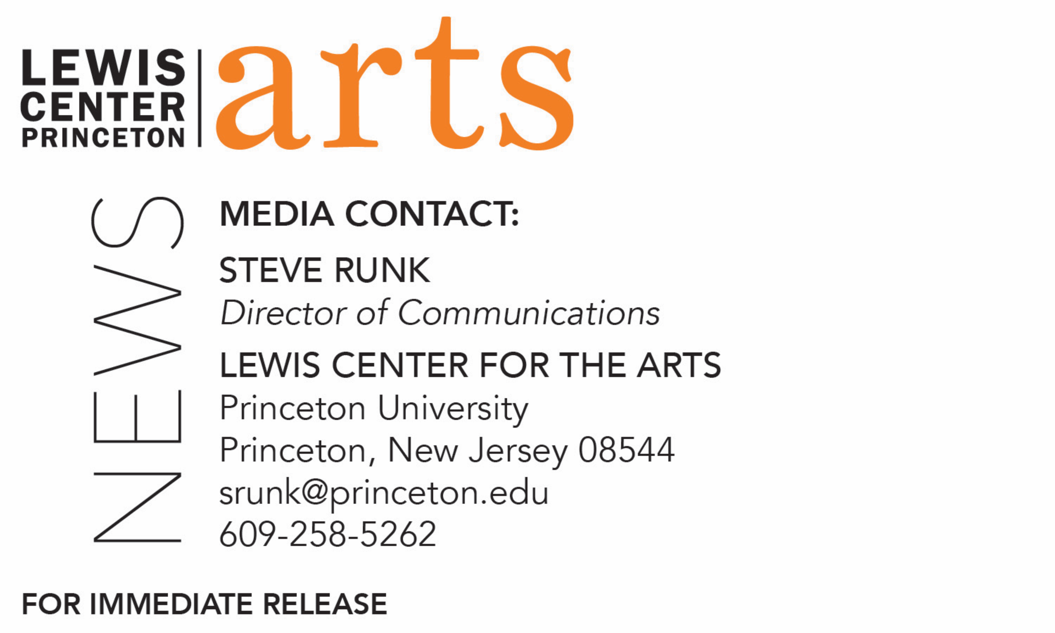

March 18, 2019

Princeton’s Lewis Center for the Arts presents
Edited by: Women Film Editors
A new website highlighting the untold history of women film editors is celebrated with a multimedia talk at Princeton Garden Theatre

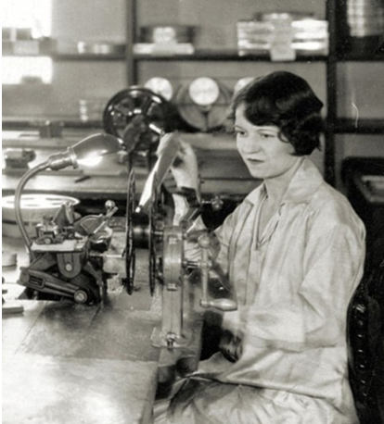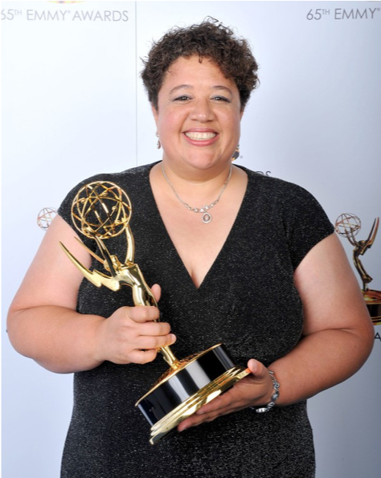

Photos caption 1: Anne Bauchens (1882 – 1967) was the primary editor of Cecile B. DeMille’s films for 40 years. She edited 41 films for DeMille and 20 for other directors. In 1934 the Academy Award for Film Editing was created and Bauchens received a nomination for editing Cleopatra. Six years later she won for North West Mounted Police, making her the first woman to win the Oscar in that category. Bauchens also received Oscar nominations for The Ten Commandments and The Greatest Show on Earth.
Photo credit 1: © 2016 Cecil B. De Mille Foundation
Photo caption 2: Kelley Dixon who began professionally editing in 1990, as an assistant editor on feature films and TV series including Good Will Hunting, Reservoir Dogs, and Without a Trace). As primary editor, she is known for her work between 2008-2017 on several noteworthy series, including Better Call Saul, Breaking Bad, The Walking Dead, and Shameless. Dixon won an Emmy for Outstanding Single-Camera Picture Editing for Breaking Bad and has been nominated 20 other times for various editing awards.
Photo credit 2: © Academy of Television Arts & Science

What/Who: Filmmaker and Professor of Visual Arts Su Friedrich presents a multimedia talk about her latest project, the newly launched website “Edited by” that surveys 139 women film editors who invented, developed, fine-tuned and revolutionized the art of film editing.
When: Tuesday, March 26 at 7:30 p.m.
Where: Princeton Garden Theatre at 160 Nassau St., Princeton
Tickets: and open to the public

(Princeton, NJ) Filmmaker and Professor of Visual Arts Su Friedrich will present a multimedia talk about her latest project and newly launched website “Edited by,” which surveys 139 women film editors who invented, developed, and revolutionized the art of film editing. Presented by the Lewis Center for the Arts’ Program in Visual Arts at Princeton University, the talk will take place at 7:30 p.m. at the Princeton Garden Theatre at 160 Nassau Street in Princeton. Tickets for this event are free with Princeton ID, free for Garden Theatre members, and general admission tickets are available at the Garden Theatre box office.

Friedrich’s development of the website began a year ago when she read a chapter in a textbook about major milestones in film editing and found that the director of each film was named, but not the editor. This led her to investigate who those editors were, and to discover that almost half of them were women. Further investigation found that there was no book or website resource that detailed the fact that women editors were central players in the evolving film industry and were instrumental in the development of the technologies, practices and tools that revolutionized the art of film editing.

As films moved from long single shots to ones with multiple shots, as pioneered by directors such as Alice Guy Blaché, editing those scenes together birthed the profession of editor. The early professionals who did this work were “cutters” and women were often relegated to this task because it was viewed as akin to the skills of sewing and knitting. When sound came to film, it was considered “too technical” for women, but in fact the first sound films from all the major Hollywood studios were edited by women, including Blanche Sewell at MGM, Viola Lawrence at Goldwyn, and Jane Loring at Paramount. Women have continued to be a force in film editing with such recognized luminaries as Dede Allen, Anne V. Coates, and three-time Oscar winner Thelma Schoonmaker.

Friedrich notes that editing in general – whether done by men or women – is not highly visible, stating that, “The relative invisibility of editors—whether male or female—in contrast to the attention paid to writers, directors, cinematographers and composers, has been unwarranted and unjust. Editors make an essential contribution to the success or failure of a film. It’s time to stop imagining that ‘it’s really the director’ who does the editing.”

Some of the most well-known films were edited by women including The Wizard of Oz, Singin’ in the Rain, Lawrence of Arabia, Breathless, Star Wars, Persona, The 400 Blows, Dog Day Afternoon, Jaws, One Flew Over the Cuckoo’s Nest, The Elephant Man, Daughters of the Dust, Pulp Fiction, Mad Max and Moonlight.

The website, at womenfilmeditors.princeton.edu, represents the field through a selection of 64 women editors and an additional group of 75 “filmmakers who edit” and was created with the hope that others will continue to research, promote and honor this most essential aspect of the art of filmmaking. In addition to information on the editors, quotes by the editors about their work, and posters of films they each edited, the website has an extensive appendix with carefully selected links to articles about, and interviews with, each editor. One can also view and download Edited by: The Companion Film, a 75-minute film made up of one-minute clips from films edited by each of these women editors. Friedrich notes that the site is “not meant to be comprehensive, as no site could contain the names of all the great, hard-working editors since the advent of cinema and from around the world.” The project is hosted by Princeton University, where Friedrich has taught film production since 1998.

During the event on March 26 Friedrich will show the 75-minute film, present the website, and talk about the art of film editing and the women who were part of its genesis as a profession.

Friedrich’s work on the website was supported through Princeton’s University’s Committee on Research in the Humanities and Social Sciences. The website framework and all the data entry was done by Sorat Tungkasiri from the University’s Digital Learning Lab at the McGraw Center for Teaching and Learning. Working with Friedrich on assembling the comprehensive appendix were four research assistants. Three of them, Lydia Cornett, Charlotte Maher Levy and Jane Pritchard, are recent Princeton alumni who studied film with Friedrich and are currently working in the film and television industry and in education. The fourth, Lili Dekker, is a recent graduate of New York University's Gallatin School for Individualized Study and a documentary filmmaker.

Friedrich has produced and directed twenty-three 16mm films and digital videos, including I Cannot Tell You How I Feel (2016), Queen Takes Pawn (2013), Gut Renovation (2012), From the Ground Up (2007), Seeing Red (2005), The Head of a Pin (2004), The Odds of Recovery (2002), Hide and Seek (1996), Rules of the Road (1993), First Comes Love (1991), Sink or Swim (1990), Damned If You Don't (1987), The Ties That Bind (1984), Gently Down the Stream (1981), and Cool Hands, Warm Heart (1979). With the exception of Hide and Seek, Friedrich is the writer, director, cinematographer, sound recordist and editor of all her films. Friedrich's films have won many awards, including the Best Narrative Film Award at the Athens International Film Festival, the Outstanding Documentary Feature at Outfest in Los Angeles, the Special Jury Award at the New York Gay & Lesbian Film Festival, the Grand Prix at the Melbourne Film Festival, the Golden Gate Award at the San Francisco Film Festival, and the Best Experimental Narrative Award at the Atlanta Film Festival. Her work is widely screened in the United States, Canada and Europe and has been the subject of retrospectives at the Museum of Modern Art, the Whitney Museum of American Art, the Rotterdam International Film Festival, The London Lesbian and Gay Film Festival, The Stadtkino in Vienna, the Pacific Cinematheque in Vancouver, and the National Film Theater in London. In 2016, her film Sink or Swim (1990) was selected for inclusion in the National Film Registry of The Library of Congress. Friedrich is the recipient of the Alpert Award in the Arts (1996), an Independent Television Service production grant (1994), an NEA Fellowship (1994), a Rockefeller Foundation Fellowship (1990), a Guggenheim Foundation Fellowship (1989), and a DAAD grant as artist-in-residence in Berlin (1984), as well as multiple grants from the New York State Council on the Arts, the New York Foundation for the Arts, and the Jerome Foundation. Her work is in the collection of the Museum of Modern Art, the Art Institute of Chicago, the Royal Film Archive of Belgium, the Centre Pompidou in Paris, the National Library of Australia, as well as many university libraries. The films are distributed by The Museum of Modern Art, Outcast Films, Canyon Cinema, The Canadian Filmmaker's Distribution Center, Light Cone in Paris and the Freunde der Deutschen Kinemathek in Berlin. More on her work can be found at www.sufriedrich.com.

Princeton Garden Theatre, operated by the nonprofit organization Renew Theaters, maintains an ongoing collaborative relationship with the Lewis Center for the Arts and other departments throughout the University. The theater presents independent, foreign, and classic films and special film-related programming and in 2017 was named by NJ.com as The Best Movie Theater in New Jersey.
To learn more about this event, the Program in Visual Arts, and the more than 100 other performances, exhibitions, readings, screenings and lectures presented each year at the Lewis Center visit arts.princeton.edu.

###

