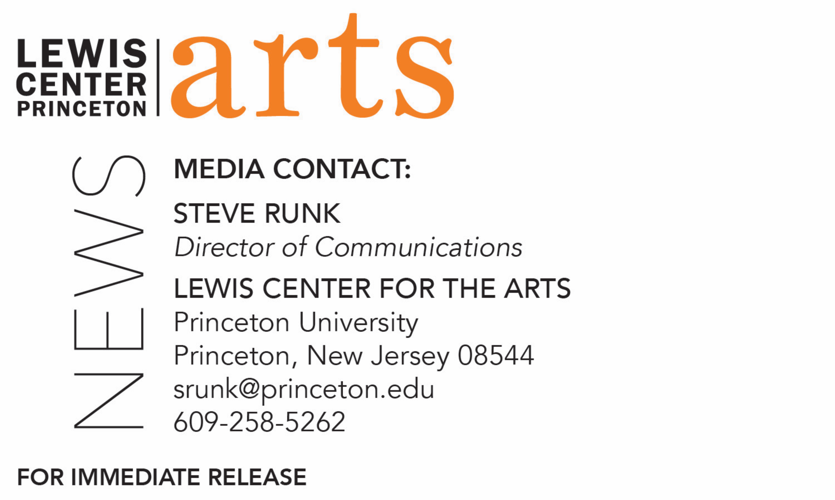

March 11, 2019

Princeton’s Visual Arts Program presents
a series of exhibitions of new work by seniors
Solo and group shows by visual arts majors and certificate students run through early May in three gallery spaces around campus

For images https://drive.google.com/file/d/1nOyjtbtGII7eEe6lFN8HwmzudKmYJazg/view?usp=drive_web
Photos caption 1 and 2: Two photos by senior YuanYuan Zhao for her show
Elephant. The first is titled “Silent Drama, 2018”; the second is titled “梦醒时分 (The
Moment When You Wake), 2018”
Photo caption 3 and 4: Collages of prints by senior Kyra Gregory for her show The
Lady’s Room
Photo caption 5 and 6: Two photos by senior Sanneh for their show Holy. The first is
titled “Eve in Brooklyn, 2018;” the second is titled “black sun across my eyes, I’m blind”
Photo credit: Courtesy of the artists

What/Who: A series of 13 exhibitions by seniors in Princeton University’s
Program in Visual Arts
When: Through May 3
Where: Hurley Gallery and Forum at Lewis Arts complex, Lucas Gallery and Hagan Studio at 185 Nassau St., on the Princeton University campus
Free and open to the public
For information: arts.princeton.edu/vis-seniors-2019

(Princeton, NJ) The Program in Visual Arts at Princeton University’s Lewis Center for the Arts presents a series of 9 solo and 4 group exhibitions by seniors in the Program through May 3 in galleries on the Princeton campus.

The series of exhibitions, which will range widely in media and ideas explored, are among the requirements of seniors in the program who are either majoring in visual arts through a collaborative program of the Lewis Center and the Department of Art and Archaeology or are majoring in another area and pursuing a certificate in visual arts. The seniors are required to create a body of work generally organized around a central idea or area of investigation and present that work in a cohesive exhibition, with accompanying mentorship and critiques by their advisors and other faculty in the program. Each exhibition includes a reception where guests can meet and speak with the artist.

“This year’s seniors have created a particularly eclectic and wide-ranging body of work,” notes Martha Friedman, director of the Program in Visual Arts. “Running through May 3, one can stop by the Hurley, Hagan, or Lucas galleries on almost any given day and find themselves exposed to the unique voice of an emerging artist. By visiting the galleries periodically during the thesis exhibitions, one will experience a broad spectrum of perspectives, experiencing a snapshot of our current historical moment viewed through an array of vantage points that only the freshest survey shows can offer.”

Although its title suggests otherwise, Holy, a show by Sanneh, is not a show about religion. Rather, Sanneh (who goes by a single name and uses the pronoun “they”) notes that religion is used as a tool to get closer to the impossible and to articulate the essence of the holy and sacred, an essence that demands reverence and attention from the viewer and is often dissociated from black people. Sanneh explains that through alluding to the religious and situating subjects in a decontextualized plane, their work maps this inarticulable essence onto their black subjects, simply showing: this is what it can mean to be black. Holy will be presented in Hurley Gallery on March 11 through 15.

Another show, Elephant, by Yuanyuan Zhao, consists of photographs that are derived from poems, folktales, and myths. Populated by intimate family members, these photographs probe different aspects of East Asian identities. In many of her pieces, the subjects are Zhao’s family members and friends. Zhao notes that these subjects are not photographed to emphasize the relationship between the photographer and the photographed, but rather, use their own characters to develop and represent different social roles in their community. The show also features clashing details and combining different patterns. In doing so, Zhao juxtaposes the epic with the mundane world. Zhao explains that under the dramatic façade, which creates an immediate, externally perceived drama, these clashing details — or the elephant in Zhao’s world — aim to create an internal turbulence for viewers. Her exhibition will be presented in the Hurley Gallery on April 1 through 5.

A show by Kyra Gregory, entitled The Lady’s Room, focuses around a bathroom in the house where she grew up which she shared with her mother and older sister. Gregory notes that the bathroom, deemed "The Lady's Room" by her mother through a light switch cover she made when Gregory’s family moved into the house, creates an environment of traditional hyper-femininity through its decoration. Gregory explains that she will be using collage and woodblock relief printing as modes of deconstruction and subsequent reconstruction of The Lady's Room and thus the definitions of womanhood, gender, and sexuality that live within it. The show will feature a series of large-scale collages made of drawings, prints, and photographs alongside other works that live within the theoretical space of The Lady's Room, prioritizing the experiences of queer and trans individuals. Her exhibition will be presented in the Lucas Gallery on April 22 through 26.

The series of 13 exhibitions will primarily be presented at the Lucas Gallery and Hagan Studio at 185 Nassau Street and the Hurley Gallery at the Lewis Arts complex. With the move in 2017 of the Lewis Center’s Programs in Dance, Theater, Music Theater and the Princeton Atelier from 185 Nassau Street to the new arts complex, the Program in Visual Arts has expanded at 185 Nassau with the former Hagan Dance Studio converted to a gallery where several of the exhibitions will be presented. The Hurley Gallery at the arts complex offers a new state-of-the-art exhibition space.

The Lucas Gallery and Hagan Studio are open Monday through Saturday from 9 a.m. to 5 p.m. with access from the Williams Street parking lot entrance. The Hurley Gallery and spaces at the Lewis Arts complex are open daily 10 a.m. to 8:30 p.m.

The Program in Visual Arts offers studio courses that emphasize direct, hands-on art making under the guidance of practicing visual arts professionals. In order to develop their work, students are also given access to state-of-the-art technical, analog, and digital labs, including a fully functional letterpress studio. New specialized studio spaces are under construction this year. Students accepted into the program can pursue a degree or certificate in visual arts.

On May 11 through June 5 a group exhibition of work by all the seniors in the program, the Senior Show, will be presented in the Hurley Gallery. Also in early May, the work of students in the program focusing on filmmaking will be presented in a series of screenings.

To learn more about this event, the Program in Visual Arts, and the more than 100 performances, exhibitions, readings, screenings, concerts and lectures offered each year at the Lewis Center, most of them free, visit arts.princeton.edu.

###

