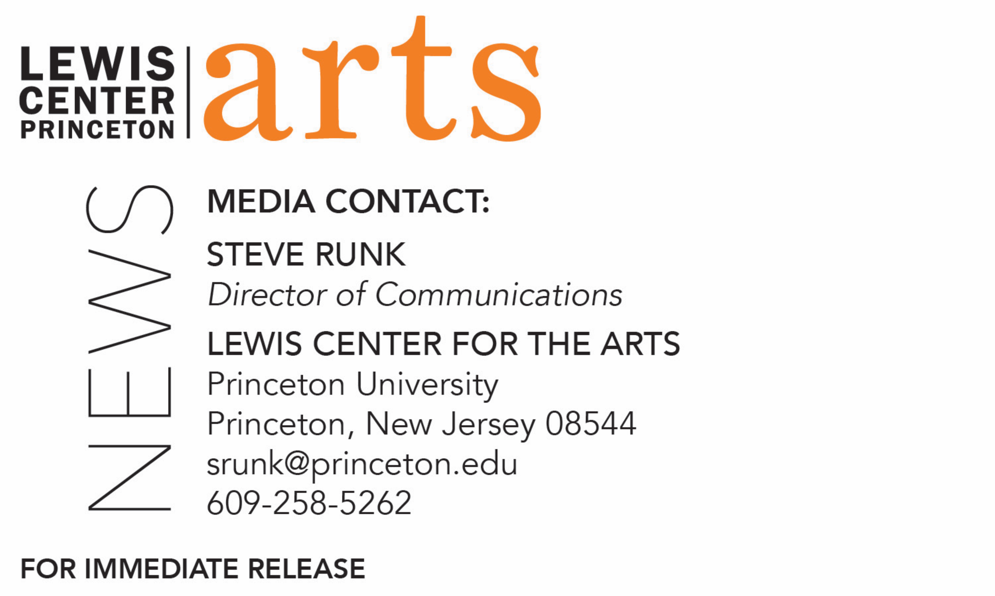

April 25, 2019

Lewis Center for the Arts presents

Readings of New Work by Students in the Creative Writing Program

What: Three Student Readings - Althea Ward Clark W’21 Reading Series

When: Wednesday, May 1 at 5:00 p.m.

Where: Chancellor Green Rotunda in East Pyne Hall on the Princeton University campus
Who: Select students in the Lewis Center for the Arts’ Program in Creative Writing workshops read from recent work they created during the spring semester in fiction, poetry, screenwriting and literary translation.
Free and open to the public

When: Monday, May 6 at 4:30 p.m.

Where: Prospect House on the Princeton University Campus
Who: Seniors in Princeton’s Program in Creative Writing read from the screenplays, collections of poems, or translations written as their senior theses under mentorship of professional writers on the faculty.
Free and open to the public

When: Wednesday, May 8 at 4:30 p.m.

Where: Prospect House on the Princeton University Campus
Who: Seniors in Princeton’s Program in Creative Writing read from the novels or collections of short stories written as their senior theses under mentorship of professional writers on the faculty.
Free and open to the public

(Princeton, NJ) Students in the Lewis Center for the Arts’ world-renowned Program in Creative Writing at Princeton University will present new work in a series of readings. On May 1 at 5:00 p.m. at Chancellor Green Rotunda in East Pyne Hall on the University campus, selected students from spring workshops in fiction, poetry, screenwriting, and literary translation will read from work they have completed during the past semester. At two additional readings, seniors completing a certificate in the Program will read from their thesis work, which they completed over the course of the 2018-20198 academic year. On May 6 at 4:30 p.m. in Prospect House, senior thesis students will read from their recent work in poetry, screenwriting, and translation; on May 8 at 4:30 p.m., also in Prospect House, seniors will read from their recent work in fiction. The readings, part of the Program in Creative Writing’s Althea Ward Clark W’21 Reading Series at the Lewis Center for the Arts, are free and open to the public.

Through the Program, students can earn a certificate in creative writing in addition to their degree in a major. They have the opportunity to pursue original work in fiction, poetry, screenwriting, and translation under the guidance of practicing, award-winning writers, including Aleksandar Hemon, Jhumpa Lahiri, Yiyun Li, Paul Muldoon, Kirstin Valdez Quade, James Richardson, Tracy K. Smith, Susan Wheeler, and a number of distinguished lecturers. Small workshop courses, averaging eight to ten students, provide intensive feedback and instruction for both beginning and advanced writers. Each year, 20 to 30 seniors work individually with a member of the faculty on a creative writing thesis, such as a novel, screenplay, or a collection of short stories, poems, or translations.

On May 6, seniors who will be presenting work in poetry, with their major, are Christian Bischoff (History), Sena Cebeci (Politics), Nicolette D’Angelo (Classics), Jona Herzog-Arbeitman (Physics), Madeleine Le Cesne (Anthropology), Li Ruting (Woodrow Wilson School of Public and International Affairs), Crystal Liu (Philosophy), Remi Shaull-Thompson (English), and Annabelle Tseng (French). Helena Van Brande (Comparative Literature) will read from her work in translation, and reading from their work in screenwriting are Simi Prasad (Psychology), Elias Stern (Economics), and Max West (English).

Seniors presenting work in fiction on May 8, with their major, are Mohammad Adnan (History), David Exume (Sociology), Sonia Joseph (Neuroscience), Lian Kirit Lemperis (Molecular Biology), Kandance Rosser (English), Jordan Salama (Spanish and Protuguese), Iris Samuels (Politics), Paul Schorin (English), James Welch (Slavic Languages and Literatures), Sebastian Witherspoon (Philosophy), and Joanna Zhang (Ecology and Evolutionary Biology).

Graduates of the Program include such well-known and diverse writers as Jonathan Ames ’87, Jane Hirshfield ’73, Jonathan Safran Foer ’99, Monica Youn ’93, and Jodi Picoult ’87.

The Althea Ward Clark W’21 Reading Series annually brings a number of distinguished writers to campus to read and discuss their work, in addition to readings by students. Guest writers over the past academic year included Li-Young Lee, Lynn Nottage, Robin Coste Lewis, Sheila Heti,
Guy Maddin, Caryl Phillips, Layli Long Soldier, Jacob Shores-Argüello, Frank Bidart, Yuri Herrera, Han Kang, and Ngũgĩ wa Thiong’o. All readings are free and open to the public.

To learn more about the Program in Creative Writing, the reading series, and the more than 100 performances, exhibitions, readings, screenings, concerts and lectures offered each year by the Lewis Center for the Arts, most of them free, visit arts.princeton.edu.

###

