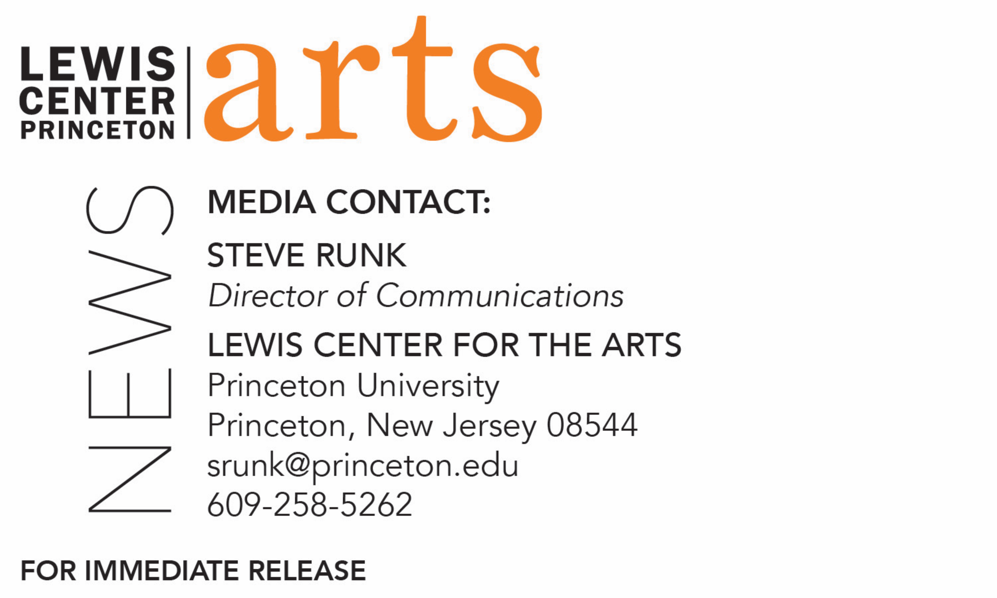
April 8, 2019

Lewis Center for the Arts’ Program in Creative Writing presents
A Reading by novelist Han Kang and novelist/playwright Ngũgĩ wa Thiong’o
Next in Althea Ward Clark W’21 Reading Series at Princeton University

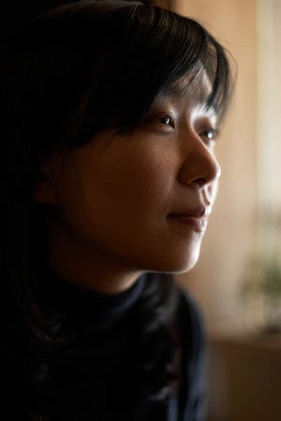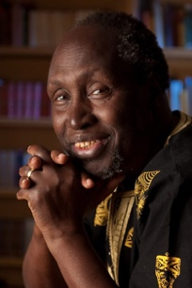
Photo caption/credit 1: South Korean novelist Han Kang, photo by Park Jaehong
Photo caption/credit 2: Novelist/playwright Ngũgĩ wa Thiong’o, photo courtesy of Ngũgĩ wa Thiong’o

Who/What: Reading by Man Booker International Prize-winning South Korean novelist Han Kang and award-winning Kenyan-born novelist and playwright Ngũgĩ wa Thiong’o, next in the 2018-19 Althea Ward Clark W’21 Reading Series presented by the Lewis Center for the Arts’ Program in Creative Writing at Princeton University.
When: Wednesday, April 17, at 7:30 p.m.
Where: Wallace Theater at Lewis Arts complex on the Princeton University campus
Free and open to the public

(Princeton, N.J.) On Wednesday, April 17, two international award-winning writers, novelist Han Kang and novelist and playwright Ngũgĩ wa Thiong’o, will read from their work as part of the Althea Ward Clark W’21 Reading Series of the Lewis Center for the Arts’ Program in Creative Writing. The reading, beginning at 7:30 p.m. in the Wallace Theater at the Lewis Arts complex on the Princeton University campus, is free and open to the public.

Han Kang was born in Gwangju, South Korea, and moved to Seoul at the age of ten. She studied Korean literature at Yonsei University. Her writing has won the Yi Sang Literary Prize, the Today’s Young Artist Award, and the Korean Literature Novel Award. The Vegetarian, her first novel to be translated into English, was published by Portobello Books in 2015 and won the 2016 Man Booker International Prize. She is also the author of Human Acts (Portobello, 2016) and The White Book (Portobello, 2017). She is based in Seoul.

Kang will be introduced by Aleksandar Hemon, Professor of Creative Writing at Princeton and author of The Lazarus Project, which was a finalist for the 2008 National Book Award and National Book Critics Circle Award.

Ngũgĩ wa Thiong’o was born in Kenya in 1938. His first major play, The Black Hermit, premiered at the National Theatre in Kampala, Uganda, in 1962, as part of the celebration of Uganda’s Independence. In 2006 he published what some have described as his crowning achievement, Wizard of the Crow, an English translation of the Gikuyu language novel, Murogi wa Kagogo. He is author of numerous short stories, plays, novels, and other works which have been translated into more than thirty languages and continue to be the subject of books, critical monographs, and dissertations. He has served as editor for literary journals including Penpoint, Zuka, Ghala, and Mutiiri. His honors include the 2001 Nonino International Prize for Literature and eleven honorary doctorates. He is currently Distinguished Professor of English and Comparative Literature at the University of California, Irvine.

Ngũgĩ will be introduced by Susan Wheeler, Professor of Creative Writing at Princeton and author of a novel, Record Palace, and six books of poetry, Bag ‘o’ Diamonds, Smokes, Source Codes, Ledger, Assorted Poems and Meme, which was shortlisted for a National Book Award.

The Lewis Center’s Program in Creative Writing annually presents the Althea Ward Clark W’21 Reading Series, which provides an opportunity for students, as well as all in the greater Princeton region, to hear and meet the best contemporary writers. All readings are at 7:30 p.m. in venues in the Lewis Arts complex and are free and open to the public.

The series will also include readings in May of new work by selected students in spring creative writing courses and readings by seniors in the Program from the novels, collections of short stories, poems or translations, or screenplays written as their senior theses under mentorship by the Creative Writing faculty.

To learn more about this event, the Program in Creative Writing, and the more than 100 other performances, exhibitions, readings, screenings, concerts, and lectures presented each year by the Lewis Center, most of them free, visit arts.princeton.edu.

###

