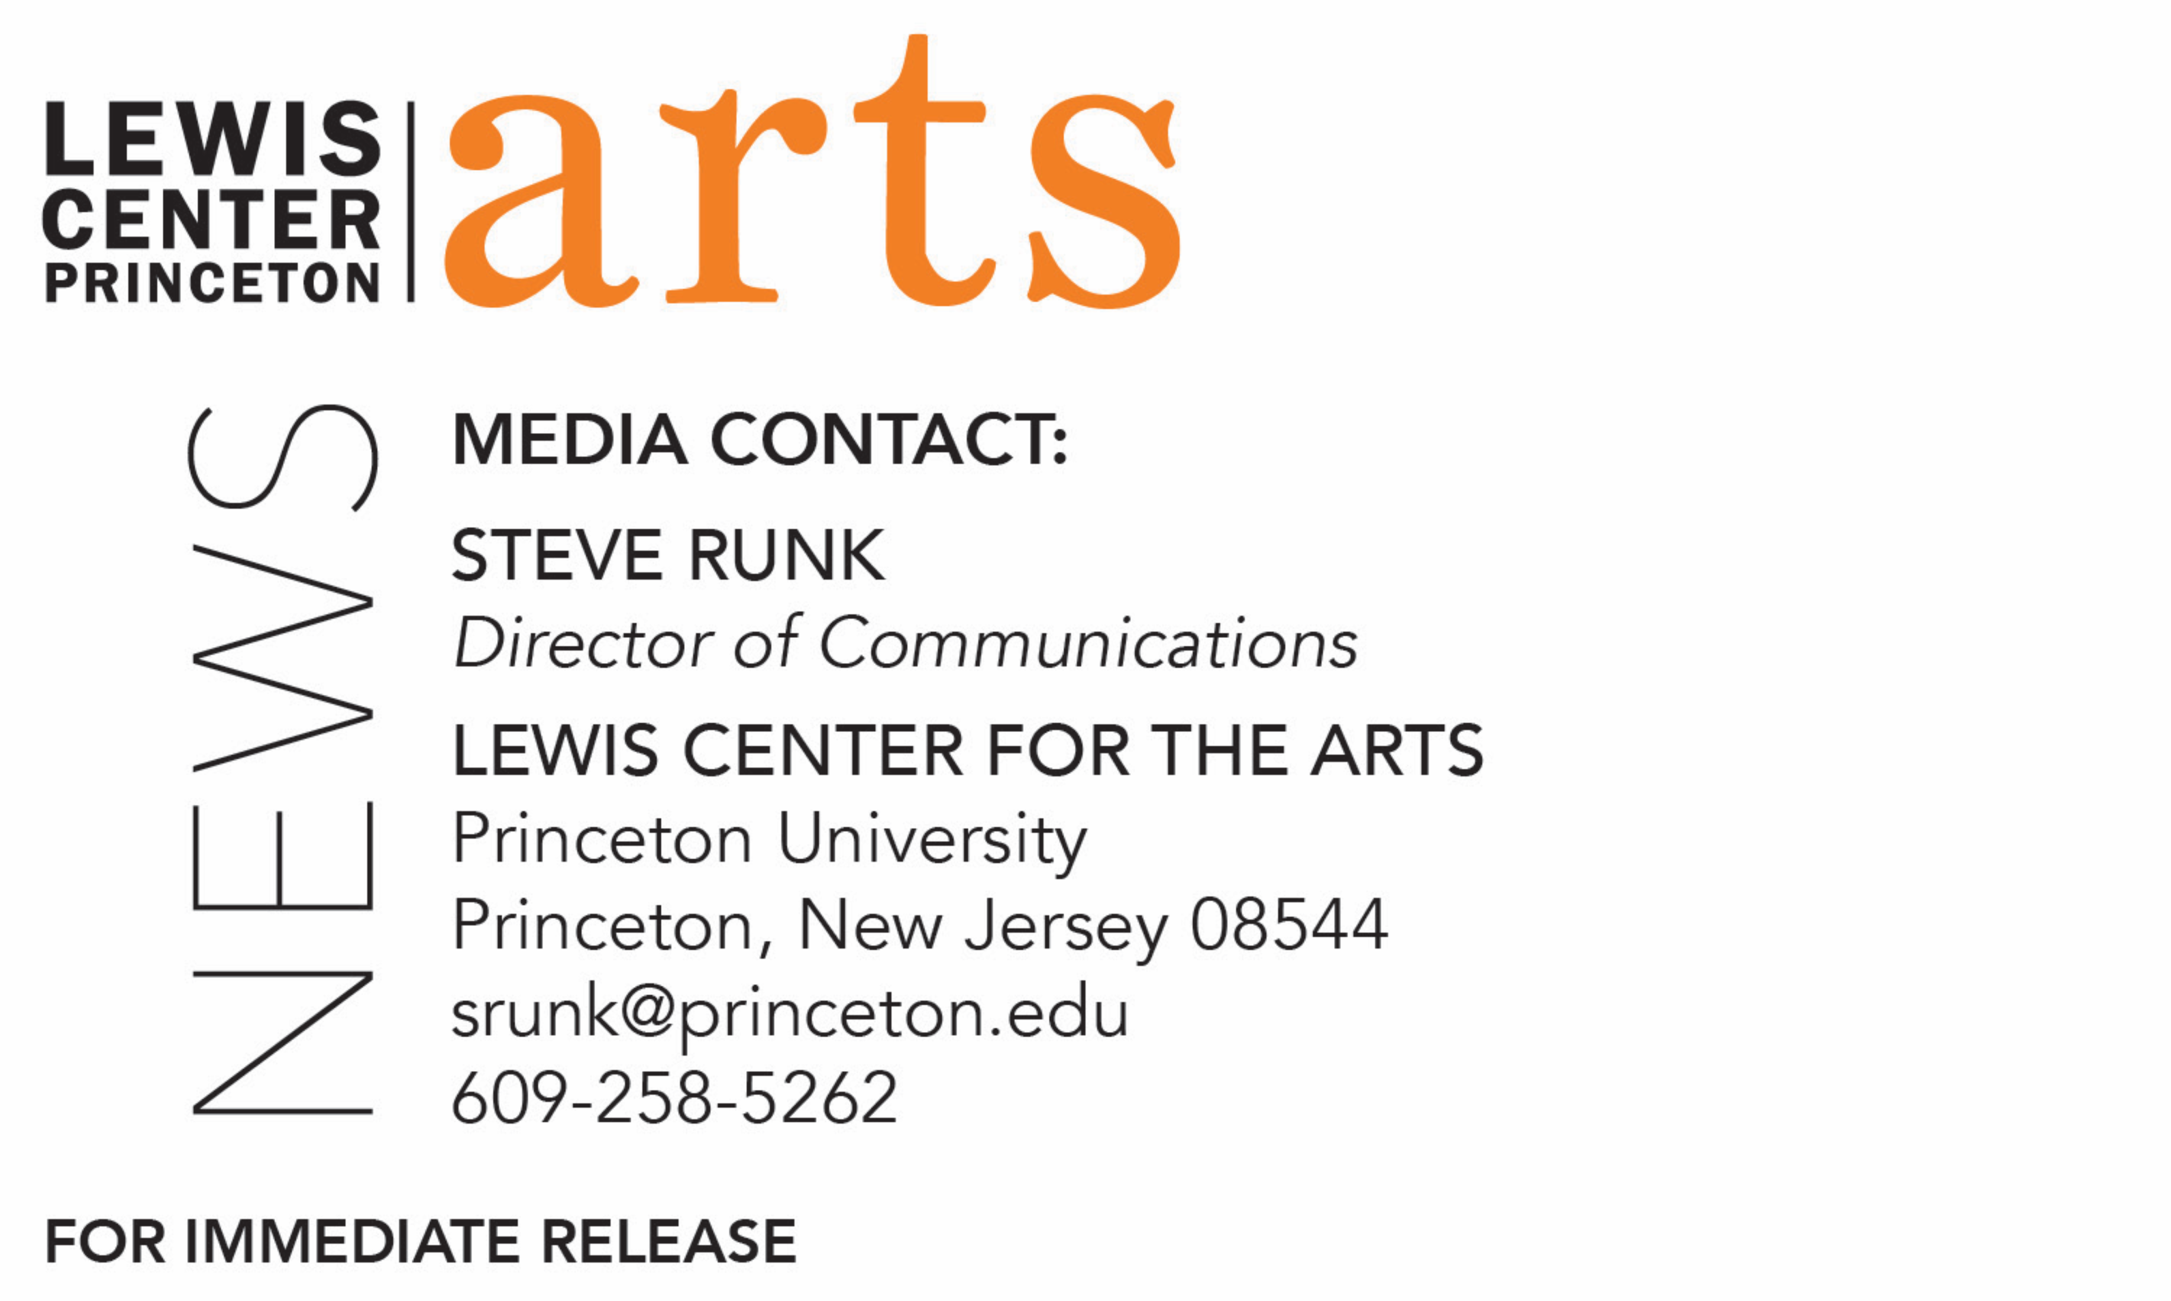

April 4, 2019

Screening of Oscar-winning Documentary Free Solo at Princeton
Stunning portrait of free soloist climber Alex Honnold followed by Q&A with the filmmaker presented as part of Princeton Environmental Film Festival

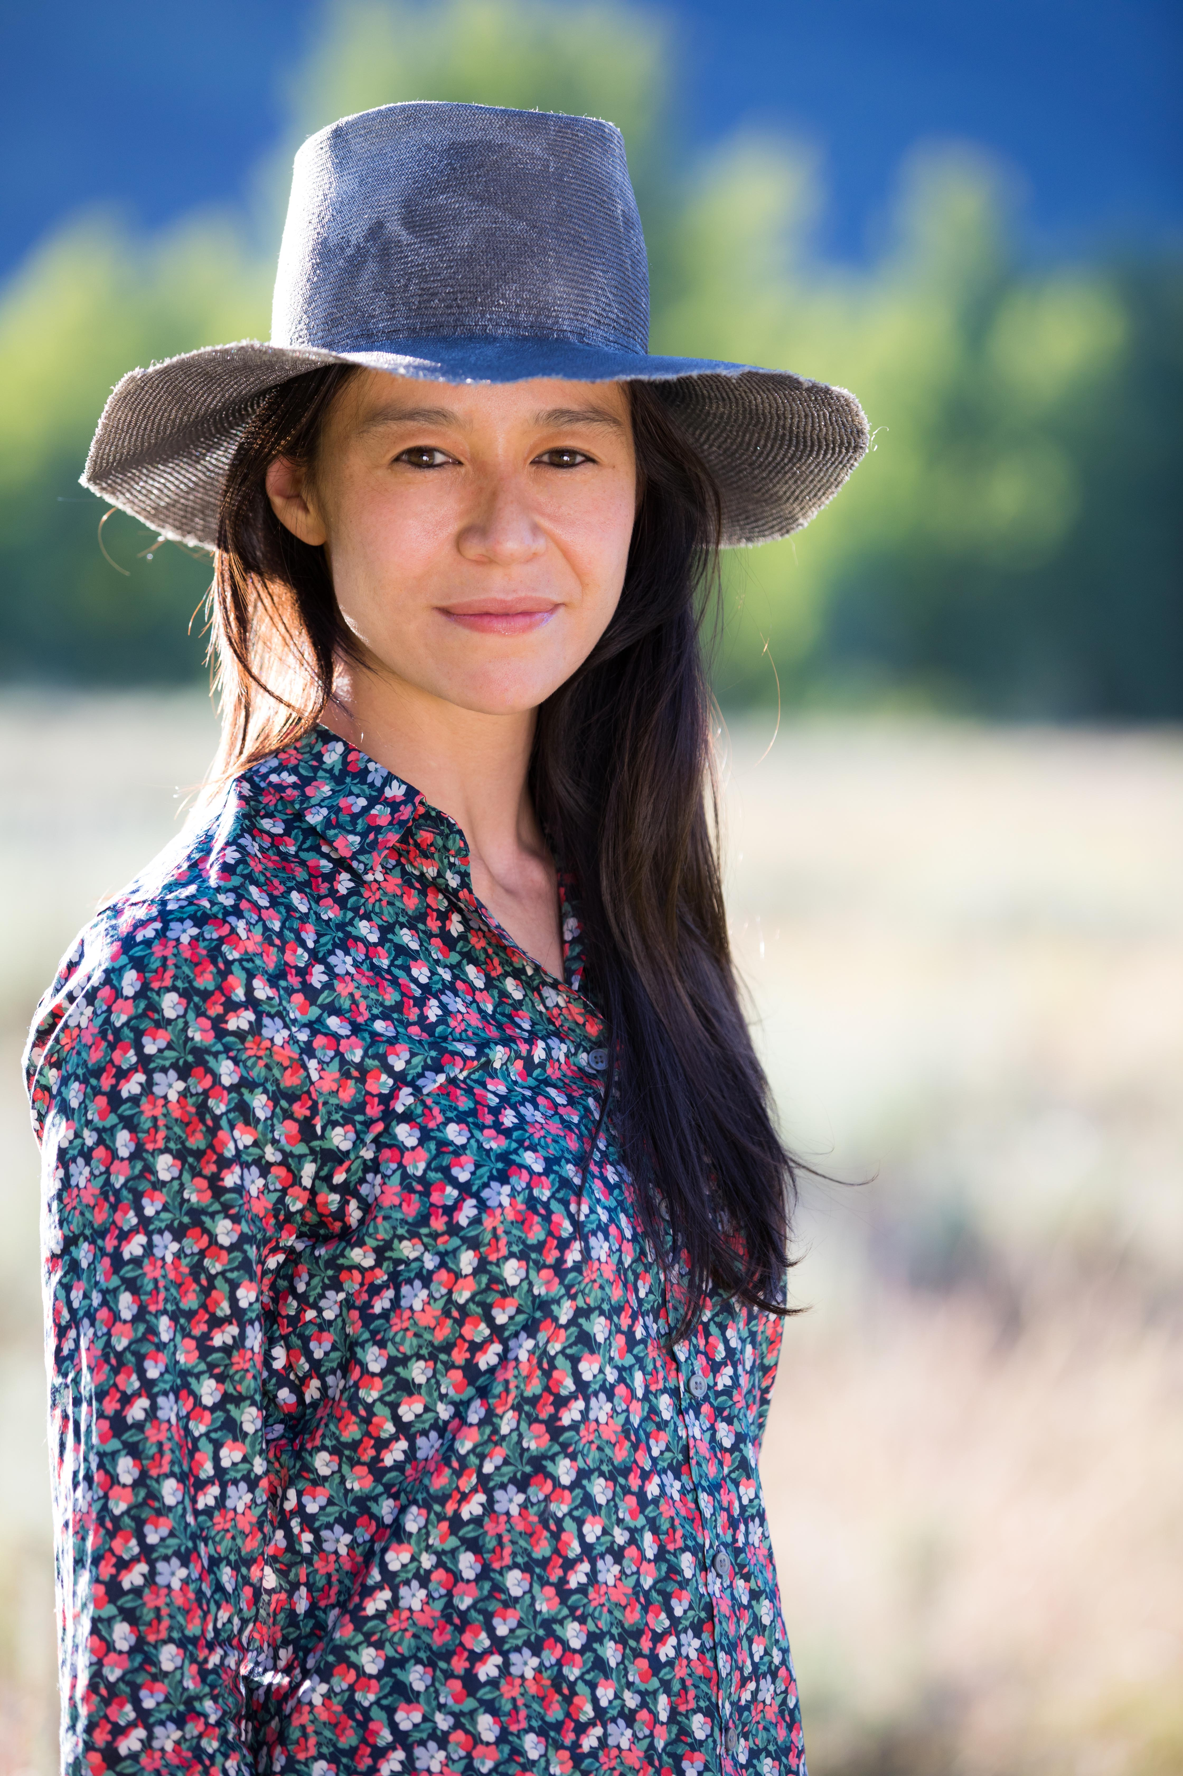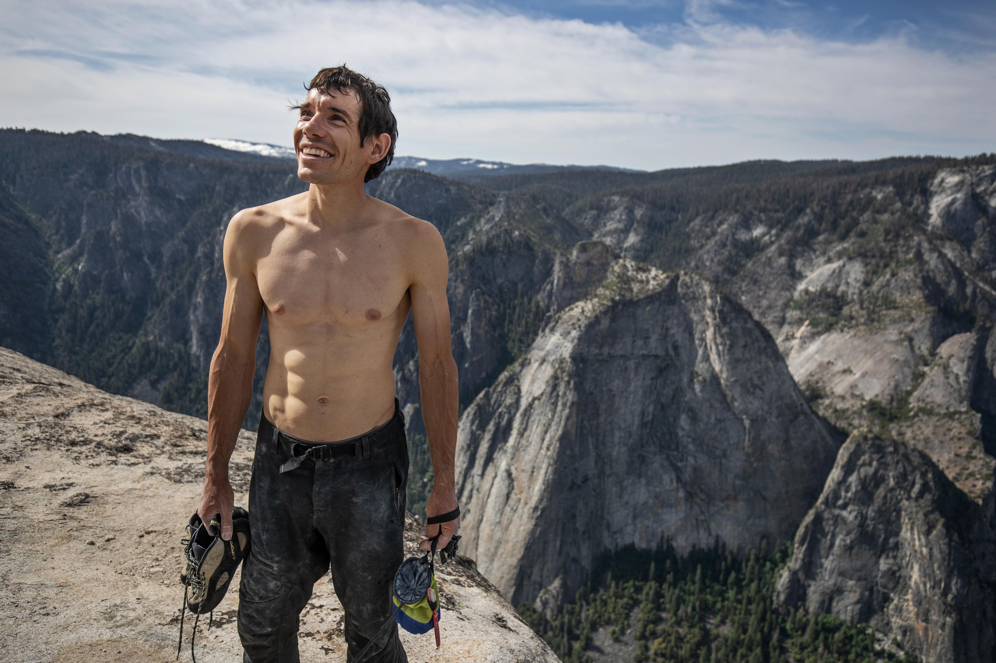
Image caption/credit 1: Elizabeth Chai Vasarhelyi on location during the filming of Free Solo. (National Geographic/Chris Figenshau)
Image caption/credit 2: Alex Honnold holds all of his climbing gear atop the summit of El Capitan. He just became the first person to climb El Capitan without a rope. (National Geographic/Jimmy Chin)

What/Who: Screening of the Oscar-winning documentary Free Solo followed by a Q&A with filmmaker and Princeton alumna Elizabeth Chai Vasarhelyi (Class of 2000). The film is a stunning, intimate and unflinching portrait of free soloist climber Alex Honnold as he prepares to achieve his lifelong dream: climbing the face of the world’s most famous rock — the 3,200-foot El Capitan in Yosemite National Park — without a rope. Presented by the Princeton Environmental Film Festival in partnership with the Lewis Center for the Arts and Outdoor Action.
When: Monday, April 8 at 7:00 p.m.
Where: James Stewart Film Theater, 185 Nassau St., Princeton

Free and open to the public; seating limited; doors open at 6:30 p.m.
For information: https://arts.princeton.edu/events/screening-of-free-solo/

(Princeton, NJ) The Lewis Center for the Arts in collaboration with the Princeton Environmental Film Festival and Outdoor Action present a screening of the Oscar-winning documentary Free Solo about free soloist climber Alex Honnold as he prepares to climb the face of El Capitan in Yosemite National Park — without a rope. The screening, on Monday, April 8 at 7:00 p.m. at the James Stewart Film Theater at 185 Nassau Street, will be followed by a Q&A discussion with the film’s director/producer Elizabeth Chai Vasarhelyi, Princeton Class of 2000. The screening is free and open to the public with no tickets required. Please note that seating is extremely limited; doors to the theater will open at 6:30 p.m. for patrons to claim seats.

Free Solo is an edge-of-your seat thriller and an inspiring portrait of an athlete who challenges both his body and his beliefs on a quest to triumph over the impossible, revealing the personal toll of excellence. As the climber begins his training, the armor of invincibility he’s built up over decades unexpectedly breaks apart when Honnold begins to fall in love, threatening his focus and giving way to injury and setbacks. Vasarhelyi, along with co-director and world-renowned photographer Jimmy Chin, succeed in beautifully capturing deeply human moments with Honnold as well as the death-defying climb with exquisite artistry and masterful, vertigo-inducing camerawork. Free Solo is winner of a 2019 Academy Award for Best Documentary (Feature) and a Bafta Film Awards winner for Best Documentary.

Celebrated as one of the greatest athletic feats of any kind, Honnold’s climb set the ultimate standard: perfection or death. Succeeding in this challenge places his story in the annals of human achievement. The triumph of the human spirit revealed in the film represents what The New York Times calls “a miraculous opportunity for the rest of us to experience the human sublime.”

Award-winning director Elizabeth Chai Vasarhelyi’s films include Meru, shortlisted for the 2016 Oscars and winner of the 2015 Sundance Audience Award; Incorruptible, winner of the Truer Than Fiction Independent Spirit Award 2016; Youssou N'Dour: I Bring What I Love, which premiered at the Telluride and Toronto Film Festivals; A Normal Life, winner of Best Documentary at the 2003 Tribeca Film Festival; and Touba, winner of the Special Jury Prize for Best Cinematography at SXSW 2013. Vasarhelyi has directed a New York Times Op Doc, an episode for Netflix's nonfiction design series Abstract and two episodes for ESPN's new nonfiction series Enhanced. She is the recipient of grants from the Sundance Institute, the Ford Foundation, the Rockefeller Brothers Fund, Bertha Britdoc, the William and Mary Greve Foundation and the National Endowment of the Arts. She is a member of the DGA as well as AMPAS. She holds a B.A. in comparative literature from Princeton University, Class of 2000, and lives in New York City.

The Princeton Environmental Film Festival is sponsored by the Princeton Public Library and is held annually at 65 Witherspoon Street in downtown Princeton, New Jersey, with additional special events offered throughout the year. Founded in 2006, the festival's mission is to share exceptional documentary films and engage the greater community in exploring environmental sustainability from a wide range of angles and perspectives. To learn more about the films shown as part of the festival, visit https://princetonlibrary.org/peff/schedule/.
To learn more about this event, the Lewis Center for the Arts, and the more than 100 other performances, exhibitions, readings, screenings and lectures presented each year at the Lewis Center, visit arts.princeton.edu.

###

