April 2, 2019

The Lewis Center for the Arts’ Program in Theater presents
Halfway Home, a new play by senior Zara Jayant
Drama focuses on four college students thrown into crisis as one of them struggles with substance abuse

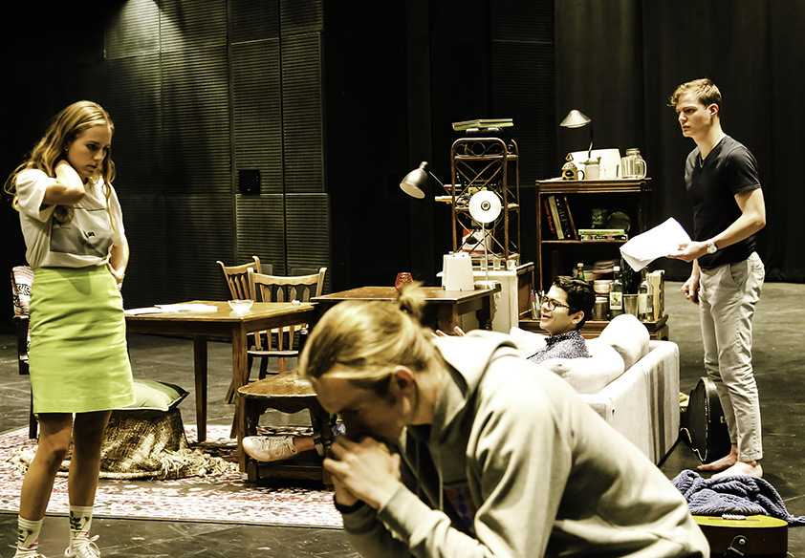
Photo caption: The cast of Halfway Home in rehearsal (left to right) Chase Hommeyer ’19, Cameron Kerr ’19, Marcelo Jaimes-Lukes ’19 and Ian Johnson ’22
Photo credit: Hope VanCleaf

What/Who: Halfway Home, a new play by senior Zara Jayant, in which four college seniors are thrown into crisis as one of them struggles with substance abuse. Unable to ignore it any longer, the group is forced to reevaluate their priorities and relationships. Directed by junior Jhor van der Horst and presented by the Lewis Center for the Arts’ Program in Theater.
When: April 4 & 5 at 8 PM and April 6 at 2 PM and 8 PM
Where: Wallace Theater at Lewis Arts complex on the Princeton University campus
Free and open to the public (no tickets required)
For information: https://arts.princeton.edu/events/halfway-home/2019-04-06/

(Princeton, NJ) The Lewis Center for the Arts’ Program in Theater at Princeton University will present Halfway Home, a new play by senior Zara Jayant, on April 4 and 5 at 8:00 p.m. and April 6 at 2:00 p.m. and 8:00 p.m. in the Wallace Theater at the Lewis Arts complex on the Princeton campus. The show, directed by junior Jhor van der Horst, is free and open to the public; no tickets are required.

Halfway Home tells the story of four college seniors who are thrown into crisis as one of them struggles with substance abuse. Unable to ignore the situation any longer, the group is forced to reevaluate their priorities and relationships.

Jayant, majoring in politics and pursuing a certificate in the Program in Theater, proposed the new play as her senior thesis work in theater. She began writing the play last spring during a Lewis Center playwriting course with playwright Migdalia Cruz, which she describes as an amazing experience. She notes she was inspired by Eugene O’Neill’s Long Day’s Journey into Night and drew upon situations she has witnessed as a student at Princeton. Casting the four roles in the play further influenced the play’s development and editing process, and, as a London native, Jayant counted on her American-born cast to help her negotiate American vernacular.

Jayant’s introduction into the theater world began as a sound technician at the age of 12. In her later teen years she began writing plays, and she usually focuses on comedic or political plays. Halfway Home, a drama, posed a new challenge for her as a very personal piece of writing. At Princeton she has also studied playwriting with R.N. Sandberg, performed with the student group Theatre Intime and served on the group’s board, co-directed a new musical based on Mary Shelley’s Frankenstein, and continued her work as a sound technician. In 2017 she wrote a monologue for Theater for One presented at the multi-day arts festival marking the opening of the Lewis Arts complex; Theater for One is a mobile state-of-the-art performance space for one actor and one audience member.

Jayant knew she wanted the new play to be directed by someone else for the benefit of seeing how her writing was interpreted in the directing process. She has been friends with van der Horst, a native of the Netherlands, since arriving at Princeton when they met at first-year orientation for international students. She has created soundscapes for his choreographic works, and he was familiar with her writing. Jane Cox, Director of the Program in Theater, suggested they collaborate on this project.

Van der Horst is majoring in visual arts and pursuing certificates in both the Program in Theater and the Program in Dance. Coming from a movement and design perspective as a director, he welcomed the challenge of working with the actors to develop and understand Jayant’s characters and the process of bringing her vision from the written page to the stage. Last year he helped bring another senior’s new play to the stage, directing Fiona Bell’s Letters & Dreams. He has also served as movement consultant for the Lewis Center’s recent production of Machinal, is currently choreographing a new musical by junior Allison Spann, Masquerade, and was assistant choreographer for the world premiere of the new play GURLS by alumnus Branden Jacobs-Jenkins in fall 2017. Van der Horst has also performed annually in the Princeton Dance Festival, created work each year for the Program in Dance’s Performance Lab, and is a member of the student dance group BodyHype.

Jayant would like to see Halfway Home move next to Edinburgh Fringe Festival.

To learn more about this event, the Program in Theater, and the more than 100 other performances, exhibitions, readings, screenings, concerts, and lectures presented each year by the Lewis Center, most of them free, visit arts.princeton.edu.

###

