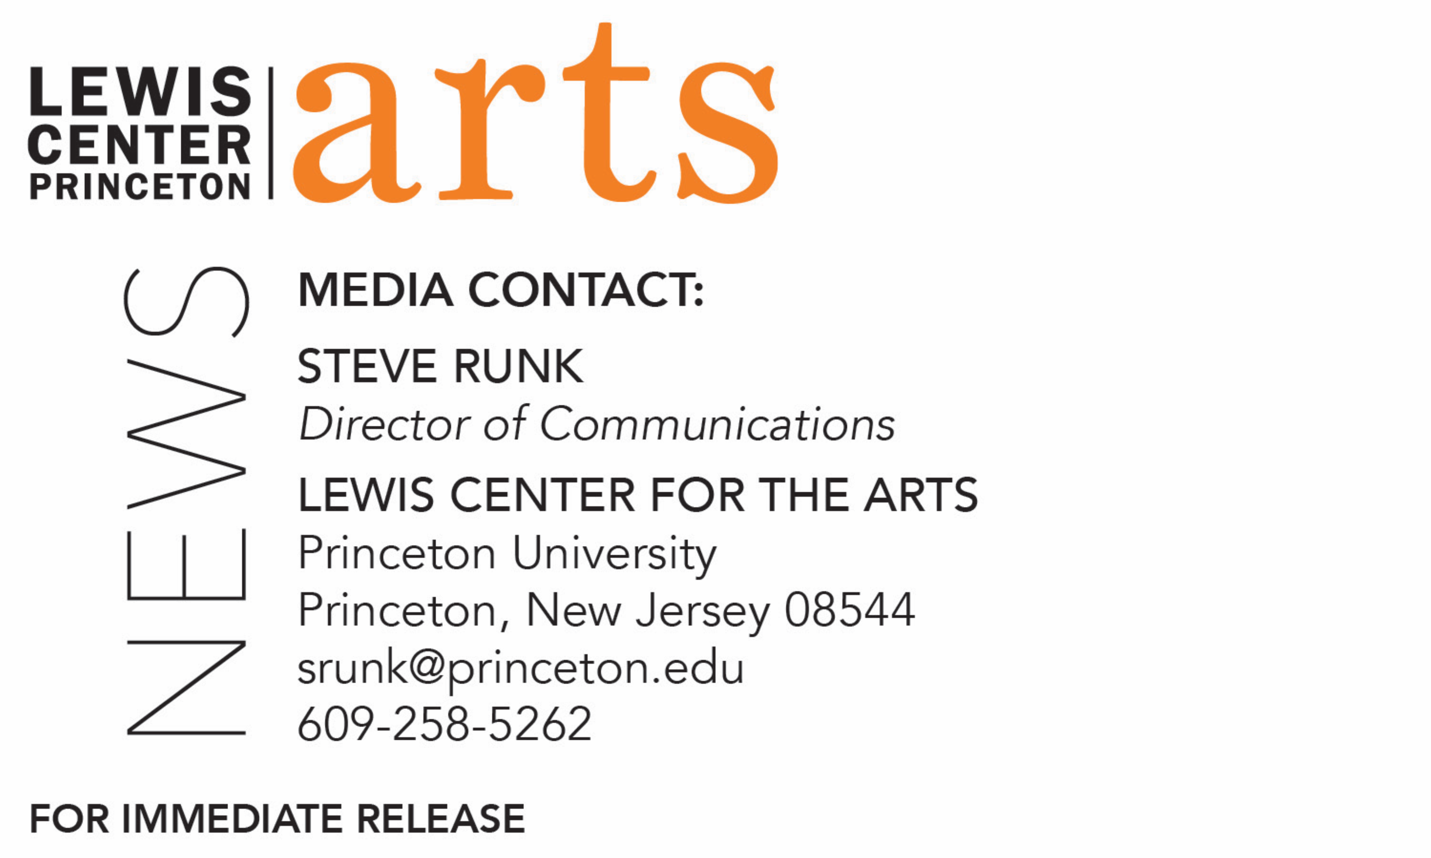

April 24, 2018

Lewis Center for the Arts presents performance of original songs by students in the spring course “How to Write a Song” taught by poet Paul Muldoon

Photo caption: Students perform an original song created in the course “How to Write a Song.” Photo credit: Courtesy of Lewis Center for the Arts

What: Students perform a concert of original songs with music and lyrics written over the past semester as part of the spring course “How to Write a Song” taught by Pulitzer Prize-winning poet Paul Muldoon with visits by singer/songwriter guest artists.
Who: Presented by Lewis Center for the Arts’ Program in Creative Writing
When: Tuesday, April 30 at 4:30 p.m.
Where: Frist Film/Performance Theatre at Frist Campus Center on the Princeton campus
Free and open to the public

(Princeton, NJ) Students in Princeton University’s spring course “How to Write a Song,” offered by the Lewis Center for the Arts’ Program in Creative Writing, will present original songs at a concert on April 30 at 4:30 p.m. at the Frist Film/Performance Theatre at the Frist Campus Center on the Princeton campus. The students will perform selected new work completed over the past semester. The concert is free and open to the public.

Taught by Pulitzer Prize-winning poet Paul Muldoon, this enormously popular course required students to write new songs throughout the semester inspired by a broad range of varying emotions. Each week the students, all with varying levels of literary and musical backgrounds, split into different groupings of two to three participants and wrote lyrics and composed tunes on an assigned emotional topic, such as, joy, despair, defiance, or desire. At each class, the students performed their pieces for Muldoon and their classmates, who then provided critiques. Guest critics and singer/songwriters, including Jon Pareles, chief pop music critic of The New York Times, and Bridget Kearney of Lake Street Dive, joined the class to share their experience and to listen to and provide feedback to the student songwriters.

“I know I should be used to it by now but I continue to be astonished by the range and depth of talent shown by these songwriters,” notes Muldoon. “The work on show on April 30 will represent only a fraction of what was achieved in the class, and I promise you it’ll knock your socks off.”

Muldoon is the Howard G.B. Clark ’21 University Professor in the Humanities, Professor of Creative Writing in the Lewis Center for the Arts, and Director of the Princeton Atelier. He has been described by the The Times Literary Supplement as “the most significant English-language poet born since the Second World War” and his thirteenth volume of poems, Frolic and Detour, will be published later this year by Farrar, Straus and Giroux. A selection of songs written for his rock band, Rogue Oliphant, has been published by Eyewear under the title Sadie and the Sadists, itself the title of a double LP available locally at the Princeton Record Exchange.

For more information on this event, the Program in Creative Writing, or any of the more than 100 performances, exhibitions, readings, screenings, concerts, and lectures presented each year by the Lewis Center for the Arts, most of them free, visit: arts.princeton.edu.

###

