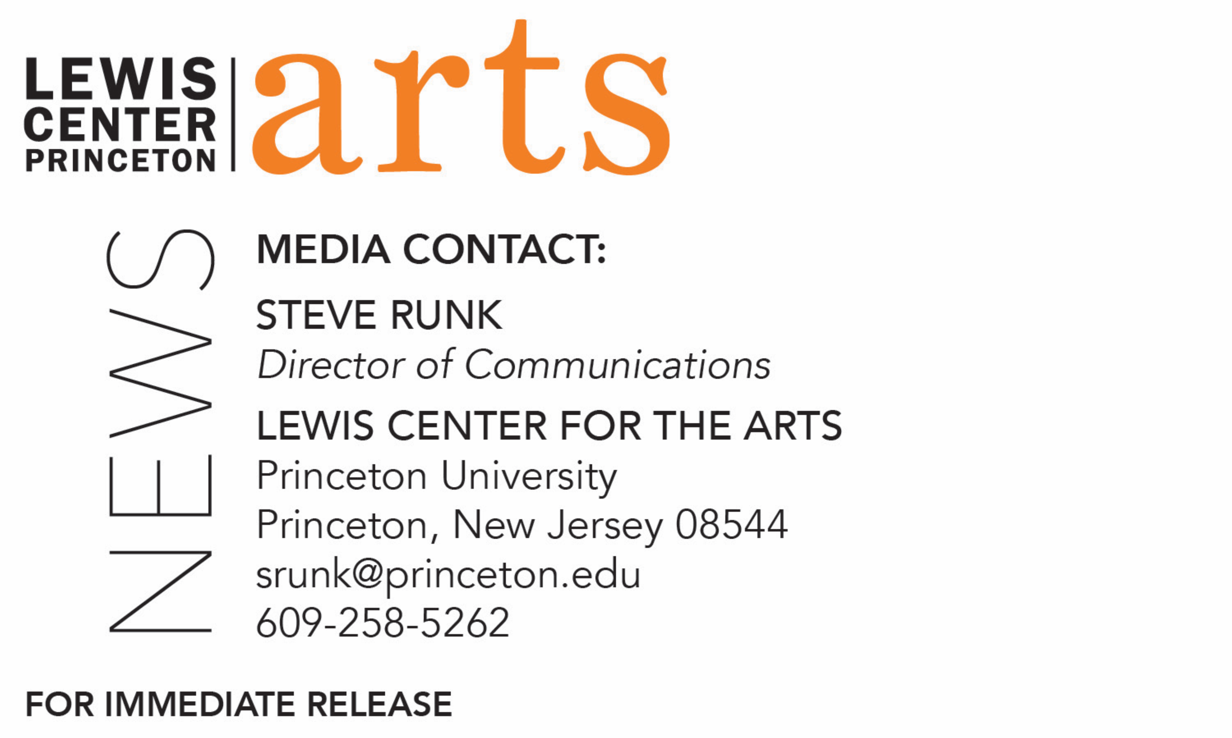

May 3, 2019

Lewis Center for the Arts presents Screenings of Film, Video and Animation by Princeton students on May 7, 9 and 16

Photo caption 1/Credit: A still from Princeton senior Amanda Morrison’s documentary film on feminist activists detained in China, Do You Hear the Women Sing?
Photo caption 2/Credit: A still from Princeton junior Seb Benzecry’s animated film exploring patriarchal oppression and undiagnosed depression, The Yellow Wallpaper.

What/Who: Screening of Junior & Senior Thesis Films, presented by the Lewis Center for the Arts’ Program in Visual Arts, including documentaries on feminist activists detained in China and a contemporary Italian artist; an animated film exploring patriarchal oppression and undiagnosed depression; and four narrative films on moving onto the afterlife, origami to restore a friend’s health, a distracted man struggling to complete a presentation for his boss, and one that asks the question: does knowing what happens in the future affect what you do in the present? All seven films will be screened on both dates at both locations.
When/Where: May 7 at 7:30 PM at James Stewart Film Theater at 185 Nassau St. and May 9 at 10 PM at Princeton Garden Theatre, 160 Nassau St.
Free and open to the public
For more information: https://arts.princeton.edu/events/junior-and-senior-thesis-film-screening-stewart-sp19/ and https://arts.princeton.edu/events/junior-and-senior-thesis-film-screening-garden-sp19/

What/Who: Video and Animation Screening, presented by the Lewis Center for the Arts’ Program in Visual Arts, including short new works by 31 Princeton students created in spring video/film production and digital animation courses.
When: May 16 at 4:00 PM & 7:30 PM
Where: James Stewart Film Theater at 185 Nassau St. on the Princeton campus
Free and open to the public
For more information: https://arts.princeton.edu/events/video-and-animation-screening-sp19/

(Princeton, NJ) The Program in Visual Arts in the Lewis Center for the Arts at Princeton University will present screenings of new student work in May.

A Junior & Senior Thesis Film Screening featuring seven new short films by students in the Program will be presented on May 7 at 7:30 p.m. at the James Stewart Film Theater at 185 Nassau St. and on May 9 at 10 p.m. at Princeton Garden Theatre, 160 Nassau St.
On May 16 at 4:00 p.m. and 7:30 p.m. the Program will screen short works by 31 students in spring video and animation courses at the James Stewart Film Theater. All the screenings are free and open to the public.

The seven juniors and seniors screening thesis films are pursuing degrees or certificates in the Program in Visual Arts with a focus on filmmaking.

In the documentary Giulia, junior Bes Arnaout, majoring in French and Italian, reflects on the life and work of a prolific yet often unacknowledged Italian artist Giulia Niccolai, born in 1934, whose oeuvre includes photography, novels, essays, poetry, literary translation, and Buddhist monasticism.

Junior English major Seb Benzecry’s animated film The Yellow Wallpaper is based on the short story by Charlotte Perkins Gilman of the same name and explores themes of patriarchal oppression and undiagnosed depression through the lens of animation. A woman, locked in a small attic room against her will, begins to lose touch with reality as she becomes obsessed with the wallpaper that surrounds her.

Inverse, Fold by junior Milan Eldridge, a Practice of Art major, tells the story of Ori, whose friend Roo falls ill, and how she must overcome her lackadaisical attitude toward origami in order to bring her friend back to full health.

Two Blue Pills is a film by junior Tom Hoopes, a philosophy major, in which a young, easily distracted man struggles to complete a presentation for his boss.
After learning he has passed away, Joseph must discover how he died in order to proceed to the afterlife in The Waiting Room, a film by senior Rami Farran, a computer science major.

Does knowing what happens in the future affect what you do in the present? is the central question in senior David Lopera’s film Carmesí. Lopera is a Practice of Art major.

Do You Hear the Women Sing? is a documentary film by senior Amanda Morrison, majoring in the Woodrow Wilson School of International and Public Affairs. The day before International Women’s Day in 2015, five feminist activists were detained in Beijing, China, after three years of creative and effective street activism. The film tells the story of the feminists who pushed back against the patriarchal Chinese regime and found ways to adapt to systematic repression and censorship to continue their fight for women’s rights.

The short works being screened on May 16 at 4:00 p.m. are from the course “Documentary Filmmaking II,” taught by Su Friedrich, an advanced course in which each student produces a short documentary while also analyzing classic and contemporary strategies in documentary filmmaking. At 7:30 p.m. works will be screened from the course “Narrative Filmmaking I,” taught by Moon Molson, which introduces students to narrative and avant-garde narrative film production and the basic tools and techniques for storytelling with digital media; and the course “Digital Animation,” taught by Tim Szetela in which students engage in a variety of timed-based collage, composition, visualization, and storytelling techniques and learn the fundamental techniques of 2D animation production.
To learn more about this event, the Program in Visual Arts, and the more than 100 other performances, exhibitions, readings, screenings, concerts and lectures offered each year by the Lewis Center, most of them free, visit arts.princeton.edu.

###

