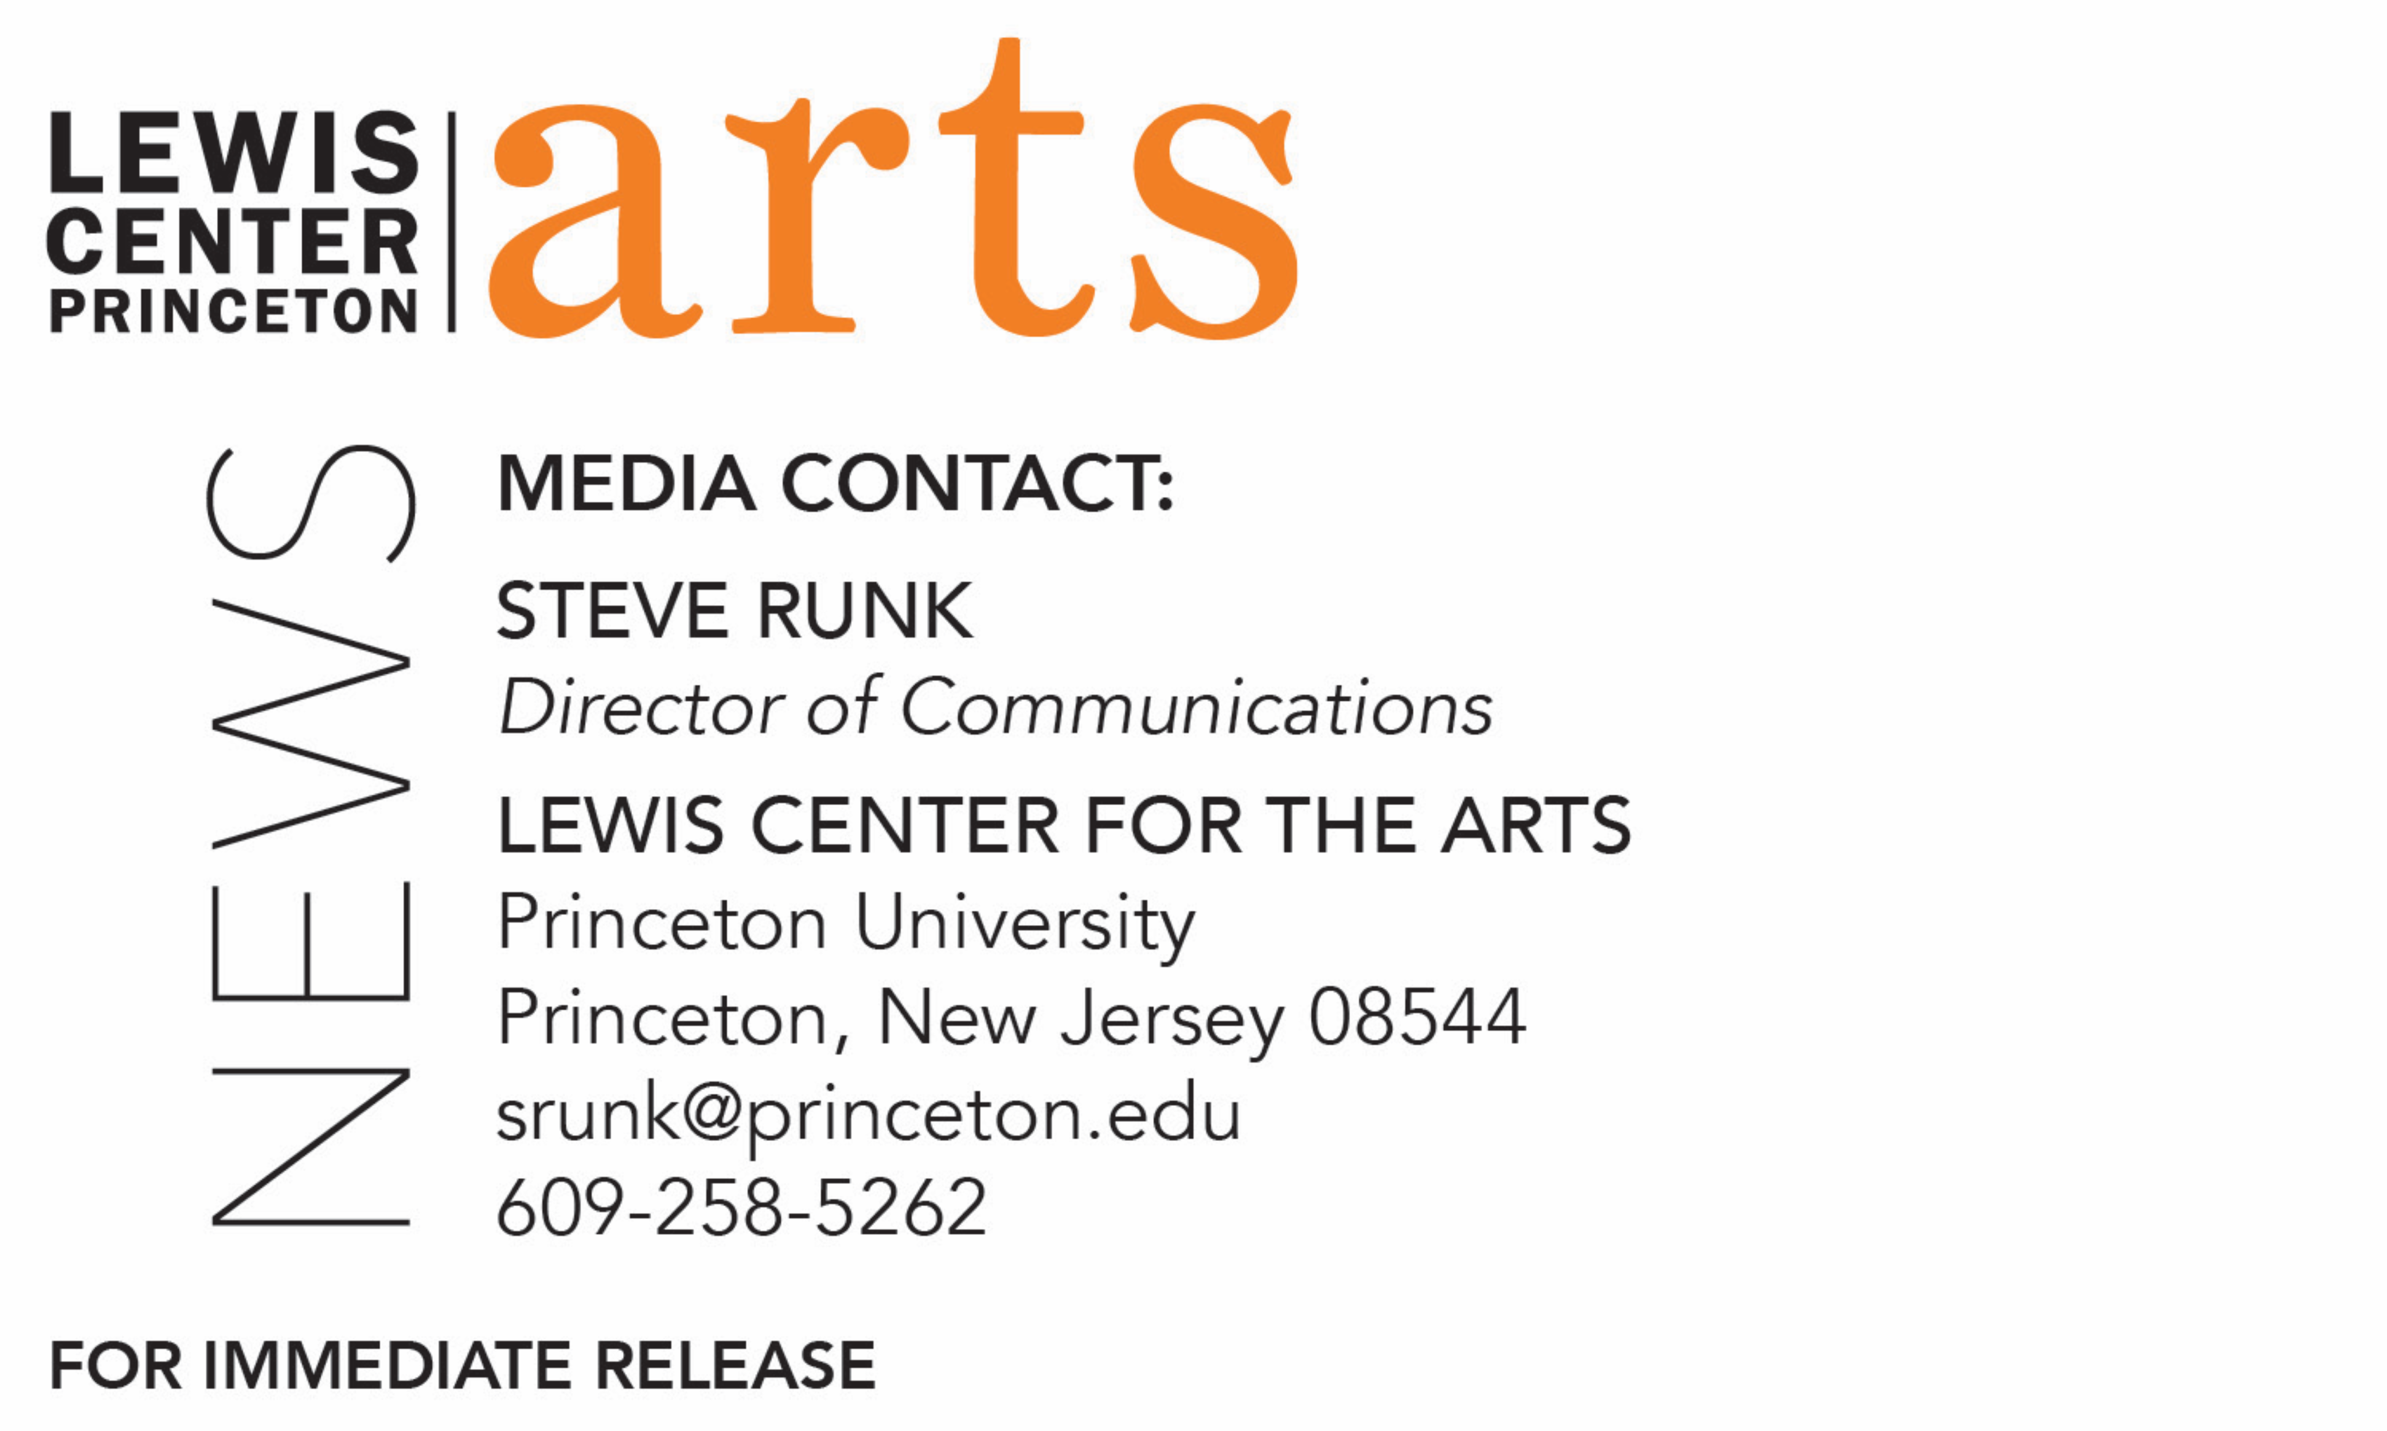

May 15, 2019

The Lewis Center for the Arts presents
Final Runnings Before the After
A special, mixed media exhibition of work by graduating seniors in the Visual Arts program

Photo caption 1/Credit: An installation view of seniors Pearl Thompson and Maya Von Ziegesar’s exhibition Dazzle Camouflage/Cloak Cloak (left image)/ Jaclyn Sweet
Photo caption 2/Credit: A work from senior Anna Berghuis’ exhibition Unsaid (center image)/Courtesy of the artist
Photo caption 3/Credit: A font created by senior Kara Bressler that references geographic land masses and bodies of water, used in the title for the senior exhibition, Final Runnings Before the After (right image) / Courtesy of Kara Bressler

What: Final Runnings Before the After, an exhibition of recent work in a wide range of media
Who: Work created by 20 graduating seniors in the Lewis Center for the Arts’ Program in Visual Arts at Princeton University, curated by faculty member Nathan Carter
When: May 11 - June 5; opening reception on Thursday, May 16 from 6:00 p.m. - 7:30 p.m.
Where: Hurley Gallery at the Lewis Arts complex on Princeton University Campus.
Gallery Hours: Daily from 10:00 a.m. - 8:30 p.m
Free and open to the public

(Princeton, NJ) The Visual Arts Program in the Lewis Center for the Arts at Princeton University will present an exhibition of recent work in a wide range of media by graduating seniors in the Program. The exhibition, titled Final Runnings Before the After, will highlight work by students completed as part of their senior thesis projects and will be on view through June 5 in the Hurley Gallery in the Lewis Arts complex on Princeton University campus. An opening reception at the gallery will be held on May 16 from 6:00 p.m. to 7:30 p.m. The exhibition and reception are free and open to the public.

The work featured in this exhibition has been selected by faculty member Nathan Carter from among photography, paintings, drawings, prints, sculpture, photography, film, video and multimedia installations created by students majoring in visual arts or earning a certificate in visual arts in addition to a degree in their major. Each presented a solo exhibition or a screening of new work during the past semester as a requirement of the program.

This multimedia show, including film work showcased on monitors in the gallery, features the work of 20 seniors including ten majoring in visual art, Anna Berghuis, MacLean Collins, Kyra Gregory, Cody Kohn, David Lopera, Isaiah Nieves, Kathryn Northrop, Sanneh, Pearl Thompson, Yuanyuan Zhao; and ten pursuing a certificate in visual arts in addition to their major, Kara Bressler, Hudson Cooke, Caroline de Brito Gottlieb, Rami Farran, Susan Liu, Amanda Morrison, Elaine Romano, Maya von Ziegesar, Alice Wang, and Jessica Zhou.

The seniors’ exhibitions and bodies of work included diverse ideas including: photographic explorations of California and of an artists’ visit to his family’s origins in Puerto Rico; collages, drawings, prints, and photographs that explore definitions of womanhood, gender, and sexuality and the experiences of queer and trans individuals; photographs that probe different aspects of East Asian identities; works in a range of media that examine mental illness, child development, and that dissect and reconstruct the foundations of human life on Earth; a photographic exploration of black subjects and blackness that refuses to reach out to stereotypes; installation of a bedroom as a space to encapsulate the worries, obsessions, thoughts, and dreams of its occupant; abstract figurative paintings that present different facets of the female voice; an exhibition and fashion show of garments designed to respond to uncomfortable or frequently asked questions of cultural identity; gallery and off-site installations of work in crowd-sourced typographic exploration and ephemeral documentation; and films on the afterlife, on how knowing what happens in the future affects what one does in the present, and a documentary about five feminist activists detained in Beijing, China.

Many of the seniors plan to continue working in the visual arts field when they graduate, while others will take what they have learned as student artists into a career in another field.

The Hurley Gallery is open daily from 10:00 a.m. to 8:30 p.m.

To learn more about the exhibition, the Program in Visual Arts, and the more than 100 performances, exhibitions, readings, screenings, concerts and lecture presented each year at the Lewis Center, most of them free, visit arts.princeton.edu.

###

