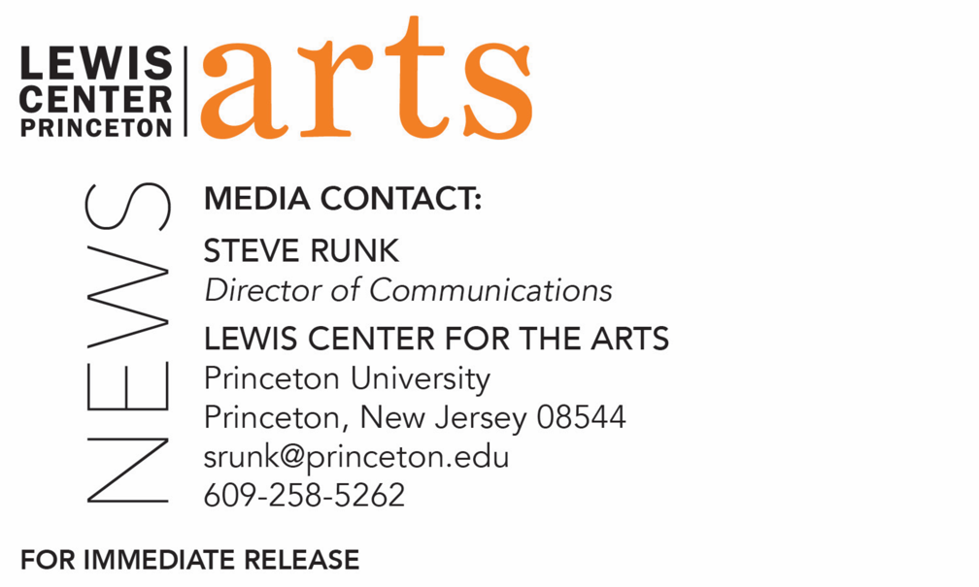

September 27, 2019

Poet Matthew Zapruder Reads with Three Seniors in Princeton’s Creative Writing Program on October 4
The C.K. Williams Reading Series is organized by Princeton students

Photo caption: Poet Matthew Zapruder
Photo credit: B.A. van Sise

What/Who: A reading by poet Matthew Zapruder and three seniors in Princeton’s Program in Creative Writing – Sarah Barnette, David Babikian, and Kevin Zou – kicks off the 2019-20 season of the C.K. Williams Reading Series, presented by the Lewis Center for the Arts’ Program in Creative Writing at Princeton University
When: October 4, 2019 at 6:30 p.m.
Where: Forum at the Lewis Arts complex on the Princeton University campus
Free and open to the public

(Princeton, NJ) Matthew Zapruder, renowned poet, editor, and translator, will read from his work at 6:30 p.m. on October 4, 2019, at Princeton University’s Lewis Arts complex Forum. Joining him will be Sarah Barnette, David Babikian, and Kevin Zou – three seniors in Princeton’s Program in Creative Writing who will be reading from their recent work. This event opens the 2019-20 C.K. Williams Reading Series, named after the late Pulitzer Prize and National Book Award-winning poet C.K. Williams, who also served on Princeton’s faculty for 20 years. The event, presented by the Lewis Center for the Arts’ Program in Creative Writing, is free and open to the public.

The series showcases senior thesis students of the Program in Creative Writing alongside established writers as special guests. The Program is celebrating its 80th anniversary this year with readings by 80 writers, including those in the C.K. Williams Series.

Matthew Zapruder has authored several poetry collections including Sun Bear (2014), Come On All You Ghosts (2010), The Pajamaist (2006), American Linden (2002), and Why Poetry, which has been called “a roaring success” by the New York Times Book Review. Zapruder collaborated with painter Chris Uphues on For You in Full Bloom
(2009) and co-translated, with historian Radu Ioanid, Romanian poet Eugen Jebeleanu’s last collection, Secret Weapon: Selected Late Poems (2008). His most recent collection, Father’s Day, was published in early September 2019 by Copper Canyon Press.

Zapruder was born in Washington, D.C., and graduated from Amherst College with a B.A. in Russian literature. He has also achieved an M.A. in Slavic languages and literature from the University of California, Berkeley, and an M.F.A. in poetry from the University of Massachusetts, Amherst. His work has won a number of awards including a 2011 Guggenheim Fellowship, a Lannan Foundation Residency Fellowship in Marfa, Texas, and the May Sarton prize from the American Academy of Arts and Sciences. Zapruder is an Associate Professor at Saint Mary’s College of California and is editor at large for Wave Books, a company he co-founded. He also plays lead guitar in a rock band called The Figments.

Barnette, Babikian, and Zou, who are pursuing certificates in creative writing in addition to their major areas of study, will read from their senior thesis projects. Each is currently working on a novel, a screenplay, translations, or a collection of poems or short stories as part of a creative thesis for the certificate. Thesis students in the Program in Creative Writing work closely with a member of the faculty, which includes award-winning writers Michael Dickman, Aleksandar Hemon, A.M. Homes, Christina Lazaridi, Jhumpa Lahiri, Yiyun Li, Paul Muldoon, James Richardson, Tracy K. Smith, Kirstin Valdez Quade, Susan Wheeler, Monica Youn, and a number of distinguished lecturers.

Other upcoming guests in the 2019-20 C.K. Williams Series include Hala Alyan, Emily Jungmin Yoon, Aaron Robertson, Hernan Diaz, and Maya Phillips.

In addition, the Program in Creative Writing presents the Althea Ward Clark W’21 Reading Series, also free and open to the public, on Wednesday evenings on the Princeton campus. Upcoming guests in that series include Aleksandar Hemon and Andrew Motion on October 16,
Andrey Kurkov and Sapphire on November 20, Joy Harjo and Sheila Heti on February 12,
Mei-Mei Berssenbrugge and Yoko Tawada on March 4, and Kaitlyn Greenidge, Helen Oyeyemi, and Nicole Sealey on April 15.

To learn more about these reading series, the Program in Creative Writing, and the more than 100 public performances, exhibitions, readings, screenings, concerts and lectures presented each year by the Lewis Center for the Arts, most of them free, visit arts.princeton.edu.

###

