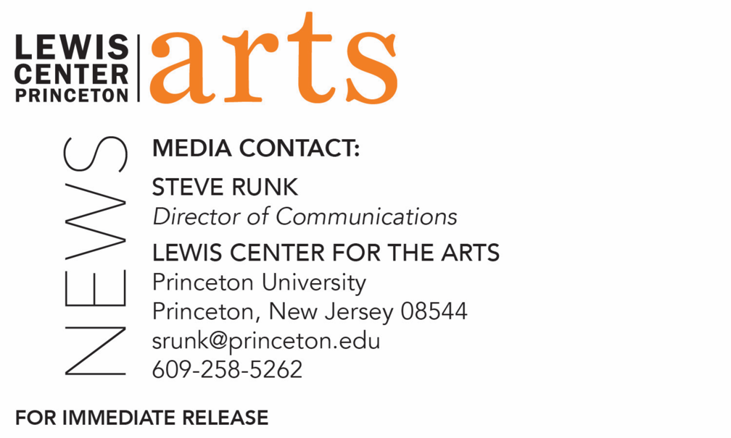

September 13, 2019

Lewis Center for the Arts’ Program in Creative Writing celebrates its 80th anniversary
Kicks off a year-long celebration with a reading by
Maxine Hong Kingston, Yusef Komunyakaa, and David Treuer
Award-winning writers open Althea Ward Clark W’21 Reading Series at Princeton

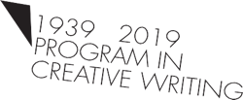

Photo caption 1: Maxine Hong Kingston
Photos credit 1: Michael Lionstar
Photo caption 2: Poet Yusef Komunyakaa
Photos credit 2: Crampton
Photo caption 3: David Treuer
Photos credit 3: Nisreen Breek
Photo 4: 80th anniversary logo

What: A year-long celebration of the 80th anniversary of the Lewis Center for the Arts’ Program in Creative Writing at Princeton University kicks-off with the first event in the 2019-20 Althea Ward Clark W’21 Reading Series
Who: Reading by National Book Award-winning writer Maxine Hong Kingston, Pulitzer Prize-winning poet Yusef Komunyakaa, and award-winning Ojibwe novelist and non-fiction writer David Treuer, a Princeton alumnus, Class of 1992
When: Wednesday, September 25 at 7:30 p.m.
Where: Richardson Auditorium on the Princeton University campus
Free and open to the public

(Princeton, N.J.) On Wednesday, September 25, the Lewis Center for the Arts’ Program in Creative Writing kicks off a year-long celebration of its 80th anniversary with a reading by National Book Award-winning writer Maxine Hong Kingston, Pulitzer Prize-winning poet Yusef Komunyakaa, and Ojibwe novelist and non-fiction writer David Treuer, a Princeton alumnus, Class of 1992. The reading opens the 2019-20 Althea Ward Clark W’21 Reading Series and begins at 7:30 p.m. in Richardson Auditorium on the Princeton University campus. The reading is free and open to the public and will be followed by a book sale and signing with the writers.

The Program in Creative Writing traces its origins to 1939 and a grant from the Carnegie Foundation to help Princeton focus on the cultivation of writers and other artists. A committee of faculty from the Departments of Art, Music, French and English defined the program’s mission, “to allow the talented undergraduates to work in the creative arts under professional supervision while pursuing a regular liberal arts course of study, as well as to offer all interested undergraduates an opportunity to develop their creative faculties in connection with the general program of humanistic education.”

This focus on undergraduate students working closely with some of the most celebrated and recognized writers in the world—an opportunity more typical in graduate creative writing programs—makes Princeton’s program unique.

Over 300 Princeton undergraduates take courses in poetry, fiction, screenwriting, and literary translation each semester, a number that continues to grow. Small workshop courses, averaging eight to ten students, provide intensive feedback and instruction for both beginning and advanced writers, with faculty who currently include award-winning writers Michael Dickman, Aleksandar Hemon, A.M. Homes, Christina Lazaridi, Jhumpa Lahiri, Yiyun Li, Paul Muldoon, James Richardson, Tracy K. Smith, Kirstin Valdez Quade, Susan Wheeler, and Monica Youn. Students who pursue a certificate in creative writing, similar to a minor, in addition to their degree in their area of concentration, work individually with a member of the faculty on a creative writing thesis, such as a novel, screenplay, or a collection of short stories, poems, or translations. Some of these senior thesis projects become the first published work by graduates of the program, as was the case for writers Jonathan Ames ’87 and Jonathan Safran Foer ’99. Other graduates from the program include Catherine Barnett ’82, Jane Hirshfield ’73, Boris Fishman ’01, Kristiana Kahakauwila ‘03, Galway Kinnell ’48, Walter Kirn ’83, William Meredith ’40, W. S. Merwin ’48, Emily Moore ’99, Jodi Picoult ’87, Julie Sarkissian ’05, Akhil Sharma ’92, Whitney Terrell ’91, and Monica Youn ’93, among many others.

Other writers who have served as faculty and visiting guest writers over the decades include Simon Armitage, John Berryman, Elizabeth Bowen, Jeffrey Eugenides, Robert Fitzgerald, Thom Gunn, Edmund Keeley, David E. Kelley, Chang-rae Lee, John McPhee, Lorrie Moore, Neel Mukherjee, Joyce Carol Oates, Philip Roth, Claudia Rankine, Erika Sanchez, Delmore Schwartz, Edmund White, Kevin Young, and Nobel laureates Toni Morrison and Mario Vargas Llosa.

Over the course of the 2019-20 academic year the Program in Creative Writing invites audiences to join in recognizing this milestone anniversary with events that will feature 80 writers. This special kick-off event will be introduced by Pulitzer Prize-winning poet Paul Muldoon.

Maxine Hong Kingston has earned numerous awards for her memoirs, fiction, and poetry including the National Book Award, the National Book Critics Circle Award for Nonfiction, the PEN West Award for Fiction, and an American Academy of Arts and Letters Award in Literature. Her works include The Fifth Book of Peace, The Woman Warrior, China Men, Tripmaster Monkey, I Love a Broad Margin to My Life, and Hawai’i One Summer. In 1997 she was awarded the National Humanities Medal by President Clinton, and the National Medal of Arts by President Obama in 2013. She is Emerita Senior Lecturer for Creative Writing at the University of California, Berkeley, and was recognized with the title “Living Treasure of Hawai’i” in 1980.

Yusef Komunyakaa’s books of poetry include Taboo, Dien Cai Dau, Neon Vernacular, for which he received the Pulitzer Prize, Talking Dirty to the Gods, Warhorses, The Chameleon Couch, The Emperor of Water Clocks, and Everyday Mojo Songs of Earth, forthcoming from Farrar, Straus and Giroux in 2020. His honors include the William Faulkner Prize (Université Rennes, France), the Ruth Lilly Poetry Prize, and the 2011 Wallace Stevens Award. His plays, performance art and libretti have been performed internationally and include Saturnalia, Wakonda’s Dream, Testimony, and Gilgamesh. He teaches at New York University.

David Treuer is an Ojibwe Indian from Leech Lake Reservation in northern Minnesota. He is a member of Princeton’s Class of 1992, where he studied with Toni Morrison, Paul Muldoon, and Joanna Scott. He published his first novel, Little, in 1995, and his second novel, The Hiawatha, in 1999. His third novel The Translation of Dr Apelles and a book of criticism, Native American Fiction: A User's Manual appeared in 2006. The Translation of Dr Apelles was named a Best Book of the Year by the Washington Post, Time Out, and City Pages. He published his first major work of nonfiction, Rez Life, in 2012. His next novel, Prudence, was published by Riverhead Books in 2015. His newest book, The Heartbeat of Wounded Knee: Native America since 1890, was a New York Times Bestseller. His essays and stories have appeared in Granta, Harper’s, Esquire, TriQuarterly, The Washington Post, Lucky Peach, The New York Times, Los Angeles Times, Orion, and Slate.com.

The Lewis Center’s Program in Creative Writing annually presents the Althea Ward Clark W’21 Reading Series, which provides an opportunity for students, as well as all in the greater Princeton region, to hear and meet the best contemporary writers. The series is organized by Lecturer in Creative Writing and award-winning poet Michael Dickman. All readings are at 7:30 p.m. in venues in the Lewis Arts complex and are free and open to the public. Other readings scheduled in the 2019-2020 series include:
- Aleksandar Hemon and Andrew Motion on October 16.
- Andrey Kurkov and Sapphire on November 20.
- Joy Harjo and Sheila Heti on February 12.
- Mei-Mei Berssenbrugge and Yoko Tawada on March 4.
- Kaitlyn Greenidge, Helen Oyeyemi, and Nicole Sealey on April 15.

The series will also include readings of new work in December and May by selected students in Creative Writing courses and readings in May by seniors in the Program from the novels, collections of short stories, poems or translations, or screenplays written as their senior theses.

Other 2019-20 programming that will bring 80 writers to Princeton audiences include:

The biennial Princeton Poetry Festival featuring a diverse group of poets from around the world, with this year’s festival on October 25 and 26 welcoming Ellen Bass, Gabrielle Bates, Cornelius Eady, Kimiko Hahn, Dora Malech, Harryette Mullen, and Ben Purkert from the U.S.; Indran Amirthanayagam from Sri Lanka; Lidija Dimkovska from Macedonia; Ishion Hutchinson from Jamaica; Vasyl Makhno from Ukraine; and Tommy Pico from the Kumeyaay Nation.

The C.K. Williams Reading Series, named in honor of the Pulitzer Prize and National Book Award-winning poet who served on Princeton’s creative writing faculty for 20 years, showcases new work by seniors in the program along with established writers as special guests, who this year will include Hala Alyan, Hernán Diaz, Emily Jungmin Yoon, Maya Phillips, Aaron Robertson, and Matthew Zapruder.

A reading on November 4 by award-winning poet and playwright Jay Wright will be co-presented by the Lewis Center and the Department of English.
A new Asian American Studies Lecture Series: Celebrating New Asian American Writing will feature readings throughout the year by Elaine Castillo, Ken Chen, Jessica Hagedorn, Min Jin Lee, Yiyun Li, Karan Mahajan, Parul Sehgal, Jia Tolentino, Sally Wen Mao, Jenny Xie, Monica Youn, and Jenny Zhang.
To learn more about the history of the Program in Creative Writing visit https://arts.princeton.edu/academics/creative-writing/creative-writing-history/

To learn more about this event, the Program in Creative Writing, and the more than 100 other performances, exhibitions, readings, screenings, concerts, and lectures presented each year by the Lewis Center, most of them free, visit arts.princeton.edu.

###

