September 12, 2019

Fund for Irish Studies at Princeton University presents
Reading and Conversation with John Banville
Award-winning Irish novelist John Banville, winner of the 2005 Man Booker Prize, reads from his work, followed by a conversation with Pulitzer Prize-winning poet Paul Muldoon

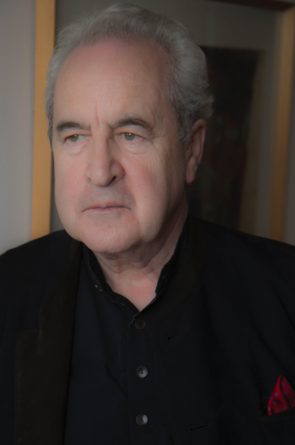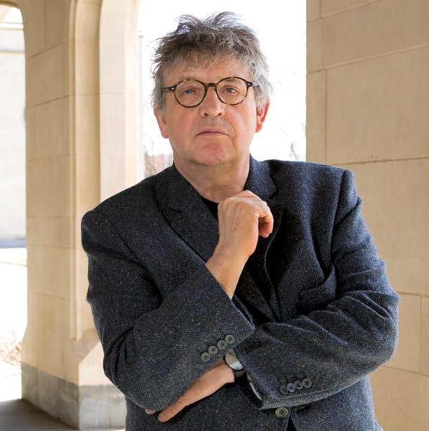
Photo Caption: Irish novelist John Banville (left) and poet Paul Muldoon (right)
Photo Credit: Photo by Douglas Banville (left) and Denise Applewhite (right)

Who/What: Irish novelist John Banville reads from his work, followed by a discussion with poet Paul Muldoon, presented by Princeton University’s Fund for Irish Studies
When: Friday, September 20 at 4:30 p.m.
Where: James Stewart Film Theater at 185 Nassau Street on the Princeton University campus
Free and open to the public

(Princeton, NJ) Award-winning Irish novelist John Banville reads from his work followed by a conversation with Princeton’s Howard G.B. Clark '21 University Professor in the Humanities Paul Muldoon on Friday, September 20. The event will take place at the James Stewart Film Theater at 185 Nassau Street on the Princeton University Campus at 4:30 p.m. The reading and conversation are free and open to the public as a part of Princeton University’s 2019-20 Fund for Irish Studies series.

Born and raised in Wexford, Ireland, Banville studied at Christian Brothers schools and St. Peter’s College before he began his career as an author. Banville worked as a clerk at Aer Lingus, Ireland’s national airline, a sub-editor at The Irish Press, and the Literary Editor of The Irish Times. Amidst Banville’s long and successful career in journalism, he began his career as a novelist.

In 1970, Banville published a short story collection and a novella, John Lankin, before publishing his first novel, Nightspawn, in 1971. Other novels by Banville include Birchwood (1973), The Book of Evidence (1989), Ghosts (1993), The Sea (2005), The Infinities (2009), and Mrs. Osmond (2017). Prague Pictures: Portraits of a City (2003) is Banville’s non-fiction book, in which he tells the story of Prague’s people and history throughout the years.

Banville has won several awards for his writing, including the Allied Irish Banks fiction prize, the American-Irish Foundation award, the James Tait Black Memorial Prize, and the Guardian Fiction Prize. Banville won the Man Booker Prize for The Sea, the Franz Kafka Prize, the Prince of Asturias Award, the Austrian State Prize for Literature, and the Irish Pen Award for Outstanding Achievement in Irish Literature. The Book of Evidence was shortlisted for the Booker Prize and Ghosts was shortlisted the Whitbread Fiction Prize. Banville also has written several crime novels, some of which have been developed for production on BBC, under the pseudonym Benjamin Black.

Muldoon is a Professor of Creative Writing at Princeton and director of the Princeton Atelier. He was born in 1951 in County Armagh, Northern Ireland, and educated in Armagh and at the Queen’s University of Belfast. From 1973 to 1986 he worked in Belfast as a radio and television producer for the British Broadcasting Corporation. Since 1987 he has lived in the United States, where he is now Howard G.B. Clark '21 University Professor in the Humanities at Princeton and Founding Chair of the Peter B. Lewis Center for the Arts. In 2007 he was appointed Poetry Editor of The New Yorker. Between 1999 and 2004 he was Professor of Poetry at the University of Oxford, where he is an honorary Fellow of Hertford College.
Muldoon’s main collections of poetry are New Weather (1973), Mules (1977), Why Brownlee Left (1980), Quoof (1983), Meeting The British (1987), Madoc: A Mystery (1990), The Annals of Chile (1994), Hay (1998), Poems 1968-1998 (2001), Moy Sand and Gravel (2002), Horse Latitudes (2006), Maggot (2010), One Thousand Things Worth Knowing (2015), and Poems 1968-2014 (2016).
A Fellow of the Royal Society of Literature, the American Academy of Arts and Sciences and the American Academy of Arts and Letters, Muldoon was given an American Academy of Arts and Letters award in literature for 1996. Other recent awards are the 1994 T. S. Eliot Prize, the 1997 Irish Times Poetry Prize, the 2003 Pulitzer Prize, the 2003 Griffin International Prize for Excellence in Poetry, the 2004 American Ireland Fund Literary Award, the 2004 Shakespeare Prize, the 2005 Aspen Prize for Poetry, and the 2006 European Prize for Poetry. He has been described by The Times Literary Supplement as “the most significant English-language poet born since the second World War.”
The Fund for Irish Studies affords all Princeton students, and the community at large, a wider and deeper sense of the languages, literatures, drama, visual arts, history, politics, and economics not only of Ireland but of “Ireland in the world.” The series is co-produced by the Lewis Center of the Arts and the 2019-20 edition of the series is organized by Muldoon and Senior Lecturer in Theater Michael Cadden.
Information about the Fund for Irish Studies series events can be found at fis.princeton.edu. Other events scheduled in the current series include:
- Journalist Anthony Murphy presenting “Dronehenge,” an illustrated talk on his 2018 discovery that has radically changed views of the Neolithic landscape of Brú na Bóinne,” on November 22
- “Fiddle strings, airplane wings and humanizing technology,” a talk by award-winning technology, innovation and creativity executive Domhnaill Hernon on December 6
- A reading by writer Hannah Sullivan on March 6
with additional events being planned for the spring.
The Fund for Irish Studies is generously sponsored by the Durkin Family Trust and the James J. Kerrigan, Jr. ’45 and Margaret M. Kerrigan Fund for Irish Studies.

To learn more about the more than 100 public performances, exhibitions, readings, screenings, concerts, lectures and special events, most of them free, presented each year by the Lewis Center for the Arts, visit arts.princeton.edu.

###

