September 18, 2019

Radical Nonfiction Film Series: Robert Greene’s Bisbee ’17
presented by Lewis Center for the Arts’ Program in Visual Arts
First in The Radical Nonfiction: Fantasy, Observation and Elasticity in the Documentary Film Series

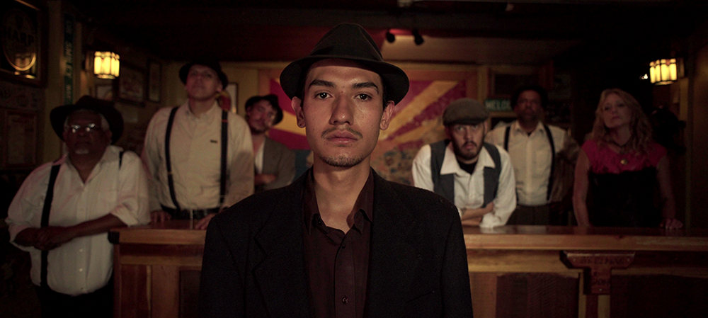
Photo caption: A still from Robert Greene’s film, Bisbee ’17
Photo credit: Courtesy of Robert Greene

What/Who: Screening of Bisbee’17 followed by a discussion with filmmaker Robert Greene and Vox film critic Alissa Wilkinson. This film is part of the Radical Nonfiction: Fantasy, Observation and Elasticity in the Documentary Film Series, organized by filmmaker Robert Greene and presented by the Lewis Center for the Arts’ Program in Visual Arts
When: Thursday, September 26 at 7:00 p.m.
Where: James Stewart Film Theater at 185 Nassau St. on the Princeton University campus
Admission: Free and open to the public

(Princeton, NJ) On Thursday, September 26, the Lewis Center for the Arts’ Program in Visual Arts at Princeton University will kick off the fall film series, Radical Nonfiction: Fantasy, Observation and Elasticity in the Documentary Film with a screening of the film Bisbee ’17 by Robert Greene, along with excerpts of some of his other films. The screening begins at 7:00 p.m. in the James Stewart Film Theater and will be followed by a conversation by Greene and Vox film critic Alissa Wilkinson. The event is free and open to the public.

The series is put together by Greene to take the current pulse of the ever-changing documentary film form. He notes, “Documentary film is full of contradictions; the staged meets the observed, intervention meets the authentic. Documentary film uses observation to show us the world we inhabit, but nonfiction images are also records of the fantasies of both filmmakers and subjects. What we believe, how we subjectively formulate our experiences — the fantasy of our own realities— can be captured and magnified by the camera and how we edit images together. This is documentary: an elastic, ever-changing attempt at working with the world as it is and as we hope it be.”

Bisbee’17, the first film in the series, is set in Bisbee, Arizona, an eccentric old mining town. The film combines collaborative documentary and western and musical elements to follow several members of the close-knit community as they attempt to reckon with their town’s darkest hour. In 1917, nearly 2,000 immigrant miners, on strike for better wages and safer working conditions, were violently rounded up by their armed neighbors, herded onto cattle cars, shipped to the middle of the New Mexican desert, and left there to die, known as the Bisbee Deportation. The film documents local residents as they play characters and stage dramatic scenes from the controversial story, culminating in a large-scale recreation of the deportation itself on the exact day of its 100th anniversary. The film premiered at the Sundance Film Festival and screened on the POV series on PBS.

Greene’s previous film Kate Plays Christine (2016) won a Jury Award for Writing at Sundance. His documentaries include the Gotham Awards-nominated Actress (2014), Fake it so Real (2011), and the Gotham Awards-nominated Kati with an I (2010). Greene was an inaugural Sundance Art of Nonfiction fellow in 2015, is a three-time nominee for Best Director at the Cinema Eye Honors, and received the 2014 Vanguard Artist Award from the San Francisco DocFest. His first documentary, Owning the Weather (2009), was screened at the COP15 Climate Change Conference in Copenhagen. He has been a Sundance Edit Lab Advisor and was on the U.S. Documentary Jury for Sundance 2017. He has edited over a dozen feature films and writes for outlets such as Sight & Sound and Indiewire, as well as serves as the Filmmaker-in-Chief for the Murray Center for Documentary Journalism at the University of Missouri.

Following Bisbee ’17 and clips from some of Greene’s other films, Vox film critic Alissa Wilkinson will engage in a conversation with Greene about his work.

Wilkinson joined Vox in 2016 as a staff writer and film critic. Before Vox, she spent a decade writing criticism and essays for a wide variety of publications, including Rolling Stone, Vulture, RogerEbert.com, The Washington Post, The Atlantic, The Los Angeles Review of Books, Christianity Today, and many more. She has also appeared as a commentator on many radio and television programs, and served on documentary juries at Sundance, Sheffield Doc/Fest, DOC|NYC, and the Hamptons Film Festival. She is an associate professor of English and humanities at The King’s College in Manhattan, where she teaches criticism, film studies, and cultural theory. She is a member of the New York Film Critics Circle and was a ’17-18 writing fellow with the Sundance Institute’s Art of Nonfiction Program.

The other screenings in the series are:
- America and new short films by Garrett Bradley followed by a conversation with the filmmaker and Greene on October 10. Greene notes that Bradley has found a language all her own, mixing performance, history, journalism and the gallery space to challenge modes of representation in exciting ways.
- My First Film with Zia Anger in which she takes the role of the filmmaker playing herself to new heights of immediacy in a live performance playing with the film Walled Unwalled by Lawrence Abu Hamdan, who uses sound and precise performances to electrify his political interventions. This event on October 17 will be followed by a reception with Anger.
- Hale County This Morning, This Evening, Easter Snap, and other new short films by RaMell Ross, who uses legacies of racial objectification to create new ways of seeing, followed by a conversation with Ross and Green, on November 7.

The film series is supported through the John Sacret Young ’69 Lecture Series fund. Sacret Young is a 1969 graduate of Princeton and an author, producer, director, and screenwriter. He has been nominated for seven Emmy Awards and seven Writers Guild of America (WGA) Awards, winning two WGA Awards. He is perhaps best known for co-creating, along with William F. Broyles Jr., China Beach, the critically acclaimed ABC-TV drama series about medics and nurses during the Vietnam War, and for his work on the television drama The West Wing. Young has also received a Golden Globe and a Peabody Award, and his original mini-series about the Gulf War, Thanks of a Grateful Nation, was honored with his fifth Humanitas Prize nomination.

For more information on the Program in Visual Arts and the more than 100 performances,
exhibitions, readings, screenings, concerts and lectures presented each year by the Lewis Center
for the Arts, most of them free, visit arts.princeton.edu.

###

