September 26, 2019

Radical Nonfiction Film Series: America and new short films
by Garrett Bradley, presented by Lewis Center for the Arts’
Program in Visual Arts
Next in the Radical Nonfiction: Fantasy, Observation and Elasticity in the Documentary Film series
Artist talk with Garrett Bradley following the films

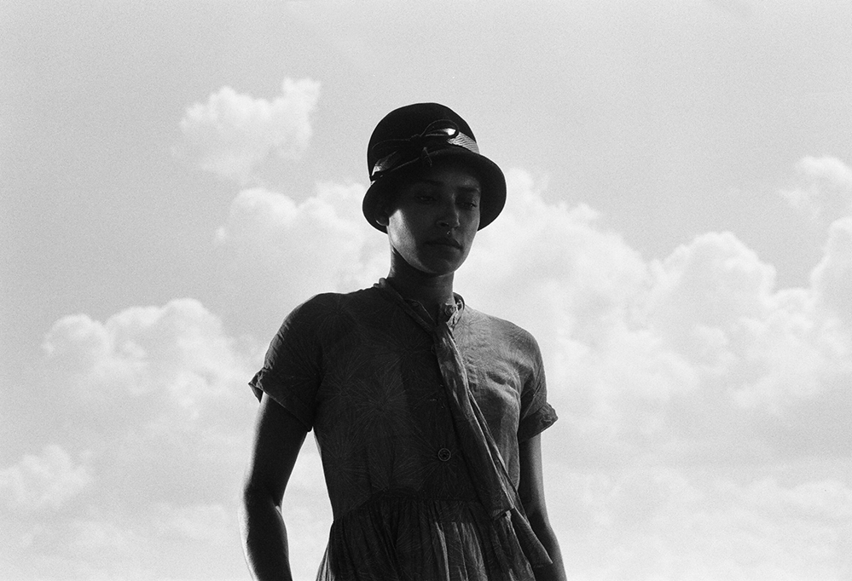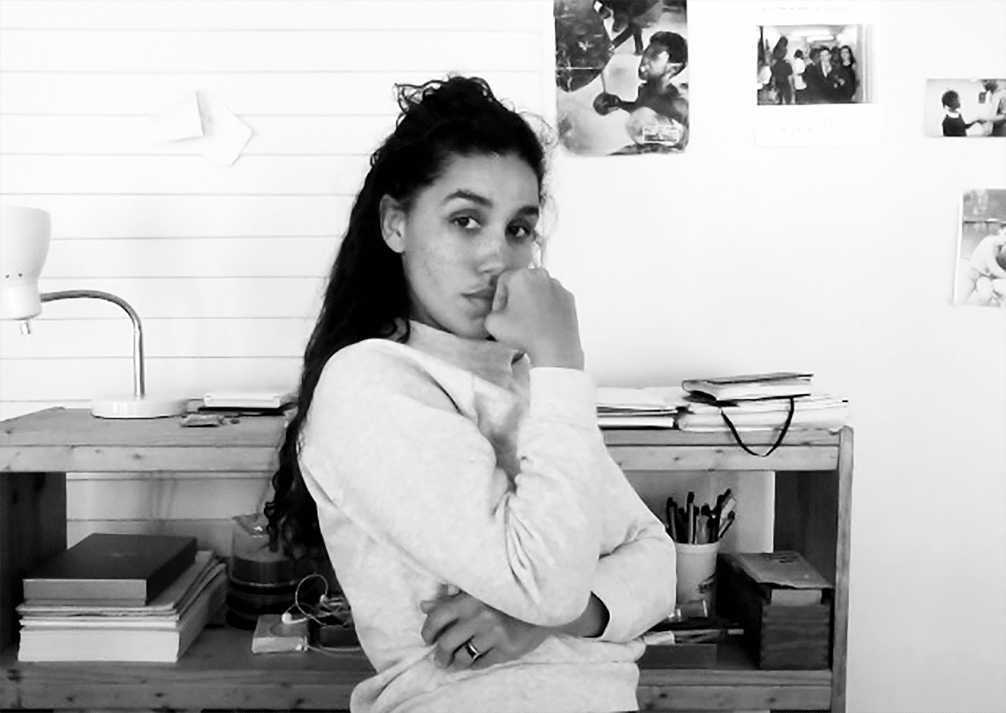
Photo caption1: A still from Garrett Bradley’s film America
Photo caption 2: Filmmaker Garrett Bradley
Photo credits: Courtesy of Garrett Bradley

What/Who: The Radical Nonfiction: Fantasy, Observation and Elasticity in the Documentary Film series continues with a screening of Garrett Bradley films including America, a film that challenges the idea of black cinema as a "wave" or "movement in time;" the Sundance-winning Alone, an investigation into the layers of mass incarceration and its shaping of the modern black American family; and The Earth is Humming about Japanese residents dealing with frequent earthquakes. Followed by an artist talk with Bradley and filmmaker/series organizer Robert Greene, and presented by the Lewis Center for the Arts’ Program in Visual Arts
When: Thursday, October 10 at 7:00 p.m.
Where: James Stewart Film Theater at 185 Nassau St. on the Princeton University campus
Admission: Free and open to the public

(Princeton, NJ) On Thursday, October 10, the Lewis Center for the Arts’ Program in Visual Arts at Princeton University continues the fall film series, Radical Nonfiction: Fantasy, Observation and Elasticity in the Documentary Film, with a screening of America and new short films by Garrett Bradley. The screening begins at 7:00 p.m. in the James Stewart Film Theater and will be followed by a conversation with Bradley and series organizer and filmmaker Robert Greene. The event is free and open to the public.

The series has been put together by Greene to take the current pulse of the ever-changing documentary film form. He notes, “Documentary film is full of contradictions; the staged meets the observed, intervention meets the authentic. Documentary film uses observation to show us the world we inhabit, but nonfiction images are also records of the fantasies of both filmmakers and subjects. What we believe, how we subjectively formulate our experiences — the fantasy of our own realities— can be captured and magnified by the camera and how we edit images together. This is documentary: an elastic, ever-changing attempt at working with the world as it is and as we hope it be.”

“The films of New Orleans-based artist Garrett Bradley relish in the most exciting instabilities of documentary,” notes Greene. “Her work is literal yet impressionistic, theatrical yet intimately observed, mannered yet emotionally raw. She is preoccupied with history and the legacies of racially-charged moving pictures, yet her films are firmly rooted in the now and more than mildly obsessed with the future of image making.”

Bradley’s recent film, America, which Greene describes as, “an experimental, visually stunning examination and transformation of African American history-through-cinema, that makes clear Bradley’s standing as one of the most exciting filmmakers working today,” premiered at the Sundance Film Festival and has since become an installation at the New Orleans Museum of Art and is touring nationally. America challenges the idea of black cinema as a "wave" or "movement in time," proposing instead, a continuous thread of achievement.
The screening will also include Bradley’s film Alone (2017), a Sundance Shorts Award winner, which is an investigation into the layers of mass incarceration and its shaping of the modern black American family as seen through the eyes of a single mother in New Orleans, Louisiana. Also on the program is The Earth is Humming (2018), in which Bradley highlights the fact that around 10 percent of all earthquakes occur in and around Japan, with citizens experiencing as many as 1,000 earthquakes per year. For them, preparing for these disasters is a part of daily life, as well as a full-blown industry.
A recipient of the Sundance Art of Nonfiction Fellowship, Bradley has been recognized by Creative Capital, Art Matters, The Ford Foundation, The MacArthur Foundation, and The Warhol Foundation. She has received numerous prizes in addition to the Sundance award for Alone, made with The New York Times OpDocs. Alone was also named Documentary of the Year by Vimeo and shortlisted for an Academy Award.
Bradley’s short films and feature-length projects have exhibited internationally at museums, festivals and platforms including The Getty Museum, The Hammer Museum, The Sundance Film Festival, The TribeCa Film Festival, Festival du Nouveau Cinema Montreal, The Rotterdam Film Festival, DokuFest, Norwegian Film Festival, Nantucket Film Festival, Rooftop Films, The New Orleans Film Festival, The LA Film Festival, Hot Docs, SXSW, The US Embassy Tel Aviv, The New York Times OpDocs, and Field of Vision.
Greene’s films include Bisbee ’17, which screened at Princeton on September 26, and Kate Plays Christine (2016), which won a Jury Award for Writing at Sundance. His documentaries include the Gotham Awards-nominated Actress (2014), Fake it so Real (2011), and the Gotham Awards-nominated Kati with an I (2010). Greene was an inaugural Sundance Art of Nonfiction fellow in 2015, is a three-time nominee for Best Director at the Cinema Eye Honors, and received the 2014 Vanguard Artist Award from the San Francisco DocFest. His first documentary, Owning the Weather (2009), was screened at the COP15 Climate Change Conference in Copenhagen. He has been a Sundance Edit Lab Advisor and was on the U.S. Documentary Jury for Sundance 2017. He has edited over a dozen feature films and writes for outlets such as Sight & Sound and Indiewire, and he serves as the Filmmaker-in-Chief for the Murray Center for Documentary Journalism at the University of Missouri.

Upcoming screenings in the series are:
- My First Film with Zia Anger in which she takes the role of the filmmaker playing herself to new heights of immediacy in a live performance, playing with the film Walled Unwalled by Lawrence Abu Hamdan, who uses sound and precise performances to electrify his political interventions. This event on October 17 will be followed by a reception with Anger.
- Hale County This Morning, This Evening, Easter Snap, and other new short films by RaMell Ross, who uses legacies of racial objectification to create new ways of seeing, followed by a conversation with Ross and Green, on November 7.

The film series is supported through the John Sacret Young ’69 Lecture Series fund. Sacret Young is a 1969 graduate of Princeton and an author, producer, director, and screenwriter. He has been nominated for seven Emmy Awards and seven Writers Guild of America (WGA) Awards, winning two WGA Awards. He is perhaps best known for co-creating, along with William F. Broyles Jr., China Beach, the critically acclaimed ABC-TV drama series about medics and nurses during the Vietnam War, and for his work on the television drama The West Wing. Young has also received a Golden Globe and a Peabody Award, and his original mini-series about the Gulf War, Thanks of a Grateful Nation, was honored with his fifth Humanitas Prize nomination.

For more information on the Program in Visual Arts and the more than 100 performances,
exhibitions, readings, screenings, concerts and lectures presented each year by the Lewis Center for the Arts, most of them free, visit arts.princeton.edu.

###

