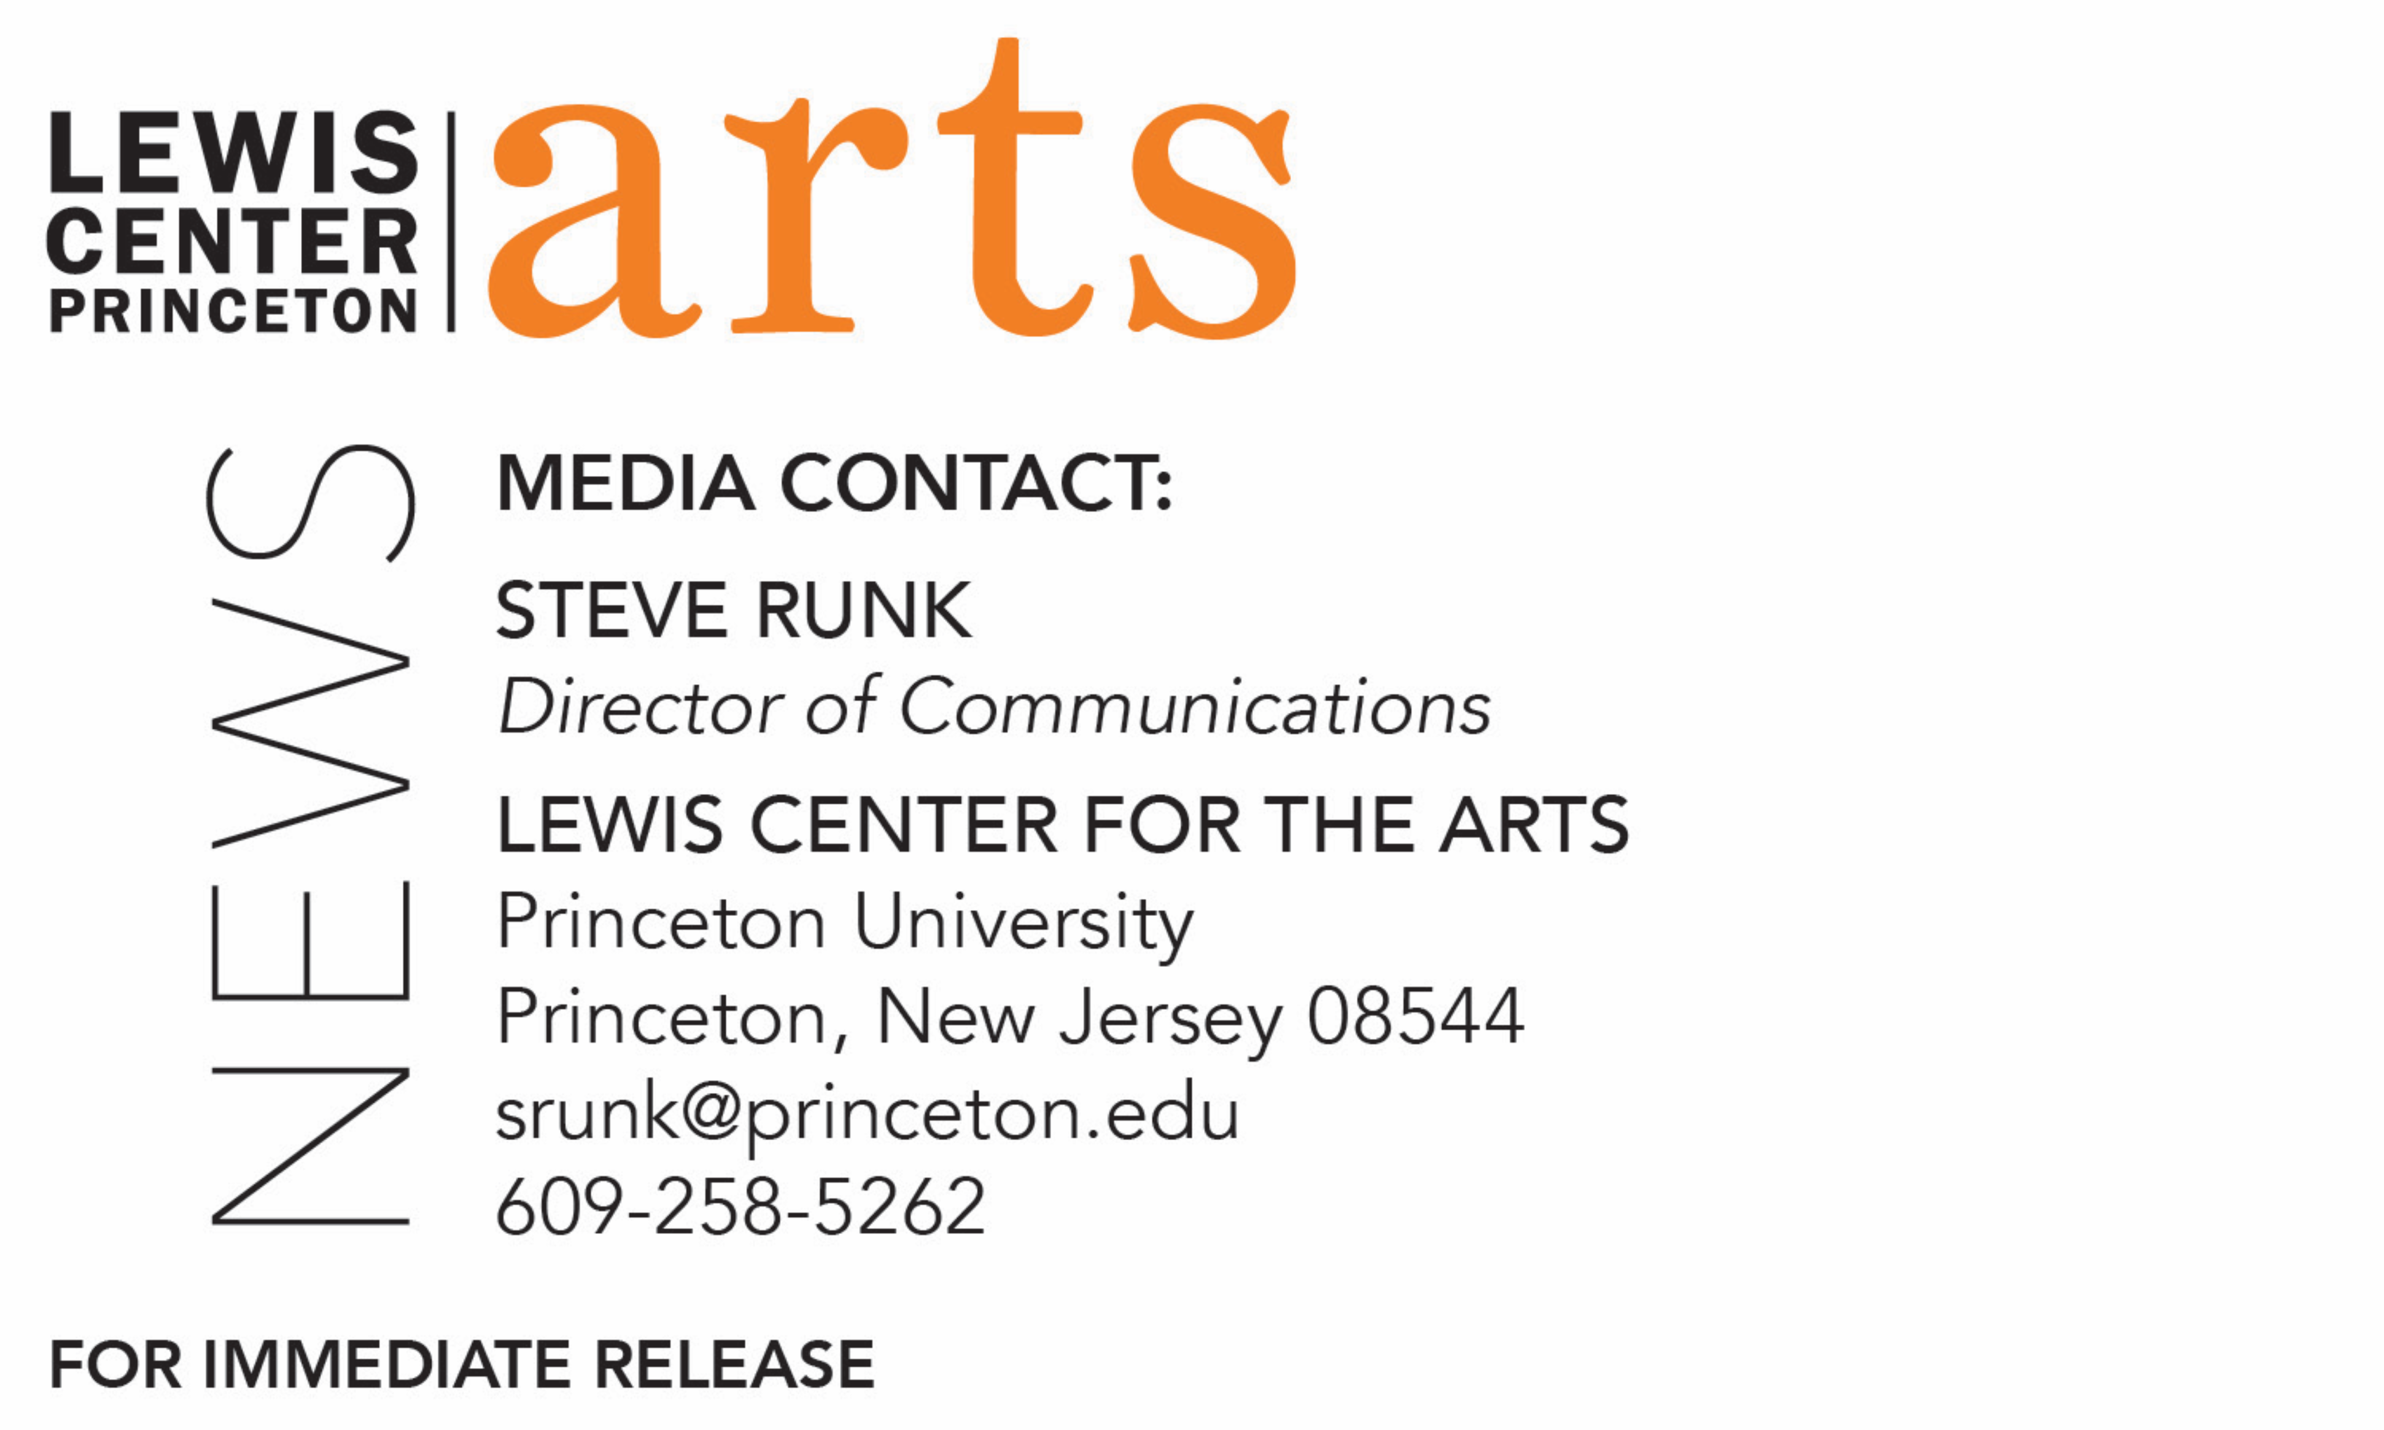

September 3, 2019

Lewis Center for the Arts’ Program in Visual Arts presents
The Work of Several Lifetimes
Exhibition by artist and 2018-2019 Hodder Fellow Mario Moore of etchings, drawings, and large-scale paintings of Black men and women who work at or around the Princeton University campus in blue collar jobs

Photo caption: Artist Mario Moore in his studio explaining one of the completed works in his series of large-scale paintings of Black men and women who work at or around the Princeton University campus in blue collar jobs that will be part of his exhibition, The Work of Several Lifetimes, on view September 19-November 17 at the Hurley Gallery at Lewis Arts complex on the Princeton University campus.
Photo credit: Jaclyn Sweet

What/Who: The Work of Several Lifetimes, an exhibition by artist and 2018-2019 Hodder Fellow Mario Moore of etchings, drawings, and large-scale paintings of Black men and women who work at or around the Princeton University campus in blue collar jobs, created over the past year, presented by the Lewis Center for the Arts’ Program in Visual Arts. Catalog cosponsored by Princeton’s Campus Iconography Committee.
When: On view September 19-November 17. Opening celebration September 19 from 6-8 p.m. and reception 8-10 p.m.
Where: Hurley Gallery at Lewis Arts complex on the Princeton University campus (122 Alexander St.)
Gallery Hours: Daily from 10:00 a.m. - 8:30 p.m.
Free and open to the public

(Princeton, NJ) The Lewis Center for the Arts’ Program in Visual Arts at Princeton University will present The Work of Several Lifetimes, an exhibition by artist and 2018-2019 Hodder Fellow Mario Moore of etchings, drawings, and large-scale paintings of Black men and women who work at or around the Princeton University campus in blue collar jobs, created over the past year. The work will be on view September 19 through November 17 in the Hurley Gallery at the Lewis Arts complex on the Princeton campus. The exhibition will open with a celebratory event with surprise performances in the gallery on September 19 from 6:00 to 8:00 p.m. followed by a dinner reception in the arts complex Forum from 8:00 to 10:00 p.m. A panel discussion is scheduled for October 22 at 4:30 p.m. in the gallery. All events are free and open to the public. A catalog for the exhibition is cosponsored by Princeton’s Campus Iconography Committee.

Moore is a Detroit native whose work has afforded him many opportunities, including multiple exhibitions and featured articles in The New York Times and elsewhere. His work is included in several public and private collections which include the Detroit Institute of Art and the Studio Museum in Harlem. Some of his solo show exhibits have been seen at the David Klein Gallery and The Urban Institute of Contemporary Art. His work is also included in Fired Up! Ready to Go! Finding Beauty, Demanding Equity: An African American Life in Art (2017) and The Studio Museum in Harlem’s catalog, Speaking of People: Ebony, Jet and Contemporary Art (2014). He has participated as an artist-in-residence at Knox College, Fountainhead, and the Albers Foundation, and he has worked as a sculptor on film sets. Moore received a B.F.A. in Illustration from the College for Creative Studies and an M.F.A. in Painting from the Yale School of Art in 2013.

In addition to this upcoming exhibition at Princeton, Moore is part of a current traveling Smithsonian exhibition, Men of Change: Power. Triumph. Truth., which recognizes African American men whose journeys have altered the history and culture of the country through politics, sports, science, entertainment, business and religion, through works created by 25 artists. Moore created a piece on Robert Smith, the billionaire investor who in May of this year announced during his commencement speech at Morehouse College that he would pay off the student loan debt for the historically black college's graduating class. Moore has also been preparing work for the International Exposition of Contemporary & Modern Art in Chicago, which opens the same day as his Princeton show. In the coming year, he will be part of a group show in Detroit and a solo show in New Orleans.

Moore is among five 2018-19 Hodder Fellows, artists chosen each year who demonstrate great promise and “much more than ordinary intellectual and literary gifts.” The support is intended to allow the selected artists to pursue an independent project with no requirement to be on the Princeton campus. However, Moore is among a growing number of Hodder Fellows who seek to engage deeply with the University’s creative community. He moved to Princeton last September and maintained a working studio in the Program in Visual Arts, housed at 185 Nassau Street.

Moore’s work for the past year was also focused on Princeton. Drawing from his own background working blue collar jobs and his father’s experience working as a security guard at the Detroit Institute of Art, Moore sought to shine a light on the often-overlooked African-American men and women who work these types of jobs at Princeton.

“My project as a Hodder Fellow at Princeton has been about people, learning about people who work hard at Princeton but are not often recognized,” said Moore. “Most people walk through elite institutions of art, education and places of exclusivity with an expectation of only acknowledging security guards or people who work in facilities when they need something. I grew up understanding all those individuals as part of my family since one of my dad’s first jobs was a security guard. Acknowledging the unacknowledged and analyzing art history with a magnifying glass is at the heart of this exhibition.”

Moore’s subjects include two security guards at the Princeton University Art Museum, a custodian at the Lewis Arts complex, three members of the staff at Rockefeller-Mathey dining hall at two of Princeton’s residential Colleges, a member of the staff at a local Mediterranean restaurant, an exhibition preparer at the Lewis Center, and two staff members — one current, one retired — from the athletics department. He depicts some of his subjects both in their work environment and in personal or leisure environments, communicating these individuals have a rich life and interests beyond their workplace role where the Princeton community typically sees them.

“I was walking around campus a lot and just seeing people, and walking up to them and telling them about my project,” explains Moore. “You know, it's kind of weird, a guy coming up like, ‘Hey you wanna be involved in this art project I'm doing?’” He recounts how he approached Art Museum security guard Michael Moore (no relation). “I asked him ‘Where can I get my hair cut?,’ because, especially for black men, there's like nowhere to get your hair cut in Princeton. He's telling me about Trenton and New Brunswick, and then I start telling him about my project. Michael wanted to introduce me to another subject to paint, but I said, ‘No, I want to paint you in this project.’”

Getting to know each of his subjects was fundamental to his process for creating the works. He sat down with each one, ultimately 11 subjects, while they were on a lunch break or after work and, while talking, he made sketches of them as a visual recording of their interaction and discussed the idea for their painting, how they should be depicted in their workplace but also placing them in a position of power or appreciation. He also took photographs of his subjects where they work. He then worked on the large-scale paintings in his studio, referencing his sketches, photographs, and the conversations. He has also created etchings of each subject.

The conversations have ultimately shaped the environment in which the subject is depicted. For example, Museum security guard Moore’s painting is an invitation into a gallery space that actually exists, and the paintings behind him on the walls are real but not actually displayed or owned by the museum. They are works by artists Mario Moore admires, like Henry Ossawa Tanner, the first African-American painter to gain international acclaim, represented by a painting of his father who was a pastor. A portion of a very large painting by artist Barkley Hendricks, who died in 2017, is also represented, along with a mid-20th century lithograph by Charles White of Frederick Douglass. Moore also includes one of his own paintings done in 2011, and directly behind the subject is a representation of part of a Nigerian bronze sculpture from the medieval period. The security guard is giving access to the viewer to this special imagined collection of works.
In addition to the exhibition opening’s special performances and dinner reception, on October 22 Moore will host a panel discussion on the work that will include Lewis Center Chair and recent U.S. Poet Laureate Tracy K. Smith, among others.

In addition to his year-long portraits project, Moore has engaged in the past year with Lewis Center visual arts students and faculty, employing a number of students as studio assistants and visiting the studios of juniors and seniors to talk about their work. In July, Moore’s studio was a stop on a campus tour for a group of students and faculty members of the Historically Black Colleges and Universities (HBCU) Alliance of Museums and Galleries who were visiting Princeton in a new partnership with the Princeton University Art Museum. During the rest of the fall semester, Moore will be involved in student critiques and mentoring and in the spring will teach the course, “Drawing I.”

For more information on this event, the Program in Visual Arts, or any of the more than 100 performances, exhibitions, readings, screenings and lectures presented annually by the Lewis Center for the Arts, most of them free, visit arts.princeton.edu.

###

