October 7, 2019

Nathan Alan Davis named a Roger S. Berlind Playwright-in-Residence at
the Lewis Center for the Arts at Princeton University
Award-winning playwright will teach in the Program in Theater and engage with the creative community at Princeton over the next several years

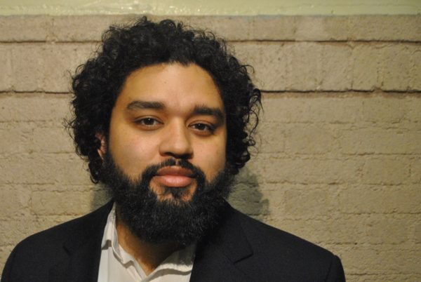

Photo caption: Playwright Nathan Alan Davis
Photo credit: Elizabeth Q. Davis

(Princeton, NJ) Award-winning playwright Nathan Alan Davis has been selected by the Lewis Center for the Arts at Princeton University as a Roger S. Berlind ’52 Playwright-in-Residence. Davis will teach in the Lewis Center’s Program in Theater and will engage with Princeton’s creative community over the next several years.

This residency, made possible by the support of Roger S. Berlind, Princeton Class of 1952, recognizes playwrights whose work has significant impact on the field.

“The theater program is delighted to deepen our relationship to this extraordinary writer and human being, who has already become an indispensable voice in our community,” said Jane Cox, Director of Princeton’s Program in Theater. “Nathan Davis has a thrilling and passionate theatrical voice as a playwright. He is also a brilliant and generous teacher at all levels, and a committed mentor who inspires and energizes our students. We feel privileged that Nathan will be able to participate in curricular and season choices in his new role as our Playwright-in-Residence, and that our students will have an opportunity to work with him at a more advanced level. We’re also very excited for our students to be able to follow along as Nathan’s Refuge Plays is staged at the McCarter in 2020!”

Davis’ plays include Nat Turner in Jerusalem, which premiered at New York Theatre Workshop in 2016; Dontrell Who Kissed the Sea, which had a National New Play Network Rolling World Premiere and received a Steinberg/American Theatre Critics Association New Play Citation in 2015; and The Wind and the Breeze, which premiered at Cygnet Theatre in 2018. His trilogy, The Refuge Plays, will premiere at the McCarter Theatre in May of 2020, directed by Patricia McGregor. Davis received a Whiting Award in Drama in 2018. Other awards include the Stavis Playwright Award, Blue Ink Award, and Lorraine Hansberry Award. He is a Usual Suspect at New York Theatre Workshop and a 2016 graduate of Juilliard’s Lila Acheson Wallace American Playwrights Program. The Rockford, Illinois, native received his M.F.A. from Indiana University and his B.F.A. from the University of Illinois. He has taught playwriting in Princeton’s Program in Theater every fall semester since 2016.

“My time teaching at the Lewis Center during the past three years has been a true blessing and a source of great happiness,” notes Davis. “As Playwright-in-Residence, I look forward to finding ways to more deeply serve, support, mentor, and encourage student-artists, as well as the community at large, while continuing to develop my own body of work.”

The Playwright-in-Residence program was established in 2014 through the support of Roger S. Berlind, Princeton Class of 1952, best known as the Tony Award-winning producer of over 100 New York shows, including The Book of Mormon, Amadeus, Annie, City of Angels, Hamlet (with Ralph Fiennes), Sophisticated Ladies, and A View from the Bridge. Berlind and his son William Berlind, Princeton Class of 1995, won the 2019 Tony Award for Best Revival of a Musical for their revival of Oklahoma!. In 2009, Berlind was inducted into the American Theater Hall of Fame; in 2011, he received a Lifetime Achievement Award from the playwright-development workshop New Dramatists. He provided the lead funding for construction of the Roger S. Berlind Theatre at McCarter Theatre Center, a venue shared by McCarter and Princeton University.

Past Berlind Playwrights-in-Residence have included Christopher Durang, Branden Jacobs-Jenkins (Princeton Class of 2006), Sarah Ruhl, Naomi Iizuka, Migdalia Cruz, Lauren Yee, Shariffa Ali, Joanna Evans and Avi Amon.

To learn more about the Lewis Center for the Arts and the Program in Theater visit arts.princeton.edu.

###

