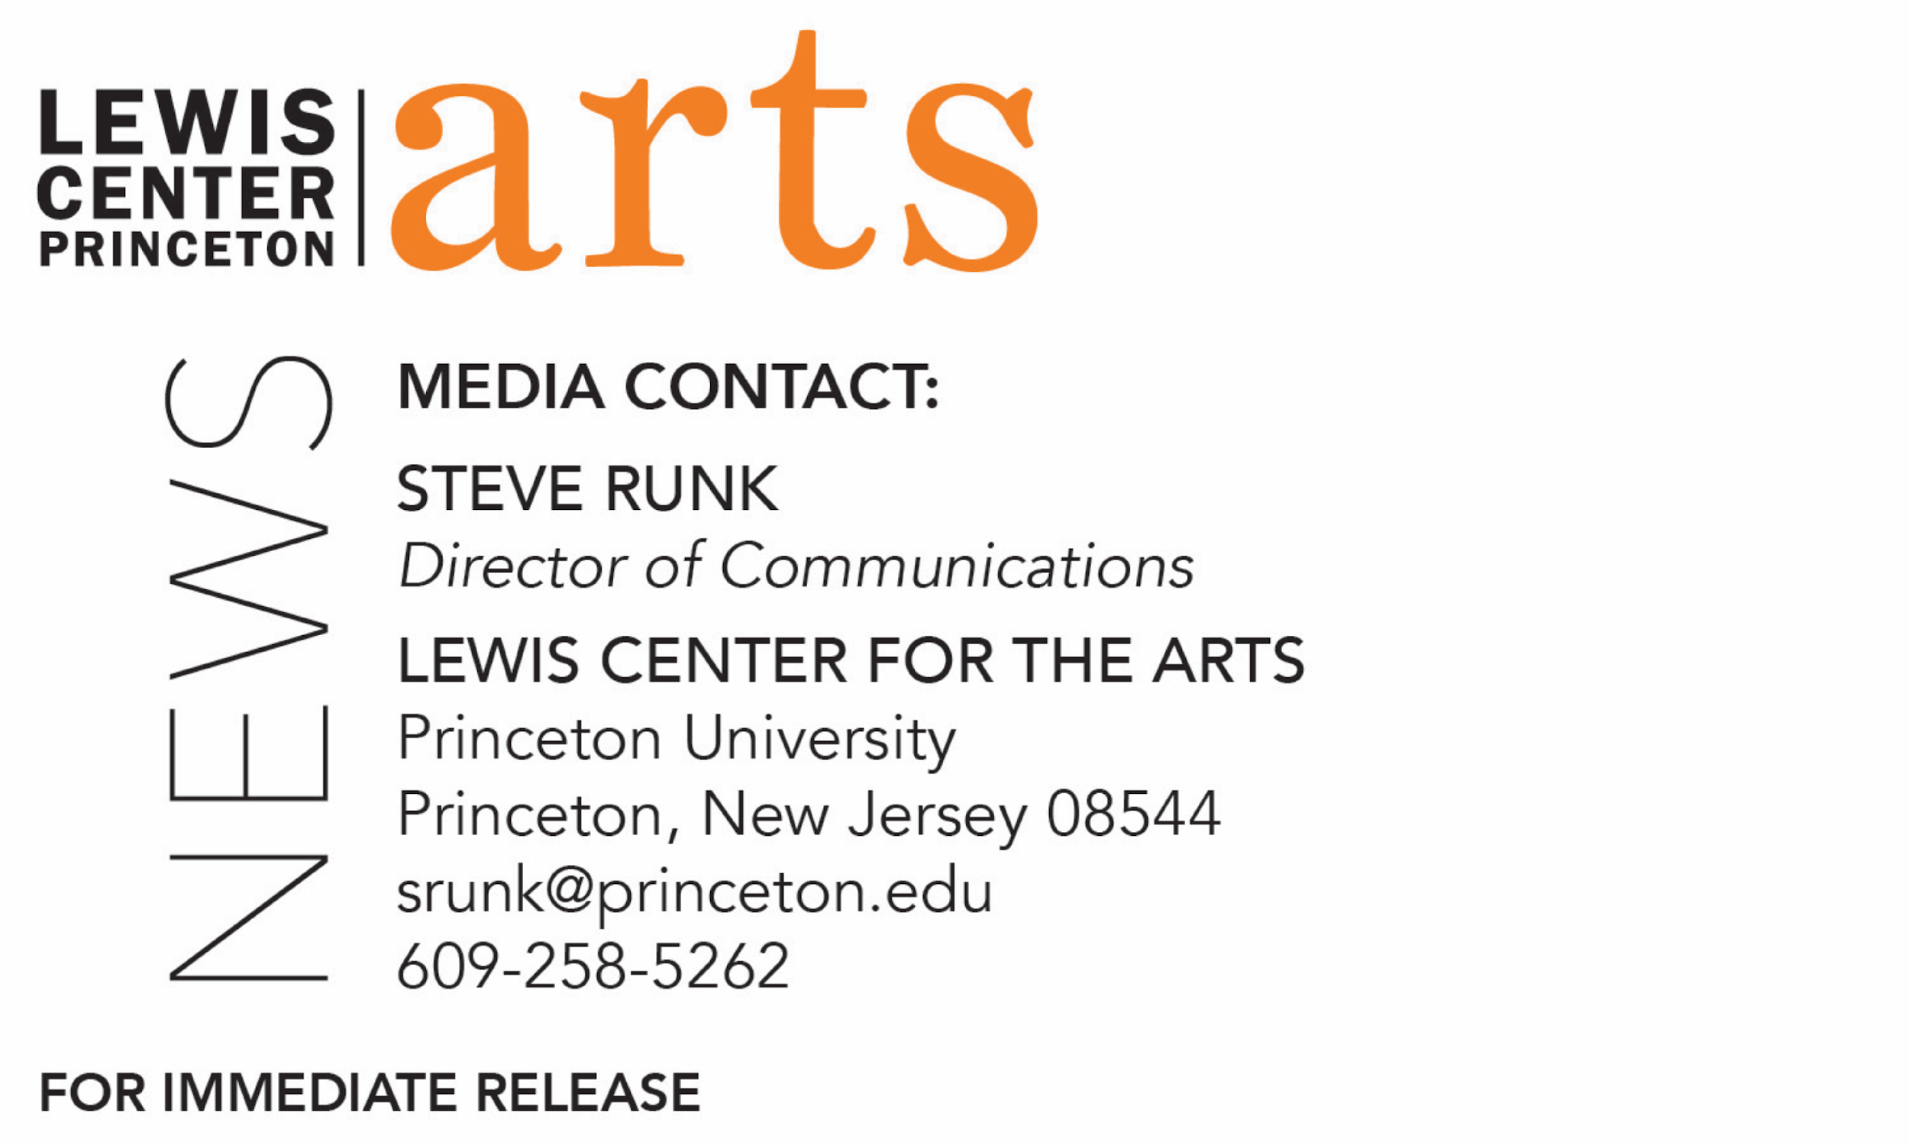

October 31, 2019

Princeton University's Lewis Center for the Arts presents
The Toni Morrison Conversations
Artists Reflect on Toni Morrison’s Gifts to Life, Art and Culture
First in a series of events organized under the Princeton Atelier spanning the 2019-20 academic year featuring artists engaging with themes, questions and possibilities relevant to the work and legacy of writer Toni Morrison

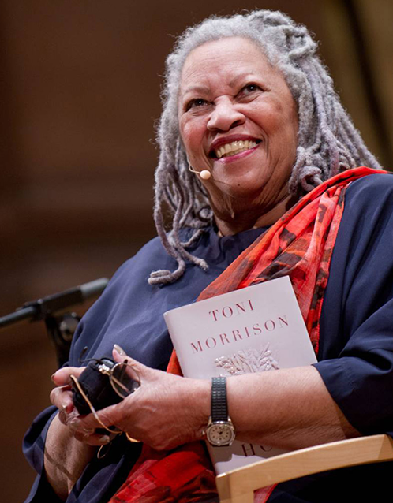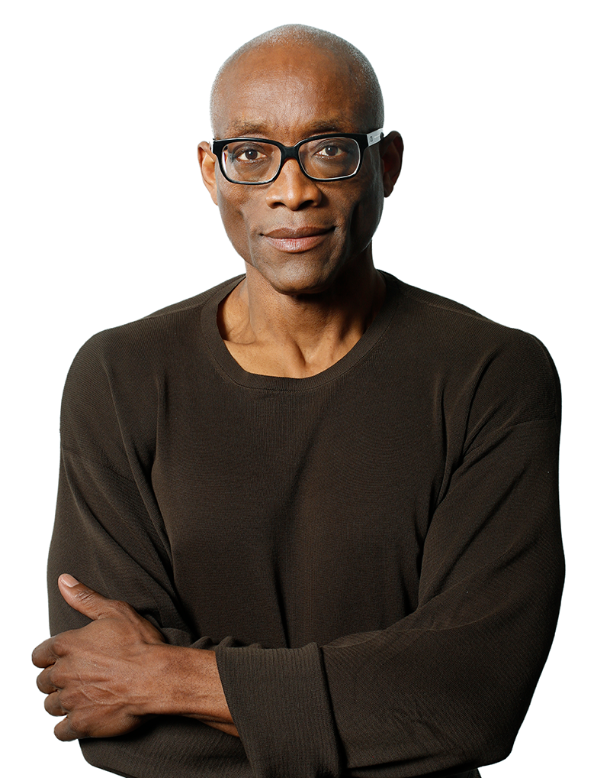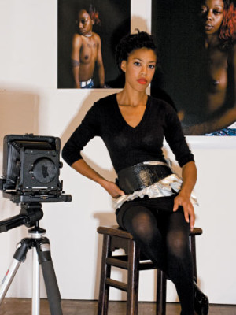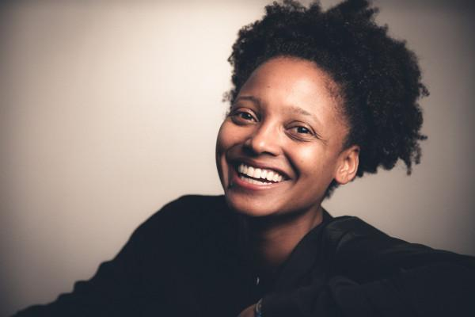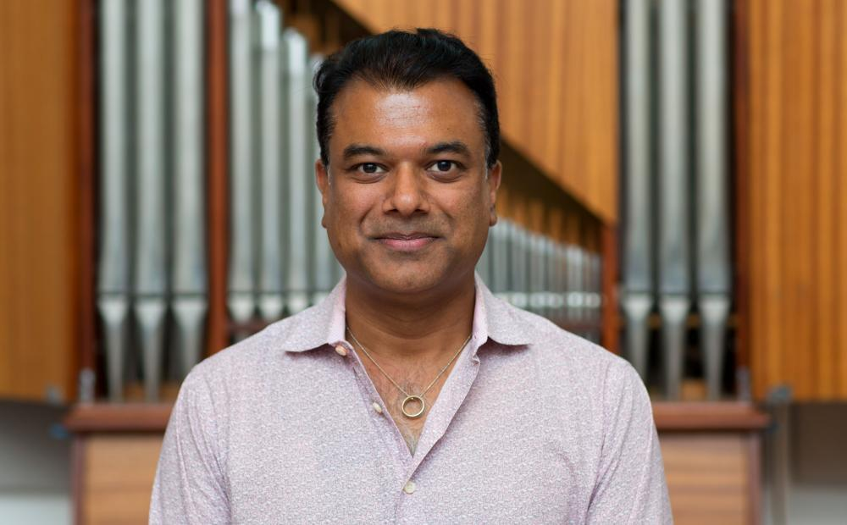

Photo caption: Left to right, Nobel Prize-winning writer Toni Morrison, choreographer Bill T. Jones, photographer Deana Lawson, 22nd U.S. Poet Laureate and Lewis Center Chair Tracy K. Smith, and saxophonist/composer Rudresh Mahanthappa
Photo credits: Left to right, Sameer Khan, Philip Habib, courtesy of Deana Lawson, Rachel Eliza Griffiths, and courtesy of Princeton University Department of Music

What/Who: The Toni Morrison Conversations – Artists Reflect on Toni Morrison’s Gifts to Life, Art and Culture, presented by the Lewis Center for the Arts’ Princeton Atelier. The first in a series of events spanning the 2019-20 academic year featuring artists engaging with themes, questions and possibilities relevant to the work and legacy of writer and Princeton Professor, Emeritus, Toni Morrison. In this first event, legendary choreographer Bill T. Jones and award-winning photographer Deana Lawson are in conversation with 22nd U.S. Poet Laureate and Lewis Center Chair Tracy K. Smith with a performance by Rudresh Mahanthappa Tiger Quartet.
When: November 13 at 7:30 p.m.
Location: Richardson Auditorium on the Princeton University campus
Free and open to the public, but tickets are required. Advance ticket reservations are encouraged through University Ticketing at tickets.princeton.edu. Tickets available starting November 4 at 12 noon.
For more information: https://arts.princeton.edu/events/the-toni-morrison-conversations-bill-t-jones-deana-lawson/

(Princeton, NJ) Princeton University's Lewis Center for the Arts will present the first event in The Toni Morrison Conversations — Artists Reflect on Toni Morrison’s Gifts to Life, Art and Culture, a series of events spanning the 2019-20 academic year featuring artists engaging with themes, questions and possibilities relevant to the work and legacy of writer and Princeton Professor, Emeritus, Toni Morrison. On November 13 the series will open with legendary choreographer Bill T. Jones and award-winning photographer Deana Lawson in conversation with 22nd U.S. Poet Laureate and Lewis Center Chair Tracy K. Smith with a performance by Rudresh Mahanthappa Tiger Quartet. The event begins at 7:30 p.m. at Richardson Auditorium on the Princeton campus. The event is free and open to the public, however tickets are required, and advance ticket reservations are encouraged through University Ticketing at tickets.princeton.edu. Tickets will be available starting November 4 at 12 noon.

The series pays tribute to Morrison, who passed away on August 5, 2019, at the age of 88. A world-renowned writer and Nobel laureate, Morrison was the Robert F. Goheen Professor in the Humanities, Emeritus, at Princeton, a Professor of Creative Writing, and founder of the Princeton Atelier. The series continues on February 4 and April 28. The April event is being planned in collaboration with Princeton’s Department of African American Studies and its annual Toni Morrison Lectures, scheduled for April 27 and 29. The series is co-organized by Smith, who is also Princeton’s Roger S. Berlind ’52 Professor in the Humanities and Professor of Creative Writing, and Paul Muldoon, Princeton’s Howard G.B. Clark ’21 University Professor in the Humanities, Director of the Princeton Atelier, and Professor of Creative Writing.

“In this year following the loss of Morrison’s presence on earth, we are grateful for the chance to celebrate all the many lasting gifts she has given to humanity,” said Smith. “This series affords us the opportunity to talk with a range of artists working in various forms and disciplines about the ongoing relevance of Morrison’s work to their own creative process.”

Morrison joined the Princeton faculty in 1989 and was a member of the University’s Program in Creative Writing until she transferred to emeritus status in 2006. In 1993, she became the first African American to be awarded the Nobel Prize in Literature. Her work has been translated into at least 20 languages. Her groundbreaking novels include The Bluest Eye (1970), Sula (1973), Song of Solomon (1977) Tar Baby (1981), Beloved (1987), Jazz (1992), Paradise (1997), Love (2003), A Mercy (2008), Home (2012), and God Help the Child (2015). Her latest book, The Source of Self-Regard: Selected Essays, Speeches, and Meditations, was published in early 2019.

In addition to the Nobel Prize, Morrison won a Pulitzer Prize for Beloved in 1988 and a National Book Critics Circle Award for Song of Solomon in 1978. In May 2019, she received the gold medal from the American Academy of Arts and Letters. She was awarded the American Academy of Arts and Sciences Emerson-Thoreau Medal in 2016, the Presidential Medal of Freedom in 2012, and the National Humanities Medal in 2000. Evincing her international readership are two major awards from France: the Ordre National de la Légion d’honneur in 2010; and the Commandeur de l’Ordre des Arts et des Lettres in 1993. Morrison was also an acclaimed essayist and librettist. She wrote children’s books with her son Slade Morrison. This past summer, a documentary of her life, Toni Morrison: The Pieces I Am by Timothy Greenfield-Sanders, was released in theaters.

Morrison’s arrival helped to attract other faculty and students from traditionally underrepresented backgrounds to Princeton, and she played a catalytic role in expanding Princeton’s commitments both to the creative and performing arts and to African American studies. In 1994 she founded the Princeton Atelier, bringing together undergraduate students in interdisciplinary collaborations with acclaimed artists and performers such as Jacques d’Amboise, A.S. Byatt, Peter Sellars, Yo-Yo Ma, Richard Danielpour, Bernice Johnson Reagon, Gabriel García Márquez, Anonymous 4, Richard Price, Pig Iron Theatre Company, Maria Tucci and Allegra Kent among others, now directed by Muldoon. In honor of Morrison’s career achievements and contributions to Princeton, the University dedicated Morrison Hall, formerly West College, in 2017. In 1996, she gave the keynote address — “The Place of the Idea, The Idea of the Place” — as the University celebrated its 250th anniversary. In 2005, Morrison was the Baccalaureate speaker for the graduating class. In 2012, she returned “home” to campus to read from her then new novel, Home. Morrison’s papers are part of the Princeton University Library’s permanent collection with a selection of first editions, translations, corrected typescripts, and a handwritten first draft of her novels currently on display in the Firestone Library lobby. Last spring, the Lewis Center awarded its inaugural Toni Morrison Prize, which is given to one or more graduating seniors whose individual or collaborative artistic practice has pushed the boundaries and enlarged the scope of our understanding of issues of race. This prize honors work in any form that, in the spirit of Morrison, is “characterized by visionary force and poetic import.”

“We are delighted to present these events under the aegis of the Princeton Atelier,” said Muldoon, “a program that takes as its major article of faith the idea that art reflects partnerships — between artist and artist, the artist and their community, the artist and audience member.”

Bill T. Jones is artistic director, co-founder, and choreographer of Bill T. Jones/Arnie Zane Company. He is the associate artist of the 2020 Holland Festival and recipient of the 2014 Doris Duke Performing Artist Award; the 2013 National Medal of Arts; the 2010 Kennedy Center Honors; a 2010 Tony Award for Best Choreography of the critically acclaimed FELA!; a 2007 Tony Award, 2007 Obie Award, and 2006 Stage Directors and Choreographers Foundation CALLAWAY Award for his choreography for Spring Awakening; the 2010 Jacob’s Pillow Dance Award; the 2007 USA Eileen Harris Norton Fellowship; the 2006 Lucille Lortel Award for Outstanding Choreography for The Seven; the 2005 Wexner Prize; the 2005 Samuel H. Scripps American Dance Festival Award for Lifetime Achievement; the 2005 Harlem Renaissance Award; the 2003 Dorothy and Lillian Gish Prize; and the 1994 MacArthur “Genius” Award. In 2010, Jones was recognized as Officier de l’Ordre des Arts et des Lettres by the French government, and in 2000, The Dance Heritage Coalition named Jones “An Irreplaceable Dance Treasure.” Jones choreographed and performed worldwide with his late partner, Arnie Zane, before forming the Bill T. Jones/Arnie Zane Dance Company in 1982. He has created more than 140 works for his company. He is the artistic director of New York Live Arts, an organization that strives to create a robust framework in support of the nation’s dance and movement-based artists through new approaches to producing, presenting and educating.

Photographer Deana Lawson has been a member of Princeton’s Program in Visual Arts faculty in the Lewis Center for the Arts since 2012 and was recently promoted by Princeton’s Board of Trustees to the status of Professor. Her work was included in the 2017 Whitney Biennial, New Photography 2011 at the Museum of Modern Art, New York, and she had a solo exhibition at The Art Institute of Chicago in 2015. She has participated in group exhibitions at The Studio Museum, Harlem; MoMA P.S.1 Contemporary Art Center; Artists Space, New York; and the Spelman College Museum of Fine Art, Atlanta. Gallery shows include Rhona Hoffman Gallery, Chicago; Yancey Richardson Gallery, New York; Helene Bailly Gallery, Paris; and Light Work Gallery, Syracuse, New York. Her work has been published in The New Yorker, TIME Magazine, BOMB, The Collector's Guide to New Art Photography, Photo District News, Time Out New York, Contact Sheet #154, and PQ Journal for Contemporary Photography. Lawson is the recipient of a Guggenheim Fellowship, the John Gutmann Photography Fellowship, a Rema Hort Mann Foundation Grant, an Aaron Siskind Fellowship Grant, and a New York Foundation for the Arts Grant. She has participated in the Workspace residency at the Lower Manhattan Cultural Council, the Light Work residency in Syracuse, and the Visual Studies Workshop residency in Rochester, New York.

Tracy K. Smith was appointed Chair of the Lewis Center for the Arts in July 2019. She is the author of the memoir Ordinary Light and four books of poetry: Wade in the Water (2018), awarded the 2019 Anisfield-Wolf Book Award; Life on Mars, which received the 2012 Pulitzer Prize; Duende, recipient of the 2006 James Laughlin Award; and The Body's Question, which won the 2002 Cave Canem Poetry Prize. Smith is also the recipient of the Academy of American Poets Fellowship, a Rona Jaffe Award and a Whiting Award. She was the Literature protégé in the 2009-2011 cycle of the Rolex Mentor and Protégé Arts Initiative. In June 2017 she was named the 22nd U.S. Poet Laureate Consultant in Poetry by the Library of Congress, and in March 2018 she was re-appointed to a second term for 2018-19. Smith began teaching at Princeton in 2005 and directed Princeton’s Program in Creative Writing from 2015 to 2019.

Rudresh Mahanthappa is the Anthony H.P. Lee ’79 Director of Jazz in Princeton’s Department of Music. He is an alto saxophonist, composer and educator widely known as one of the premier voices in jazz of the 21st century. He has over a dozen albums to his credit, including the acclaimed Bird Calls, which topped many critics’ best-of-year lists for 2015 and was hailed by PopMatters as “complex, rhythmically vital, free in spirit while still criss-crossed with mutating structures.” He has been named alto saxophonist of the year for seven of eight years running in Downbeat Magazine’s International Critics’ Polls (2011-2013, 2015-2018), and for five consecutive years by the Jazz Journalists’ Association (2009-2013) and again in 2016. He won alto saxophonist of the year in the 2015-2017 JazzTimes Magazine Critics’ Polls and was named the Village Voice’s "Best Jazz Artist" in 2015. He has also received the Guggenheim Fellowship and the Doris Duke Performing Artist Award, among other honors. The Rudresh Mahanthappa Tiger Quartet is comprised of Mahanthappa on alto saxophone, Maya Keren on keyboards, Gus Allen on bass, and Maya Stepansky on drums.

To learn more about the Lewis Center for the Arts, the Princeton Atelier, and the more than 100 public theater and dance performances, exhibitions, readings, screenings, concerts and lectures presented each year by the Lewis Center, most of them free, visit arts.princeton.edu.

# # #

