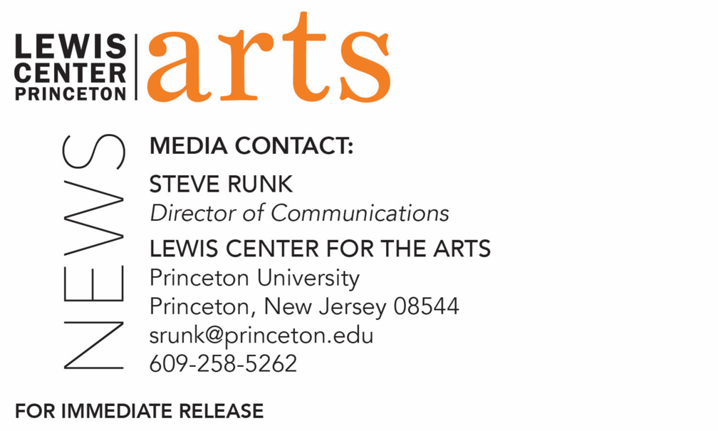

November 25, 2019

Lewis Center for the Arts’ Princeton Atelier presents
Shamilton!
Comedy supergroup Baby Wants Candy creates a completely improvised hip-hop Hamilton-inspired musical based on audience suggestion

Photo caption: Members of the comedy supergroup Baby Wants Candy.
Photo credit: Courtesy of Baby Wants Candy

What/Who: Comedy supergroup Baby Wants Candy presents Shamilton!, an improvised musical inspired by the Broadway hit Hamilton developed and performed on-the-spot with audience input, presented by the Lewis Center for the Arts’ Princeton Atelier.
When: December 2 at 7:00 p.m.
Where: Class of 1970 Theater at Whitman College on the Princeton University campus
Free and open to the public, but tickets required through tickets.princeton.edu
For more information: https://arts.princeton.edu/events/baby-wants-candy-presents-shamilton/

(Princeton, NJ) The Lewis Center for the Arts’ Princeton Atelier will present the comedy supergroup Baby Wants Candy and their production of Shamilton!, an improvised musical inspired by the Broadway hit Hamilton developed and performed on-the-spot with audience input. The one-time performance is on Monday, December 2 at 7:00 p.m. at the Class of 1970 Theater at Whitman College on the Princeton campus. The event is free and open to the public; tickets are required and advance tickets are encouraged, available at tickets.princeton.edu.

Members of Baby Wants Candy begin Shamilton! by asking the audience for suggestions of a historical figure, which could range from Genghis Khan to Frederick Douglass to Kim Kardashian, and then launches into an epic improvised musical with the same level of “hip hop, incredible songs, stunning choreography and powerhouse singing” of Hamilton.

Shamilton! was created by Baby Wants Candy in 2016 in Los Angeles and is now playing to sold out crowds in both New York City and Los Angeles. The New York Times called Shamilton!, “One of the top five comedy shows to catch.”

Baby Wants Candy originated in Chicago, the home of comedy improvisation in the U.S. The group has performed more than 3,000 completely improvised musicals to thousands of fans from Chicago to New York to Singapore to Scotland. Entirely based on audience suggestion and accompanied by a full band, the show is a roller-coaster ride of spontaneously choreographed dance numbers, rhyming verses and witty, jaw-dropping comedy. Each performance is the opening and closing night of that performance. The group has performing casts in Chicago (Apollo Theater), Los Angeles (UCB) and New York (UCB) and tours internationally.

The New York Times has described the group as a “Critics’ pick! Truly amazing.” The Chicago Sun Times calls Baby Wants Candy, “Consistently funny and crowd pleasing.” The Huffington Post writes, “It’s pretty damn brilliant, it’s pretty damn hilarious, and it was made up on the spot.”

Baby Want Candy has helped launch the careers of some of the top comedic talent in the US. Cast and alumni include Aidy Bryant (Saturday Night Live), Jack McBrayer (30 Rock), Peter Gwinn (Colbert Report), Thomas Middleditch (HBO's Silicon Valley), Lauren Conlan Adams (The Unbreakable Kimmy Schmidt), Jessica McKenna (Party Over Here), Nicole Parker (Elephaba in Wicked on Broadway) and many more. Band members/alumni include Garry W. Tallent of Bruce Springsteen and the E Street Band; Mark Pender of Conan’s Max Weinberg 7 and Bruce Springsteen and the Seeger Sessions Band; and Johnny Pisano of the Jesse Malin Band and The Marky Ramone Band.

Al Samuels, comedy writer and member of the Los Angeles team of Baby Wants Candy, will teach a Princeton Atelier course this spring, “Baby Wants Candy: Creating Comedy for Television.” Various television industry guests will visit throughout the semester. In the course students will participate in the in-process television pitch used by Baby Wants Candy, including finalizing concept and script and developing a strong pitch. By the end of the semester, the group will have a finished pitch package to present to Netflix, Amazon, Comedy Central and other networks/outlets. Students will develop their own original television concepts in groups and individually and also create shorter material e.g., desk bits for late night shows, online content, etc. This is Samuels’ second time teaching a Princeton Atelier course.

The Princeton Atelier, founded in 1994 by Nobel laureate and former faculty member Toni Morrison and currently directed by Professor Paul Muldoon, brings professional artists to the University for intensive collaborative work with students. Participating Atelier artists select a project they want to explore and experiment with in the context of a class with Princeton students before developing it for the professional art world.

For more information on this event, the Princeton Atelier, and the more than 100 other performances, exhibitions, readings, screenings and lectures presented each year at the Lewis Center visit arts.princeton.edu.

###

