Media contacts:
Jane Steuerwald, Exec. Dir.,  Thomas Edison Black Maria Film Festival  jane@blackmariafilmfestival.org  201-856-6565 | Steve Runk, Director of Communications Lewis Center for the Arts, Princeton University srunk@princeton.edu  609-258-5262

For immediate release

November 8, 2019

Thomas Edison Black Maria Film Festival Screening
The Thomas Edison Black Maria Film Festival presents selected short films from the Black Maria’s 2019 touring collection focusing on fiction-based storytelling through live-action and animation.

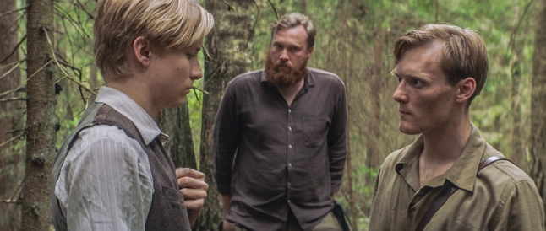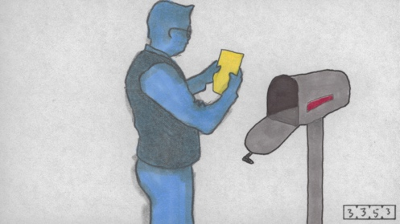

Photo caption1: A still from the narrative film, Tiger, Oak, and Echo by Cy Kuckenbaker, San Diego, CA one of eight films to be screened at the Black Maria Film Festival fall screening at Princeton.
Photo credit 1: Courtesy of filmmaker Cy Kuckenbacker
Photo caption 2: A still from the animated film Random Thoughts by Steven Vander Meer, Arcata, CA, one of eight films to be screened at the Black Maria Film Festival fall screening at Princeton.
Photo credit 2: Courtesy of filmmaker Steven Vander Meer

What: Back by popular demand, the third and final screening for 2019 from the 38th annual tour of the renowned Black Maria Film Festival at Princeton University, follows the February Festival premiere screening that had a standing-room-only audience, and a spring program focused on documentary. These eight new short narrative and animated films, introduced by Festival Director Jane Steuerwald, focus on fiction-based storytelling through live-action and animation.
Who: Presented by the Thomas A. Edison Media Arts Consortium and Program in Visual Arts of the Lewis Center for the Arts at Princeton University.
When: November 15 at 7:30 p.m.
Where: James Stewart Film Theater at 185 Nassau Street in Princeton
Free and open to the public

(Princeton, NJ) The Black Maria Film Festival returns to Princeton University’s Lewis Center for the Arts with a screening of eight more films from the 2019 tour on Friday, November 15 at 7:30 p.m. at the James Stewart Film Theater at 185 Nassau Street. The films, including animation and narrative genres, will be introduced by Festival Director Jane Steuerwald and focus on storytelling. Filmmakers represented are from South Korea, the U.S., Brazil, and Iran. The event is free and open to the public; no tickets are required. Free parking is available in University Lot #10 off William Street, behind 185 Nassau Street.

For 38 years the Black Maria Film Festival has been celebrating creativity and innovation in the moving-image arts. The festival was founded in 1981 as a tribute to Thomas Edison’s development of the motion picture at his West Orange laboratory, dubbed the “Black Maria” film studio, the first in the world. The studio received its name from Edison’s employees who thought the studio’s boxy shape and black tar paper covering resembled the so-called “black maria” police paddy wagons.

An annual juried competition of short works in all genres, the festival is a project of the Thomas Edison Media Arts Consortium, which also showcases the New Jersey Young Filmmakers Festival and the Global Insights Collection, an archive of films focusing on the environment, people with disabilities, international issues, and films with themes of social justice. The Thomas A. Edison Media Arts Consortium is in partnership with the Lewis Center for the Arts at Princeton University. The 2019 premiere screening kicking off the 38th annual tour held at Princeton in February drew a standing-room-only audience and many requests to bring more films from the Festival to campus.

The eight films being screened are:

Tiger, Oak & Echo, a narrative film by Cy Kuckenbaker of San Diego, California, in which
Young Echo longs to join his older brother in the guerilla war against the Soviet army occupying his homeland, Lithuania. He persuades his brother, Tiger, to let him join in a risky ambush. But when he makes a mistake before the battle, he has to choose — tell the truth and be left behind or stay quiet and join the fight. Set in 1950, the story is based on actual political events and is the first English language fiction film about the Lithuanian conflict.

Stone on Stone, a narrative film by Mohsen Serajia of Tehran, Iran, in which an Iranian family decides to kill an innocent woman because of her alleged adultery. Her husband’s friend is commissioned to do the murder. While he drives her outside of the city to do what is expected, their conversation takes an unexpected turn.

Recharge, a narrative film by Christopher Meyer of Seattle, Washington, in which employees at a battery-testing facility are regularly attacked while commuting across a hostile dystopian wasteland. When his car breaks down, Employee Number 235-4 is forced to confront one of the attackers, face to face.

Brainworm Billy, an animated film by Emily Hubley of East Orange, New Jersey in which a young man is haunted by a famous comedian.

Meeting MacGuffin, an animated film by Catya Plate of Brooklyn, New York, in which, in a post-apocalyptic future where humanity has fallen apart, a group of scientists and an animated sign complete the construction of a new human race and meet a groundhog climatologist who prepares them for their mission to restore balance to a decimated Earth.

Black Dog, a narrative film by Wooseok Shin of Seoul, South Korea. “Black dog syndrome” is the name for the phenomenon in which dark-coated dogs are overlooked in shelters in favor of lighter-colored dogs. The film advises: Don’t overlook that dark-coated beauty waiting in the shadows. You may be overlooking your new best friend.

moT, a narrative film by Andrew Kastenmeier of Florianópolis, Brazil, in which an odd homeless boy with a mysterious past invades a stranger’s home, befriends him, and protects a goldfish with which he has a curiously powerful bond, in this quiet tale of love and mortality.

Random Thoughts, an animated film by Steven Vander Meer of Arcata, California. Having recently completed a film made of circles and personal health problems, the film’s hero ships his masterpiece off in a box to a film festival. As he makes his way to the festival on foot, his thoughts reveal how inspiration can come to a creative spirit from anywhere, about anything, at any given time. After the festival, on his walk back home, the filmmaker feels super inspired and can hardly wait to start his next project — until, that is, he gets to his mailbox…

Black Maria received more than 400 submissions for the 2019 Festival tour from every continent around the globe except Antarctica. Following an extensive pre-screening by experts in the field of film curation, media studies and production, the highly regarded Festival jurors, Margaret Parsons, Head Curator of Film at the National Gallery of Art in Washington, DC, and Henry Baker, Emmy Award-winning filmmaker and former director of Synapse Video Center, chose 55 films for the 2019 collection and awarded the top prizes.

The Festival has traveled to more than 60 museums, cultural centers, colleges, and universities throughout the United States and abroad during 2019.

Princeton and Black Maria will present the premiere of the 2020 Festival tour on February 8, 2020, at 7:30 p.m. featuring Stellar Award-winners with filmmakers present for Q & A with Steuerwald. On February 7, 2020, at 7:30 p.m., a selection of films by women will be screened including work by Su Friedrich, animation by Emily Hubley and her mother Faith Hubley, and new selections from the Black Maria Film Festival's 2020 season. Friedrich, Emily Hubley and additional filmmakers will be present for a Q & A, also moderated by Steuerwald. Both events will take place in the James Stewart Film Theater.

Venues interested in scheduling a screening for 2020 should contact Festival Director Jane Steuerwald at jane@blackmariafilmfestival.org. The Festival offers programming options ranging from a custom-curated program presented by the host site, to an in-person film presentation by the Festival director, including a Q & A and dialog with the audience.

In addition to the support provided for the 2019 tour by the Lewis Center, the Black Maria Film Festival receives generous support from New Jersey State Council on the Arts; the Hudson County Office of Cultural and Heritage Affairs and Tourism; the Edison Innovation Foundation – Charles Edison Fund; the Hoboken Historical Museum; WithumSmith+Brown; Lowenstein Sandler, LLP; Adobe Systems, Inc.; and Microsoft through TechSoup.org.

To learn more about the Black Maria Film Festival and Thomas Edison Media Arts Consortium, visit blackmariafilmfestival.org.

To learn more about the Lewis Center for the Arts, the screening, and the more than 100 public performances, exhibitions, readings, screenings, concerts and lectures presented each year, most of them free, visit arts.princeton.edu.

###

