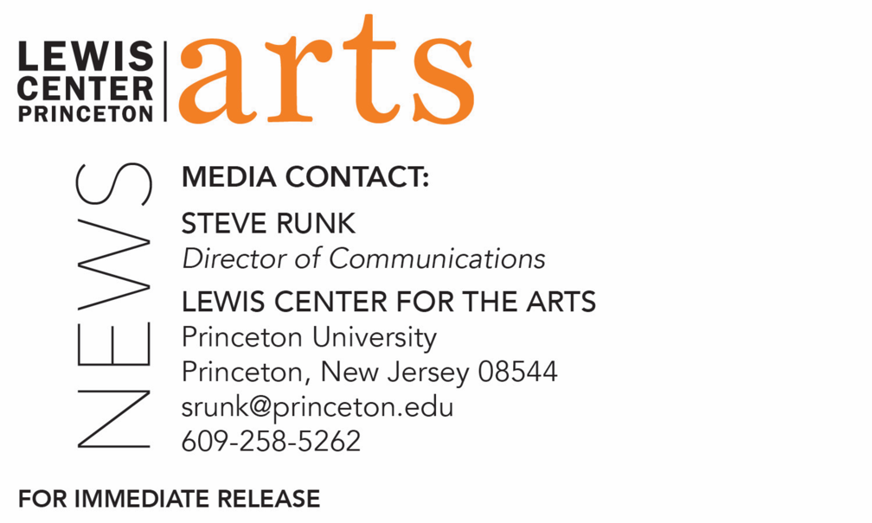

November 26, 2019

Poet Emily Jungmin Yoon reads with Five Seniors in Princeton’s
Creating Writing Program December 6
The C.K. Williams Reading Series is organized by Princeton students

Photo caption: Poet and translator Emily Jungmin Yoon
Photo credit: Jean Lachat

What/Who: A reading by poet and translator Emily Jungmin Yoon and five seniors in Princeton’s Program in Creative Writing – Liana Cohen, Somi Jun, Eunice Lee, Scooter Liapin, and Allegra Martschenko – continues the 2019-20 season of the C.K. Williams Reading Series, presented by the Lewis Center for the Arts’ Program in Creative Writing at Princeton University
When: December 6 at 6:30 p.m.
Where: Forum at the Lewis Arts complex on the Princeton University campus
Free and open to the public

(Princeton, NJ) Emily Jungmin Yoon, award-winning poet and translator, will read from her work at 6:30 p.m. on December 6 in the Forum at Princeton University’s Lewis Arts complex. Joining her will be Liana Cohen, Somi Jun, Eunice Lee, Scooter Liapin, and Allegra Martschenko – five seniors in Princeton’s Program in Creative Writing who will be reading from their recent work. This event continues the 2019-20 C.K. Williams Reading Series, named after the late Pulitzer Prize and National Book Award-winning poet C.K. Williams, who also served on Princeton’s faculty for 20 years. The event, presented by the Lewis Center for the Arts, is free and open to the public.

The series showcases senior thesis students of the Program in Creative Writing alongside established writers as special guests. The Program is celebrating its 80th anniversary this year with readings by 80 writers, including those in the C.K. Williams Series.

Emily Jungmin Yoon is the author of A Cruelty Special to Our Species (2018), winner of the Devil’s Kitchen Reading Award, and Ordinary Misfortunes (2017), winner of the Sunken Garden Chapbook Prize. Her poems and translations have appeared in The New Yorker, New York Times Magazine, Poetry, and elsewhere. She has received awards and fellowships from the Poetry Foundation, Bread Loaf Writers’ Conference, Ploughshares’ Emerging Writer’s Contest, Association of Writers and Writing Programs WC&C Scholarship Competition, the Aspen Institute, and elsewhere. She is the poetry editor for The Margins, the literary magazine of the Asian American Writers’ Workshop, and a Ph.D. candidate in Korean literature at the University of Chicago. Born in Busan, Republic of Korea, Yoon earned her B.A. in English and communication at the University of Pennsylvania and her M.F.A. in creative writing at New York University, where she served as an award editor for the Washington Square Review and received a Starworks Fellowship.

The five seniors, who are pursuing certificates in creative writing in addition to their major areas of study, will read from their senior thesis projects. Each is currently working on a novel, a screenplay, translations, or a collection of poems or short stories as part of a creative thesis for the certificate. Thesis students in the Program in Creative Writing work closely with a member of the faculty, which includes award-winning writers Michael Dickman, Aleksandar Hemon, A.M. Homes, Christina Lazaridi, Jhumpa Lahiri, Yiyun Li, Paul Muldoon, James Richardson, Tracy K. Smith, Kirstin Valdez Quade, Susan Wheeler, Monica Youn, and a number of distinguished lecturers.

Other upcoming guests in the 2019-20 C.K. Williams Series include Aaron Robertson, Hernan Diaz, Hala Alyan, and Maya Phillips.

In addition, the Program in Creative Writing presents the Althea Ward Clark W’21 Reading Series, also free and open to the public, on Wednesday evenings on the Princeton campus. Upcoming guests in that series include Joy Harjo and Sheila Heti on February 12,
Mei-Mei Berssenbrugge and Yoko Tawada on March 4, and Kaitlyn Greenidge, Helen Oyeyemi, and Nicole Sealey on April 15.

To learn more about these reading series, the Program in Creative Writing, and the more than 100 public performances, exhibitions, readings, screenings, concerts and lectures presented each year by the Lewis Center for the Arts, most of them free, visit arts.princeton.edu.

###

