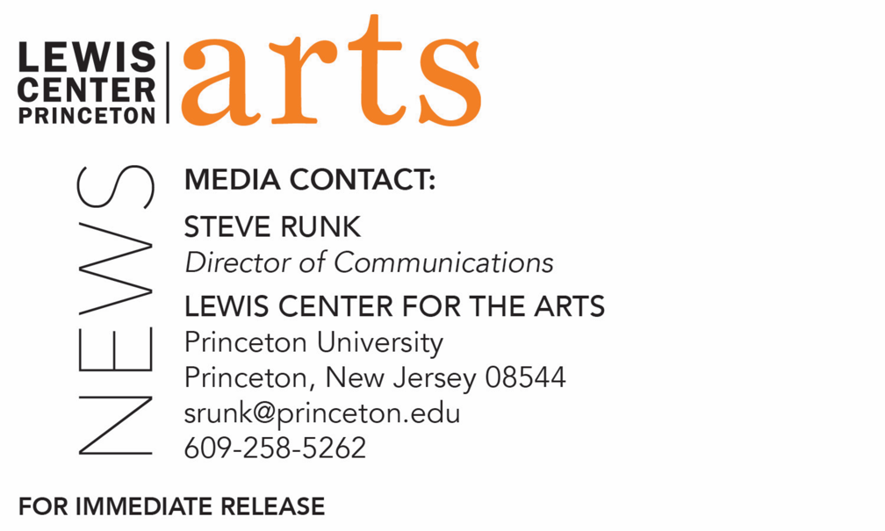

November 11, 2019

Lewis Center for the Arts’ Program in Creative Writing presents a reading by
Andrey Kurkov and Sapphire
Award-winning writers next in Althea Ward Clark W’21 Reading Series at Princeton

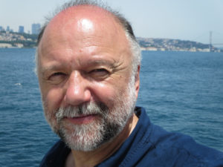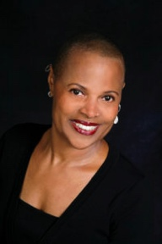
Photo caption 1: Andrey Kurkov
Photos credit 1: Courtesy of Andrey Kurkov
Photo caption 2: Sapphire
Photos credit 2: Courtesy of Blue Flower Arts

What: The next reading in the 2019-20 Althea Ward Clark W’21 Reading Series, part of a year-long celebration of the 80th anniversary of the Lewis Center for the Arts’ Program in Creative Writing at Princeton University
Who: Kiev-based novelist, screenwriter and journalist Andrey Kurkov and fiction writer, poet and essayist Sapphire, whose best-selling novel Push was adapted into the Academy Award-winning film Precious.
When: Wednesday, November 20 at 7:30 p.m.
Where: Donald G. Drapkin Studio at Lewis Arts complex on the Princeton University campus
Free and open to the public

(Princeton, N.J.) The Lewis Center for the Arts’ Program in Creative Writing continues its yearlong 80th anniversary celebration on November 20 with a reading by Kiev-based novelist, screenwriter and journalist Andrey Kurkov and fiction writer, poet and essayist Sapphire. The reading is the next event in the Althea Ward Clark W’21 Reading Series and begins at 7:30 p.m. in the Donald G. Drapkin Studio in the Lewis Arts complex on the Princeton University campus. The reading is free and open to the public.
Andrey Kurkov was born in St. Petersburg in 1961 and now lives in Kiev. He is the author of 19 novels, including the bestselling Death and the Penguin, nine books for children, and a number of documentary, fiction and television movie scripts. His work is currently translated into 37 languages and published in 65 countries. He worked for some time as a journalist and is a recognized commentator on Ukraine for the international media, notably in Europe and the United States. He served in the military as a prison warden at Odessa and worked as a film cameraman before becoming a writer.
Sapphire is the author of two bestselling novels, Push and The Kid. Push was made into the Academy Award-winning film Precious, and the film adaptation received the Academy Award for Best Screenplay and Best Supporting Actress. Sapphire’s work has been translated into 13 languages and has been adapted for stage in the United States and Europe. Her poetry, fiction, and essays have appeared in The Black Scholar, The New York Times Magazine, The New York Times Book Review, The Teacher’s Voice, The New Yorker, Spin, and Bomb.
The Lewis Center’s Program in Creative Writing annually presents the Althea Ward Clark W’21 Reading Series, which provides an opportunity for students, as well as all in the greater Princeton region, to hear and meet the best contemporary writers. The series is organized by Lecturer in Creative Writing and award-winning poet Michael Dickman. All readings are at 7:30 p.m. in venues in the Lewis Arts complex and are free and open to the public. Other readings scheduled in the 2019-2020 series include:
- Joy Harjo and Sheila Heti on February 12.
- Mei-Mei Berssenbrugge and Yoko Tawada on March 4.
- Kaitlyn Greenidge, Helen Oyeyemi, and Nicole Sealey on April 15.
The series will also include readings of new work in December and May by selected students in Creative Writing courses and readings in May by seniors in the Program from the novels, collections of short stories, poems or translations, or screenplays written as their senior theses.
To learn more about this event, the Program in Creative Writing, and the more than 100 other performances, exhibitions, readings, screenings, concerts, and lectures presented each year by the Lewis Center, most of them free, visit arts.princeton.edu.
###

