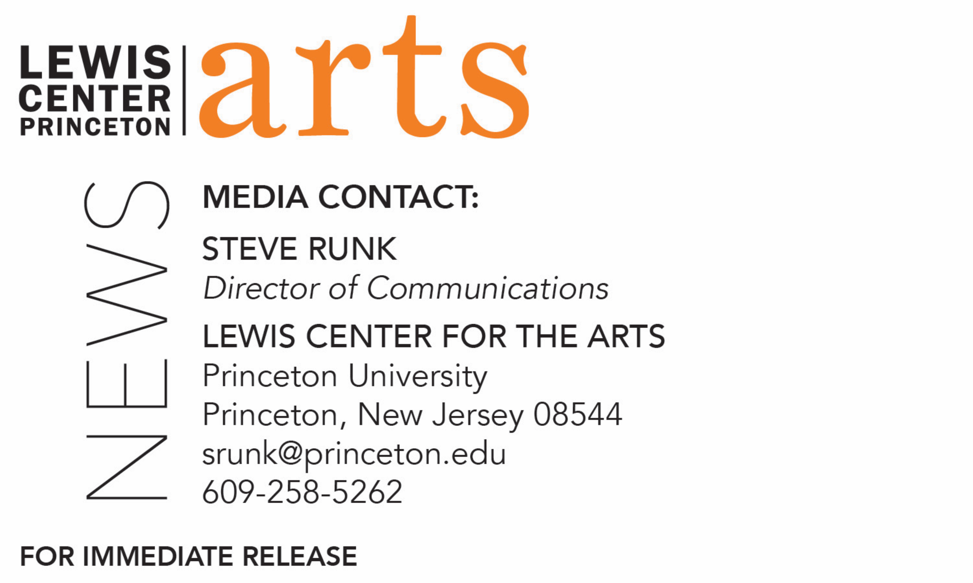

November 21, 2019

Lewis Center for the Arts’ Program in Dance presents
Princeton Dance Festival
Annual festival features a diverse program of repertory and new works and celebrates 50 years of Dance at Princeton

Photos caption: Students performing a work from the 2018 Princeton Dance Festival
Photo credit: Larry Levanti

What/Who: Princeton Dance Festival, presented by the Lewis Center for the Arts’ Program in Dance, featuring repertory works by Zvi Gotheiner and Hofesh Shechter and premiere of new dances by Rebecca Lazier, Cameron McKinney, Christopher Ralph, and Netta Yerushalmy, performed by Princeton students. This year’s Festival celebrates 50 years of dance at Princeton.
When: December 5 at 8:30 p.m., December 7 at 2 p.m. and 7 p.m., and December 8 at 2 p.m.
Where: Berlind Theatre at McCarter Theatre Center, 91 University Place in Princeton
Tickets: $12 in advance of show dates, $10 for students, and $17 purchased the day of performances at the box office, available through McCarter box office, at mccarter.org, or by calling 609-258-2787.

(Princeton, NJ) The Lewis Center for the Arts’ Program in Dance at Princeton University celebrates 50 years of dance at Princeton with this year’s annual Princeton Dance Festival. Repertory works by Zvi Gotheiner and Hofesh Shechter, along with the premiere of new works by Rebecca Lazier, Cameron McKinney, Christopher Ralph, and Netta Yerushalmy, will be performed by students in the Program. Performances will take place Thursday, December 5 at 8:30 p.m., December 7 at 2 p.m. and 7 p.m., and December 8 at 2 p.m. at the Berlind Theatre at McCarter Theatre Center.

An excerpt from Zvi Gotheiner’s ballet Lapse with music by Scott Killian features fast-paced, sweeping choreographic orchestrations. Lapse metaphorically plays in a quantum field, where material, life and action can gradually dissolve and then, at one critical moment, “leap” into nothingness. Originally from Israel, Gotheiner works in both New York and Jerusalem and is the founder of ZviDance. Lapse was originally created for Utah’s Repertory Dance Theatre.

Alexandra Damiani stages an excerpt from Violet Kid choreographed by Hofesh Shechter. During her 10-year tenure as ballet master and artistic director of Cedar Lake Contemporary Ballet, Damiani had the opportunity to work closely with Shechter and his team for the restaging of the Fools and the creation of Violet Kid on the company. Violet Kid premiered at Theater Bonn, Germany, in September 2011. Shechter composed the music for this work, a brooding score setting the tone of bottled rage. In describing his vision of the work, and his inspirations of a child’s hushed urges and passions, Shechter notes, “We all want to shout, sing, run out in the rain. The tension between good and quiet, and free and noisy – that was the physical tension that I explored in Violet Kid.” The student cast also had the opportunity to work directly with Bruno Guillore, associate artistic director of U.K.-based Hofesh Schechter company. In addition to creating for his company, Schechter has staged and choreographed works on international dance companies, including the Alvin Ailey American Theater, Bathsheva Ensemble, Candoco Dance Company, Nederlands Dans Theater 1, Paris Opera Ballet, Royal Ballet and Royal Ballet Flanders. He has choreographed for theater, television and opera, notably at the Metropolitan Opera in New York City for Nico Mulhy’s Two Boys, the Royal Court on Motortown and The Arsonists, and the National Theatre on Saint Joan and for the Channel 4 series Skins. In 2016 he received a Tony Award nomination for his choreography for the Broadway revival of Fiddler on the Roof. Grand Finale is the latest full-length work in his canon, which premiered at La Villette with Théâtre de la Ville in Paris on June 14, 2017, and was nominated for an Olivier Award for Best New Dance Production. In 2018 Shechter was awarded an honorary Order of the British Empire for Services to Dance, and the company's first dance film, Hofesh Shechter’s Clowns, was broadcast by the BBC in September to great acclaim. Shechter is an associate artist of Sadler’s Wells Theatre.

The Dance Festival also premieres four new works.

Walking Forward with Eyes Closed is a new dance created by Rebecca Lazier in collaboration with the performers. The piece asks: What is it to navigate forward in life? Can we truly see where we are going? How do we perceive the world around us as we chart our course? This work merges two dances. In one, a line perpetually advances and retreats with changing constellations of dancers who gather to support each other without seeing. In the second, the world swirls, solos erupt, people seek out each other, and communities form and dissolve. Together, they weave a work of contrasts set to Beneath, by composer Caleb Burhans, created for acapella group Roomful of Teeth. Lazier is a senior lecturer in and associate director of the Program in Dance and is currently serving as acting director of the program.

Tilted Sanctuary is a new work created by choreographer Cameron McKinney with contributions from the cast. The work places the dancers inside a house club floating precariously off the edge of a cloud. It uses a mix of street dance and contemporary floorwork to explore variations of existing off-balance. Tilted Sanctuary accesses the pulse of house music to engage the dancers in plays on rhythm and timing. McKinney, a fall 2019 visiting lecturer in dance at Princeton, has received commissions from prestigious institutions nationally and internationally, including the Joffrey Ballet School, The Ailey School, and SUNY Brockport, among others. He is a 2019-20 U.S.-Japan Friendship Commission Creative Artist Fellow, a 2018 Asian Cultural Council Grantee, and a 2017-18 Alvin Ailey Foundation New Directions Lab Choreography Fellow. Through his company, Kizuna Dance, McKinney has taught and presented work in fifteen states and four countries.

Ill at Ease (a working title) is a new work choreographed by Christopher Ralph and assisted by Sam Assemany in collaboration with the dancers. In this new creation Ralph explores the physical symptoms of anxiety, i.e. hyper vigilance, irritation and restlessness. Each section pushes the physicality of movement within a tense environment. He believes in “full body movement” and is always exploring the physical boundaries of a dancer’s body. He is also known for his musicality, and his score for this work is comprised of an eclectic variety of artists from Tune Yards to Andy Stott, all edited and mixed by Ralph. Throughout his career, Ralph has danced with a wide range of choreographers and companies including The Metropolitan Opera, Aszure Barton, Gregory Dolbashian, Janis Brenner, Loni Landon, Rebecca Lazier, Doug Varone, Patrick Corbin, and Sonya Tayeh. He teaches contemporary dance at Peridance Capezio Center, Broadway Dance Center, New York University, and at Princeton.

AFNBCG is a new work by 2019-21 Princeton Arts Fellow Netta Yerushalmy, a New York City-based award-winning choreographer and performer. Her work often uses expansive dancing, framed by conceptual maneuvers and complex choreographic structures. In this work she and the students experiment with “plucking” movement quotes from a wide range of dances that they already know. These movement quotes yield a multiplicity of textures that are treated as fabric swatches for an intricate and elaborate quilt with surprising results. Following Yerushalmy's acclaimed six-part epic series Paramodernities, where she radically appropriated movement from iconic modern choreographies, the dancing in AFNBCG is comprised of a multitude of movement quotes sourced from the students’ and Yerushalmy’s embodied dance histories, including some from dances previously performed at Princeton. By plucking or “stealing” these short movements and placing them outside of their original contexts, Yerushalmy repurposes them, re-orients them, and potentially re-cultures them. This piece for the Princeton Dance Festival is part of a larger creative research project that the choreographer is developing with professional dancers.

Dance as an artform was introduced at Princeton during the 1969-70 academic year, when the University opened its doors to undergraduate women. Dance was one of the “special needs” anticipated by the administration for the incoming women, however in those first few years the majority of students taking dance were men. Choreographer/dancer Ze’eva Cohen created the first courses in dance and directed the program for 40 years before retiring in 2010. In 1975 dance became part of the academic Program in Theater and Dance, and in 2009 became its own program. Currently under the direction of choreographer Susan Marshall, the program has grown to include five full-time and nine adjunct faculty and offers 23 different courses and a curriculum that includes introductory courses, courses suited for dancers at the pre-professional level, as well as courses in dance studies and interdisciplinary contemporary practices

The Berlind Theatre is an accessible venue with access details available at www.mccarter.org [embed link: https://www.mccarter.org/plan-your-visit/accessibility/]. Assistive listening devices are available upon request when attending a performance. Patrons in need of other access accommodations are invited to contact the Lewis Center at 609.258.5262 or LewisCtr-Comm@princeton.edu for assistance at least two weeks prior to the selected performance.

Reserved seating tickets for Princeton Dance Festival are $12 in advance of show dates, $10 for students, and $17 purchased the day of performances at the box office. Tickets are available online through https://www.mccarter.org/season/2019-2020/pdps/princeton-dance-festival/, by calling the McCarter box office at 609-258-2787, or at the door on the night of performances.

To learn more about the Princeton Dance Festival, the Program in Dance, and the more than 100 performances, exhibitions, readings, screenings, concerts and lectures presented each year by the Lewis Center for the Arts visit: arts.princeton.edu.

###

