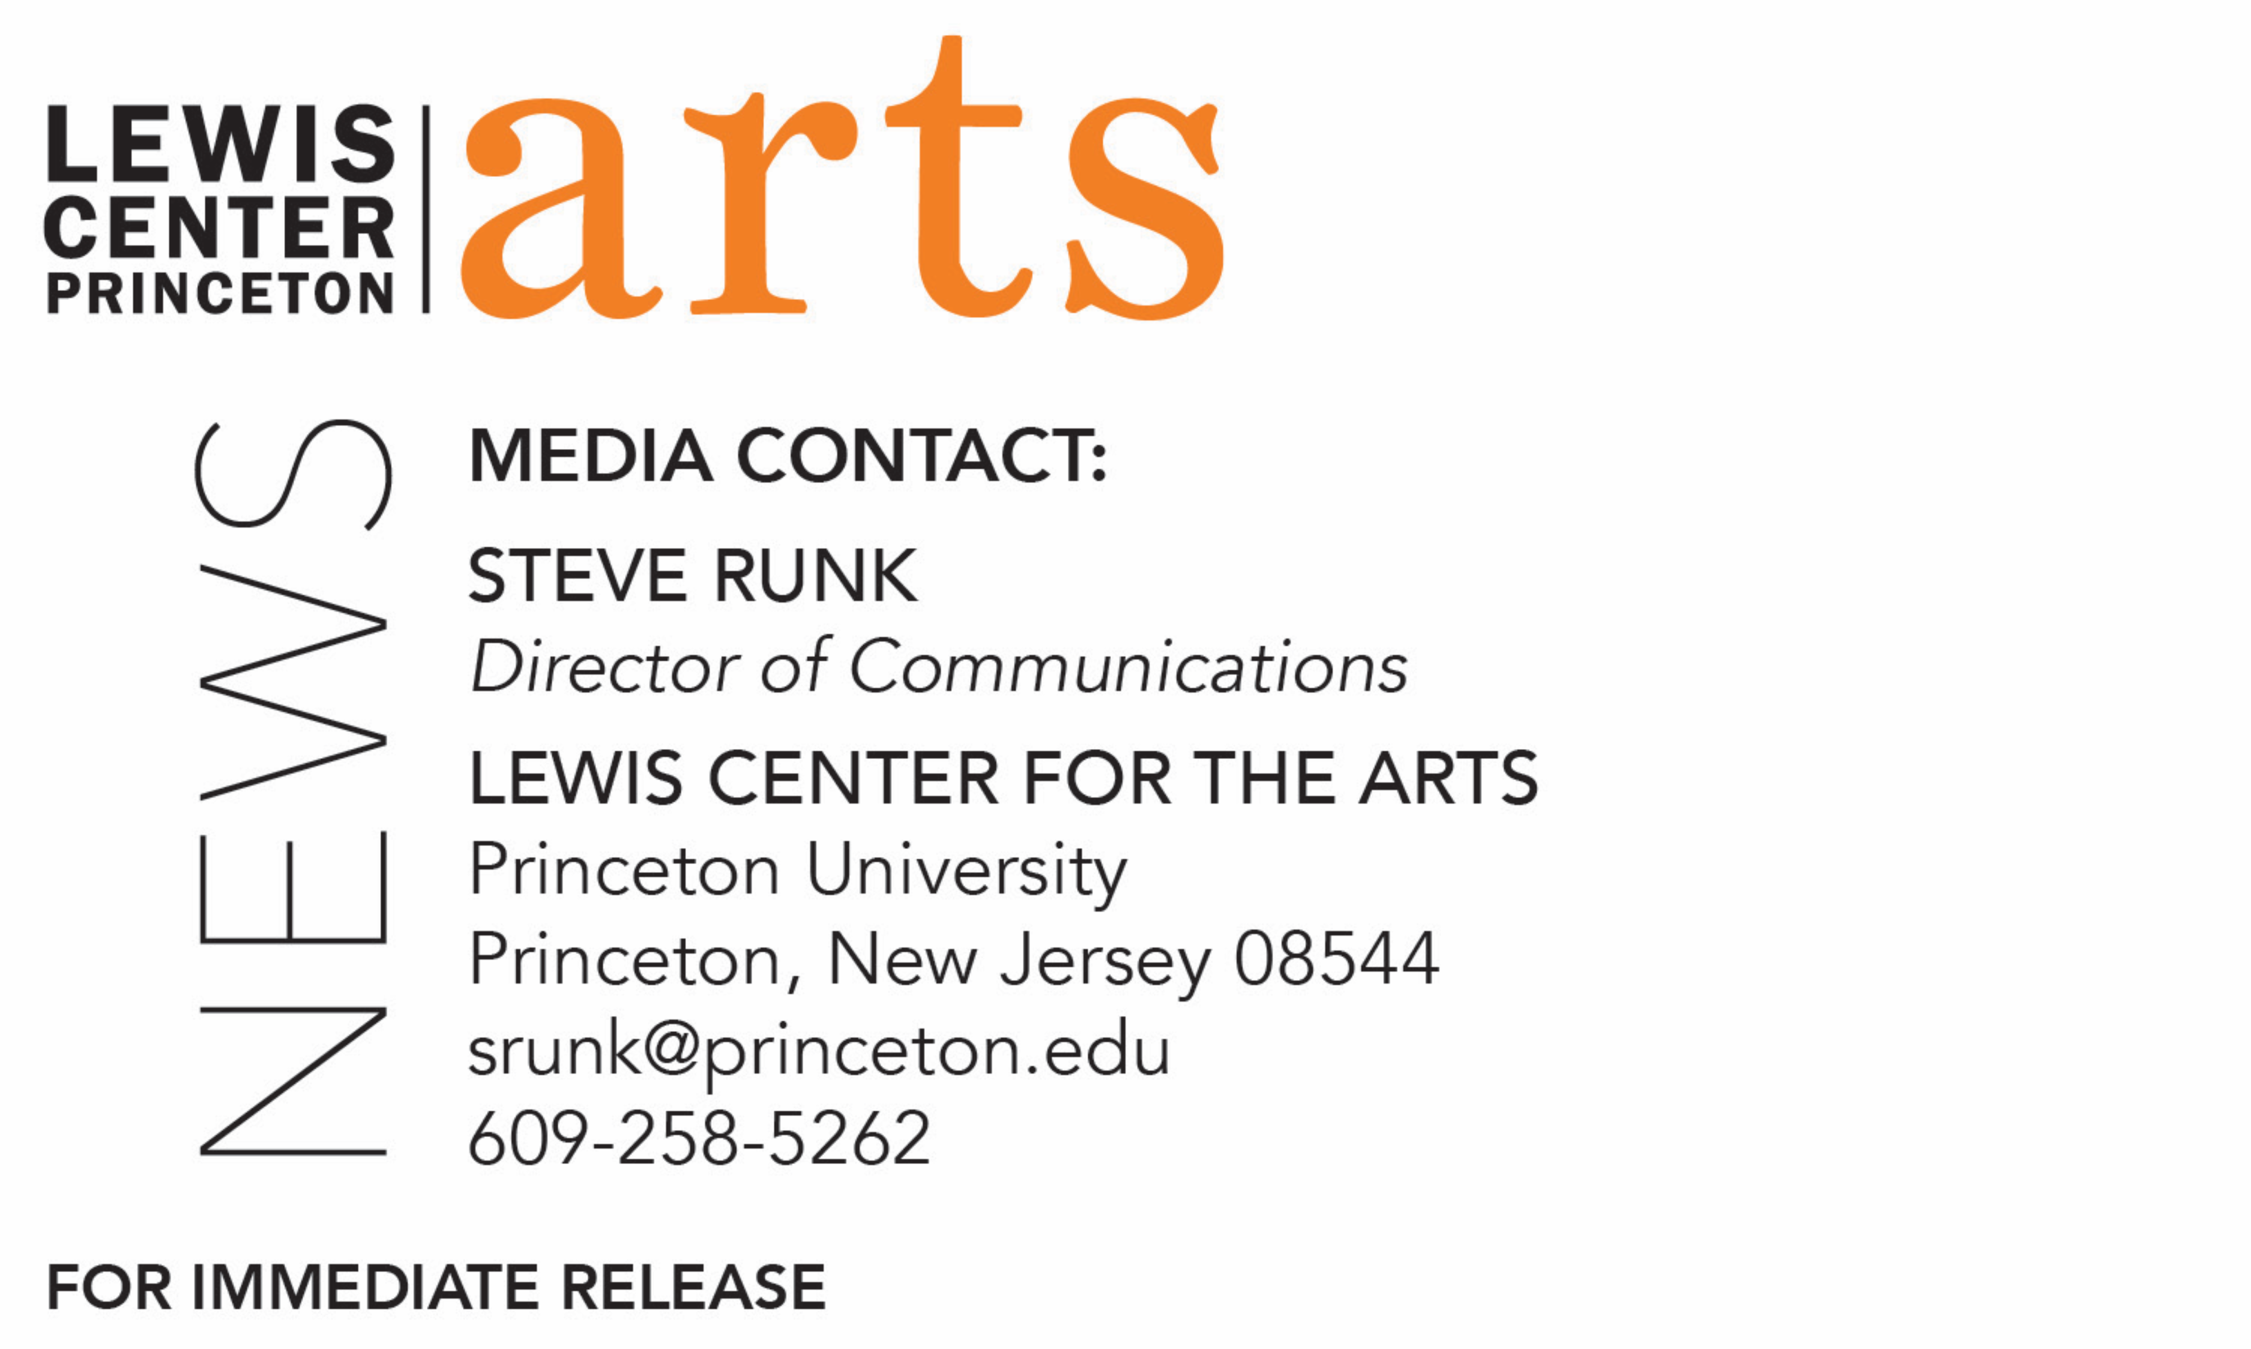

November 11, 2019

Lewis Center for the Arts’ Program in Visual Arts at Princeton University presents
A *New* Program for Graphic Design Book Launch
New textbook by faculty member David Reinfurt on graphic design and a talk by eight recent alumni working in the design field

Photos caption 1: Cover of David Reinfurt’s new book, A *New* Program for Graphic Design that offers a broad introduction to graphic design history and specific models through three courses developed at Princeton: Typography, Gestalt, and Interface.
Photo credit 1: Courtesy of Inventory Press
Photo caption 2: Princeton Lecturer in Visual Arts David Reinfurt
Photo credit 2: Courtesy of David Reinfurt

What/Who: Book launch for A *New* Program for Graphic Design by Princeton Lecturer in Visual Arts David Reinfurt that offers a broad introduction to graphic design history and specific models through three courses developed at Princeton: Typography, Gestalt, and Interface, along with talks by eight recent graphic design alumni working in the design field.
When: November 18 at 7:30 p.m.
Where: Hurley Gallery at Lewis Arts complex on the Princeton University campus
Free and open to the public

(Princeton, NJ) The Lewis Center for the Arts’ Program in Visual Arts at Princeton University will present a special event on November 18 at 7:30 p.m. to celebrate the launch of Lecturer in Visual Arts David Reinfurt’s new book, A *New* Program for Graphic Design. This do-it-yourself textbook offers a broad introduction to graphic design history and specific models through three courses developed for Princeton students in typography, gestalt, and interface. Joining Reinfurt, eight recent Princeton alumni who took these courses will discuss their various different post-graduate paths in graphic design and early career experiences working at institutions ranging from DreamWorks to The New Yorker to the Museum of Modern Art. The event will take place in the Hurley Gallery at the Lewis Arts complex on the Princeton campus and is free and open to the public.

A *New* Program for Graphic Design provides a broad introduction from Benjamin Franklin to Bruno Munari, and Moholy-Nagy to Muriel Cooper and the Macintosh computer, and includes a series of in-depth historical case studies and assignments that get increasingly complex and which serve as a guide into the study of graphic design.

Reinfurt hopes that by using these methods, his book will be able to present advanced concepts on contemporary design to a general audience. The book is published by Inventory Press and distributed by Art Publishers and was supported by the Graham Foundation for Advanced Studies in the Fine Arts, the Barr Ferree Foundation Fund for Publications, Princeton’s Department of Art and Archaeology, and the Lewis Center.

The recent alumni returning to campus to discuss their current positions in the design field are Kara Bressler ’19, a computer graphics designer for DreamWorks Animation in Los Angeles; Ben Denzer ’15, a book designer at Knopf Doubleday Publishing in New York City; Nazli Ercan ’17 a graphic designer at the Whitney Museum of Art in New York City; Lily Healey ’13, a member of the graphic production staff at The New Yorker in New York City; Eric Li ’18, a digital media designer at the Museum of Modern Art in New York City; Neeta Patel ’16, a junior designer at The New Yorker in New York City; Simon Wu ’17, a curatorial assistant at the Museum of Modern Art in New York City; and Jonathan Zong ’18, currently a Ph.D. candidate and Soros Fellow at MIT in Cambridge, Massachusetts.

Reinfurt is an independent graphic designer and writer based in New York City. After graduating from the University of North Carolina in 1993, he worked as an interaction designer with IDEO (San Francisco) from 1995 to 1997. There he eventually became the lead designer for the New York City MTA Metrocard vending machine interface, still in use by millions of people today. Reinfurt would later go on to receive his M.F.A. from Yale University in 1999, and on the first business day of 2000, he formed O-R-G inc., a flexible graphic design practice composed of a constantly shifting network of collaborators. Six years later, he and graphic designer Stuart Bailey cofounded a workshop in New York City’s Lower East Side called Dexter Sinister. The workshop models a Just-In-Time economy of print production to make work such as the semi-annual arts magazine Dot Dot Dot from 2006-2011. Eventually, in 2012, Reinfurt set up another corporation with the help of Stuart Bailey and Angie Keefer, The Serving Library. It is a cooperatively-built archive consisting of an ambitious public website, a small physical library space, and a publishing program, that assembles itself by publishing.

Reinfurt has also taught at a number of institutions including the Columbia University Graduate School of Architecture, Planning and Preservation, the Rhode Island School of Design, and Yale University School of Art. In 2010, he came to Princeton where he re-established the typography studio and introduced the study of graphic design as a starting point for students and visual artists alike. He currently teaches “Graphic Design: Circulation,” “Graphic Design: Typography,” “Graphic Design: Visual Form,” and “Advanced Graphic Design” in Princeton’s Program in Visual Arts.

Reinfurt was a 2010 United States Artists Rockefeller Fellow in Architecture and Design. His work is featured in such places as the Walker Art Center, Whitney Museum of American Art, Cooper Hewitt National Design Museum, and the Museum of Modern Art. He was also the 2016-2017 Mark Hampton Rome Prize fellow in Design at the American Academy in Rome.

To learn more about Princeton’s Program in Visual Arts, and the more than 100 other performances, exhibitions, readings, screenings and lectures presented each year at the Lewis Center visit arts.princeton.edu.

###

